**Start Dev Network**

First step is to start the dev-network, run below command to do that.

cd fabric-samples/chaincode-docker-devmode

sudo docker-compose -f docker-compose-simple.yaml up

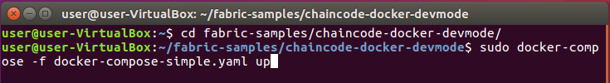

This should start 4 docker containers, you can confirm by running below command.

sudo docker ps

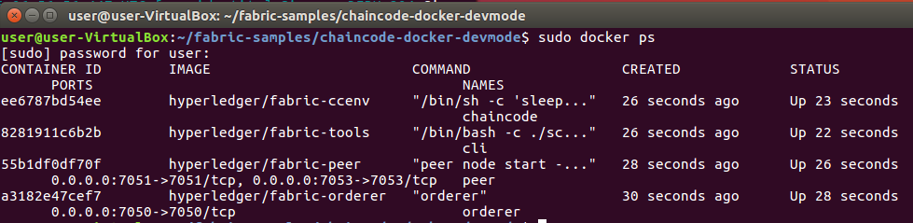

**Build Chaincode**

Now in next step, you will open the chaincode container and build the chaincode. For that follow steps.

Connect to chaincode container using below command.

sudo docker exec -it chaincodesh



Now, you will build the chaincode. For that create new folder with the name "property-app" under chaincode folder and then create "go" folder inside "property-app" folder.

mkdir property-app

cd property-app

mkdir go

Now to property-app/go folder using below command.

cd property-app/go

Place the Property.go file that you created in previous assignment to this newly created "go" folder.

Now build the chaincode using below command, first you will create module file and then build the code.

go mod init example.com/property

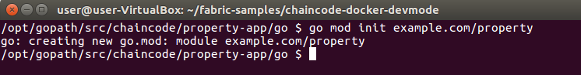

go.mod file gets created.

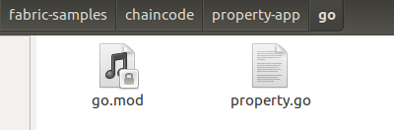

Then run below command to build the code.

go build

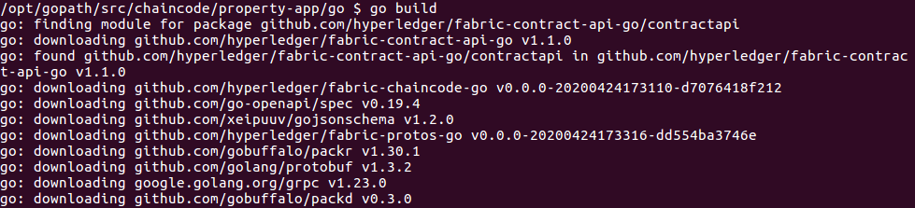

This generate go.sum file and property file that shows that build is successful.

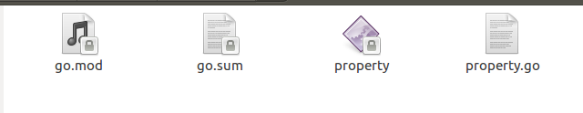

Run the chaincode with below command.

CORE_CHAINCODE_ID_NAME=prop:0 CORE_PEER_TLS_ENABLED=false ./property -peer.address peer:7052

https://img-a.udemycdn.com/redactor/raw/2020-07-26_07-12-25-453b77a4ab7d352b97663c3e6a529e6b.PNG

**Access Chaincode from CLI**

Connect to CLI container using below command.

sudo docker exec -it cli bash

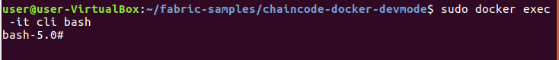

Now you will install and instantiate the chaincode. First check if you are in chaincodedev directory using below command.

pwd

Now go to chaincode folder using below command.

cd chaincode

Now run below command to install the chaincode.

peer chaincode install -p property-app/go -n prop -v 0

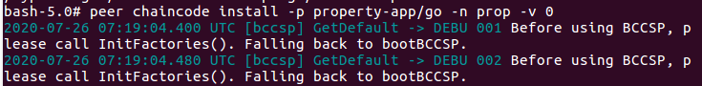

If you see response status 200, that means chaincode is successfully installed.

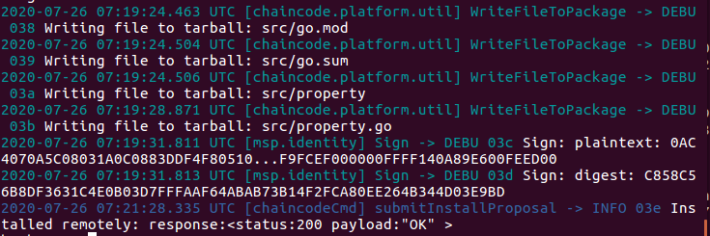

Next step is to instantiate the chaincode using below command.

peer chaincode instantiate -n prop -v 0 -c '{"Args":[]}' -C myc

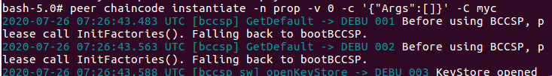

**Call Functions**

Now lets call "AddProperty" function using below command.

peer chaincode invoke -n prop -c '{"Args":["AddProperty", "1", "Property1","1000","John","1000"]}' -C myc

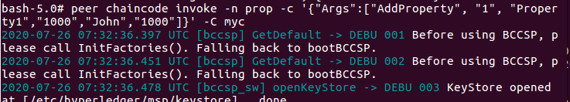

If function gets called successfully then you should see response 200 ok as shown below.

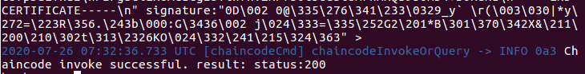

Now let's call QueryPropertyById function using below command.

peer chaincode invoke -n prop -c '{"Args":["QueryPropertyById", "1"]}' -C myc

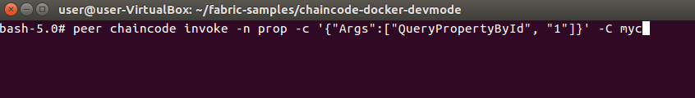

You should successful response message.

