**Interacting with network**

In Fabric 2.x, there is no CLI container so you need to run all the command and connect to network from peer CLI only. To make that happen, you need to setup some environment variables.

Ensure that you are in fabric-samples/test-network folder to run all below commands.

***Update PATH Variable***

You need to update the PATH variable with peer binaries that are there in fabric-samples/bin folder.

https://udemy-images.s3.amazonaws.com:443/redactor/raw/2020-07-27_09-18-06-89a709c9a76607e63f0db209c50e3547.PNG

Use the following command to add those binaries to your CLI Path:

export PATH=${PWD}/../bin:${PWD}:$PATH

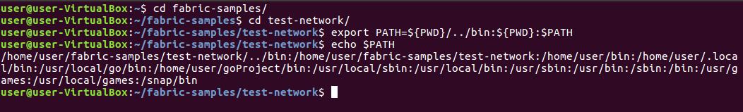

***Set FABRIC_CFG_PATH Variable***

Set the **FABRIC_CFG_PATH** to point to the core.yaml file in the fabric-samples repository:

export FABRIC_CFG_PATH=$PWD/../config/

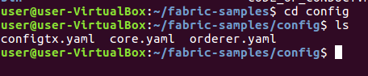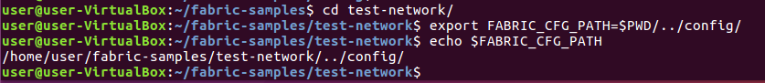

**Org1 peer environment variables**

You can now set the environment variables that allow you to operate the peer CLI as Org1:

# Environment variables for Org1

export CORE_PEER_TLS_ENABLED=true

export CORE_PEER_LOCALMSPID="Org1MSP"

export CORE_PEER_TLS_ROOTCERT_FILE=${PWD}/organizations/peerOrganizations/org1.example.com/peers/peer0.org1.example.com/tls/ca.crt

export CORE_PEER_MSPCONFIGPATH=${PWD}/organizations/peerOrganizations/org1.example.com/users/Admin@org1.example.com/msp

export CORE_PEER_ADDRESS=localhost:7051

CORE_PEER_TLS_ROOTCERT_FILE  refer to org1 peer ca certficate.

CORE_PEER_MSPCONFIGPATH  refer to org1 peer msp material.

**Org2 peer environment variables**

You can now set the environment variables that allow you to operate the peer CLI as Org2:

# Environment variables for Org2

export CORE_PEER_TLS_ENABLED=true

export CORE_PEER_LOCALMSPID="Org2MSP"

export CORE_PEER_TLS_ROOTCERT_FILE=${PWD}/organizations/peerOrganizations/org2.example.com/peers/peer0.org2.example.com/tls/ca.crt

export CORE_PEER_MSPCONFIGPATH=${PWD}/organizations/peerOrganizations/org2.example.com/users/Admin@org2.example.com/msp

export CORE_PEER_ADDRESS=localhost:9051