Step 1: Go to fabric-samples folder by using below command.

cd fabric-samples

Step 2: Go to test-network folder by using below command.

cd test-network

Step 3: Run below command to start your test-network with all the containers (2 peers, orderer, 3 ca, 2 couchdb).

sudo ./network.sh up -ca -s couchdb

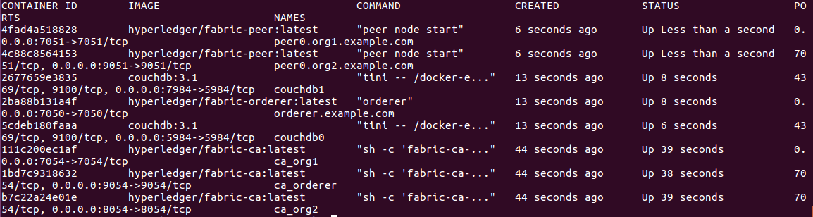

Step 4: Create new channel by using below command.

sudo ./network.sh createChannel -c testchannel3

This will create a new channel with the name testchannel3.

Step 5: To stop the network, you need to run below command.

sudo ./network.sh down