Step 1: Go to fabric-samples folder by using below command.

cd fabric-samples

Step 2: Go to test-network folder by using below command.

cd test-network

Step 3: Run below command to start your test-network and create CA container for each organization ( one for orderer, one for org1 peer and one for org2 peer)

sudo ./network.sh up –ca

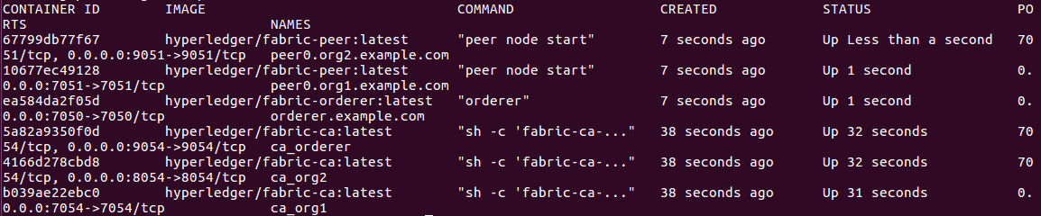

Step 4: Create new channel by using below command.

sudo ./network.sh createChannel -c testchannel2

This will create a new channel with the name testchannel2.

Step 5: To stop the network, you need to run below command.

sudo ./network.sh down