Step 1: Go to fabric-samples folder by using below command.

cd fabric-samples

Step 2: Go to test-network folder by using below command.

cd test-network

Step 3: Run below command to start the network and create couchDB containers as well.

sudo ./network.sh up -s couchdb

This command starts your network and create couchdb container for each peer as well.

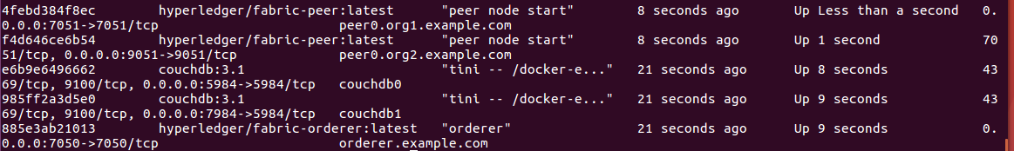

Step 4: Create new channel by using below command.

sudo ./network.sh createChannel -c testchannel1

This will create a new channel with the name testchannel1.

Step 5: To stop the network, you need to run below command.

sudo ./network.sh down