Step 1: Go to fabric-samples folder by using below command.

cd fabric-samples

Step 2: Go to test-network folder by using below command.

cd test-network

Step 3: Run below command to start your test-network

sudo ./network.sh up

This start the network, you can run below command to check docker containers.

sudo docker ps

This shows you three docker containers

1. One for Org1 peer node
2. One for Org2 peer node
3. One for Orderer

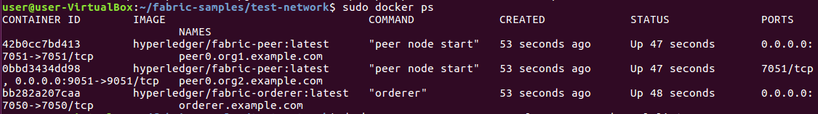

When you start the network, you will also not get any channel by default. You can check the channel by using below command.

docker exec peer0.org1.example.com peer channel list

This command shows you that, you don't have any channel created.

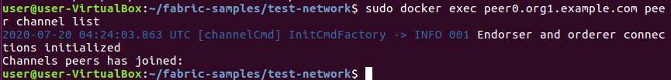

Step 4: Create new channel by using below command.

sudo ./network.sh createChannel -c testchannel

This will create a new channel with the name testchannel.

To verify this channel creation, run below command on both the peers.

sudo docker exec peer0.org1.example.com peer channel list

sudo docker exec peer0.org2.example.com peer channel list

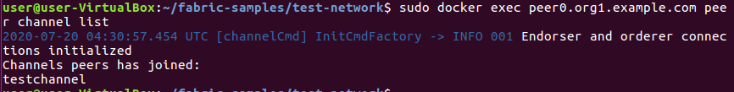

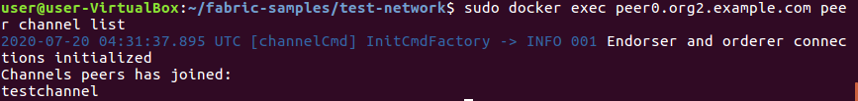

Step 5: To stop the network, you need to run below command.

sudo ./network.sh down