class04.R

rogeliocastro

2023-04-13

x <- 1:50  
plot(x,sin(x))

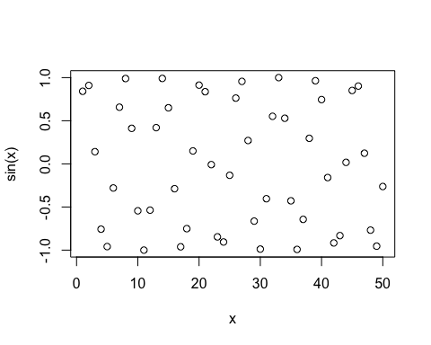

plot(x,sin(x), typ="l", col="blue", lwd=3, xlab="Hello there")

