Final Graph: Effects of Different Liquids on Apple Browning
Browning measured every 15 minutes over 90 minutes (1 = no browning; 5 = severe browning).
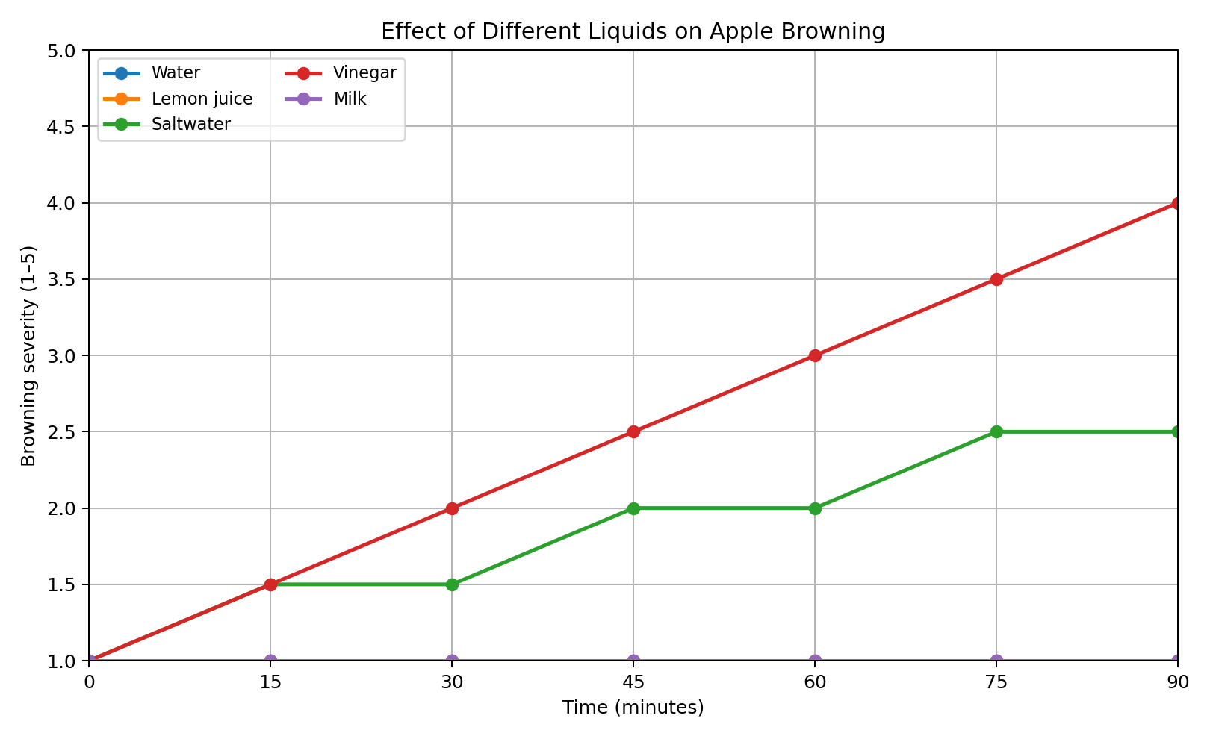
Water, lemon juice, and milk maintained a score of 1 throughout the experiment, so their lines overlap. Saltwater reached 2.5, and vinegar reached 4 after 90 minutes.

