**IS 322**

**Wellness Tracker App**

**Rocco Ricciardi & Kareem Fayek**

[*https://github.com/roccoricciardi/IS322Final*](https://github.com/roccoricciardi/IS322Final)

Original Concept

The original concept behind our application was to provide a Wellness Tracker for users who wanted a basic reminder/demonstration of their health through their eating habits. It would provide a main page with their current health status, illustrated by Peggy the Piggy, who’s physical appearance would determine what the user’s health was. The user would also be able to see the past week’s history in terms of their progression or failure in increasing their health habits.

Current Deliverable

As the project stands, it is incomplete. We were able to make the “Track a New Day” page work as intended, however we were unable to reflect the results properly on the Main Page and the History Page.

Problems/Snags

The main snags we hit in this project had to do with a misunderstanding of Javascript, which came as an annoyance because the group members had believed they possessed the necessary skills and knowledge required to complete the project based on our participation and attendance to class. The GitHub Repository for this project has over 40 commits of their process and understanding.

Notes

PLEASE READ OUR CODE AND OUR COMMITS! The deliverable may not be what was expected or proposed, but reading through the group’s code and history may help create a better understanding or appreciation for the project.

*Also, both group members certify here that there was fair participation by both people throughout the development of this project.*

*Rocco Ricciardi Kareem Fayek*

Main Page –

Keep in mind that this “Check Wellness” button was supposed to reflect the wellness of the user which was determined by the Track a New Day Page.

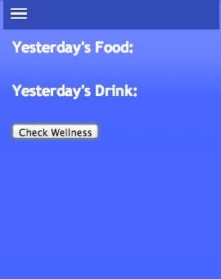 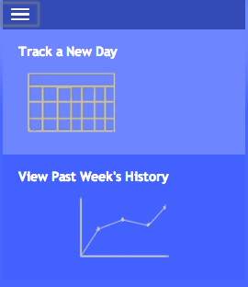

History Page –

This page was unable to be completed. It exists and is linked in the project deliverable, but displays nothing except for the menu to return to the other pages. Please observe Chart.js, as that was the model we were trying to follow.

 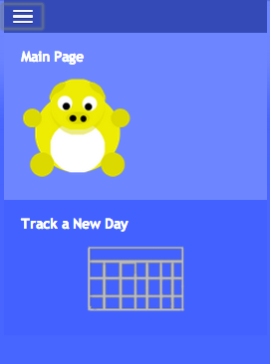

Track a New Day Page –

This page was completed as intended. Notice three different scenarios of health below.

