Rocco Vulpis

March 7, 2024

Excel Work

In this portion of the project, Microsoft Excel spreadsheets were created for various reasons such as calculating formulas and creating histograms from data. The data in the “Histograms” spreadsheet was used to create histograms from data provided by the textbook. The first histogram displays the frequency of radioactive material in an area. The second histogram displays average wind speeds in the United States.

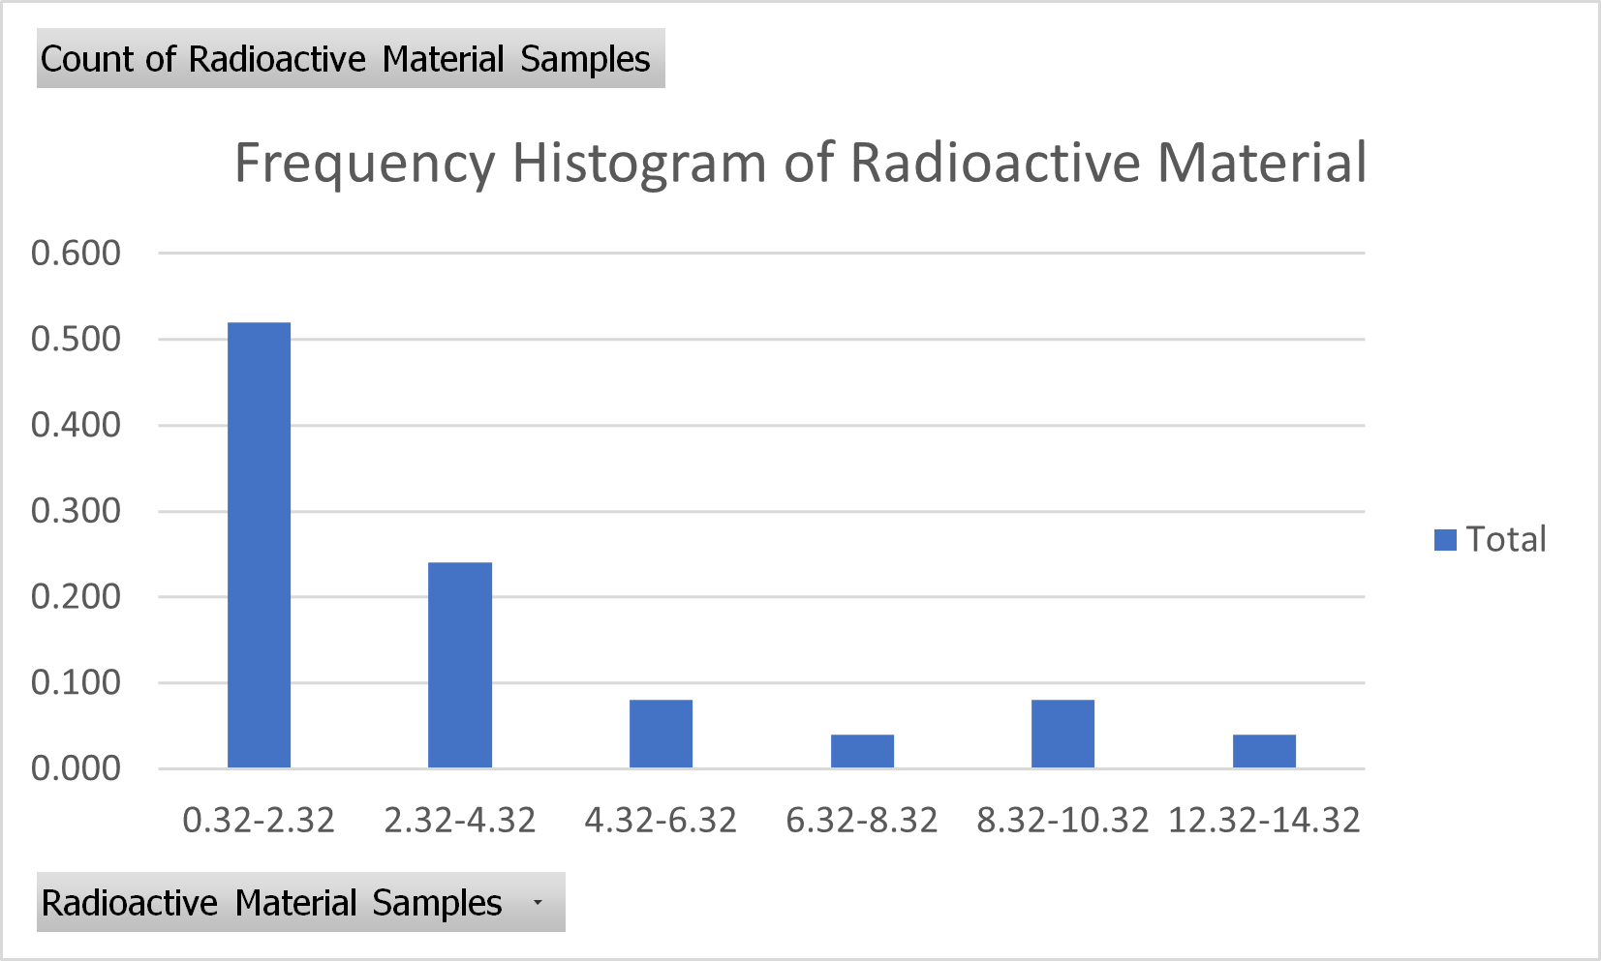

Frequency Histogram of Radioactive Material

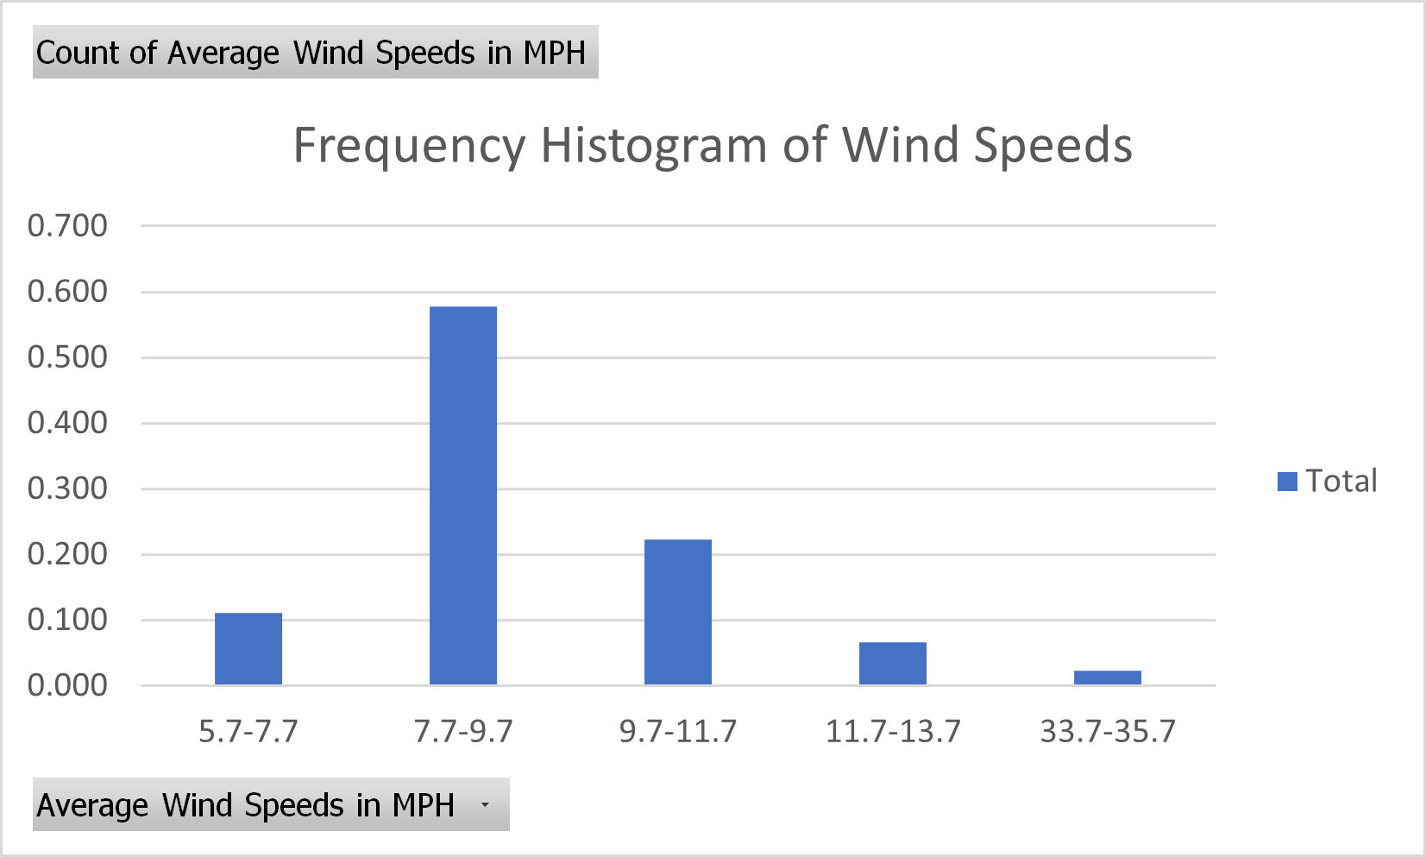

Frequency Histogram of Average Wind Speeds

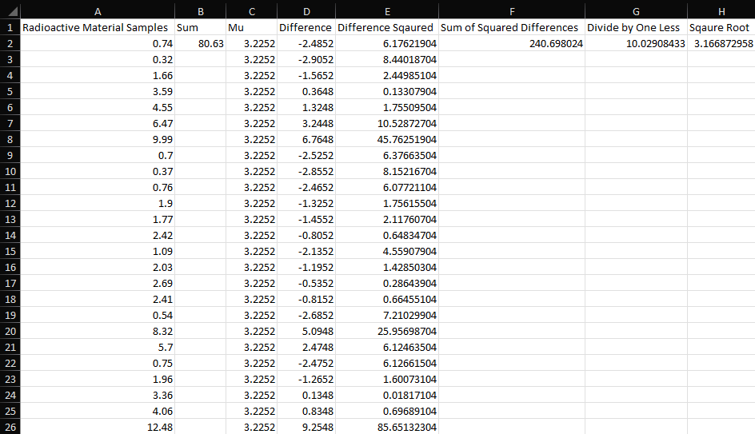 The “Standard_Deviation” spreadsheet uses the radioactive materials samples to calculate the standard deviation of the data. This process is completed with a standard deviation formula the uses each column as a part of the formula in the computation.

Standard Deviation Spreadsheet

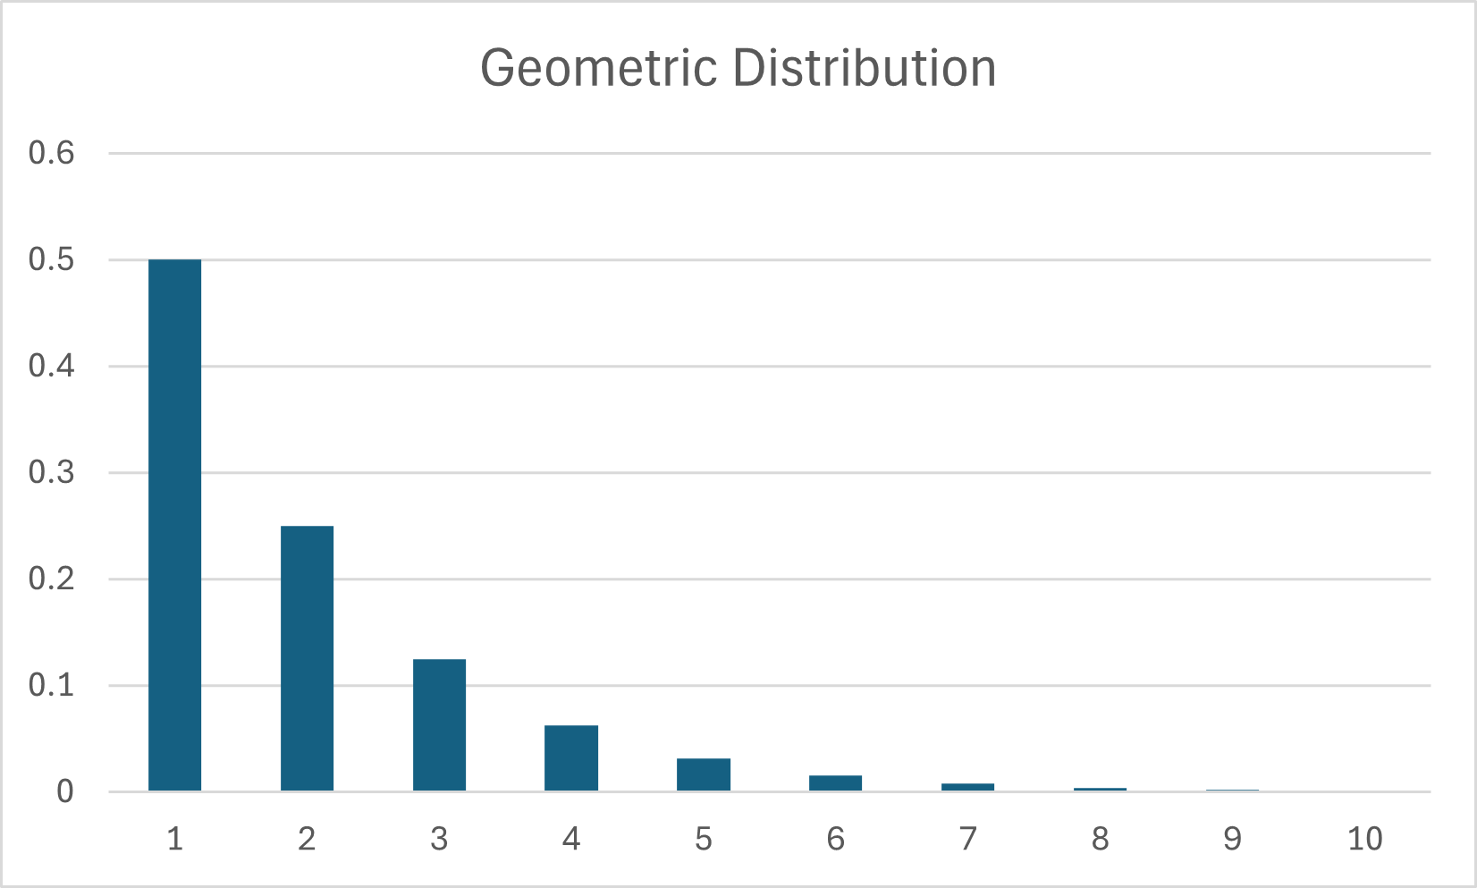 The “Geometric_Distribution_Coin_Flip” spreadsheet was the final spreadsheet created for this portion of the project. Similar to the standard deviation, it uses its columns to make up a geometric distribution formula. The example used was flipping a coin ten times. With this data, a histogram was created to measure the probability of success after ten trials.

Geometric Distribution Histogram for Flipping a Coin 10 Times