Rocco Vulpis

March 7, 2024

**Pokémon Card Game**

This Pokémon Java project is a simulation and gameplay system designed to recreate the experience of playing the Pokémon Trading Card Game. The project not only allows players to engage in battles using a collection of Pokémon, Trainer, and Energy cards but also features tools to evaluate game strategies and outcomes through Monte Carlo simulations. This Java project is divided into three main components: the base game, the Mulligan Monte Carlo simulation, and the Rare Candy Monte Carlo simulation.

**Pokémon TCG**

At its core, the base game is a digital representation of the Pokémon card game, enabling two players to compete against each other. Each player manages a deck comprising Pokémon (each with unique attacks), Energy cards (which are required to power Pokémon attacks), and Trainer cards (which provide special abilities or advantages). The game progresses through turns where players can draw cards, play Pokémon to the field, attach Energy cards, and use their Pokémon to attack the opponent's Pokémon. The objective is to defeat the opponent's last Pokémon by reducing their HP to zero, winning the game.

**Key Features**

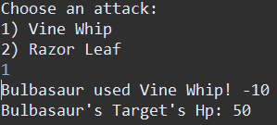Pokémon can be set as active fighters, with the capability to attack the opponent's active Pokémon.

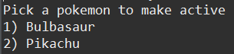

Players manage decks, hands, benches, prize piles, and discard piles.

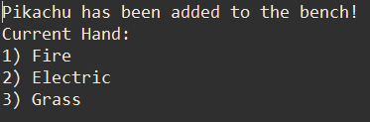

Energy cards are necessary to conduct attacks, while Trainer cards offer strategic gameplay benefits.

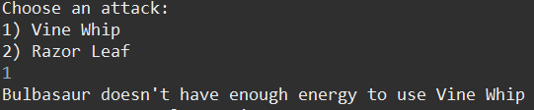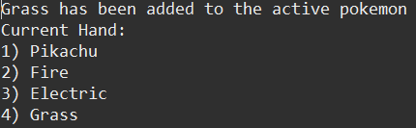

The game includes mechanisms for drawing cards, setting up the game, and determining the winner.



**Mulligan Monte Carlo Simulation**

The Mulligan Monte Carlo simulation is designed to analyze the probability of drawing a starting hand without any basic Pokémon cards, necessitating a reshuffle and redraw (a mulligan). This simulation is crucial for understanding the impact of deck composition on the game's start, guiding players in optimizing their deck configurations for competitive play.

The simulation starts with one Basic Pokémon card and 59 energy cards in the deck. For 10,000 runs, a hand of seven cards is drawn and checked to see if there is at least one Basic Pokémon card in the hand. Every time there is a valid starting hand a counter is increased, keeping track of how many times there was a good hand drawn in the 10,000 runs. From there, the number of good hands is divided by the number of runs and return the probability of drawing a good hand for the instance of having one basic Pokémon card and 59 Energy cards in the deck. After the runs are complete, one more Basic Pokémon card is added to the deck and one Energy is removed. The process is repeated until there is a total of 60 basic Pokémon cards in the deck. In the screenshot below, by the time there are 14 basic Pokémon added to the deck, the probability becomes very likely that the starting hand drawn will be a valid hand.

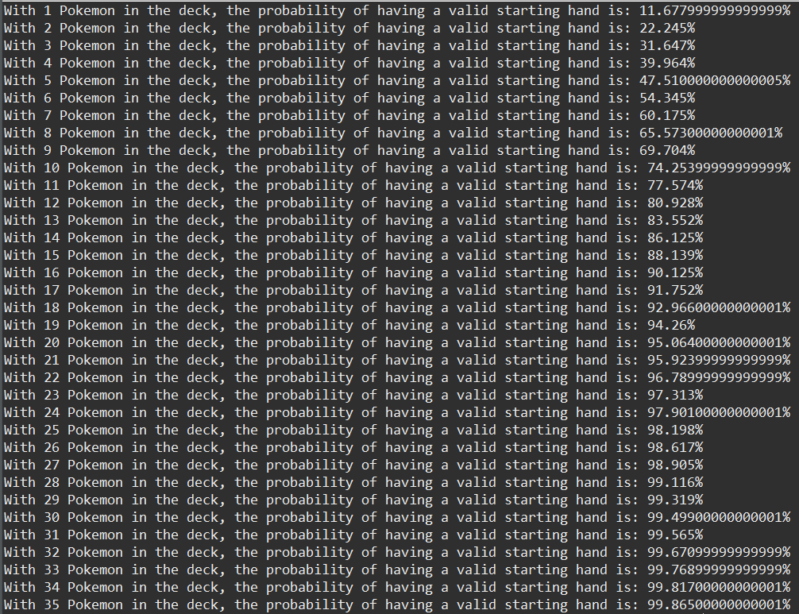

**Rare Candy Monte Carlo Simulation**

The Rare Candy Monte Carlo simulation focuses on the strategic use of the "Rare Candy" Trainer card, which allows a Pokémon to evolve directly, bypassing the usual evolution requirements. This simulation evaluates the effectiveness and timing of using Rare Candy within a game, providing insights into how it influences overall game strategy and outcomes.

This simulation starts with a deck made up of 20 Basic Pokémon, 39 Energy, and 1 Rare Candy. Similar to the Mulligan Monte Carlo simulation, a hand is drawn 10,000 times but a prize pile of six cards is drawn as well. The program checks to see if there is a valid starting hand as well as a prize pile drawn with at least one Rare Candy card. If both hold true, a count is incremented and stored. After the program finishes its runs, the count of good hands and prize piles are divided by the total number of runs giving the probability of having a good hand and prize pile with only one Rare candy in the deck. This process is repeated for the scenarios including two, three, and four Rare Candy cards being shuffled into the deck (which leaves 38, 37, 36 Energy cards in the deck for each trial). Below are the results of the Rare Candy Monte 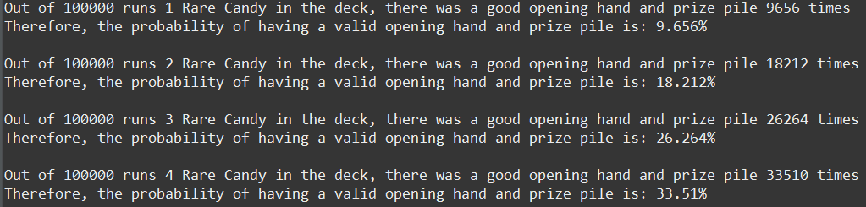Carlo simulation.