Rocco Vulpis

April 25, 2024

Plotting, Salting, and Smoothing Data using Java and JFreeChart Libraries

In this segment of the project, JFreeChart libraries are utilized not just for graphing quadratic functions, but also for demonstrating salting and smoothing. This approach differs from the previous methods used in this project which utilized Excel and Octave's graphing utilities. It combines both data generation and visualization within a single Java application, enhancing efficiency and interactivity.

The process begins with the creation of a quadratic function using the **createSlopeFunction** method. This method generates y-values for a quadratic function across a specified range of x-values. The parameters passed into this method are *a* (the coefficient of *x2*), *b* (the coefficient of *x*), *c* (a constant), *xRangeBeginning* (the starting value of the x range), *xRangeEnd* (the ending value of the x range), and *numberOfPoints* (the number of points to calculate in the specified range). The resulting x and y values are stored in arrays within the class itself.

Next, the **saltValues** method is called. This method sets the range of random adjustments from 0 to 350. Each y-value is randomly increased or decreased within this range, and the adjusted value replaces its original value in the *yValues* ArrayList.

The **smoothValues** method is called after the values are slated. This method implements a moving average technique to smooth the y-values. A specified window size determines the range of values to be averaged for each point. Within this window, y-values are averaged, and the result replaces the original y-value in the *yValues* ArrayList. The size of the window is taken in as a parameter in the class’s run method.

After each generation of these values, the class demonstrates its ability to visually represent the data through integrated plotting functions. The appearance of the graph is directly influenced by the input parameters. Each value of *a*, *b*, and *c* play a specific role in manipulating the graph of the quadratic function. The coefficient *a* determines the width and direction of the parabola. If positive, *a* will causes the parabola to open upwards, while a negative *a* will cause it to open downwards. The coefficient *b* affects the symmetry of the parabola. It shifts the position of the vertex along the x-axis, shifting it left or right depending on the value and sign of *b*. Lastly, the constant *c* is responsible for the vertical shift of the parabola. The larger the value, the higher the graph will shift upwards.

Users have the flexibility to modify the range of x-values and the total number of points plotted, allowing for a diverse array of graphical representations. Below are screenshots displaying the graphs that are generated using JFreeChart.

The following images display the plotting, salting, and smoothing of the function y = x2

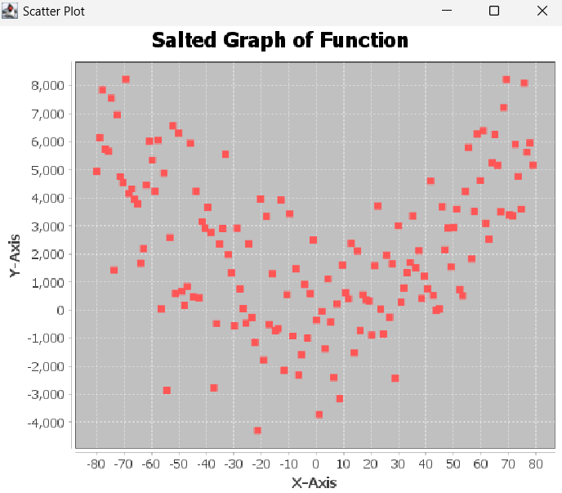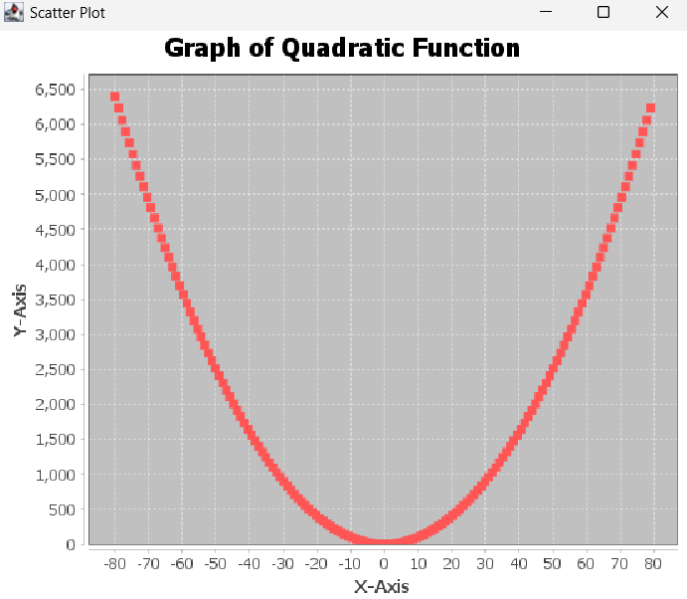

Graph of y = x2 plotted in JFreeChart Salted graph of y = x2 plotted in JFreeChart

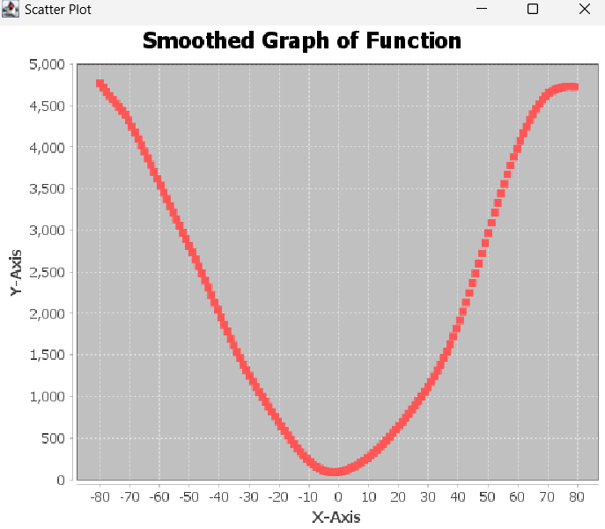

Smoothed graph of y = x2 plotted in JFreeChart