Rocco Vulpis

December 14, 2023

Plotting, Salting, and Smoothing Data using Java and JFreeChart Libraries

In this segment of the project, the JFreeChart libraries were utilized not just for graphing linear functions but also for demonstrating salting and smoothing. This approach differs from the previous methods used in this project which utilized Excel and Octave's graphing utilities. It combines both data generation and visualization within a single Java application, significantly enhancing efficiency and interactivity.

The process begins with the creation of a slope function using the createSlopeFunction method. This method generates y-values for a linear function across a specified range of x-values. The parameters for this function include the slope (m), y-intercept (b), the start and end of the x-range (xRangeBeginning and xRangeEnd, respectively), and the number of data points (numberOfPoints). The resulting x and y values are stored in arrays within the class itself.

Next, the saltValues method gets called. This method sets the range of random adjustments from 0 to 149. Each y-value was randomly increased or decreased within this range, and the adjusted value replaced its original value in the yValues ArrayList.

The smoothValues method was called after the values were slated. This method implemented a moving average technique to smooth the y-values. A specified window size determined the range of values to be averaged for each point. Within this window, y-values were averaged, and the result replaced the original y-value in the yValues ArrayList. The size of the window is taken in as a parameter in the class’s run method.

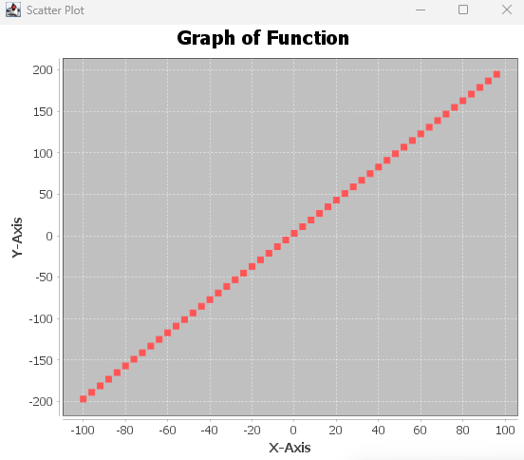 After each generation of these values, the class demonstrates its ability to visually represent the data through integrated plotting functions. The appearance of the graph is directly influenced by the input parameters. For example, changing the slope value (m) alters the steepness of the graph, while adjusting the y-intercept (b) shifts where the line intersects the y-axis. Users have the flexibility to modify the range of x-values and the total number of points plotted, allowing for a diverse array of graphical representations. Below are screenshots displaying the graphs that are generated using JFreeChart.

Graph of y = mx + b plotted in JFreeChart

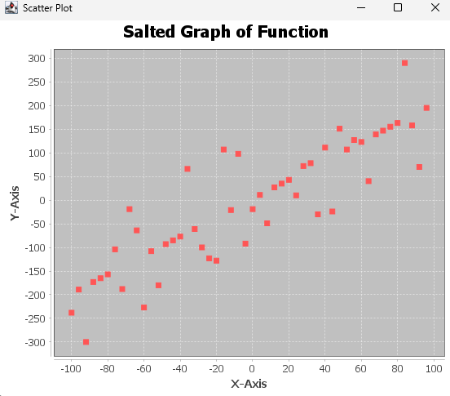

Salted graph of y = mx + b plotted in JFreeChart

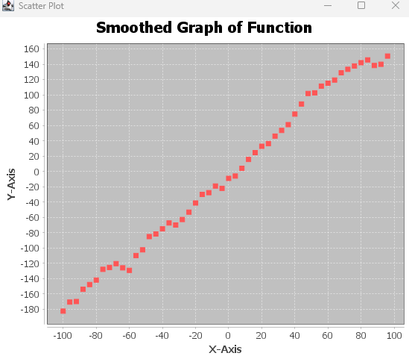

Smoothed graph of y = mx + b plotted in JFreeChart