Events, MyPeople
Social Calendar
Aug. 16, 2019
Rochelle Arlitch

CONTENTS
Introduction . . . 1
Summary . . .1
Technology Stack . . .1
Main Module. . .1
Messaging Module TBD
Timeline Module TBD
Design Goals . . .1
Specifications . . .1
Stakeholders . .2
Use Case . .2
Requirements . .3
Domain, Scope and Architecture . . . 4
Scope and Diagrams . . . 4
Proposed Architecture. . .5
Ethical Considerations . . .6

VERSION COMMENTS
0 - Document created with basic outline.
1.0 - Added Content to Design Goals and Backlog
1.1 - Corrected framework information
1.1.1 - Added Technology Stack Details
1.2 - Added Diagrams
1.2.1 - Cleaned up sections and added better tech stack details

Introduction
Summary
Events MyPpl is a web application that helps facilitate event hosting and guests. It allows users to manage events they are hosting or going to, keep in touch with all involved parties, and view past events including pictures, contacts for vendors and the information about the event.
Long term, Events’ goal is to bring people in closer, realer, focused contact with their friends, family and groups. The goal of the application interface and design is to make it simple and create a sense of space to accomplish a task and communicate.

Technology
Main Module
  Frontend | 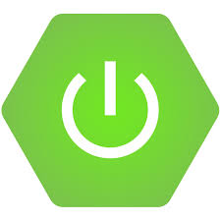  Backend |   Tooling
Javascript  Vue JS  Vuex  Axios | Java  Spring Boot  Hibernate  MySQL DB | Maven - Manages project pieces and a few dependencies  NPM - Manage frontend dependencies

Project setup is simple and parts are distinct.
Modular - Main module responsibilities limited to users and events, message module and additional(memories/timeline) module separate DBs assuming more traffic.
Robust DB for main module.

Messaging Module

Design Goals
Request Specifications
Stakeholders
Host - Person creating and managing an Event
Attendee - Contact who has accepted an event invitation (and now holds a “ticket”)

Use Cases:
Round 1: Hosts and Invitees

Plan An Event
User: Host
Details: Customer wants to plan an event.
- Sign in
- Navigate to Dashboard (if separate from timeline)
- Create new event
- Enter event details into a form
- Add invitees
- Post/Send Invite

Attend Event
User: Attendee
- Sign in
- Notification of new Invitation
- Invitation Options
  - Accept invitation convert to ticket (fill out any fields required)
  - Declined invitation allows to send message back
  - Maybe invitation (save and doesn’t require all fields filled)
- Accepted Invitation - Turns into “Ticket”
- Set Reminders
- Event updates will send notifications

Track Event
User: Host
- Sign into Event Dashboard: My Events
- See all invitation status
- See questions related to event (viewable to all invitees)
- Can re-invite people up to 2 times for a total of three
- See business contacts (different color and queue)
Invitation Status
Message Board
Event Contacts
Vendors
Attendees
Invitees

Requirements

- User must be able to sign in
- User must be able to Host and have access to Event and Attendee details
- User must be able to be an Attendee of an event and edit responses to event
- User must be able to set up as business (general use of platform)
- User must be able to set up as vendor business (specific use of platform)
- Users must be able to communicate with each other

- System must be reliable
- System must be accessible
- System must be available
- System must be robust
- System must be secure

- It would be great to have a past timeline
- It would be great to access pictures and create albums or other things that could be printed
- It would be great to have collab album projects and picture storage (permissions and ownership policies)
- It would be great to incorporate mobile phone/voice and camera capabilities

- It would be nice to incorporate outside contacts and calendars
- It would be nice to incorporate outside map service

Domain, Scope and Architecture
Scope
- Design Figures
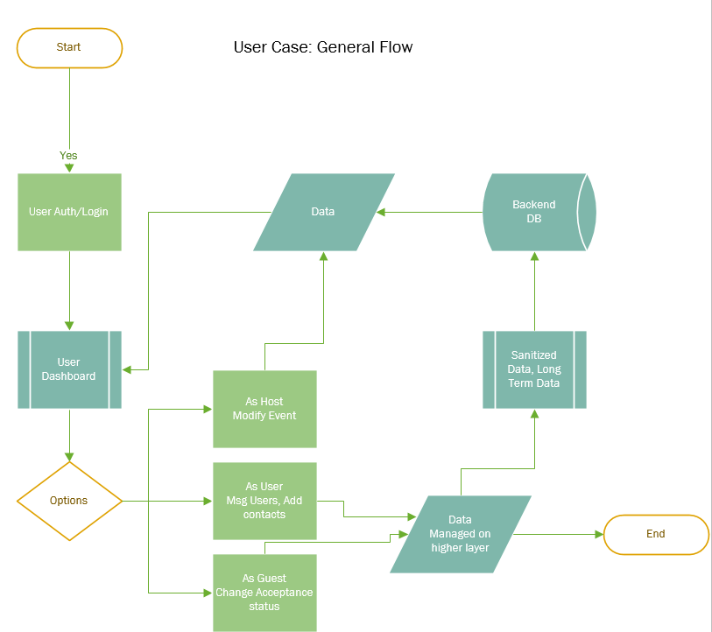
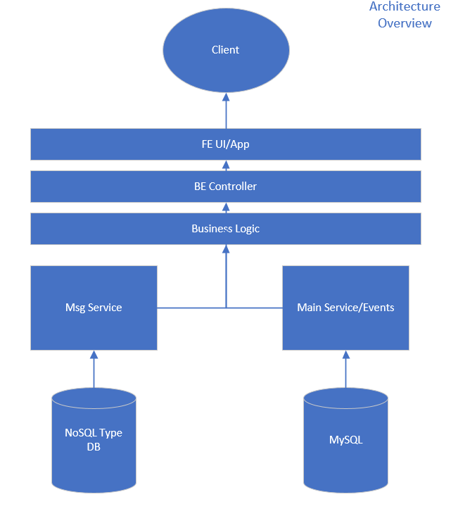

- Estimated Costs

Proposed Architecture
A two-tier web application. Spring’s architecture is based on Model View Controller. The frontend Vue JS is similar. Both also utilize a singleton type pattern with Vue using a “store” and Spring using a main backend “controller”.
If this application gets any bigger, would probably change to a modern module type design where each module is sort of treated as a seperate mini-program or create more managing classes (more stores/more controllers that interact with the frontend).

Ethical Considerations
There are two major considerations that this application aims to address. One is to make money off of the product itself and instill in users a sense of what they’re getting for what they’re paying. This is in contrast to the free applications that cost users their privacy and data and attention (with ads and constant distractions.) The second consideration is a conscious effort to make the application direct and keep outside distractions and influences at an absolute minimum. With this application, I hope to give users a sense of protected space in the digital landscape. This application is meant to be a pay subscription.

Mission Goals
- Distraction free environment
- Defined/concise/singular purpose
- Privacy and secure user info
- Redundant memory/cold storage

