e-portfolio 5: Automated Decision-Making (ADM) in Government Systems
Student name: Rochak Chhetri
Student ID: 12323983
Unit Coordinator : Harita Chugh
A collection of artefacts that demonstrate what I have learnt about the ethical and societal issues of Automated Decision-Making (ADM) in government systems, in Australia and overseas.

Table of Content:

My ideas about ADM before this unit 3
What is ADM? 4
Why ADM matters to me as an ICT student 4
ADM in Australia and overseas 5
Artefact 1: What is ADM? The Commonwealth Ombudsman’s Better Practice Guide (2025) 6
Summary of the artefact 6
Justification on why I chose the artefact 6
Artefact 2: Robodebt as a socio-technical failure (journal article, 2024) 7
Summary of the artefact 7
Justification on why I chose the artefact 7
Artefact 3: A further $475 million Robodebt settlement (2025) 8
Summary of the artefact 8
Justification on why I chose the artefact 8
Artefact 4: Australia’s ADM reform consultation (2025) 9
Summary of the artefact 9
Justification on why I chose the artefact 9
Artefact 5: Bias in the UK’s AI benefits-fraud system (2024) 10
Summary of the artefact 10
Justification on why I chose the artefact 10
Artefact 6: Algorithmic discrimination in Dutch student finance (2024) 11
Summary of the artefact 11
Justification on why I chose the artefact 11
What I have learned 12
References 13

My ideas about ADM before this unit
Before studying COIT11223, I mainly thought automated decision-making was a way for organisations to make decisions faster and handle large amounts of information. I had heard about Robodebt, but I had not fully considered how an automated decision could affect a person’s income or ability to access support. I now understand that a system can produce consistent results and still be unfair if its rules, data or review process are flawed. People also need a clear way to question decisions that affect them.

What is ADM?
Automated Decision-Making (ADM) is the use of computer systems to make, or help make, decisions that affect people. The Commonwealth Ombudsman defines an automated system as “a computer system that automates part or all of an administrative decision-making process” (Commonwealth Ombudsman, 2025, p. 7). ADM covers a wide range of systems:
- Rule-based systems that apply “if–then” business rules, such as calculating benefit eligibility.
- Data-matching systems that compare records between agencies, as Robodebt did with tax office income data.
- Machine learning models that predict risk scores, such as fraud-detection systems.
A system can make the final decision, recommend a decision to a human officer, or automate only part of the process, such as gathering facts or flagging cases for review (Commonwealth Ombudsman, 2025, p. 7).

Why ADM matters to me as an ICT student
Government ADM is different from most commercial software. People usually cannot choose another provider, and the decisions affect income, housing, education and freedom. Errors happen at scale: one flawed rule can affect hundreds of thousands of people at once. The people affected are often the most vulnerable members of society.
The unit material gives me several lenses for these issues:
- ACS Code of Professional Conduct: the Primacy of the Public Interest, Honesty, Competence and Professionalism require me to raise concerns about harmful systems, even when a client or employer wants them delivered quickly.
- Kantianism: people must be treated as ends in themselves, not as means to save money. Systems that reverse the onus of proof fail this test.
- Act and rule utilitarianism: efficiency gains must be weighed against total harm, including distress, compensation and loss of trust.
- Social contract theory: citizens accept government power only when fair rules protect them, including rules about transparency and the right to review decisions.
- Virtue ethics: a good professional shows honesty, courage and care, for example by testing for bias and speaking up about it.

ADM in Australia and overseas
My artefacts cover one Australian case and two cases from overseas. They show the same pattern in different countries: systems built to detect fraud or recover money end up harming innocent or disadvantaged people.
 | Australia: Robodebt | United Kingdom: DWP fraud model | Netherlands: DUO risk scores
Purpose | Recover welfare overpayments | Flag universal credit claims for fraud | Select students for fraud checks
Type of ADM | Data matching and income averaging | Machine learning risk model | Rule-based risk scoring
Main harm | Unlawful debts; burden of proof reversed | Disparities by age, disability, marital status and nationality | Indirect discrimination by migration background
Response | Royal Commission, settlements, ADM reform | DWP says a human makes the final decision | Government apology; process to change

Artefact 1: What is ADM? The Commonwealth Ombudsman’s Better Practice Guide (2025)
Link: https://www.ombudsman.gov.au/__data/assets/pdf_file/0025/317437/Automated-Decision-Making-Better-Practice-Guide-March-2025.pdf
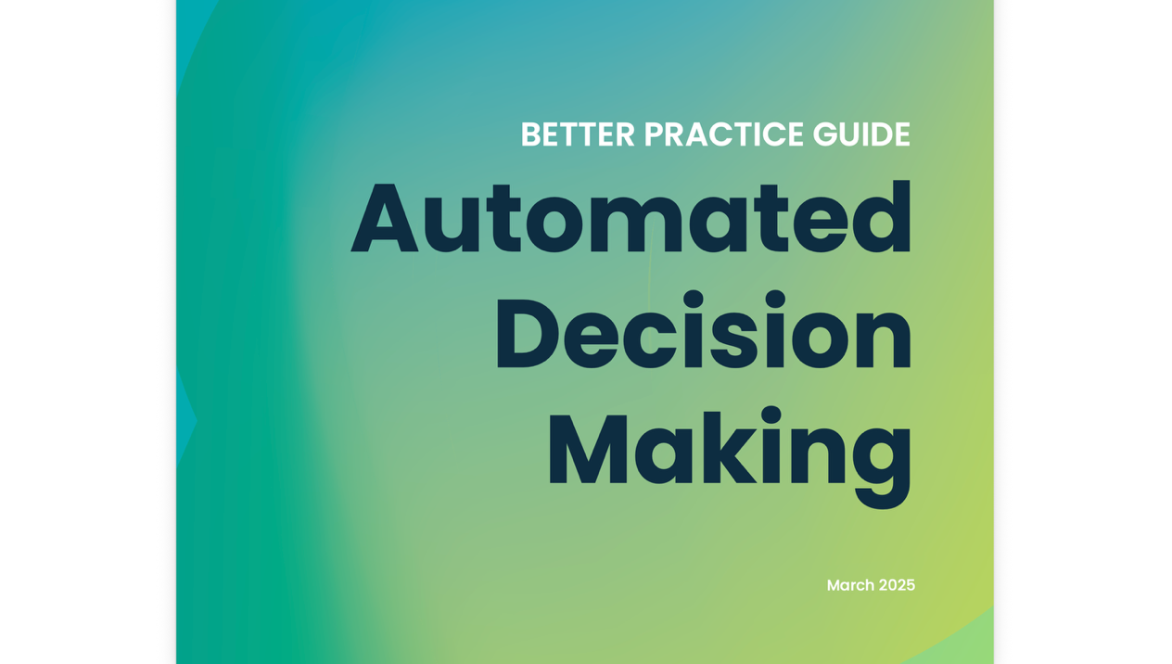

Summary of the artefact
This March 2025 guide explains how Australian Government agencies should design and run automated systems. It defines an automated system as “a computer system that automates part or all of an administrative decision-making process” (Commonwealth Ombudsman, 2025, p. 7). It also states that these systems must follow the principles of legality, fairness, rationality and transparency (Commonwealth Ombudsman, 2025, p. 8).

Justification on why I chose the artefact
I chose this guide because it gave me an official answer to “what is ADM?” I thought ADM meant only AI, but simple rule-based systems also count. Its focus on contestability and human oversight (Commonwealth Ombudsman, 2025, p. 10) links to the ACS Code’s Primacy of the Public Interest and to Kantian ethics: people must be able to challenge decisions, not be treated as data points.

Artefact 2: Robodebt as a socio-technical failure (journal article, 2024)
Link: https://doi.org/10.3127/ajis.v28.4681

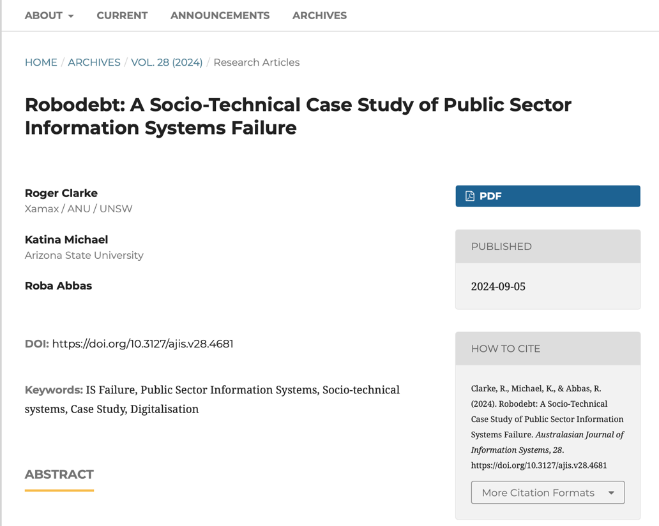

Summary of the artefact
This peer-reviewed case study analyses Robodebt, Australia’s automated debt-recovery scheme, which raised debts against about 433,000 people (Clarke, Michael & Abbas, 2024, p. 1). It used “income averaging”, splitting annual income into 26 equal fortnights (Clarke, Michael & Abbas, 2024, p. 15), and made recipients prove they owed nothing (Clarke, Michael & Abbas, 2024, p. 17).

Justification on why I chose the artefact
I selected this article because it presents Robodebt as a socio-technical failure rather than simply a programming mistake. As an ICT student who is learning to build software, I can see why meeting technical requirements is not enough: developers also need to consider the assumptions behind a system and the people affected by its outputs. The article’s discussion of manual review for complex cases (Clarke, Michael & Abbas, 2024, p. 21) connects with the idea that people should have a meaningful opportunity to explain their circumstances. From a Kantian perspective, reversing the onus of proof risks treating citizens as a means to achieve savings rather than as people deserving fair treatment.

Artefact 3: A further $475 million Robodebt settlement (2025)
Link: https://www.servicesaustralia.gov.au/new-robodebt-class-action-settlement

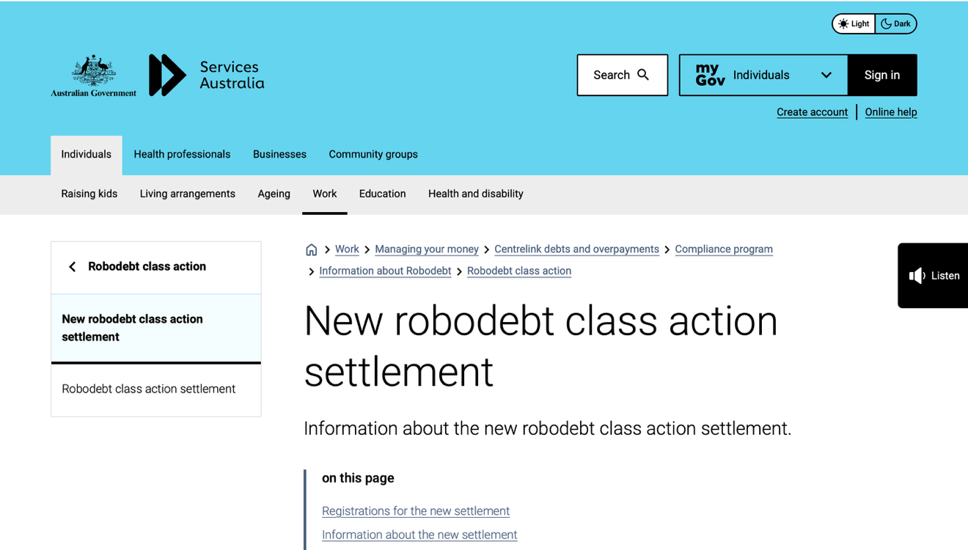

Summary of the artefact
In September 2025 the Commonwealth agreed to pay a further $475 million to people harmed by Robodebt, on top of the original 2021 class action settlement (Services Australia, 2025). Up to $60 million more may be spent administering the scheme. The settlement needed Federal Court approval, and eligible people had to register again.

Justification on why I chose the artefact
I chose this item because it shows that ADM harms do not end when a system is switched off. Years later, the government is still paying and victims are still waiting. This links to act utilitarianism: the promised savings are far outweighed by compensation, legal costs and human suffering. It reminded me that our work as ICT professionals has consequences long after a project ends.

Artefact 4: Australia’s ADM reform consultation (2025)
Link: https://consultations.ag.gov.au/integrity/adm/user_uploads/automated-decision-making_summary-of-the-public-consultation-process.pdf
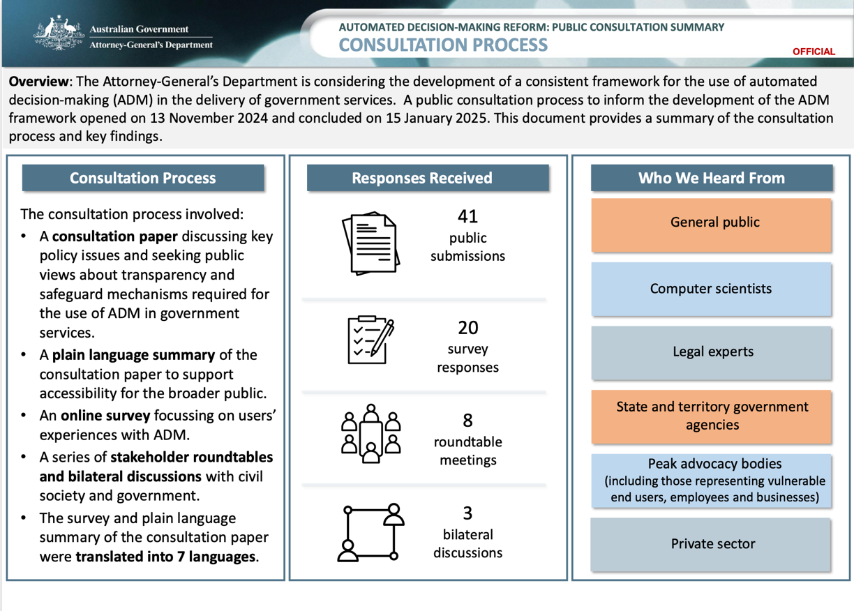

Summary of the artefact
After Robodebt, the Attorney-General’s Department consulted the public on a consistent framework for government ADM, receiving 41 submissions and 20 survey responses (Attorney-General’s Department, 2025, p. 1). Stakeholders called for transparency about when ADM is used, meaningful explanations, risk assessment before implementation, ongoing auditing and clear pathways for human review.

Justification on why I chose the artefact
I chose this document because it shows Australia responding to Robodebt at a policy level. Ethics in ICT is not only about individual developers but also about the rules society agrees on. This is social contract theory in action: citizens accept government ADM only if fair rules protect them. No respondent wanted weaker rules for ADM than for human decisions (Attorney-General’s Department, 2025, p. 3).

Artefact 5: Bias in the UK’s AI benefits-fraud system (2024)
Link: https://computing.co.uk/news/2024/ai/ai-bias-uncovered-in-uk-welfare-system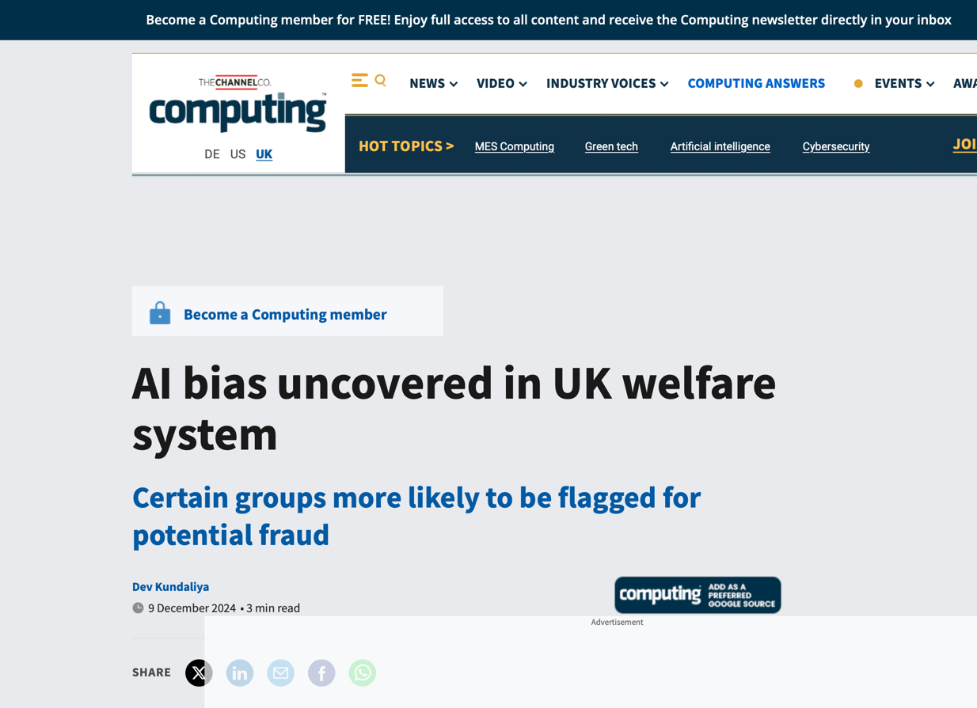

Summary of the artefact
The UK Department for Work and Pensions (DWP) uses machine learning to flag universal credit claims for possible fraud. An internal fairness analysis, released under Freedom of Information, found “statistically significant outcome disparities” by age, disability, marital status and nationality (Kundaliya, 2024). The DWP said a human caseworker still makes the final decision.

Justification on why I chose the artefact
I chose this because it closely matches our Question 1 scenario: a model that met its technical goals but treated groups unfairly. It made me question whether “human in the loop” is real oversight or a rubber stamp. Under the ACS Code, Competence and the Primacy of the Public Interest require bias testing before deployment and openness about the results, not redaction.

Artefact 6: Algorithmic discrimination in Dutch student finance (2024)
Link: https://www.erasmusmagazine.nl/en/2024/05/24/discrimination-by-duo-even-worse-than-thought/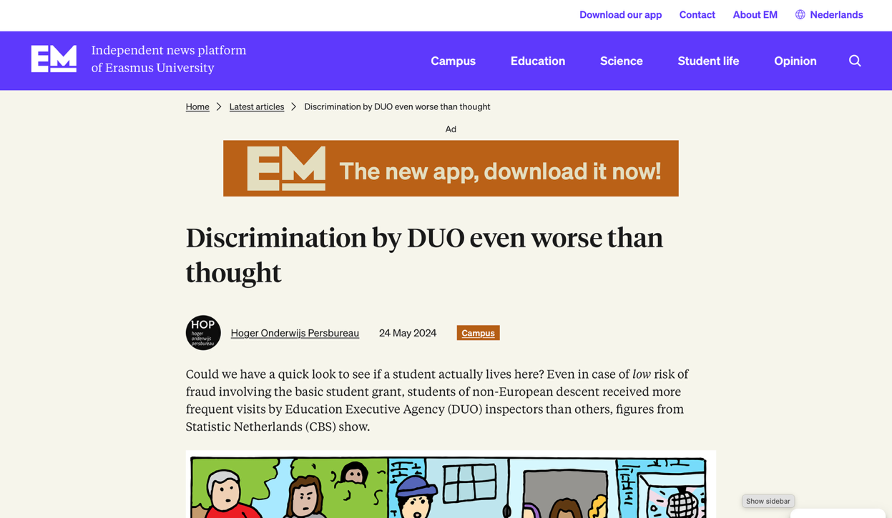

Summary of the artefact
The Dutch student finance agency DUO used a risk-scoring algorithm to select students for fraud checks, weighting level of study, age and distance from the parents’ home. Students with a non-European migration background were selected for home visits 6.2 times more often than others (Erasmus Magazine, 2024). The government apologised for “indirect discrimination”.

Justification on why I chose the artefact
I chose this case because it shows that unfair outcomes can arise even when ethnicity is not directly included as an input. Variables that appear neutral may still act as proxies for a person’s background. As an ICT student, this reminds me that removing one sensitive field does not automatically make a system fair. Developers need to test how decisions affect different groups and investigate unexpected patterns. Virtue ethics emphasises diligence and care, which are important when a system can affect people’s access to financial support.

What I have learned
This e-portfolio has changed how I understand automated decision-making. I have learned that a system can satisfy its technical requirements and still create unfair outcomes. Robodebt, the UK benefits-fraud model and the Dutch student-finance system show why efficiency cannot be the only measure of success. Transparency, appropriate data, human oversight and a fair way to challenge decisions are also important. In my ICT studies and software project work, I have focused on whether features work as intended; I now see that I should also ask who might be disadvantaged and how the system could fail in real situations.
In future software projects, I want to consider possible harms and test how a system behaves for different users, rather than checking only whether the main features work. I would also want clear explanations and a practical way for users to appeal important decisions. The ethical theory that best matches my values is Kantianism, because people should be treated with dignity and not merely as a way to reduce costs or improve efficiency. This means that protecting people’s rights should remain important even when automation seems convenient.

References
Attorney-General’s Department 2025, Automated decision-making reform: public consultation summary, Attorney-General’s Department, Canberra, viewed 12 October 2026, https://consultations.ag.gov.au/integrity/adm/user_uploads/automated-decision-making_summary-of-the-public-consultation-process.pdf.
Clarke, R, Michael, K & Abbas, R 2024, ‘Robodebt: a socio-technical case study of public sector information systems failure’, Australasian Journal of Information Systems, vol. 28, https://doi.org/10.3127/ajis.v28.4681.
Commonwealth Ombudsman 2025, Automated decision-making: better practice guide, Commonwealth Ombudsman, Canberra, viewed 12 October 2026, https://www.ombudsman.gov.au/__data/assets/pdf_file/0025/317437/Automated-Decision-Making-Better-Practice-Guide-March-2025.pdf.
Erasmus Magazine 2024, ‘Discrimination by DUO even worse than thought’, Erasmus Magazine, 24 May, viewed 12 October 2026, https://www.erasmusmagazine.nl/en/2024/05/24/discrimination-by-duo-even-worse-than-thought/.
Kundaliya, D 2024, ‘AI bias uncovered in UK welfare system’, Computing, 9 December, viewed 12 October 2026, https://computing.co.uk/news/2024/ai/ai-bias-uncovered-in-uk-welfare-system.
Services Australia 2025, New robodebt class action settlement, Services Australia, Canberra, viewed 12 October 2026, https://www.servicesaustralia.gov.au/new-robodebt-class-action-settlement.

