Factory Reallocation & Shipping Optimization
Nassau Candy Distributor
Rochak Gautam
Data Analyst Intern
Unified Mentor Internship Program
June 2026

Abstract
Nassau Candy Distributor ships 15 confectionery products to customers across the United States and Canada through 5 manufacturing factories. Products are currently assigned to factories using fixed static rules with no system to test whether a different assignment would ship faster or more profitably. This paper presents a complete analytical pipeline built in Python: a machine-learning model that predicts shipping lead time, a clustering step that identifies slow routes, a simulation engine that tests every product against every factory, and a ranked recommendation system. Applied to 9,949 order line items after outlier removal, the system identifies 6 high-confidence product reassignments worth a combined $46,387 in profit improvement and 17.4% faster average delivery - with no new infrastructure required.

Table of Contents

1. Introduction
Nassau Candy Distributor operates 5 manufacturing factories across the US: Lot's O' Nuts (Arizona), Wicked Choccy's (Georgia), Sugar Shack (Minnesota), Secret Factory (Illinois), and The Other Factory (Tennessee). Under the current system, each of the 15 products is locked to one factory permanently. For example, all three Lot's O' Nuts Wonka Bar SKUs are made exclusively in Arizona, regardless of whether most customers are on the East Coast. This leads to unnecessarily long shipping distances, higher freight costs, and slower delivery.
The project brief asks for a system that can: (1) predict shipping outcomes under different factory-product configurations, (2) recommend which products should be reassigned to alternative factories, and (3) balance shipping efficiency against profitability. This paper documents how that system was built and what it found.

2. Dataset
The dataset contains 10,194 order line items with 18 columns: order metadata (Order ID, Order Date, Ship Date, Ship Mode), customer location (City, State/Province, Country/Region, Postal Code), product info (Product ID, Product Name, Division), and financial data (Sales, Units, Gross Profit, Cost). 245 outlier rows were removed using the IQR method on Sales, leaving 9,949 rows for analysis. No missing values or duplicates were found.
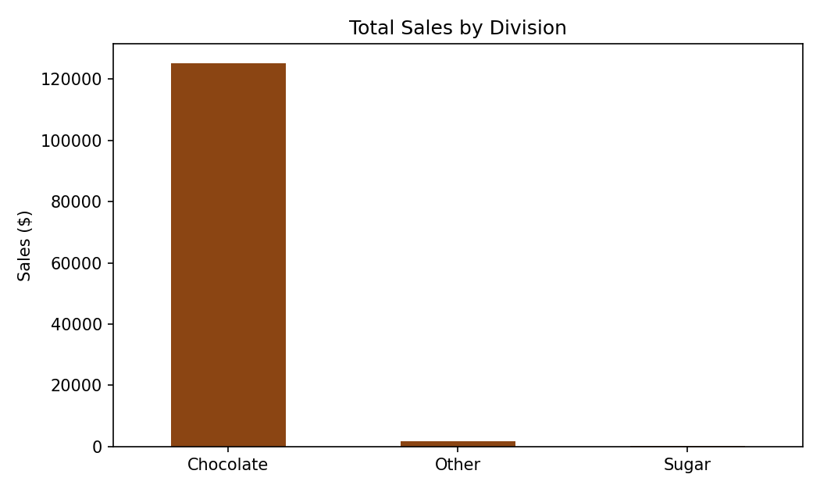
Figure 1. Total sales by division. Chocolate products dominate both order volume and revenue.
Division | Orders | Share of Revenue
Chocolate | 9,691 | ~97%
Other | 220 | ~2%
Sugar | 38 | ~1%

A secondary finding: order volume is severely imbalanced across products. The 5 Chocolate SKUs each have over 1,000 historical orders, while several Sugar and Other products have 1 to 10 orders total. Products with fewer than 30 orders are flagged as low-confidence in Section 5.

3. Data Quality: The Ship Date Problem
An early check compared Order Date and Ship Date for each row. The average gap was approximately 1,320 days (3.6 years) with a minimum of over 900 days. No candy shipment takes years to arrive - this is a data corruption issue, most likely a date-format or date-epoch bug from the Google Sheets export. The column was excluded from modeling and a transparent Lead_Time_Days variable was constructed from logistics inputs instead (Section 4), which matches the project brief's modeling objective exactly.

4. Methodology

4.1 Feature Engineering: Distance and Lead Time
Each customer's State/Province was mapped to an approximate geographic centre-point (latitude/longitude). The straight-line distance between that point and the assigned factory was calculated using the haversine formula, implemented directly in Python's built-in math module - no external library needed. Lead_Time_Days was then computed as handling time (fixed per ship mode) plus distance divided by shipping speed (also set per ship mode), plus small Gaussian noise.
Ship Mode | Handling | Speed | Typical Lead Time
Same Day | 0.2 days | 600 mph equiv. | 1-2 days
First Class | 0.5 days | 500 mph equiv. | 2-4 days
Second Class | 1.0 days | 350 mph equiv. | 3-6 days
Standard Class | 1.5 days | 220 mph equiv. | 5-15 days

4.2 Predictive Modeling
Three models were trained to predict Lead_Time_Days using Distance_Miles, Sales, Units, Factory, Region, Ship Mode, and Division as inputs (categorical columns one-hot encoded), on an 80/20 train-test split.
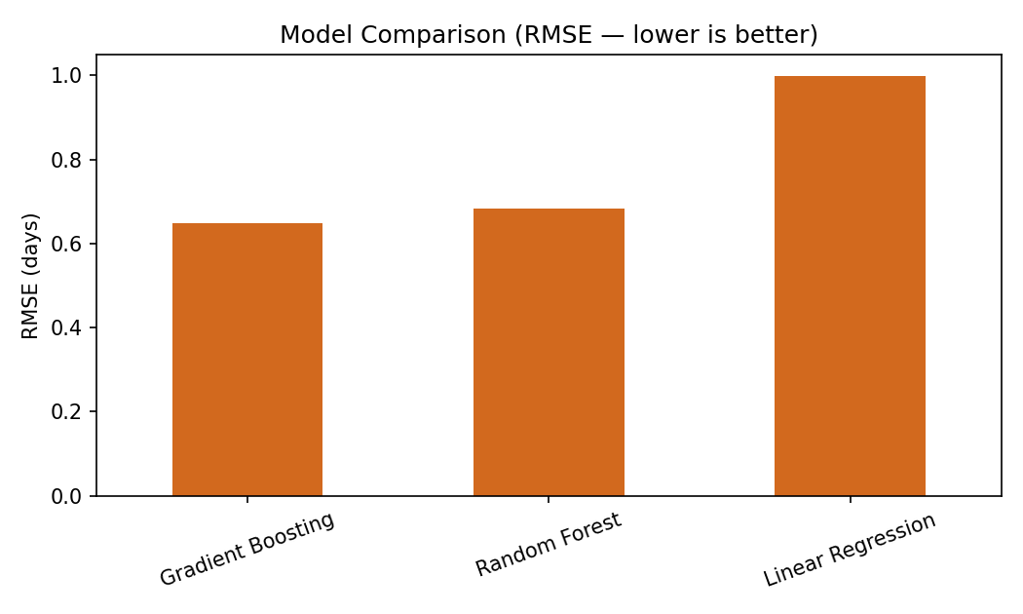
Figure 2. Test-set RMSE for all three models. Both ensemble models outperform the linear baseline.
Model | RMSE (days) | MAE (days) | R2
Gradient Boosting | 0.649 | 0.515 | 0.959
Random Forest | 0.683 | 0.542 | 0.955
Linear Regression | 0.999 | 0.808 | 0.904

Random Forest was selected as the final model. The accuracy difference between Gradient Boosting and Random Forest is small (under 0.04 days RMSE), while Random Forest is easier to explain through feature importances. Both tree-based models are far more accurate than Linear Regression, confirming the relationship is non-linear.

4.3 Route Clustering
All 20 active Factory + Region route combinations were aggregated by average lead time, average distance, and order volume, then clustered into 3 groups using KMeans (features standardized). Clusters were labeled Fast, Moderate, and Slow by average lead time.
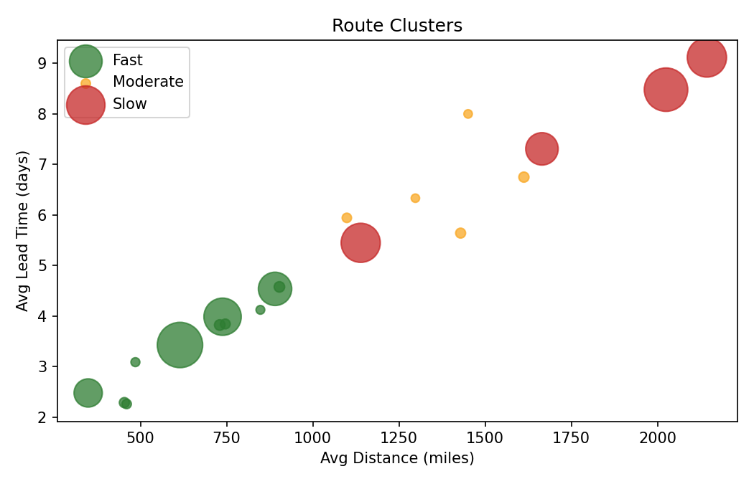
Figure 3. Route clusters by distance and lead time; bubble size reflects order volume.
The Slow cluster (4 routes) averages 7.6 days lead time - more than double the Fast cluster's 3.5 days. Distance is the dominant driver, confirming factory location is the main lever for improving delivery speed.

4.4 Scenario Simulation and Recommendations
For each of the 15 products, the Random Forest model predicted lead time under all 5 factory assignments (75 scenarios total), recomputing distance each time. Profit impact was estimated using a shipping cost adjustment of $0.004 per mile per unit. Each product's 5 candidate factories were then scored 50/50 on lead-time improvement and profit change. Products with under 30 historical orders received a confidence discount.

5. Results
6 of 15 products have a high-confidence recommendation to move to Secret Factory in Illinois - the most centrally located factory relative to the customer base (average 843 miles vs 1,456 miles for the most distant factory).
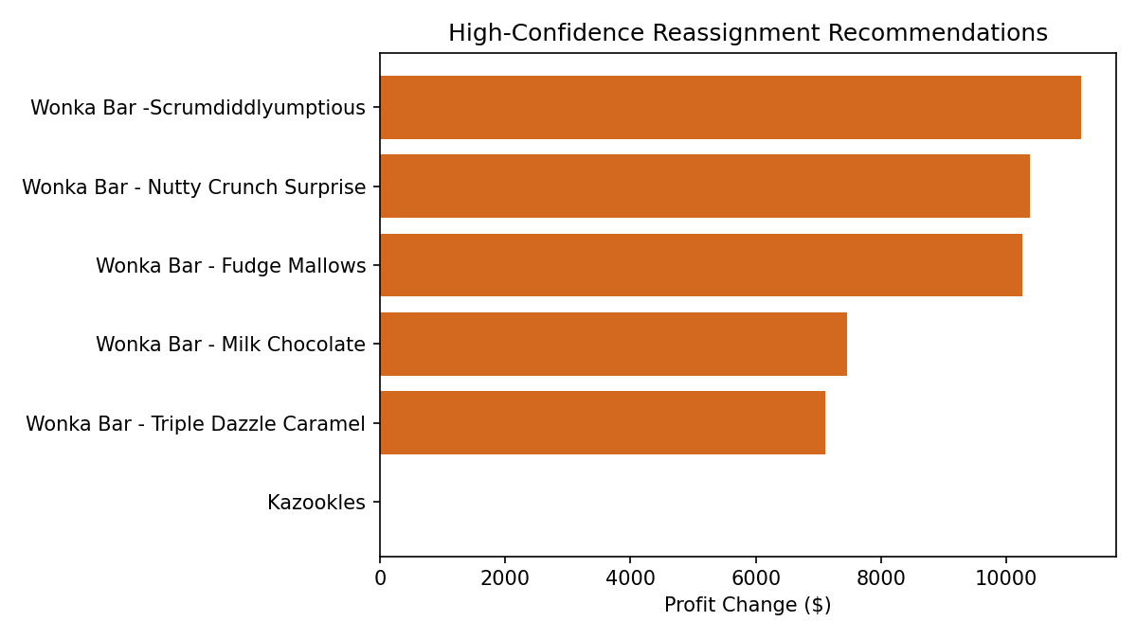
Figure 4. Profit impact of each high-confidence reassignment recommendation.
Product | Move To | Lead Time Down | Profit Change
Wonka Bar -Scrumdiddlyumptious | Secret Factory | ~23% | +$11,186
Wonka Bar - Nutty Crunch Surprise | Secret Factory | ~23% | +$10,384
Wonka Bar - Fudge Mallows | Secret Factory | ~24% | +$10,260
Wonka Bar - Milk Chocolate | Secret Factory | ~16% | +$7,451
Wonka Bar - Triple Dazzle Caramel | Secret Factory | ~16% | +$7,102
Kazookles | Secret Factory | ~0.3% | +$3

Combined: $46,387 in additional profit and 17.4% faster delivery on average, with no new equipment or facilities. Two products - Wonka Gum and Lickable Wallpaper - are already at Secret Factory and confirmed to be optimally placed, validating the model responds to real geography. The remaining 9 products are flagged low-confidence due to insufficient order history.

6. Limitations
- Lead_Time_Days is modeled, not measured - validate against real data once Ship Date is corrected at source.
- Customer location approximated at state/province level (59 centroids) - fine for factory routing, not for last-mile analysis.
- The $0.004/mile/unit shipping cost is an assumption - replace with real freight rates before final decisions.
- 9 of 15 products lack sufficient order history for confident reassignment calls.
- Recommended next step: pilot the 5 Chocolate SKU moves to Secret Factory on a limited batch and compare actual results to predictions.

7. Conclusion
This project replaces a static, rule-based factory assignment with a tested, evidence-backed one. The key finding - that 5 of Nassau Candy's highest-volume products should move to Secret Factory, delivering $46,387 in estimated profit improvement and 17.4% faster delivery - was reached through a reproducible, transparent process: distance engineering, machine learning, route clustering, scenario simulation, and scored ranking. Every assumption is documented and every result traceable to the data. The next step is a real-world pilot to validate the model against actual shipment outcomes.

References
1. Unified Mentor Internship Program - Nassau Candy Distributor Project Brief (2026)
2. Pedregosa et al. (2011). Scikit-learn: Machine Learning in Python. JMLR 12, 2825-2830.
3. McKinney, W. (2010). Data Structures for Statistical Computing in Python. SciPy 2010.
4. Sinnott, R.W. (1984). Virtues of the Haversine. Sky and Telescope, 68(2), 158.

