Google Ads Campaign Project: GrowthSpark Digital
I recommend starting with Google Search text ads because I want to reach businesses actively searching for digital marketing services.
1. Text Ads (Search Ads)
I want to reach people searching for SEO agencies, Google Ads management and digital marketing services.
- Goal: Generate qualified leads
- Target: Businesses with immediate marketing needs
- CTA: Get a Consultation
2. Display Ads
I want to use visual banner ads across eligible websites and apps to build awareness and reconnect with previous website visitors where consent and platform policies permit.
- Goal: Brand awareness and remarketing
- Target: Relevant business audiences
- CTA: Explore Our Services
3. Video Ads
I want to create short videos explaining how SEO, paid advertising and social media marketing can help businesses.
- Goal: Awareness and consideration
- Target: Entrepreneurs and business owners
- CTA: Learn More
Imaginary Website description and Target Audience
GrowthSpark Digital provides digital marketing solutions to small and medium-sized businesses looking to improve their online presence, attract potential customers and increase enquiries.
Services offered
- Search Engine Optimization (SEO)
- Google Ads and PPC management
- Social media marketing
- Website design and development
- Content marketing
- Target audience
Attribute | Target
Location | India
Business size | Small and medium-sized businesses
Industries | Retail, healthcare, education, professional services
Decision-makers | Business owners, founders, marketing managers
Needs | More leads, online visibility and measurable marketing results
Search intent | Businesses actively looking for agency services

Campaign objectives
My main objective is to generate qualified leads for the agency services.
Objective | Measurement | Priority
Lead generation | Completed enquiry forms | High
Phone enquiries | Qualified calls | High
Website traffic | Relevant clicks and engaged visits | Medium
Brand awareness | Impressions and video reach | Supporting
Sales | Signed clients and attributed revenue | Long-term

Primary conversion: A successfully submitted consultation enquiry form.
Secondary conversions: Qualified phone calls and booked consultations.

Bid and budget allocation
I have proposed a planning budget of ₹15,000 per month, equivalent to an average of ₹500 per day over 30 days.
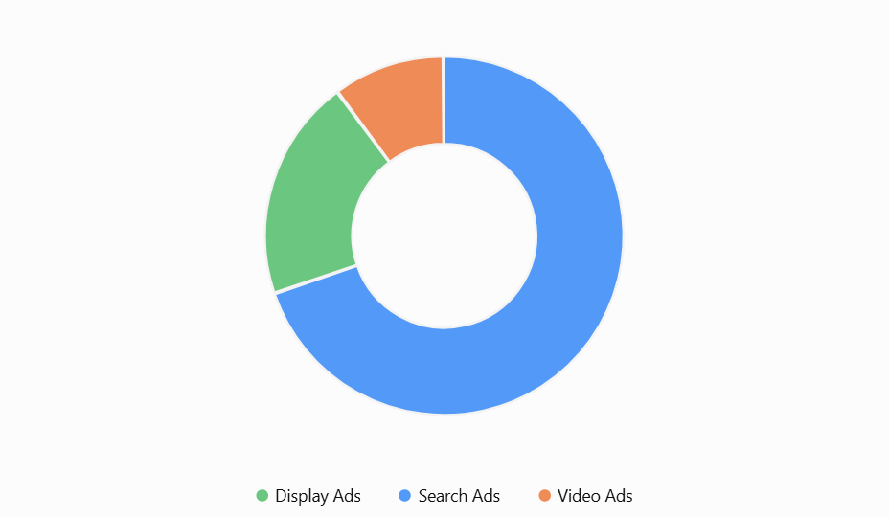

Channel Budget
Search Ads 10500
Display Ads 3000
Video Ads 1500

Bidding strategy
- For search start with maximize clicks with a suitable maximum CPC limit if initial conversion data is unavailable. Once reliable conversion tracking is active and sufficient data is available, test Maximize Conversions.
- For Display use a bidding strategy aligned with the chosen awareness or remarketing goal. Monitor placement quality and conversion performance.
- For video select a bidding approach that matches the campaign's objective, such as awareness or conversions, depending on available campaign settings.
Review the performance weekly. Increase spending only when the campaign generates relevant traffic and leads at an acceptable cost.

Keyword themes and strategy
We have to Focus on commercial-intent keywords that suggest a business is looking to hire an agency.

Theme 1: SEO services
Intent: Businesses seeking organic search growth
- [seo agency in India]
- "seo services India"
- "seo company in India"
- "hire seo expert"

Theme 2: Google Ads management
Intent: Businesses seeking paid advertising services
- [google ads agency India]
- "ppc management services"
- "google ads management company"
- "paid advertising agency"

Theme 3: Social media marketing
Intent: Businesses seeking social media support
- [social media marketing agency India]
- "social media management services"
- "social media advertising agency"

Theme 4: Full-service digital marketing
Intent: Businesses comparing agencies
- [digital marketing agency India]
- "digital marketing company India"
- "online marketing agency"
- "digital marketing services for small business"

Keyword match types
- Exact match: Use for high-intent searches you want to target closely, such as [seo agency in mumbai].
- Phrase match: Use to discover relevant searches around services, such as "ppc management services".
- Broad match: Test selectively when conversion tracking and smart bidding have enough reliable data to guide optimization.

Negative keyword strategy
Consider excluding irrelevant searches such as:
free, jobs, salary, internship, course, tutorial, definition
Review the actual search terms before adding negatives. For example, do not exclude course if the agency also sells digital marketing training.

6. Campaign structure
Campaign 1: Search | Lead Generation
Main conversion-focused campaign
Ad Group 1: SEO Services
Ad Group 2: Google Ads Management
Ad Group 3: Social Media Marketing
Ad Group 4: Digital Marketing Agency
Campaign 2: Display | Awareness or Remarketing
Campaign 3: Video | Brand Awareness

Week 2
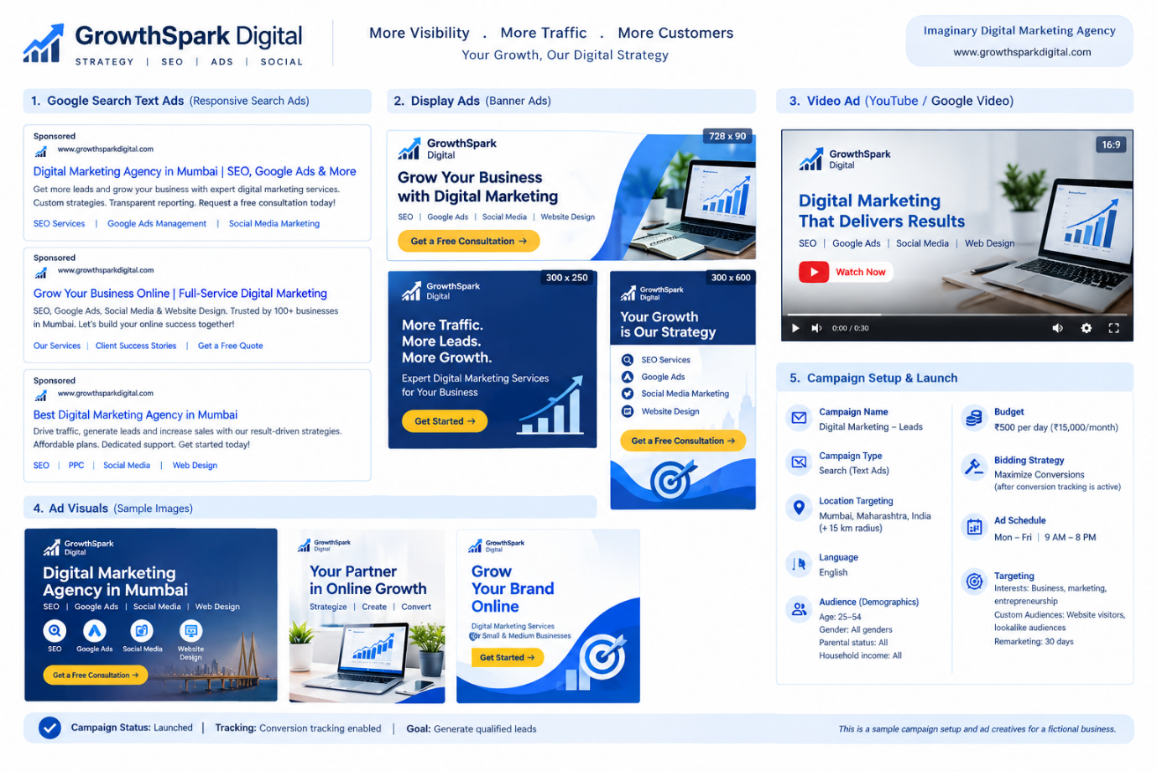
we will create compelling ad copy and visual concepts for Search Ads and Display Ads. Search Ads use text assets, while Display Ads use banners, images, and headlines.

Search Ad copy
Sponsored
growthsparkdigital.com

Digital Marketing Agency Mumbai
SEO Services | Google Ads Management
Grow your business with strategic SEO, PPC and social media marketing. Connect with GrowthSpark Digital to discuss your marketing goals and request a consultation.
Suggested call to action: Get a Consultation
Additional headline ideas
- Grow Your Business Online
- Professional SEO Services
- Google Ads Management
- Digital Marketing for Small Business
- Improve Your Online Visibility
Google responsive search ads combine eligible headlines and descriptions, so each asset should work independently and comply with Google's advertising policies.
You can create them in Canva or another design tool.

GrowthSpark Digital: Display ad creatives

Leaderboard banner
728 × 90 px · Website banner placement
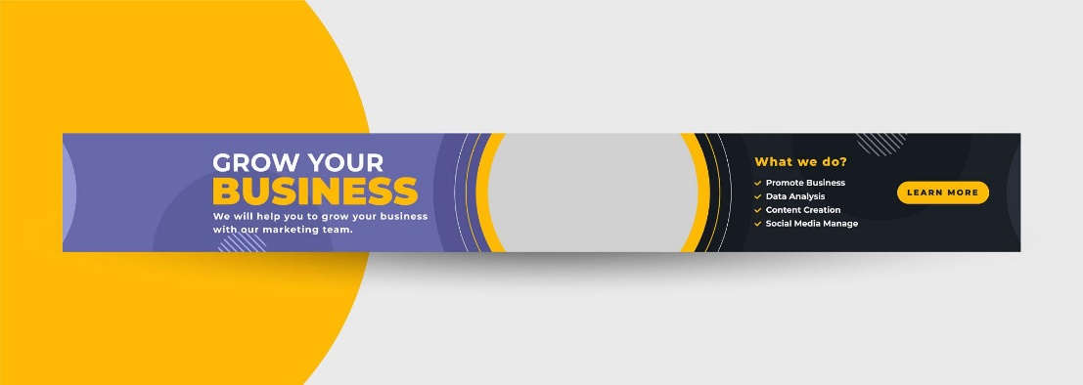
Headline: Grow Your Business Online
CTA: Get a Free Consultation

Suggested sizes for responsive display creative testing include landscape images at 1.91:1, square images at 1:1 and portrait images at 4:5. Google supports multiple asset formats, subject to campaign requirements.

Ad copy for Google Display Ads
Element | Suggested copy
Business name | GrowthSpark Digital
Main headline | Grow Your Business Online
Supporting headline | Digital Marketing That Delivers Results
Description | Build your online presence with SEO, Google Ads and social media marketing.
Call to action | Get a Free Consultation
Landing page | Your digital marketing services landing page

Recommended campaign settings
- Campaign type: Google Display
- Objective: Leads and brand awareness
- Location: Mumbai, Maharashtra, India
- Audience: Small business owners, entrepreneurs and marketing decision-makers
- Budget: ₹3,000 per month as a proposed test allocation
- Conversion tracking: Equiry form submissions and qualified calls

Key performance metrics
The following is an illustrative monthly performance scenario for all three campaign types combined.
Total impressions Total clicks

100,000 1,500

CTR Average CPC

1.5% ₹10
Conversions Cost per conversion
₹250 60
Performance metric | Illustrative result
Total monthly spend | ₹15,000
Impressions | 100,000
Clicks | 1,500
Click-through rate | 1.5%
Average CPC | ₹10
Conversions | 60
Conversion rate | 4%
Cost per conversion | ₹250
Calculations
- CTR = (1,500 ÷ 100,000) × 100 = 1.5%
- Average CPC = ₹15,000 ÷ 1,500 = ₹10
- Conversion rate = (60 ÷ 1,500) × 100 = 4%
- Cost per conversion = ₹15,000 ÷ 60 = ₹250
These figures are not guaranteed benchmarks or forecasts. Actual results depend on competition, targeting, creative quality, landing page performance and conversion tracking.

Weekly performance trends
The example below distributes the ₹15,000 budget across four reporting weeks.
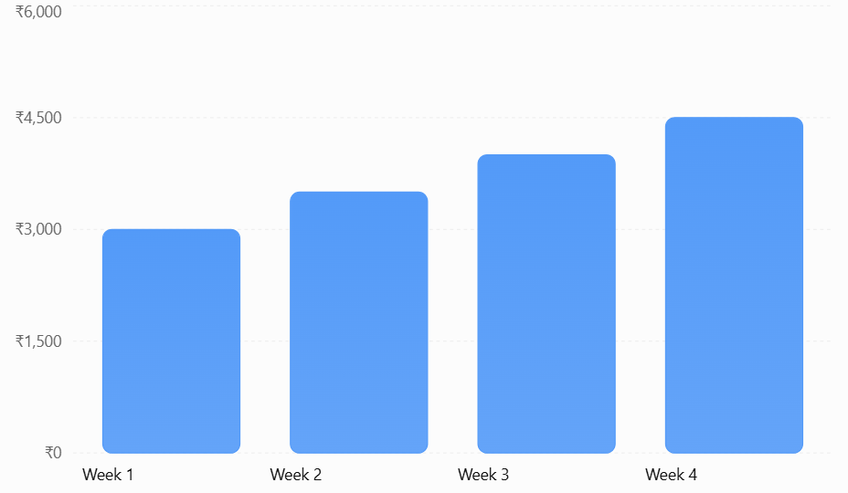
Illustrative data: total spend ₹15,000.

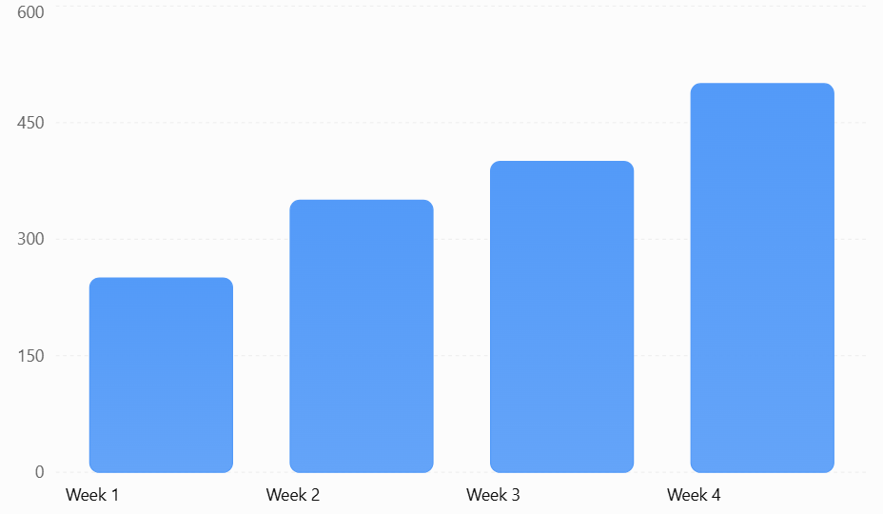
Illustrative data: total 1,500 clicks.
Analysis: The example shows an increase in clicks as weekly spending rises. In a live campaign, compare weekly spend with conversions and cost per lead before concluding that the additional budget improved performance.

Recommendations for future improvements
- Optimize display creatives. Test different banners, headlines, colours and calls to action. Compare CTR and conversion rate to identify effective designs.
- Improve audience targeting. Focus on relevant business audiences and review placement and demographic performance. Exclude low-quality placements only when supported by sufficient data.
- Refine Search keywords. Use high-intent keywords such as “SEO agency in Mumbai” and “Google Ads management services” in the separate Search campaign.
- Review budget allocation. Compare cost per qualified lead across Display, Search and Video. Reallocate budget based on actual results instead of automatically increasing spending each week.
- Improve landing page conversions. Use clear service descriptions, mobile-friendly design, a simple enquiry form and a prominent consultation CTA.
- Track genuine conversions. Verify form submissions and qualified calls in Google Ads. Monitor lead quality, not just clicks and impressions.

Conclusion
GrowthSpark Digital has a proposed monthly Google Ads budget of ₹15,000, distributed across Display, Search and Video advertising. Display Ads receive the largest allocation to support brand visibility, while Search Ads target users actively looking for digital marketing services.
The sample scenario demonstrates how campaign performance can be evaluated through CTR, CPC, conversion rate, total spend and cost per conversion. Future optimization should focus on creative testing, relevant targeting, accurate conversion tracking and budget allocation based on qualified leads.

