# **MRD**

# **Name of Product: Go4Local**

## **Vision**

For working professionals and senior citizens who want to buy groceries but do not have time to go out, our new product Go4Local helps connect them with local grocery store owners. Unlike Big Basket, we deliver products from local brands freshly delivered at a lower cost.

**Motivation**

**Customer Segments**

The platform is used to connect the buyers and the sellers. There are sub-segments for each of these two categories. The top three buyer segments we identified are working professionals, students, and senior citizens considering their age, occupation, and spending potential. We validated the assumption that there is an unmet need for these segments by interviewing customers from Mumbai. We found that people in this segment generally call the store and send the list to get products delivered by their cashiers. The service was often delayed along with unclear bills. People from this segment also often could not find time for shopping generally when needed products from multiple stores. The buyer's customer segments are detailed below.

**1.** **Buyers:**

|  |  |
| --- | --- |
| **Title** | **Working professionals** |
| Age | 25 - 40 |
| Income level | >$14000/ year (10,00,00 INR) |
| Location | Mumbai, Maharashtra, India |

|  |  |
| --- | --- |
| **Title** | **Students (off-campus)** |
| Age | 18-25 |
| Budget | > 2,500$ / year (2,00,000 INR) |
| Region | Mumbai, Maharashtra, India |

|  |  |
| --- | --- |
| **Title** | **Senior Citizens (live alone)** |
| Age | 60+ years |
| Income level | >$7000/ year (5,00,000 INR) |
| Location | Mumbai, Maharashtra, India |

The top three sellers’ segment we identified are grocery store owners, pharmacists, and dairy product store, owners. These are the small businesses most often found in the neighborhoods of Mumbai. The target segment was further narrowed based on annual revenue. This helped us align with our larger vision of uplifting local small businesses. We tested our hypothesis by interviewing people from these segments in Mumbai. We found that they desire to reach out to more customers in their neighborhood as they have seen many people order online but their business’ infrastructure does not allow them to scale up.

**2.** **Sellers:**

|  |  |
| --- | --- |
| **Title** | **Grocery Shops owners** |
| Distance proximity | < 2 Kilometers |
| Revenue (Annual) | < 140,000 $ (1,00,00,000 INR) |
| Region | Mumbai, Maharashtra, India |

|  |  |
| --- | --- |
| **Title** | **Pharmacists** |
| Distance proximity | < 2 Kilometers |
| Revenue (Annual) | < 80,000 $ (60,000 INR) |
| Region | Mumbai, Maharashtra, India |

|  |  |
| --- | --- |
| **Title** | **Dairy Product Store owners** |
| Distance proximity | < 2 Kilometers |
| Revenue (Annual) | < 250,000 $ (1,80,00,000 INR) |
| Region | Mumbai, Maharashtra, India |

Early adopters of our products will be those we have some relationship with. The buyers could be our friends & family, along with people in our neighborhood. Since there is a higher chance of these buyers using our platform, the shops in the neighborhood could become our early adopters for seller segments. There is high trust due to close relationships, the referral system to expand could work well initially. The early adopters would prioritize cash-on-delivery over advance payment, compared to the mainstream users. In addition to that, early adopters would seek the word of mouth to decide on using the service, whereas advertisements would work better for mainstream users.

**Customer Persona:**

**Buyer and Seller:**

**Buyer**

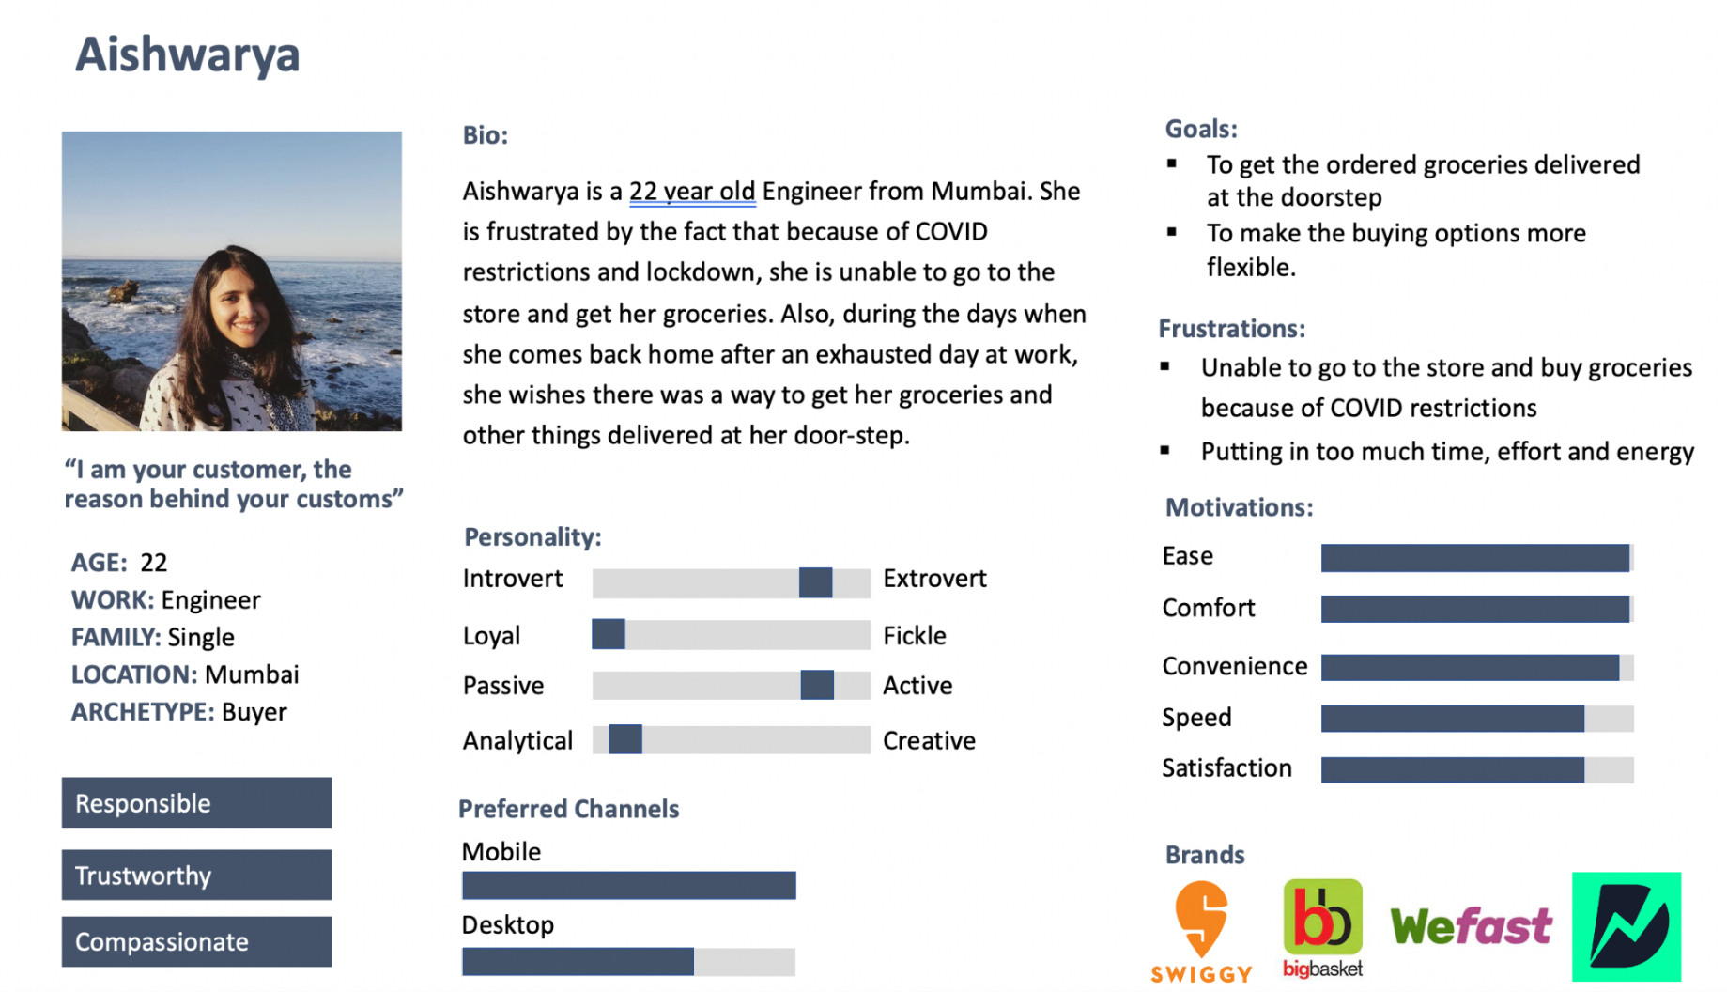

**Seller**

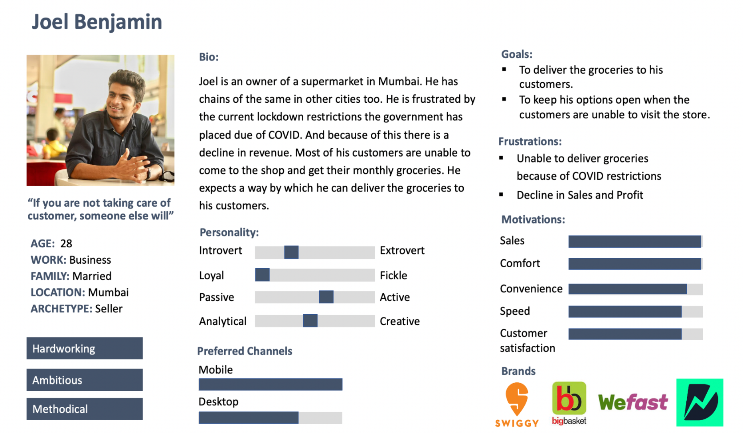

**Unmet Needs**

**Working Professional:** I believe working professionals face the problem of finding time to buy groceries due to their ever-changing and hectic schedules. They get tired and feel unwilling to go out to shop. Their only option is purchasing from franchise stores which sell at a higher cost and lack the quality the customers are familiar with in their local stores. Rajath, a working professional says, “I feel big brand products are more expensive than the ones that we get at our local stores. But I can find only big stores on delivery apps, not the local ones.”

**Senior Citizen:** I believe senior citizens living alone face the challenge of bringing groceries to their homes and of buying multiple products from different shops because they are physically weak. Their only option is to call the shop and ask them to deliver by sending their employees. Meenakshi, a senior citizen says, “Sometimes I am not well, and other times I am caught with other things. In those times I call up my son, who is living 5 miles away, or maid to help me out in getting stuff from stores. Otherwise, I will call the store owner and if there is no rush in the store, he will send his boy to deliver things and charge for the delivery.”

**Student:** I believe students living independently away from home have difficulty managing time to buy groceries due to their hectic academic and social schedules. They also experience unclear pricing structure when shopping in new cities for products without MRP example - dairy products, grains, etc due to this they end up spending more. Sakshi, a student says, “Order from Big Basket which has 2hr delivery time until 10 pm night, but I can choose only from their product. Desired brands not available like for products - sugar, paneer, only inhouse brands available.”

**Grocery store owner:** I believe grocery store owners experience a shortage of staff and time when delivering the products to the daily customers. This reduces the profits and is also a bad experience for the target users. Due to the large market and competition, they also lose some customers. Guruprasad, a local grocery store owner says, “I usually do not offer home delivery of products unless they are placing a large order and if they are regular customers at my shop. I would not charge extra.”

**Dairy store owner:** I believe dairy store owners are very high in demand throughout the day and experience a high number of customers in the shop daily. Hence, there is no time for the owner to send a person away from the shop for delivery. Existing daily milk delivery costs them high and inconvenience due to lack of vehicle, no delivery charge, on-time delivery to more than 1000+ customers, and at the same time avoiding milk spillage/ product damage. Ramesh, a dairy store owner says, “We usually have a milk delivery service twice a day in local buildings. For milk, we do not have a minimum order amount and do not have any delivery service for other dairy products like cheese, yogurt, cakes, bread, etc. The shop is crowded and it’s impossible to take orders.”

**Pharmaceutical store owner:** I believe local pharmaceutical store owners do not deliver medicines because of high delivery costs and low shopping cart prices. Arjun, a pharmacy owner says, “Minimum order is Rs 400. Sometimes people call up just to deliver Crocin or Paracetamol, and it is not feasible, hence this amount.”

### **Existing Solutions**

Current existing solutions include the following:

1. As and when a person requires or feels the need to go and get a product or a commodity from his nearby local store, he ventures out by physically himself/herself to procure it. It can be a common household grocery item or a medicine (along with his prescription).
2. They can use an already existing smartphone-based application to place an order to get the item delivered by paying a fee for the service.
3. Some local grocery store owners provide the service of delivering groceries and items to the doorstep if the order exceeds a certain amount, through which the customer calls up the local grocery store owner to place an order and get it delivered.

All the existing solutions mentioned above require the customer to physically go and get it by himself or to use an already existing application to place an order delivery.

The existing solutions cannot meet the customer’s needs as it makes it hard for a certain subset of customers to physically step out to get the items and groceries which they require frequently. Senior citizens or working professionals find it hard to get the groceries and medicines by themselves. In addition, the online delivery applications do not let the customer get their order delivered within a stipulated amount of time. At times they have to schedule an order which will be delivered the next day causing inconvenience when the customer requires medicines during an emergency. Applications such as Big Basket deliver products only sold by them. One of our customers, Nandini, who is a senior citizen, said that she often could not find her favorite products and the fruits & vegetables delivered were of poor quality.

Grocery store owners who are willing to provide this service expect the customer to place a minimum order which is at times a large value which refrains the customer to request the order and in addition, they do not provide the service of live tracking which frustrates the customer and requires the customers to make repeated calls to the grocery store owner/local pharmacy to get status updates on his order. One of our customers, Hariprasad, who owns a grocery store, said that more people want their products delivered to home. He said, since he doesn’t have the infrastructure for this, they find it hard to deliver on time.

### **Differentiation**

|  |  |
| --- | --- |
| **Go4Local** | **Other Competitors** |
| Delivery of known high-quality products | Unknown/ cheap brands delivered |
| Quick and scheduling delivery | Book slots for next day or future delivery |
| Cash/Card payment on Delivery | Advance payment before Delivery |
| Full refund policy for missing/ damaged items  (No Questions Asked) | Exchange or return items in person/ no refund |
| The delivery fee charged on a cart value | The delivery fee charged on distance |

The existing competitors who provide delivery services concentrate on the products produced only by their parent brand or offered by partners. This makes the local products unavailable for the customers. Customers have long developed trust with these local vendors and enjoy their brands the most. Local shops also offer products at a very competitive price. Most local shops have their farming lands, cow and buffalo farms for dairy products, which are available fresh to the customers. Making this available for the customers at doorsteps is the advantage of using our app.

**Competitive Analysis**

**Feature Comparison:**

|  |  |  |  |  |  |
| --- | --- | --- | --- | --- | --- |
| **Attribute** | **Go4Local** | **Swiggy** | **Dunzo** | **Big Basket** | **We Fast** |
| **Delivery Distance** | Within a 2km radius (for initial 2 months and then extending) | 4-6 km | Max - 20 km | No radius due to multiple locations | Intra City delivery  (Intercity: Coming soon) |
| **Category of Items** | Groceries, and medicines. (Initial 2 months and scaling up gradually) | Medicines, stationary, laundry pick up and drop, fruits and vegetables, meat. | Packages, pick up and drop, Online restaurant discovery, Online Ordering, Grocery Delivery, Bike Taxi, Laundry Delivery, Medicine Delivery, Local Couriers | Fruits, vegetables, groceries,  Meat,  Kitchen supplies,  Beauty products | Gifts, documents, cakes, fragile items etc. |
| **Cost per delivery** | 15% of the cart value | Rs. 40 (first two km) | Minimum 40 rupees (4kms) with 120 (20kms) being the maximum | Rs. 50 (for order value up to Rs. 199), Free (for order value >200) | Rs 60. Cost starts from Rs.60 and then depends on distance + tax) |
| **Minimum Order Value** | Rs 80 | Rs. 300 (for free delivery) | No minimum value | Rs. 200 (for free delivery) | Rs 80 |
| **Number of Delivery partners** | Planning for 600 in the initial 2 months and then expanding | >1,30,000 | >11,000 partners | >5,000 | >1000 partners in multiple cities |
| **Grocery associates** | >2000 | > 20,000 | >30,000 | > 2000 | > 2000 |
| **Operational Timings** | 24x7 | 24x7 | 24x7 | 7 am to 10 pm | 24x7 |
| **Premium Features** | Live track,  24x7 customer support,  Reduced rates for premium members, Money back guarantee in case of loss/damage | Instant delivery, live- tracking on an app | Dunzo Daily -  19 Minute Delivery, Free Delivery, 2 step quality check | Express delivery in 60 mins | Reimburses the full amount in case of loss or damage. |

We have plotted a stacked bar graph to show the analytics of our product versus the existing products. A survey was conducted among a group of buyers, and we asked them the satisfaction levels for features such as quality of products, delivery time taken, fee, etc. Accordingly, we plotted a graph shown below:

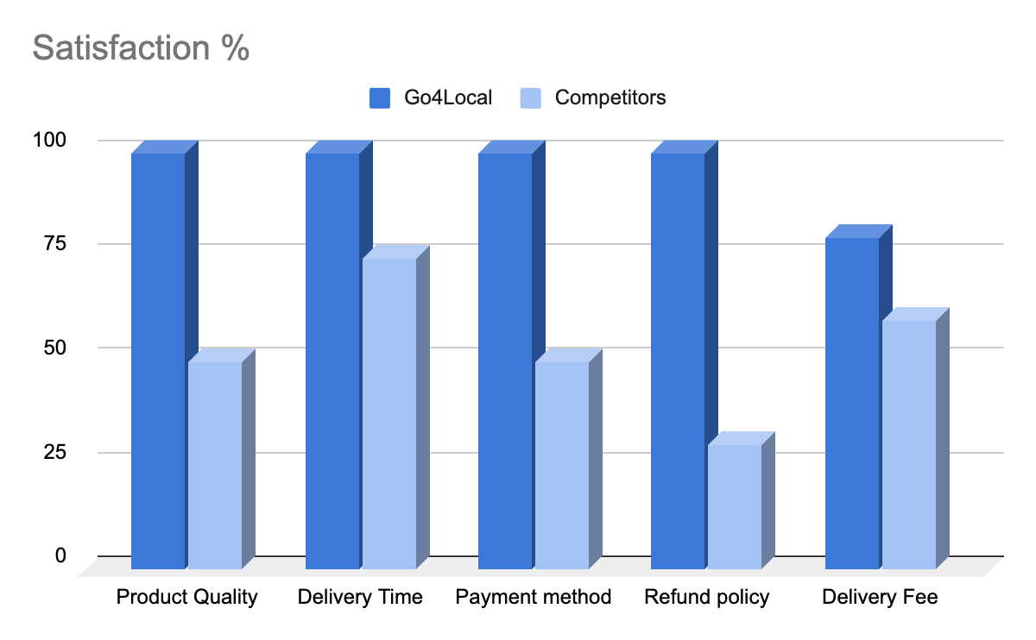

### **Why Now?**

There has been a significant change in consumer behavior, they value quality over the brand, convenience, and quick delivery of their products from their favorite and trustworthy local stores. Furthermore, common people have access to smartphones and cheap internet bringing a large segment of the previously offline market online. Next, sellers want to increase their market reach and desire to compete with top brands. Taking advantage of this opportunity, we plan to connect local buyers and sellers for quality and quick delivery of products at a reasonable price.

## **Use Cases**

**Customer Segment: Buyer**

**Use Case 1: - Working Professional**

A 9 am to 5 pm working employee, Nandini wants to get her groceries delivered at home as soon as possible as she is tired of going to shop. Guests are coming to Nandini’s house and she does not have time to go personally to different shops. She quickly grabs her mobile and orders from the local stores. Nandini gets her groceries delivered from her favorite local stores and favorite brands on time. She can now enjoy quality time with her guests.

**Use Case 2: Senior Citizen**

Ajji, a senior citizen aged 68, is not feeling well and wants her monthly medications delivered at home from the local chemist store. The chemist knows her personally and medicines that she usually buys and has her doctor’s prescription past copies. Ajji opens her app and selects the name of the local pharmacist, uploads the doctor’s prescription, and orders her medicine at home. She does not have to rely on any helpers or maids to get her medicine at home. Ajji soon gets her medicine delivered to the doorstep and is relieved that she will not have to go downstairs.

**Customer Segment: Seller**

**Use Case 3: Grocery Store owner, Pharmacy Store owner**

Hariprasad owns a Grocery Store and pharmacy store. He must look after both the shops he does not have time and resources to get groceries or medicines delivered to his customers. His customers are often disappointed due to no delivery service, and they prefer buying fresh vegetables and fruits and other items from his store. Hariprasad downloaded the Go4Local app and registered his shop on the app. Now he can connect with his customers and get their items delivered through the app.

**Market Size**

The main customers of this product are people who do not have time to shop from their neighborhood stores. The TAM is dependent on the average revenue per user and the total number of customers in that market. Our analysis is done for Mumbai on students, working professionals, and senior citizens living in the neighborhood of local stores. The number of people in each segment was calculated using census data from 2020-2021. Next, we estimated the average number of times in a week a customer from each segment goes to a neighborhood shop along with their average amount spent on each visit. Since we are delivering within the neighborhood for a fixed distance, we charge a delivery fee of 15% of the cart value. Considering all these factors we calculate TAM for the three buyers segment whiz. students, working professionals, and senior citizens. The step-by-step calculation of TAM is shown as follows. Total TAM is calculated by added individual market potentials.

1. **Students:**

**TAM = #students x avg times visit per week x avg cart value*delivery fee**

● Total number of students between the age group of (15-25) in Mumbai:31,865,346

● Total number of students who use a smartphone in Mumbai: 4,651,040 (28.36% of the total population)

● Assume the average number of times students shop per week = 4

● Assuming that the average amount spent on each visit = 40 INR

● Assuming the average amount of “pocket money” received per week: 100 INR

● Market Potential: 744,166,400 * 0.15 INR /week = 111,624,960 * 52(weeks) / 75 = ~$780,000,000/year

**2.** **Working professionals:**

**TAM = #people x avg times visit per week x avg cart value x delivery fee**

● Population between age group 25-40= 35,00,000

● Population earning more than 5,00,000 INR per year =

● Assume 80% earn over 5,00,000 INR per year = 0.8x 35,00,000 = 28,00,000 (#people)

● Assume only 60% of these people regularly shop in a week = 28,00,000 * 0.60 = 16,80,000 (#people)

● Assuming the avg. number of times people shop per week = 2

● Assuming the avg. shopping cart price per person = 800 INR

● Market potential = 16,80,000*2*800*0.15*52/75 = ~$ 280,000,000/ year

**3. Senior citizens:**

**TAM = #people x avg times visit per week x avg cart value x delivery fee**

● Population between age group >60= 10,00,000

* Population earning more than 3,00,000 INR per year →

● Assume 80% earn over 3,00,000 INR per year = 0.8*10,00,000 = 8,00,000 people

● Assume only 50% of these people regularly shop in a week = 8,00,000 * 0.50 = 4,00,000 (#people)

● Assuming the avg. number of times people shop per week = 2

● Assuming the avg. shopping cart price per person = 500 INR

● Market potential = 4,00,000*2*500*0.15*52/75= ~ $42,000,000/ year

**Total market potential = $780,000,000 + $280,000,000 + $42,000,000 = $1.1B**

## **Caveats / Risks / Key Dependencies**

Consider presenting risks in table format with columns providing detailed descriptions and possible mitigants for each risk.

|  |  |  |
| --- | --- | --- |
| **Risk** | **Description** | **Mitigation Strategy** |
| Privacy Concern | Both buyers and sellers would have privacy concerns regarding who has access to their data, eg: transaction, debit/credit card information, etc | We need to have a team of highly skilled professionals who work on secure data storage and encryption systems for all customer records. |
| Legal/Patent Risk | We need to make sure that we are not breaking any law. | A team of corporate lawyers for the company would be a great way to avoid any ignorance of the law. |
| Piracy Concern | Since there are a lot of competitors who are already there in the market it is easier for them to replicate the features. | Copyrights, patents, end-user agreements. Having an app product key. |
| Interdependencies with key internal systems/processes/operations | Need to make sure all the cross-functional teams are following the deadline, on the same page, and can reach the milestone on the agreed timeframe. | Hiring a Product Manager is a good start to making sure all the teams are on the same page and working within the agreed timeframe. |
| Availability of required 3rd- party complements | Collaborating with any 3rd party complements can pose a threat for credential theft and data exfiltration. | Having a solid team that would work towards secure data storage and encryption systems. |
| Cash Flow | Falling short or stagnation of cash flow for the development of features of the product. | 1. Conduct a prior predictive analysis of cash flow. 2. To raise funds through other sources. 3. Keeping operational costs low by optimizing processes. 4. To keep a buffer amount for future development of the product. |

**SWOT Analysis:**

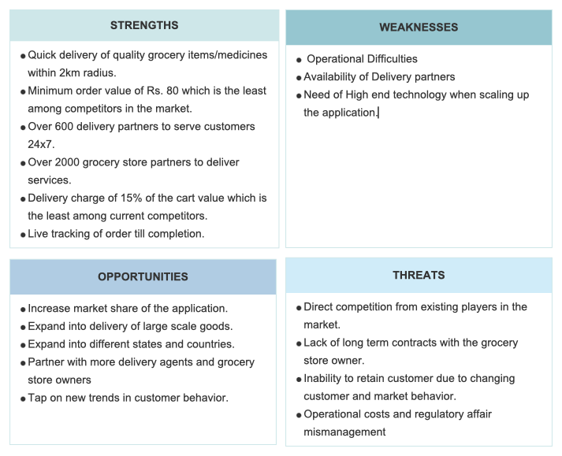

**Appendix 1**

**Interview Notes #1: Nandini, Age: 64, Senior citizen. – Video Call**

**Q1: How far do you go to buy groceries/ medicines/ dairy products and how often?**

Mostly, I prefer to buy weekly vegetables from the shopkeeper 5mins away from my home because I have a knee problem. The chemist shop, dairy shop and grocery shops are located just beside each other so I prefer them. But there are a few things such as meat, eggs, and seasonal fruits that I buy from different vendors. It takes 30 mins to walk from my house.

**Q2: Can you tell me about a time when you didn’t have time to get groceries/ medicines/ dairy products and how did you manage the situation?**

So, one day I was out of salt, oil, and basic groceries at home, and I had guests at my house. So, I called my local shop and requested him to deliver a few items. I tipped him a few rupees because it was a very urgent situation, and I could not go down in person. There was another incident when my daughter had a cough and fever in the middle of the night. I could not leave her alone and go down to buy Crocin which would give temporary relief to her. After calling the chemist, he generously agreed to give over the counter medicines so that my daughter would get temporary relief

**Q3: Have you used any delivery services before and how were your experiences? If not, do you always buy groceries yourself?**

Oh yes, especially during COVID lockdown I had to use Big Bazar, Amazon Fresh, or Nature’s Basket app. They were cool to use, however, I could not get the specific brands that I prefer to use. Sometimes, the vegetables/ fruits were not fresh, and also, they were costlier than my local vendor's prices. Another problem was that a few items don’t get delivered and they show out of stock. Also, they don't promise same-day delivery.

**Interview Notes #2: Vagad, Age: 40, Grocery Shop Owner - Call**

**Q1: How do you handle customers who ask for delivery of products, and do you charge them extra?**

During COVID, a lot of customers were asking for delivery of products, but we didn’t have the facility to deliver at everyone’s house. Sometimes when there are fewer customers in a shop, my helper goes and delivers it to a few daily customers but otherwise, we do not deliver. This is because we do not charge any extra fees.

**Q2: What is the minimum order amount for which you offer delivery service?**

The bigger the order, the better. Approximately, we keep the minimum order amount to Rs. 100 ($1.34). Mostly my customers order products weekly which surpasses the minimum order amount.

**Q3: How are you reaching out to your customers especially during COVID times? How do they pay you once the order is delivered?**

Our customer base is established very well, people from the nearby building come to our shop to buy fresh vegetables and fruits and they spread a word since they like all the items they buy. During COVID my customer base increased because all working professionals also started working from home and they tried my products for the first time due to low cost and they prefer buying from me now. They used to pay me cash-on-delivery and I also have online PayTM payment.

**Interview #3: Priyanka, Age 28, Corporate employee – Video Call**

**Q1: How far do you go to buy groceries/ medicines/ dairy products and how often?**

I usually bring groceries on my way back home from work from a grocery shop below my building. Sometimes I also buy online from Nature’s Basket if not urgently required. I usually stock items for two weeks.

**Q2: Can you tell me about a time when you didn’t have time to get groceries/ medicines/ dairy products and how did you manage the situation?**

Since I am working from home now due to the COVID situation, I have work piled up for the entire day, and most of the time I do not get time to get groceries. I usually ask the shopkeeper to deliver a few vegetables and dairy products (milk, eggs, cottage cheese) to my house.

**Q3: Have you used any delivery services before and how were your experiences? If not, do you always buy groceries yourself?**

Yes, of course, I do not have time to go to the supermarket to buy fresh fish and meat. So I order it from an online delivery app (Nothing But Chicken) every week.

**Interview #4: Chotu, Age 24, Local Chemist - Call**

**Q1: How do you handle customers who ask for delivery of products and do you charge them extra?**

We offer delivery services during day time only and when the shop does not have high customers. Sometimes, if there is an urgency of a few medicines then we try and deliver asap. But we do charge a delivery fee of around 10%. Most customers tip us well.

**Q2: What is the minimum order amount for which you offer delivery service?**

There is no minimum order amount for which we offer delivery but it depends on products. For example, we sell cosmetic products, shampoos, hair products, etc as well but do not deliver those at the doorstep because it is not urgent.

**Q3: How are you reaching out to your customers especially during COVID times? How do they pay you once the order is delivered?**

We have partnered with the nearby clinics and doctors, they usually refer us for medicines and the locals come and buy from us because we are the only chemist in the area who has a large variety of products. We accept PayTM (online payment) after delivery since COVID times, but now we also accept Cash on delivery.

**Interview Notes #5: Hariprasad, Age: 40, Grocery Shop Owner - Call**

**Q1: How do you handle customers who ask for delivery of products, and do you charge them extra?**

There are a lot of customers, who are asking for delivery especially because of the current scenario. COVID happened and even our profit margin was reduced because hardly anyone came to the store, so I eventually had to hire a few people who would go and deliver things. I charge them depending on how far the place is.

**Q2: What is the minimum order amount for which you offer delivery service?**

The minimum order value that I have for my store is 200 Rs. Because less than that is not feasible, because I need to pay these guys who are delivering the things.

**Q3: How are you reaching out to your customers especially during COVID times? How do they pay you once the order is delivered?**

We have been here for the past 25 years, so our shop is well known among the people nearby. I don’t take any extra effort in reaching out to people because I never thought I needed it for some reason. Usually, they pay via cash/google pay.

**Interview #6: Rajath, Age 27, Engineer /Working professional - Call**

**Q1: How far do you go to buy groceries/ medicines/ dairy products and how often?**

Usually, on my way back from the office, I do the grocery shopping if it is necessary. Else I go out on Sundays to the nearby supermarket and stock up the things needed for the week. Even medicines I do the same since I have a bike I just ride to the shop and get it by myself. The dairy product I get from the supermarket itself.

**Q2: Can you tell me about a time when you didn’t have time to get groceries/ medicines/ dairy products and how did you manage the situation?**

This has happened several times, once I met with an accident and couldn’t walk and it was my friends who helped me out to get groceries. If they were busy, I would ask my maid to get some things for me but usually, she comes for 2 hours and then if I ask her to buy some things then she will vanish for 1 hour in the name of this. So, I prefer my friends, the worst-case scenario, I call up the store and ask them if they are willing to deliver. Sometimes they do, other times they don’t depend on the availability of people there.

**Appendix 2**

1. Mumbai population segmentation [Link](https://www.populationu.com/cities/mumbai-population).

2. Students living in apartments [Link](https://housing.com/news/student-housing-indian-real-estates-next-big-segment-2019/).

3. Population and employment profile of Mumbai [Link](https://mmrda.maharashtra.gov.in/documents/10180/6867434/Population+and+Employment+Profile.pdf/4e3d18f0-4c6c-4708-9130-09915551c5e9).

4. Increase in India’s online grocery market [Link](https://apps.fas.usda.gov/newgainapi/api/Report/DownloadReportByFileName?fileName=COVID-19%20Accelerates%20the%20Growth%20of%20India%27s%20Online%20Grocery%20Market_Mumbai_India_05-17-2021).

5. India’s online grocery market trend [Link](https://www.grandviewresearch.com/industry-analysis/india-online-grocery-market).

6. Frequency of online grocery shopping India [Link](https://www.statista.com/statistics/980117/india-online-shopping-frequency/).

7. Online grocery to grow 8 times in India [Link](https://www.business-standard.com/article/companies/online-grocery-to-grow-8-times-in-5-years-in-india-jiomart-big-gainer-121012400098_1.html).

8. Popular online grocery services in India [Link](http://www.walkthroughindia.com/grocery/10-most-popular-online-grocery-stores-in-india/).

9. Online grocery market outlook for 20220-2021 [Link](https://www.imarcgroup.com/indian-online-grocery-market).

10. Changing consumer grocery shopping behavior [Link](https://www.forbesindia.com/article/bharatiya-vidya-bhavan039s-spjimr/have-consumers-changed-the-way-they-buy-essentials-and-groceries/67345/1)

**Team Members:**

1. Rochana Dudwadkar (dudwadkar.r@northeastern.edu)
2. Prateek Revadi (revadi.p@northeastern.edu)
3. Krishna Unnikrishnan (unnikrishnan.k@northeastern.edu)
4. Ashutosh Vishwakarma (vishwakarma.a@northeastern.edu)