

**INSTITUTION INNOVATION COUNCIL**

**OBJECTIVES**

* Igniting a campus-wide culture of innovation and entrepreneurship through creative thinking and collaboration.
* Empowering student-led ideas with hands-on support in prototyping, mentorship, and startup development.
* Driving awareness on IPR, startups, and national innovation programs to shape future-ready innovators.

**WHY IIC?**

IIC fosters innovation through idea generation, prototyping, IPR awareness, and business model development.  
It provides expert guidance, startup support, and access to industry and incubation networks.  
Empowering students to transform ideas into impactful, scalable solutions.

**MOU**

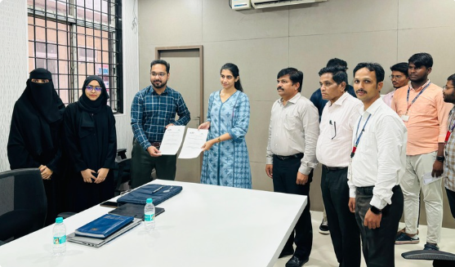 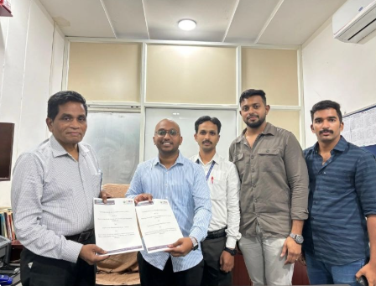

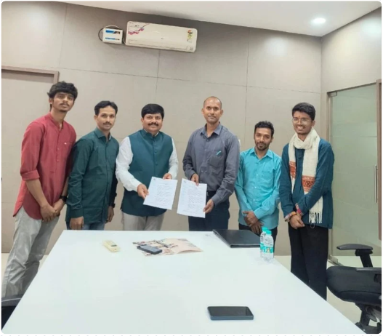

**ACHIEVEMENTS**

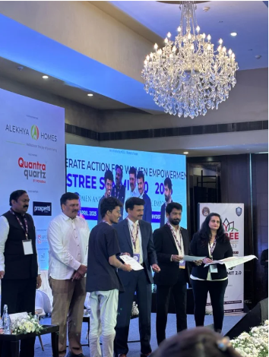 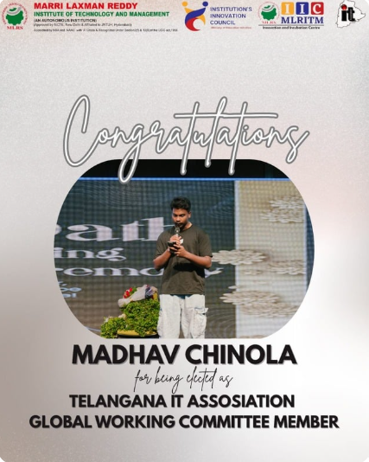 **Volunteered at the "Stree Summit" Securing positions in the Telangana Information Technology Association**

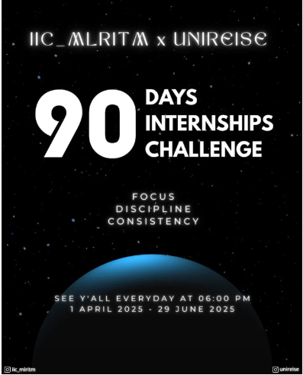 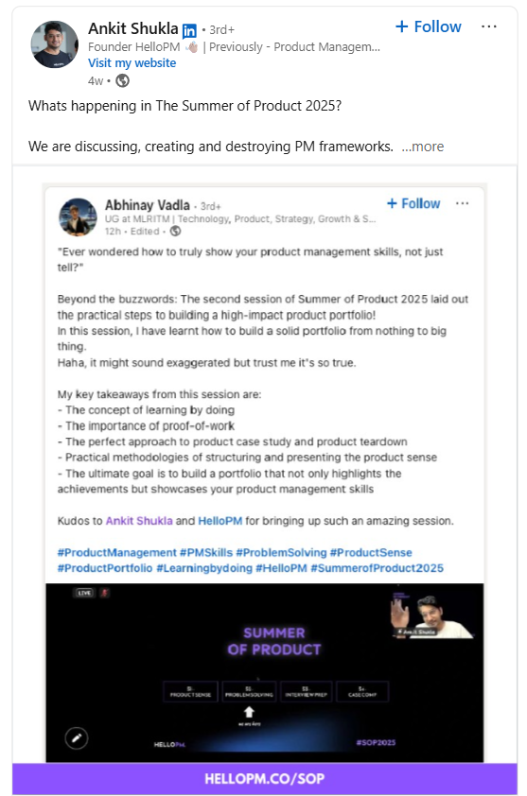

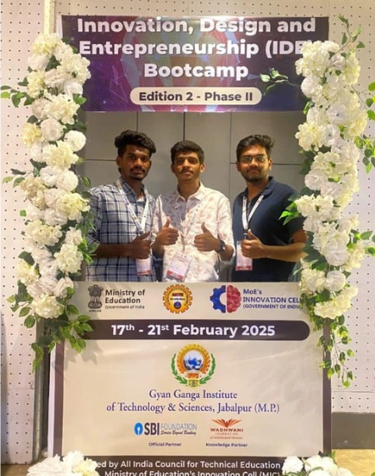 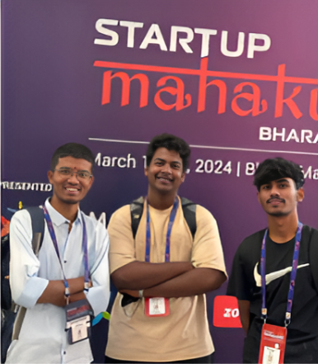

**SOCIAL MEDIA**

 



**DEAN OF IIC**



Dr. S.P. Jani is the Dean of the Institution’s Innovation Council (IIC), where he leads efforts to foster innovation, entrepreneurship, and startup culture among students. Under his dynamic leadership, IIC has evolved into a vibrant startup incubator, guiding students from ideation to prototyping and national-level recognition. As a passionate mentor, Dr. Jani plays a key role in empowering student innovators and building a future-ready ecosystem.

**MOBILE NO:** 8148625005

**EMAIL ID:** spjani10@gmail.com

**Dr. S.P. JANI**

** STUDENT LEAD**

Abhinay is a young innovator and tech enthusiast, founder of three startups — Unireise, Swasaayu, and Krishi Mandal. As President of IIC at MLRITM, he led the *"90 Days 90 Internships Challenge"* and represented the institute among the top 6 teams out of 500 at the AICTE IDEA Bootcamp. His blend of leadership, innovation, and industry exposure sets him apart.

**MOBILE NO:** 7569501144

**EMAIL ID:** abhichary1@gmail.com **ABHINAY CHARY**