Beauty GAN Project,

Additional Function 1st, Personal Color Detection(using LGB Model)

Detail of Packages Version

- python 3.6.10

- keras 2.3.1

- matplotlib 3.1.3

- numpy 1.18.1

- pandas 1.0.3

- scikit-learn 0.22.1

- seaborn 0.10.0

Install lightgbm

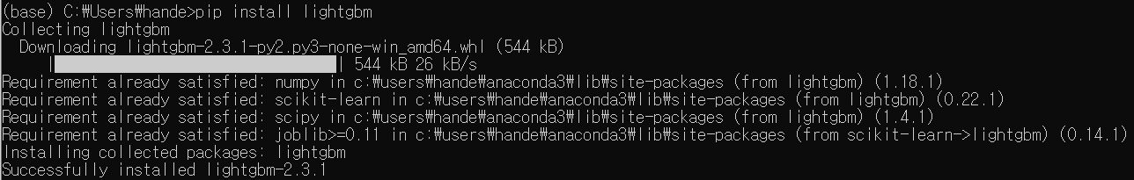

Install Bayesian optimizer

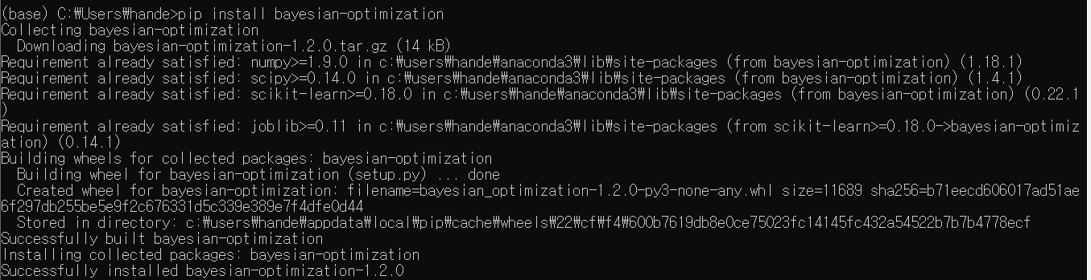

Data

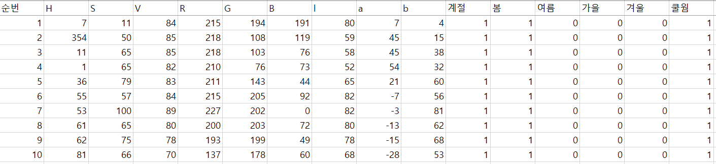

Code

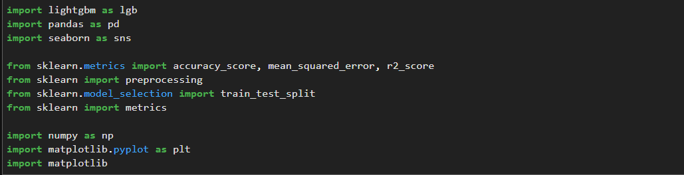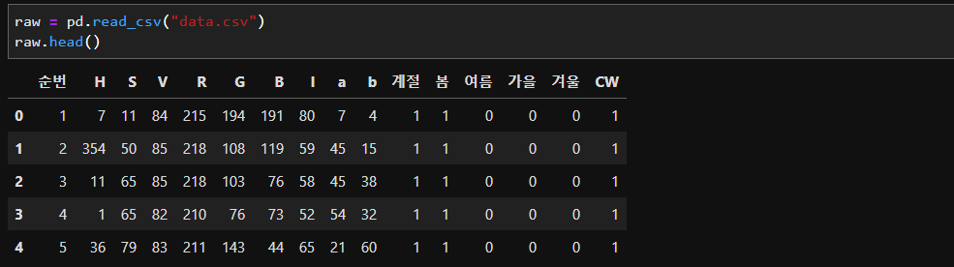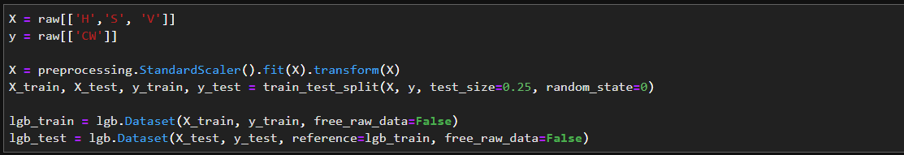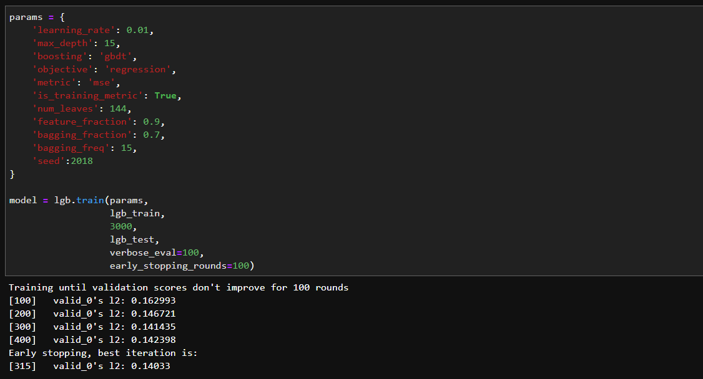

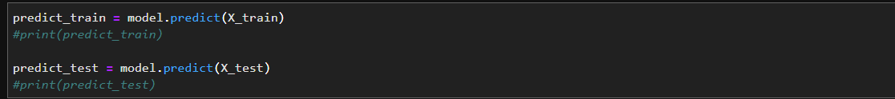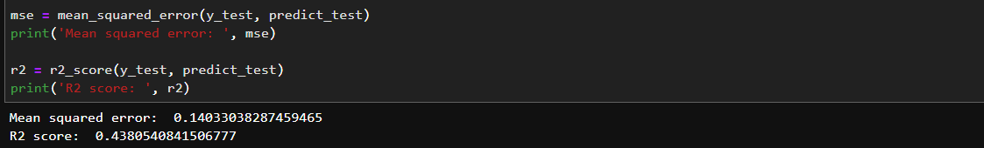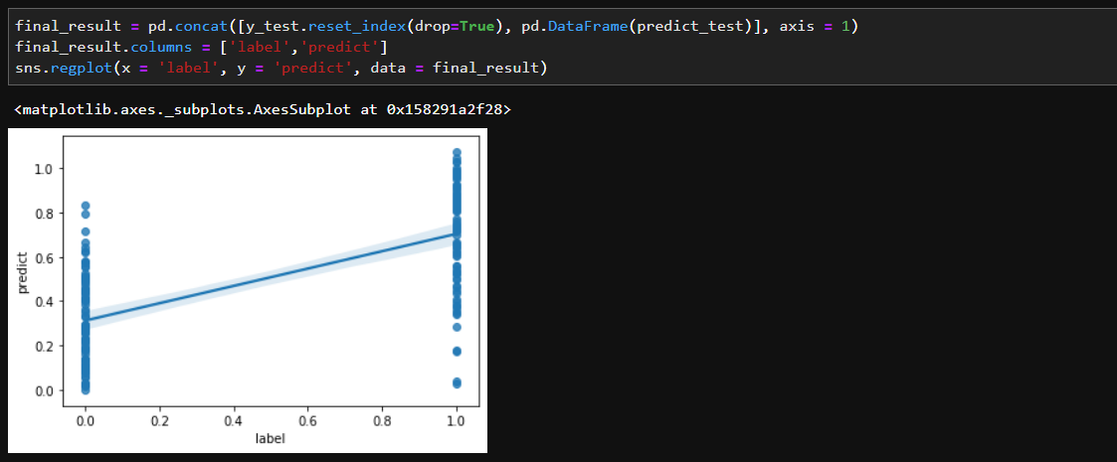

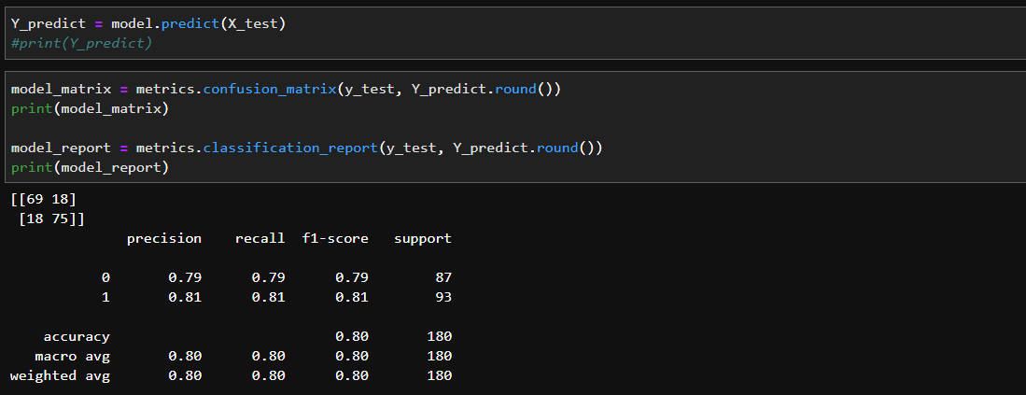

결과 분석

성능 최적화를 위해 Bayesian Optimizer를 사용하려 했으나, 에러 때문에 못함

독립변수 3개(H, S, V), Max_depth 16, bagging_freq 5일 때 0.81로 높음

독립변수 6개(HSV+RGB), Max_depth 16, bagging_freq 5일 때 0.81로 동일

독립변수 9개(HSV+RGB+lab), Max_depth 16, bagging_freq 5일 때 0.79로 낮음

LGBM 관련

<https://lightgbm.readthedocs.io/en/latest/pythonapi/lightgbm.LGBMClassifier.html>

<https://github.com/microsoft/LightGBM/blob/master/examples/python-guide/advanced_example.py>

<http://machinelearningkorea.com/2019/05/18/lightgbm%EC%9D%84-%EC%9D%B4%EC%9A%A9%ED%95%9C-%ED%9A%8C%EA%B7%80%EC%98%88%EC%B8%A1-%ED%8C%8C%EC%9D%B4%EC%8D%AC-%EC%B9%98%ED%8A%B8%EC%BD%94%EB%93%9C/>

Bayesian Optimizer 관련

<https://github.com/fmfn/BayesianOptimization>

<http://research.sualab.com/introduction/practice/2019/04/01/bayesian-optimization-overview-2.html>

<https://data-newbie.tistory.com/160>

<https://www.kaggle.com/chocozzz/bayesian-optimization-for-lightgbm>