Beauty GAN Project,

Additional Function 1st, Personal Color Detection(using XGB Model)

Detail of Packages Version

- python 3.6.10

- keras 2.3.1

- matplotlib 3.1.3

- numpy 1.18.1

- pandas 1.0.3

- scikit-learn 0.22.1

- seaborn 0.10.0

Install Xgboost

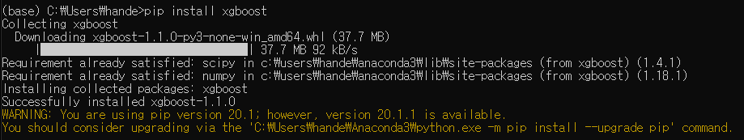

Data

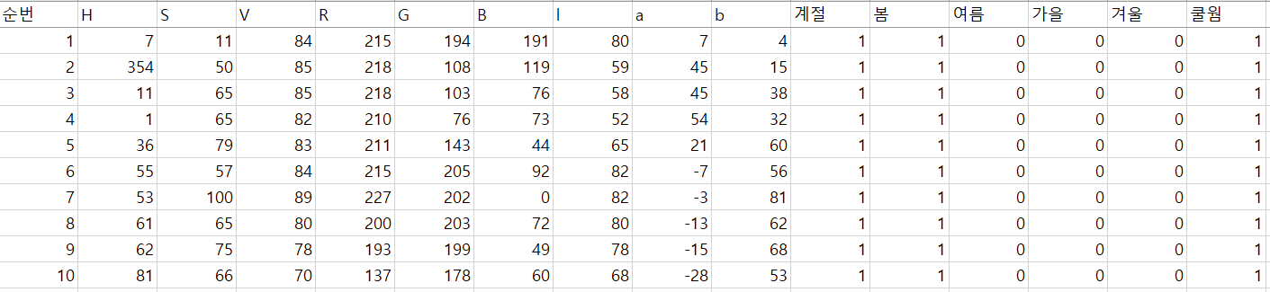

Model

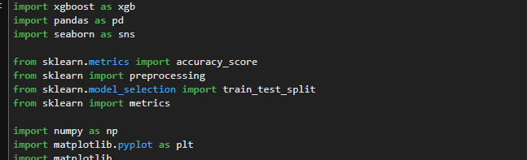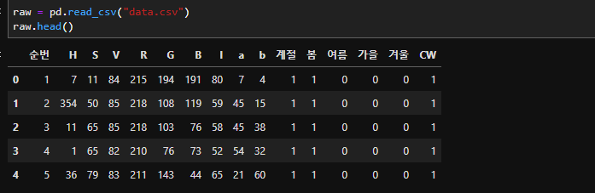

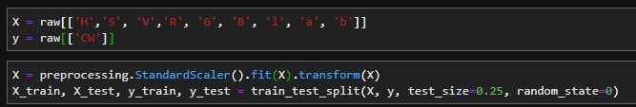

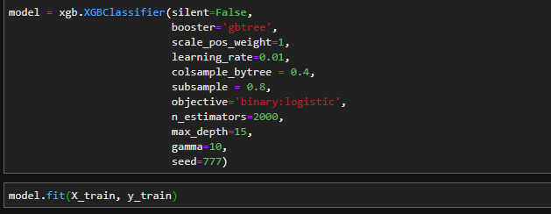

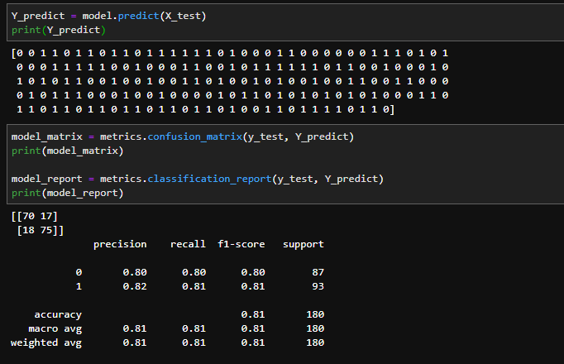

결과 분석 1

모델 학습 방식은 동일, 독립 변수를 변경했을 때,

model = xgb.XGBClassifier(silent=False,   
 booster='gbtree',  
 scale_pos_weight=1,  
 learning_rate=0.01,   
 colsample_bytree = 0.4,  
 subsample = 0.8,  
 objective='binary:logistic',   
 n_estimators=2000,

Case 1) 독립변수 : 9개(H, S, V, R, G, B, l, a, b) => 0.81

Case 2) 독립변수 : 3개(H, S, V) => 0.79

Case 3) 독립변수 : 6개(H, S, V, R, G, B) => 0.81

결과 분석 2

독립 변수는 6개 또는 9개로 두고, 모델 학습 방법(max_depth)을 변경했을 때,

Case 1) 독립변수 : 9개(H, S, V, R, G, B, l, a, b)

Max_Depth : 3 => 0.79

Max_Depth : 5 => 0.80

Max_Depth : 7 => 0.80

**Max_Depth : 9 => 0.81**

Max_Depth : 11 => 0.81

Max_Depth : 13 => 0.81

Max_Depth : 15 => 0.81

Max_Depth : 17 => 0.81

Max_Depth : 19 => 0.81

Max_Depth : 21 => 0.81

Case 2) 독립변수 : 6개(H, S, V, R, G, B)

Max_Depth : 3 => 0.78

**Max_Depth : 5 => 0.81**

Max_Depth : 7 => 0.81

Max_Depth : 9 => 0.81

Max_Depth : 11 => 0.81

Max_Depth : 13 => 0.81

Max_Depth : 15 => 0.81

Max_Depth : 17 => 0.81

Max_Depth : 19 => 0.81

Max_Depth : 21 => 0.81

Case 3) 독립변수 : 3개(H, S, V)

Max_Depth : 3 => 0.78

Max_Depth : 5 => 0.79

Max_Depth : 7 => 0.79

Max_Depth : 9 => 0.79

Max_Depth : 11 => 0.79

Max_Depth : 13 => 0.79

Max_Depth : 15 => 0.79

Max_Depth : 17 => 0.79

Max_Depth : 19 => 0.79

Max_Depth : 21 => 0.79

Ref : XGBoost Regression Python Code

<http://machinelearningkorea.com/2019/06/08/%EC%B4%88%EA%B0%84%EB%8B%A8-xgboost-%ED%9A%8C%EA%B7%80-%ED%8C%8C%EC%9D%B4%EC%8D%AC-%EC%B9%98%ED%8A%B8%EC%BD%94/>

Ref : XGB Classification Python Code

<https://statkclee.github.io/model/model-python-xgboost-hyper.html>

<https://www.it-swarm.dev/ko/python/xgboost-xgbclassifier-%EA%B8%B0%EB%B3%B8%EA%B0%92%EC%9D%80-python/822921857/>

<https://rosypark.tistory.com/59>

<http://swlock.blogspot.com/2019/01/xgboost-python.html>

<https://www.programcreek.com/python/example/99824/xgboost.XGBClassifier>

<https://xgboost.readthedocs.io/en/latest/parameter.html>