UNIVERSITY OF COMPUTER STUDIES, YANGON
2025-2026 ACADEMIC YEAR

Project Report On
PHONE BUYING BEHAVIOR ANALYSIS
Semester IX
DATA AND KNOWLEDGE MINING (IS-212) PROJECT
Submitted By
YKPT-22323 Ma Khin Than Thar
September 9, 2026 B.C.Sc.(BIS)

Acknowledgement
I would like to express my sincere gratitude to my instructor and department for the guidance and resources provided throughout the Data and Knowledge Mining (IS-212) course, which made this project possible. I am also thankful to all my friends who participated in my survey to collect this dataset used in this study, and to my family and classmates for their continuous support and encouragement during the completion of this project.

Table of Contents
Acknowledgement 2
List of Figures 4
List of Tables 4
Chapter 1 5
Introduction 5
1.1 Project Background 5
1.2 Objectives of the project 6
Chapter 2 7
Dataset Understanding, Preprocessing and Feature Engineering 7
2.1 Dataset Description and Cleaning 7
2.2 Feature Engineering and Encoding 8
Chapter 3 9
Exploratory Data Analysis and Descriptive Mining 9
3.1 Univariate and Bivariate Analysis 9
3.2 Customer Segmentation using K-means Clustering 11
3.3 Association Rule Mining of Buying Priorities 12
Chapter 4 13
Predictive Modeling and Recommendation Engine 13
4.1 Gradient Boosting Classification Model 13
4.2 Feature Importance 13
4.3 Brand Recommendation Engine 14
Chapter 5 16
Conclusion 16
5.1 Advantages of using this project 16
5.2 Disadvantages of using this project/ Limitation 16
References 18

List of Figures
Figure 3.1 Age Distribution 9
Figure 3.2 Loyalty Score Distribution 10
Figure 3.3 Budget Distribution 10
Figure 3.4 Priority by Gender Heatmap 10
Figure 3.5 Elbow Method for Optimal k 10
Figure 3.6 Cluster Visualization with PCA 11
Figure 3.7 Support vs Confidence Scatter Plot 11
Figure 3.8 Priority Network Graph 12
Figure 4.1 Top 15 Top 10 Features Importances 14

List of Tables
Table 2.1 Descriptive Statistics of Key Numeric Columns 8
Table 3.1 Customer Cluster Profiles (k = 4) 11
Table 3.2 Frequent Itemsetws 11
Table 3.3 Top Association Rules by Lift 12
Table 4.1 Model performance Comparison 13
Table 4.2 Gradient Boosting Confusion Matrix 13
Table 4.3 Brand Performance Summary 14

Chapter 1

Introduction
In Myanmar today’s smartphone market, almost everyone has a phone but what drives the customers to choose or leave a brand is important for business success. Numerous brands like Apple, Samsung, Redmi are competing for market in Myanmar, and they invest highly in marketing and product development to attract the customers. However, I would like to know switch between brands and factors influence their decisions.
This project addresses that gap by applying data mining and machine learning techniques to a survey-style dataset of 550 individuals, each described by 15 behavioral and demographic attributes including age, gender, current and previous brand, loyalty score, top priorities (camera, battery, affordability, etc.), budget range, and interest in features like AI and foldable screens. The project cleans and explores this data, mines it for behavioral patterns, trains a predictive model for brand switching, and finally wraps the model in a brand recommendation engine that helps companies understand their competitive position and customer retention strategies.

1.1 Project Background
The dataset used in this project, "Phone buying behavior 2026 - Form responses.csv". I took survey to collect this data in my university and 550 students participate in this survey. In this survey, it contains age, gender, their current phone and their previous phone and whether they like to switch to another phone and also their budget. Some questions like interest in AI, foldable screens, and after-sales service.
Top Priorities column is the one of the part of the survey to work with. Because people can select multiple things they care about while choosing a phone like camera, battery, SOC, brand reputation, etc…. That’s why I had to separate the comma before starting a real analysis.
This is a practical work of data mining and machine learning can turn a simple survey into something valuable.

1.2 Objectives of the project
Objectives of making this project:
- To clean and pre-process the raw survey data, determining and inputting structural missing values and translating the list-valued “Top-Priorities” column into binary indicator features.
- To analyze the data descriptively, with visual analysis, clustering of customers/lifestyles and association-rule mining to identify the patterns in the relations and how they relate to brand choices.
- To develop and test a supervised classification model, which can predict whether a person will stay or switch brands based on demographic.
- To create a recommendation engine that, for a given brand, analyze who is switching to and from the brand and identifies the top priorities that make their choices.

Chapter 2

Dataset Understanding, Preprocessing and Feature Engineering
To perform any modelling, the raw data needs to be comprehended, cleansed and converted into a number that can be fed into machine-learning algorithms. This chapter records the nature of that pipeline: the form and content of the data, how missing values are addressed, how values in columns containing lists are addressed, data-quality checks, and the encoding used to create the model-ready dataset.

2.1 Dataset Description and Cleaning
The data set consists of 550 rows and 15 columns of raw data. Most columns are age, gender, and brand names.
I checked for the missing values first. “Other Devices?” has two rows empty values. I filled with the median value.
“Top Priorities” column contains multi-valued answers. The responders could pick several options from a list. The data comes as comma-separated such as “Camera, Battery”. I split those strings into individual values. Then created a binary columns for each like Cameras, Battery, Affordability, Brand, Gaming and SOC. If a responders choose one of it, it counts as 1 and if not 0.

Table 2.1 Descriptive Statistics of Key Numeric Columns
Statistic | Age | Loyalty(1-5) | AI Features(1-5) | After-Sales (1-5) | Max_Budget_Lakhs | Ownership_Duration_Months | Priority_Count
Mean | 22.8 | 3.73 | 3.48 | 4.11 | 16.07 | 24.84 | 2.21
Std Dev | 5.14 | 1.07 | 1.329 | 1.32 | 1.01 | 4.99 | 20.83
Min | 19 | 1 | 1 | 1 | 6 | 0.5 | 1
Max | 54 | 5 | 5 | 5 | 22 | 84 | 5

2.2 Feature Engineering and Encoding
For the ownership duration , it comes up with things like ‘2 years’ . ‘3 months’. I converted into months. I encoded variables like gender, yes / no questions into 0 and 1. I created target variable “switched”. If a person’s current brand is different from the previous brand, and 0 if they stayed with the same brand.
After that I looked for duplicate rows and there are none. I checked all the numeric make sense. Ages are between 19 to 54. Budget range from 6 to 22 lakhs. After that I move to next stage.

Chapter 3

Exploratory Data Analysis and Descriptive Mining
Having a clean, encoded data set, this chapter delves into the data visually and applies two descriptive data-mining methods: K-Means clustering to break down its respondents into lifestyle profiles and association-rule mining to identify consistent sets of buying behavior.

3.1 Univariate and Bivariate Analysis
Overall, the distribution of Age (Figure 3.1) is right-skewed because this survey is actively participated by the university students. Most respondents were between 19 and 25, with a mean age of about 23.
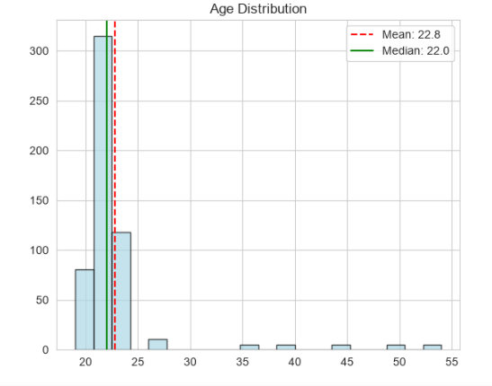
Figure 3.1 Age Distribution Histogram
Budget is another key variable for people to buy a phone. Most of the people fell in the 10-20 lakh range. The mean is about 16 lakhs. However, most of the people are around 10 lakhs, which means a lot of student here are budget-conscious.
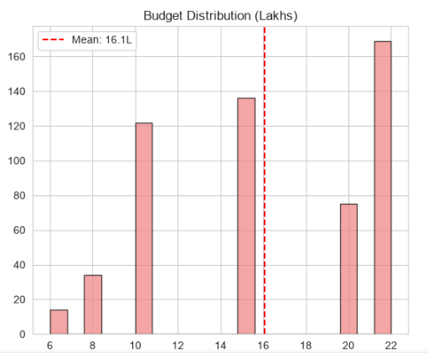
Figure 3.2 Budget Distribution Histogram
To understand how the difference between men and women, I built a priority heatmap. Camera is top priority for women and Battery is top priority for men. 84% of women listed camera as a top priority compared to men 41.4%. Even for Battery, women listed 62.9% as important than men 52.5%.
On the other hand, men listed gaming 41.4% and SOC as 39.5% than women (24.2%). Theses differences suggest that men and women have different priorities.
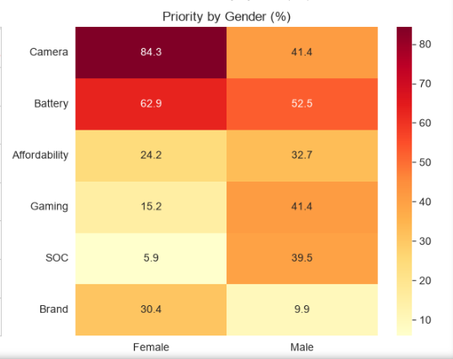
Figure 3.3 Priority by Gender Heatmap
For loyalty scores, the average was around 3.7 out of 5, which means people are satisfied with the phone but not loyal to the brand. The distribution is fairly spread out with no single score dominating.

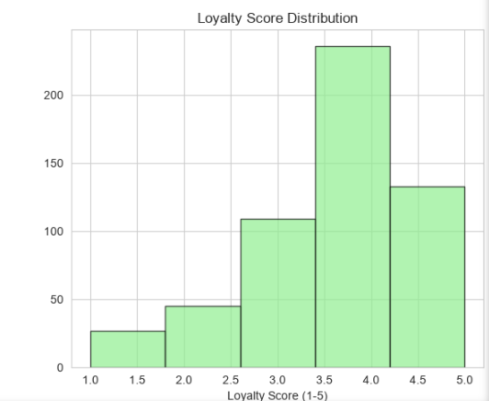
Figure 3.4 Loyalty Score Distribution

3.2 Customer Segmentation using K-Means Clustering
I use K-Means clustering to group customers into segments. First, I standardized all the numeric features first because budget and age are on different scales.
To figure out how many customer segments to create, I used the elbow method tested counts from 2 to 8. For each K, we ran K-Means and recorded the inertia. As K increases, inertia goes down. The elbow curve pointed a clear bend at k=4. So, I went with four clusters.
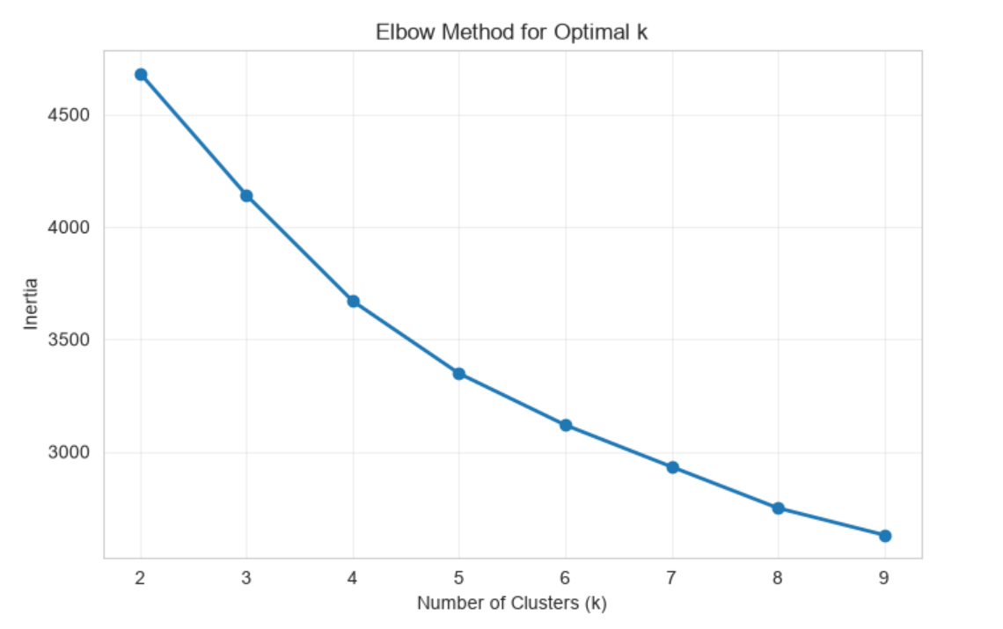
Figure 3.5 Elbow Method for Selecting k
I then used PCA (Principal Component Analysis) to visualize the clusters in two dimensions. The clusters separated fairly which means my segmentation is meaningful.
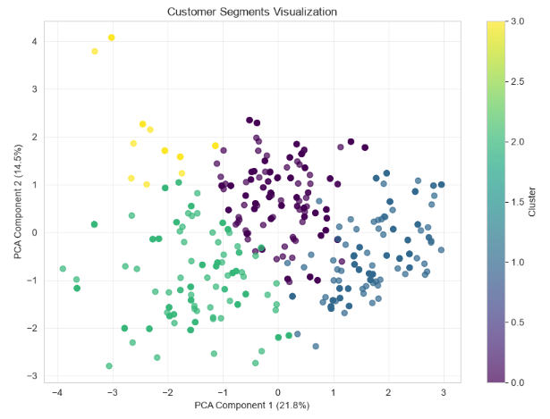
Figure 3.6 Cluster visualization with PCA
Table3.1 provides an overview of each of the four resulting clusters, showing that there are clear lifestyle segments: a cluster of Feature-Obsessed Enthusiasts (215 customers, 39.1%); a cluster of Premium Power Users (155 customers, 28.2%); a cluster of Senior Traditionalists (155 customers, 28.2%); and a cluster of Budget-Conscious Hunters (25 customers, 4.5%).
Table 3.1 Lifestyle Cluster Profiles (k = 4)
 | n | Avg Loyalty | Avg AI features | Avg Budgets | Foldable interest | Having  Associated devices
0 | 215 | 3.48 | 3.79 | 15.8 | 0.8 | 0.04
1 | 155 | 4.57 | 3.85 | 21.3 | 0.55 | 0.87
2 | 155 | 3.27 | 2.39 | 12.2 | 0.25 | 0.14
3 | 25 | 3.60 | 3.00 | 9.8 | 0.80 | 0.00

3.3 Association Rule Mining of Buying Priorities
I used association-rule mining to find patterns in customer priorities. To use association-rule mining, I have to use the binary columns I have created for each priority such as camera, battery, affordability, brand, gaming and SOC. Then I use Apriori Algorithm to find the frequent combinations.
The most common individual priorities are camera (71.64%) and Battery (59.8% support). The most common pair is Battery and Camera.
Table 3.2 Frequent Itemsets
Support | Items
71.64% | Camera
59.82% | Battery
41.64% | Battery, Camera
26.73% | Affordability
24.36% | Brand
22.91% | Gaming
19.45% | Brand, Camera
18.91% | Battery, Affordability
15.82% | SOC

I then generated association rules from these itemsets with a lift above 1.0.
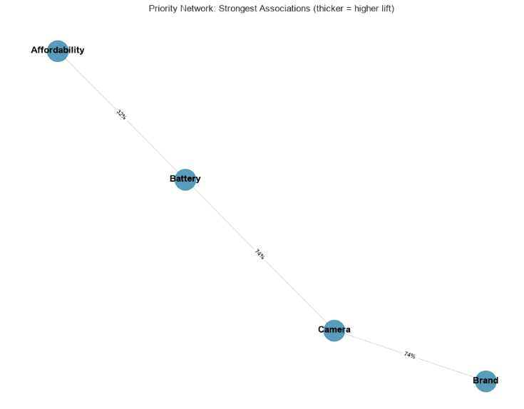
Figure 3.8 Priority Network Graph
Table 3.3 Top Association Rules by Lift
Antecedent | Consequent | Support | Confidence | Lift
Affordability, Camera | Battery | 10.18% | 75.68% | 1.27x
Battery | Affordability, Camera | 10.18% | 17.02% | 1.27x
Affordability | Battery | 18.91% | 70.75% | 1.18x
Battery | Affordability | 18.91% | 31.61% | 1.18x
Brand | Camera | 19.45% | 79.85% | 1.11x
Camera | Brand | 19.45% | 27.16% | 1.11x

Chapter 4

Predictive Modeling and Recommendation Engine
As explained in Chapter 3, the descriptive analysis reveals patterns that who buys what, how people segment and priorities go together. In this chapter, I will build a model to predict if a customer will switch brands. I will reveal which features matter most for the prediction. Third, I build a recommendation engine that brands could use to understand their competitive position.

4.1 Gradient Boosting Classification Model
The 16 encoded lifestyle features were used as input for the Random Forest Classifier. It is designed to capture non-linear interactions among features. The model can use to capture the complex interactions like how budget and loyalty.
My challenge was about the class being imbalance. Because the dataset contains 73% of customers had switched brands and only 27% had stayed. I use this it would be right 73% of the time and it wouldn’t be useful.
To handle this, I use two techniques. First, we stratified train-test-splitsto be alerted minority class (Stayers). I use train-test splits to make sure both classes were represented proportionally in training and test set. So, I split the data into 70/30 split. The training set has 385 samples and test set had 165 samples.
For comparison, we trained a Gradient Boosting Model and a Logistic Regression model. Gradient Boosting performed better with 91.5% accuracy and F1 score of 0.94.
Table 4.1 Model Performance Comparision
Model | Accuracy | F1-Score | Precision | Recall
Random Forest | 89.1% | 0.92 | 0.99 | 0.86
Gradient Boosting | 91.5% | 0.94 | 0.96 | 0.93
Logistic Regression | 73.3% | 0.79 | 0.90 | 0.71

Table 4.2 Gradient Boosting Confusion Matrix
 | Predicted Stayed | Predicted Switched
Actual Stayed | 40 | 5
Actual Switched | 9 | 111

4.2 Feature Importance
The feature importances of the trained model (Figure 4.1) reveals that AI feature (1-5) is the most important for brand switching. Age comes second, followed by max_budget, after-sales (1-5) and loyalty (1-5). This chart represents that customers who love AI features and younger and have higher budgets are most likely to switch brands.
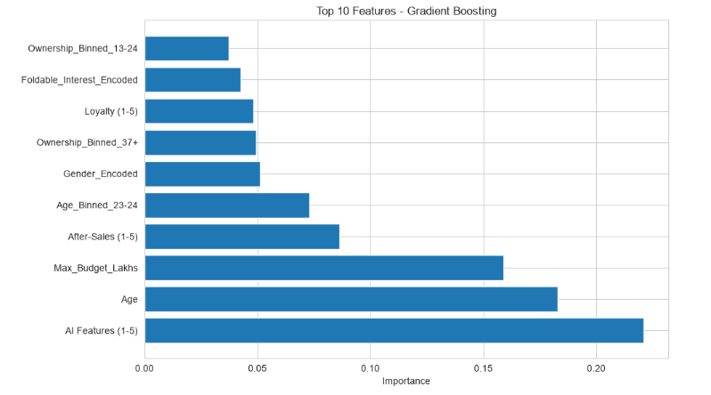
Figure 4.1 Top 10 Feature Importances

4.3 Recommendation Engine
Last but not least, the final of the project is a brand recommendation engine. For the given brand, the model engine analzye who is switching and who is staying for this brand. It identifies the top priorities driving those switches.
How it works:
Switched To : show that any brand switch to the current brand
Switched From: Show that any brand switch from the current brand to another
Net gain or loss: Calculates whether the brand is winning or losing customers.
Table 4.3 Brand Performance Summary
Rank | Brand | Switched To | Switched From | Loyal | Net Gain
1 | Apple | 143 | 15 | 22 | +128
2 | Infinix | 21 | 0 | 0 | +21
3 | Honor | 10 | 0 | 0 | +10
4 | Realmi | 5 | 5 | 0 | 0
5 | Oppo | 10 | 14 | 0 | -4
6 | Techno | 9 | 17 | 0 | -8
7 | Xiaomi | 46 | 58 | 0 | -12
8 | Huawei | 0 | 22 | 0 | -22
9 | Samsung | 78 | 103 | 23 | -25
10 | Redmi | 71 | 111 | 95 | -40
11 | Vivo | 8 | 56 | 5 | -48

This engine performs the predictive model into actionable business insights.

Chapter 5

Conclusion
This project has successfully implemented a complete data mining pipeline. It started with the survey data from 550 respondents. I clean the data, handled missing values, and split list-valued column into binary features. Then I explored the data through visualizations, customer segmentation using K-means and association-rule mining to find the patterns in purchasing.

5.1 Advantages of using this project
- Provides data-driven insights about customer behavior and brand switching patterns
- The recommendation engine give actionable advice
- Recommendations are based on a Gradient Boosting Model (91.5% accuracy)
- The clustering results reveals different customers segments
- The modular structure (clean data, encode, predict, recommend) is easily wrapped up in a simple web form or mobile app interface.

5.2 Disadvantages of using this project/ Limitation
- The dataset is a self-reported survey, thus response bias may be present
- The survey only captured 550 responses, which may not represent all smartphone buyers
- The mode was trained on a specific datasets which was helped by all my friends and family and may not generalize to other regions or time periods.
- The recommendation engine analyzes one brand at a time and doesn’t consider competitive responses.

References
[1] F. Pedregosa et al., "Scikit-learn: Machine Learning in Python," Journal of Machine Learning Research, vol. 12, pp. 2825–2830, 2011.
[2] S. Raschka, "MLxtend: Providing machine learning and data science utilities and extensions to Python’s scientific computing stack," Journal of Open Source Software, vol. 3, no. 24, p. 638, 2018.
[3] W. McKinney, "Data Structures for Statistical Computing in Python," Proc. 9th Python in Science Conf., pp. 56–61, 2010.
[4] M. Waskom, "seaborn: statistical data visualization," Journal of Open Source Software, vol. 6, no. 60, p. 3021, 2021.

