***The Eccentric Party***

***Election Manifesto 2015***

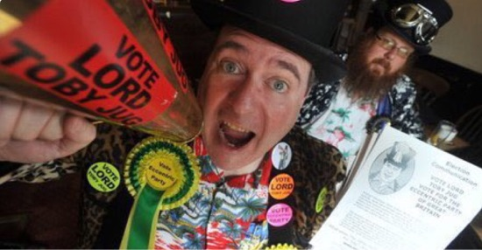

***POLICIES: iPads, smartphones, X-boxes etc will come with a slot metre to reduce the amount of time kids are glued to these gadgets, once they've run out of money they can be chucked outside to get fitter playing sport, this will end childhood obesity. We're going to replace all sleeping policemen with members of the House of Lords***

***Obesity....All lip balm will be made with super glue.***

***Education - You will be required to read a book for every 10 selfies you take***

***A GCSE in lying will be created.***

***We'll build new schools using revolutionary inflatable classrooms making it easier for delinquent pupils to let the entire school down, reducing class sizes to 3'x2'6" and the abolition of student top-up fees; students should be entitled to full pints the same as everyone else.***

***Immigration - We propose placing giant photos of "celebrities" such as Russell Brand, Katie Hopkins and Jeremy Clarkson at airports "to discourage foreigners from entering Britain and staying to long.***

***We propose 8 hours of spare time, 8 hours of rest and 8 hours of sleep everyday.***

***Taller buildings will be built for higher education.***

***We'll nationalise paid for public toilets so they're free to use.***

***The national debt with will be paid off with credit cards.***

***We will nationalise crime to make sure it doesn't pay.***

***All locks will be made out of bra fasteners.***

***15% off of phone bills for people who stutter.***

***Discarded chewing gum that blights our streets, will be used to fill in all the pot holes on our roads.***

***We will complicate Britain's tax system even more so that large companies can no longer find money-saving loopholes.***

***All swimming pools will be drained once a week for non-swimmers.***

***People who allow their dogs to poo on the pavement without cleaning it up should be forced to wear it as a moustache.***

***Anyone found guilty of homophobic hate crime has to serve their sentence in drag.***

***Unemployment: We'll eliminate unemployment by abolishing Statistics, thereby eliminating the bureaucrats that measure unemployment.***

***Eastenders will come with free Prozac.***

***Text lanes for mobile phone users will be introduced for pedestrians to stop them walking into lampposts.***

***Defence: Beer will be used as a National Defence strategy: leaving bottles of beer on all beaches, so that any invading army would abandon its attack and get drunk while the broken bottles would prevent the army advancing any further.***

***Vote Sensible...Vote For The Eccentric Party Of Great Britain - We Dance To The Beat Of A Different Drum!!!***