IR Plus Repository, Institutional Collection and Institutional Publication Administration Functional Requirements Specification

Updated By | Updated Date | Version
Nathan Sarr  Sharmila Ranaganathan | 1/1/2007 | 1.0
Nathan Sarr | 1/1/2008 | 1.1

- Repository and Institutional Collection Administration

  - General Overview

The repository will be the root location for all information in the system and be controlled by the institution.

Institutional collections will be the containers of information that will be recognized as published by the university. The university will have full control over this information. Users who have published into these collections, in general, will not be able to modify or change this published information.

General overview of repository with collections (Figure 1.1):

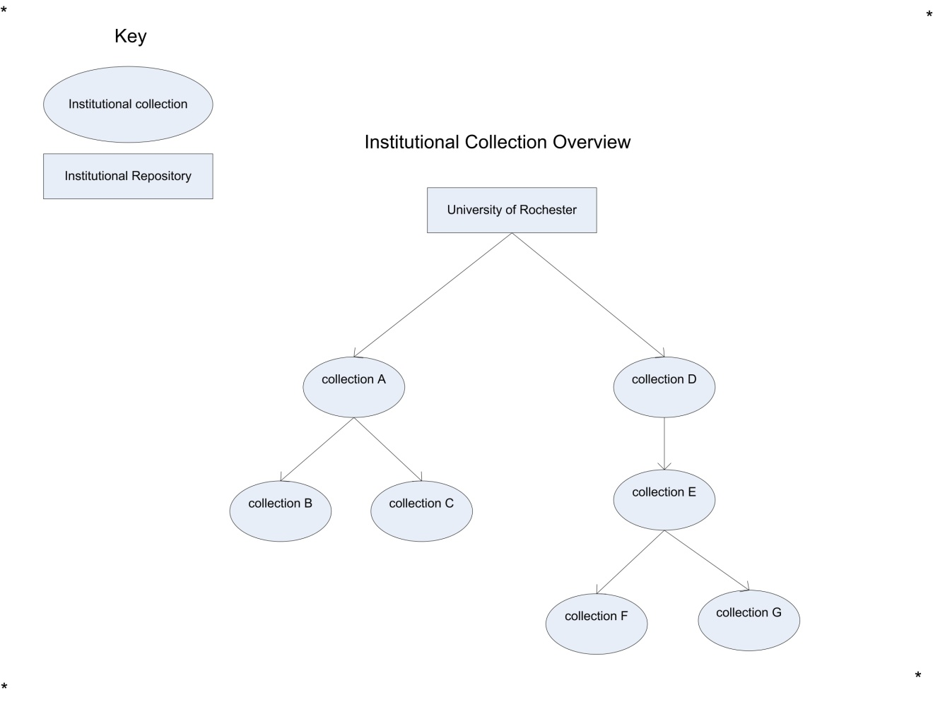

The above shows the institutional repository called “University of Rochester” with seven institutional collections. Collections will be in a tree format. Collections A and D are referred to as “top level” collections. Collections B and C are sub-collections and will be referred to as children of collection A. Collection E is a child of Collection D and collections F and G are children of Collection E. Collections E, F and G can all be referred to as children of Collection D.

  - Collection Permissions

The following are the permissions that users can have on an Institutional Collection:

Permission Name | General Description
Collection Viewer | User is allowed to view the collection – this is only needed if the collection is marked private
Collection Reviewed Submitter | User is allowed to submit to the collection but only after the submitted publication has been reviewed
Collection Direct Submitter | User is allowed to submit publications directly to the collection
Collection Reviewer | User is allowed to review publications to the collection
Collection Administrator | Allows a user to administer a collection and all child collections

Here is a table of the privileges given to each user on individual collections:

 | Collection Administrator | Collection Reviewer | Collection Direct Submitter | Collection Reviewed Submitter | Collection Viewer
View collection | X | X | X | X | X
Submit to collection with review | N/A | N/A | N/A | X
Submit to collection directly | X | X | X
Review a publication | X | X
Edit an institutional collection | X
Change users’ permissions | X

  - Collection Permissions Management

Collection permission management will be group based. (Note: System administrators will have access to all collections and groups within the system). User groups can be created by administrators and then users added to those groups.
Giving any permission to an institutional collection except Administration Permissions applies those permissions to only that group. Giving Administration Permissions on an institutional collection to a group has consequences which will be described below.
The simplest case is giving Administration privileges on an institutional collection that has no children. It would look like figure 1.2 below
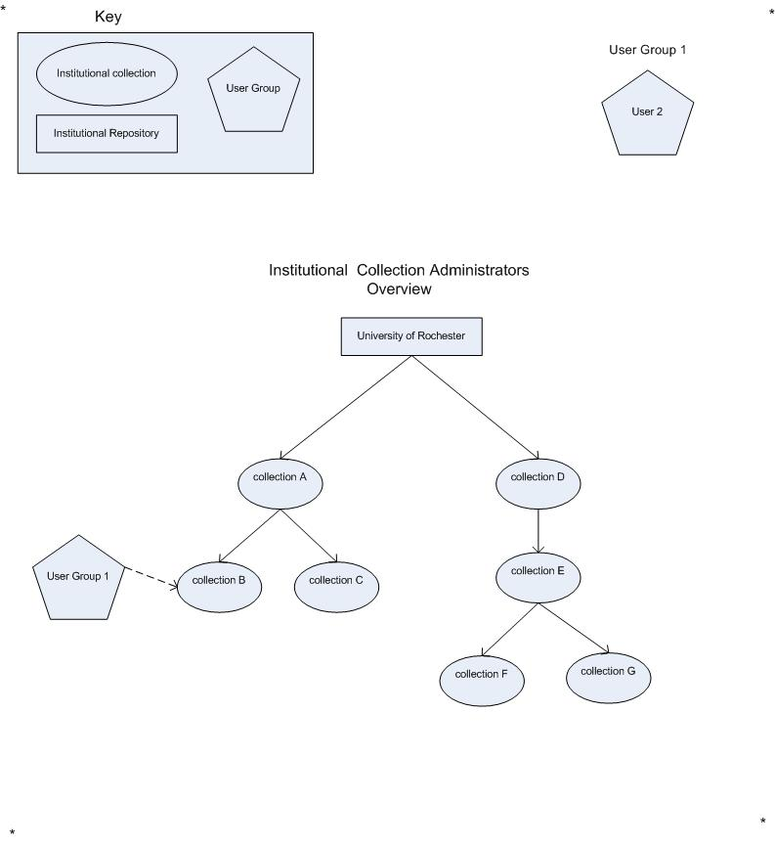
Figure 1.2

Figure 1.2 shows adding user group 1 with administration permissions to collection B.
The next case is when a group is given Administration permissions on an institutional collection with children. The next figure 1.3 shows user group 2 being given permissions on collection D:
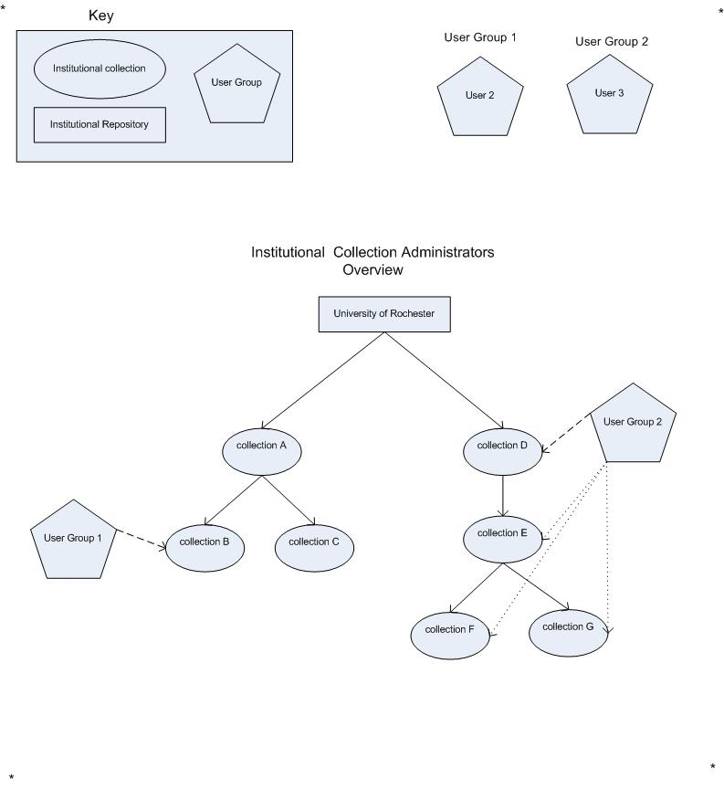
Figure 1.3
When this happens, User Group 2 will automatically be given administration privileges on all of Collection D’s children so here it is collections E, F and G.

If a new collection is added all groups with collection administrator privileges in parent collections will be given administration privileges on the child. Figure 1.4 shows the simple case where child H is added to collection F:
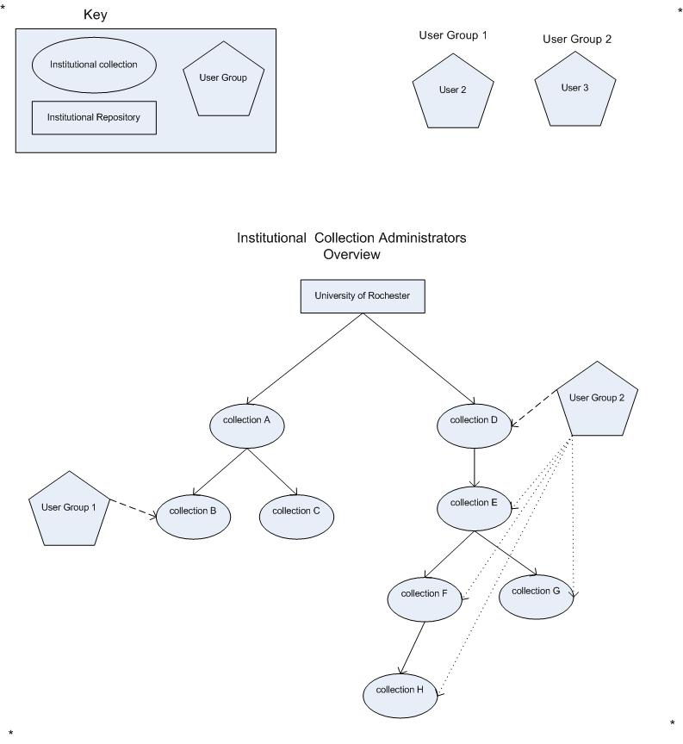
Figure 1.4
Here group two is automatically given Administration privileges on collection H.

Moving collections and administration privileges: Figure 1.5 shows what happens when an administrator moves an institutional collection. (Note: Collection administrators can move institutional collections but they must have permissions on both the collection being moved and the destination parent collection.).
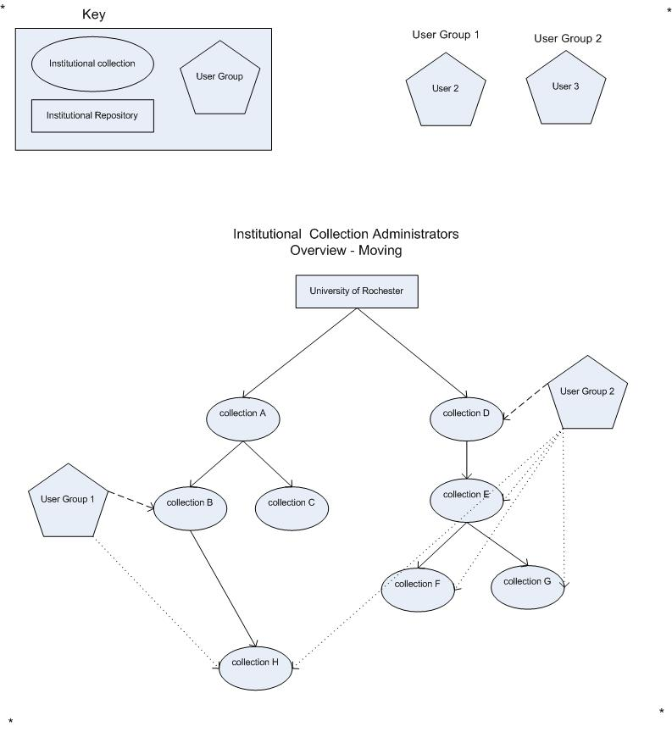
Figure 1.5
When a collection is moved all existing collection permissions are maintained also all groups that have administration privileges on the new parent are also given administration privileges to the existing child. So here User Group 1 is given administration privileges on collection H while User Group 2 retains permission on collection H.

  - Permissions for Files within Published Publication

Administrators will be able to change the view rights to individual files within a publication. The permission to view the file will first default to the parent published publication. If the publication is private, only users that can see the publication can see the files. Furthermore, if a file within the publication is marked private, only users within groups added to the view list of the file are allowed to see the file.

- Functional Requirements

FR-1: There will be a set of collections called “top level collections”. These are collections at the root of the repository. Only System Administrators will be able to create top level collections. These collections will have the virtual path (note beginning and trailing slashes):

/ {Repository name} / {Institutional collection name} /

FR-2: There will be no publications at the root of the repository

FR-3: Administrators will be able to see all publications in a collection

FR-4: Administrators will be able to withdraw a specific version of a publication or all versions of a publication

FR-5: Collections below the “top level collections” will have the following virtual path (note beginning and trailing slashes):

/ {Parent collection path} / {institutional collection name} /
Where parent collection path = /{Repository name} / {parent institutional collection name 1} /…
FR-6: Collections will be able to be moved from one collection to another. Collections will not be allowed to be moved into their own children.

FR-8: Collection administration will be cascading to child collections

FR-9: All other User Group permissions except for collection administration will NOT be cascading to child collections

FR-10: Institutional collections will have the following information:

Name | Description | Required
Collection Name | Name of the collection | Y
Collection Description | Description of the collection | N
Primary Collection Picture | Picture that will represent the collection – generally a logo | N
Set of secondary pictures | Set of pictures that can also be shown | N
Set of user groups | Groups that allow sets of permissions to be given to many users at once | N
Set of publications | Set of publications submitted to the collection | N
Publicly Viewable Flag | Indicates that the collection can be viewed by anyone – defaults to true – false indicates only select users will be able to view the collection | Y

FR-11: Publications in institutional collections will have the following virtual path (note NO trailing slash):

/ {parent collection path} / {publication title}

FR-12: Thumbnails of the primary collection picture and secondary pictures will be attempted to be created for all .png, .gif, .jpg, .tif and .tiff files.

FR-13: Administrators will be able to see all withdrawn publications for collections that they mange.

FR-14: Withdrawing a publication from a collection will not withdraw the publication from other collections this publication has been published into.

FR-15: Withdrawing a publication will capture the following information:
- Date withdrawn
- Reason for withdrawal
- Flag to indicate that metadata can be shown
- Flag to indicate if all versions should be withdrawn (otherwise only current version withdrawn)

FR-16: Administrators will be able to edit metadata of published items.

FR-18: If a collection is private, its children can still be public. Users will be able to navigate the tree through private collections to child collections. No items of a private collection will be visible.

FR-19: Reviewers will have a “reviewer location” which is a location to allow reviewers to deal with publications that need to be reviewed.

FR-21: Deleting an institutional collection will result in the following:

- All child collections will be deleted
- All versions of the publication will be deleted from the system if the following are true:
  - Version of publication does not exist in another collection
  - Version of publication does not exist in the user’s account

FR-22: Groups with administration privileges in parent collections will not be able to be removed from child collections.

FR-23: Groups will contain the following information

Name | Description | Required
Group Name | Name of the group – must be unique across all groups | Y
Collection Description | Description of the group | N
List of Members | List of users in the group | N
List of group administrators | Set of users who can administer the group | N

FR-24: A group name must be unique across all groups
FR-25: A group cannot be deleted if it attached to one or more collections
- Institutional Collection Management Use Cases

Id | User | Use Case Name | Priority
1400 |  | Create top level Institutional Collection
1401 |  | Create child collection
1402 |  | Edit an Institutional Collection
1403 |  | Move an Institutional Collection
1404 |  | Delete an Institutional Collection
1405 |  | Create user group
1406 |  | Delete user group
1407 |  | Add a user to a user group
1409 |  | Move a publication
1410 |  | Delete a publication
1411 |  | Withdraw a publication and all versions of that publication within a collection
1412 |  | Withdraw a specific version of a publication within a collection
1413 |  | Edit an institutional publication [No use case defined – see FR-16]
1414 |  | Remove a subscriber from an institutional collection
1415 |  | Add a subscriber to an institutional collection
1416 |  | Give a user group direct submit privileges for an institutional collection
1417 |  | Remove direct submit privileges from a user group for an institutional collection
1418 |  | Give reviewer privileges to a user group for an institutional collection [ see use case 1416 for example]
1419 |  | Remove reviewer privileges from a user group for an institutional collection [ see use case 1417 for example]
1420 |  | Make an institutional collection private
1421 |  | Give a user group review submit privileges on an institutional collection [ see use case 1416 for example]
1422 |  | Remove review submit privileges from a user group [see use case 1417 for example]
1423 |  | Re-Instate a withdrawn publication
1424 |  | Give user group collection administration rights to a group [see use case 1416 for example]
1425 |  | Remove collection administration rights from a user group [see use case 1417 for example]
1426 |  | Make a private institutional collection public
1427 |  | View all groups a user belongs to
1428 |  | Add an administrator to a user group – See 1407 for general example

Use Cases:

Id: | 1400
Name: | Create top level Institutional Collection
Primary Actor: | Administrator
Scope: | IR Plus
Level: | User Goal
Stakeholders and Interests: | Create top level collections for publishing into the system
Precondition: | User is an administrator
Minimal Guarantee: | Top level collection is created or user notified why top level collection could not be created
Success Guarantee: | Top level collection is created in the system
Main Success Scenario: | - Administrator selects Create New Collection at repository level of system  - Administrator enters required information [See FR-10]  - Administrator confirms creation  - Top level collection is created
Extensions: | - [step-3]Institutional collection with name already exists in as a top level collection  - Administrator notified collection name already exists  - The top level collection is not created

Id: | 1401
Name: | Create a child collection
Primary Actor: | Administrator or Collection Administrator
Scope: | IR Plus
Level: | User Goal
Stakeholders and Interests: | Create sub collections in the system
Precondition: | User is an administrator or has collection administrator rights
Minimal Guarantee: | Child collection is created or administrator notified why child collection could not be created
Success Guarantee: | Child collection is created in the system
Main Success Scenario: | - Administrator selects create new collection to add child to  - Administrator enters in required information [See FR-10]  - Administrator confirms creation  - Child collection is created  - All groups in parent collections with administration groups are assigned to the child collection
Extensions: | - [step-2]Child collection with name already exists in parent collection  - Administrator notified collection name already exists  - Child collection is not created

Id: | 1402
Name: | Edit an institutional collection
Primary Actor: | Administrator or Collection Administrator
Scope: | IR Plus
Level: | User Goal
Stakeholders and Interests: | Updated collection information in system
Precondition: | User is an administrator or has collection administrator rights
Minimal Guarantee: | Collection information updated or user notified why update could not occur.
Success Guarantee: | Collection information updated
Main Success Scenario: | - Administrator selects collection properties option  - Administrator updates collection information [See FR-10]  - Administrator confirms update  - Collection is updated
Extensions: | NOTE* - this use case is ambiguous – it will need to be broken out into editing each major aspect of the collection (Editing Groups, Editing Subscribers …)

Id: | 1403
Name: | Move an institutional collection
Primary Actor: | Administrator or Collection Administrator
Scope: | IR Plus
Level: | User Goal
Stakeholders and Interests: | Collection is moved to help with organization and system growth
Precondition: | User is an administrator or has collection administrator rights for all collections involved [parent destination collection and collection being moved]
Minimal Guarantee: | Institutional collection moved or administrator notified why collection cannot be moved
Success Guarantee: | Institutional collection moved
Main Success Scenario: | - Administrator selects collection to move  - Administrator selects move option  - Administrator selects destination collection  - Administrator confirms move  - Collection is moved  - If collection has groups – groups permissions checked – see section 1.2 Collection management
Extensions: | - [step 1] User does not have permissions to move collection  - Collection not moved  - [step 4] User does not have permissions on destination collection  - User notified they do not have permissions on destination collection  - Move not completed  - [step 4] Collection with same name already exists  - Collection not moved

Id: | 1404
Name: | Delete an institutional collection
Primary Actor: | Administrator or Collection Administrator
Scope: | IR Plus
Level: | User Goal
Stakeholders and Interests: | Allow for collections to be cleaned up or removed from the system
Precondition: | User is an administrator or has collection administrator rights on institutional collection
Minimal Guarantee: | Institutional collection deleted or administrator notified why collection cannot be deleted
Success Guarantee: | Institutional collection deleted
Main Success Scenario: | - Administrator selects collection to delete  - Administrator selects delete option  - Administrator confirms delete  - Collection and all children and all related information are deleted – see FR-21
Extensions: | - [step 2] User does not have permissions to delete collection  - Collection not deleted  - User notified they do not have delete permissions

Id: | 1405
Name: | Create a user group
Primary Actor: | Administrator or Collection Administrator
Scope: | IR Plus
Level: | User Goal
Stakeholders and Interests: | Allow for permissions to be assigned to a group of users
Precondition: | User has rights to create user group
Minimal Guarantee: | User group created or administrator notified they cannot create the user group
Success Guarantee: | User group created
Main Success Scenario: | - Administrator navigates to user groups area  - Administrator selects create user group option  - Administrator enters in user group name- se FR-23  - Administrator confirms create  - User group is created – user allowed to add/remove group members
Extensions: | - [step 2] Administrator does not have permissions to create group  - Group not created  - Administrator notified they do not have permissions to create the group  - [step 3] User group with name already exists for the selected collection/repository.  - Group not created  - User notified a group with that name already exists in the current collection/repository

Id: | 1406
Name: | Delete a user group
Primary Actor: | Administrator or Collection Administrator
Scope: | IR Plus
Level: | User Goal
Stakeholders and Interests: | Allow cleanup of user groups
Precondition: | User has rights to delete user group. User group has not been assigned permissions to any collections.
Minimal Guarantee: | User group deleted or administrator notified they cannot delete the user group
Success Guarantee: | User group deleted
Main Success Scenario: | - Administrator identifies group to delete  - Administrator selects delete user group option  - Administrator confirms delete  - User group is deleted
Extensions: | - [step 2] Administrator does not have permissions to delete group  - Group not deleted  - administrator notified they do not have delete abilities for this group  - [step 2] User group assigned permissions to a collection  - Administrator notified the user group cannot be deleted.

Id: | 1407
Name: | Add user to user group
Primary Actor: | Administrator or Collection Administrator
Scope: | IR Plus
Level: | User Goal
Stakeholders and Interests: | Allows for users to be assigned to group
Precondition: | User has rights to assign users to group
Minimal Guarantee: | User assigned to user group or administrator notified why user cannot be assigned to group
Success Guarantee: | User assigned to group
Main Success Scenario: | - Administrator selects group to add user to  - Administrator searches for a user  - Administrator selects add user option  - Administrator selects user to add to group  - Administrator confirms add  - User added to user group
Extensions: | - [step 3] User already added to group  - Administrator notified user already part of group  - [step 3] Administrator does not have permissions to manage this group  - Administrator notified they do not have permissions to manage the group

Id: | 1409
Name: | Move a publication
Primary Actor: | Administrator or Collection Administrator
Scope: | IR Plus
Level: | User Goal
Stakeholders and Interests: | Allow publications to be re-organized as system grows
Precondition: | Administrator has rights to both source and destination collections
Minimal Guarantee: | Publication is moved or administrator notified the publication cannot be moved
Success Guarantee: | Publication is moved
Main Success Scenario: | - Administrator selects publication to move  - Administrator selects location to move the publication to  - Administrator selects move option  - Publication is moved
Extensions: | - [step 3] Administrator does not have permissions to move the publication  - Administrator not allowed to move publication  - Administrator notified they do not have permissions to move the publication

Id: | 1410
Name: | Delete a publication
Primary Actor: | Administrator or Collection Administrator
Scope: | IR Plus
Level: | User Goal
Stakeholders and Interests: | Allow publications to be completely removed from the collection
Precondition: | Administrator has rights to delete the publication
Minimal Guarantee: | Publication is deleted or administrator notified the publication cannot be deleted
Success Guarantee: | Publication is deleted
Main Success Scenario: | - Administrator selects publication to delete  - Administrator selects delete option  - Administrator asked to confirm delete  - Publication is deleted from the collection (the publication is not removed from any other collections)  - A delete publication record is stored in the system
Extensions: | - [step 3] Administrator does not have permissions to delete the publication  - Administrator not allowed to delete publication  - Administrator notified they do not have permissions to delete the publication

Id: | 1411
Name: | Withdraw a publication and all versions within a collection
Primary Actor: | Administrator or Collection Administrator
Scope: | IR Plus
Level: | User Goal
Stakeholders and Interests: | Allow administrator to withdraw publications from the system
Precondition: | Administrator has rights to withdraw the publication
Minimal Guarantee: | Publication and all versions withdrawn or administrator notified the publication cannot be withdrawn
Success Guarantee: | Publication and all versions are withdrawn
Main Success Scenario: | - Administrator selects publication to withdraw  - Administrator selects withdraw option  - Administrator enters in withdrawn information - see FR-15  - Publication and all versions are withdrawn from the collection - FR-14
Extensions: | - [step 3] Administrator does not have permissions to withdraw the publication  - Administrator not allowed to withdraw publication  - Administrator notified they do not have permissions to withdraw the publication

Id: | 1412
Name: | Withdraw a specific version of a publication
Primary Actor: | Administrator or Collection Administrator
Scope: | IR Plus
Level: | User Goal
Stakeholders and Interests: | Allow administrator to withdraw a version of a publication from the system
Precondition: | Administrator has rights to withdraw the publication
Minimal Guarantee: | Specified version of publication withdrawn or administrator notified the publication cannot be withdrawn
Success Guarantee: | Version of publication is removed
Main Success Scenario: | - Administrator selects version of publication to withdraw  - Administrator selects withdraw option  - Administrator enters withdrawn information - see FR-15  - Selected version of publication is withdrawn from the collection- see FR-14
Extensions: | - [step 3] Administrator does not have permissions to withdraw the publication  - Administrator not allowed to withdraw publication  - Administrator notified they do not have permissions to withdraw the publication

Id: | 1414
Name: | Remove a subscriber from an institutional collection
Primary Actor: | Administrator or Collection Administrator
Scope: | IR Plus
Level: | User Goal
Stakeholders and Interests: | Allow administrator to unsubscribe a user who no longer wishes to receive emails for a particular collection
Precondition: | Administrator has rights to manage collection
Minimal Guarantee: | User unsubscribed or administrator notified why user cannot be unsubscribed
Success Guarantee: | User unsubscribed
Main Success Scenario: | - Administrator selects collection  - Administrator selects user to unsubscribe  - Administrator selects unsubscribe option  - Administrator asked to confirm unsubscribe  - User unsubscribed
Extensions: | - [step 4] Administrator cancels unsubscribe  - User is not unsubscribed

Id: | 1415
Name: | Add a subscriber to an institutional collection
Primary Actor: | Administrator or Collection Administrator
Scope: | IR Plus
Level: | User Goal
Stakeholders and Interests: | Allow administrator to subscribe a user who wishes to receive emails for a particular collection
Precondition: | Administrator has rights to manage collection
Minimal Guarantee: | User subscribed or administrator notified why user cannot be subscribed
Success Guarantee: | User subscribed
Main Success Scenario: | - Administrator selects collection  - Administrator searches for user to subscribe  - Administrator selects user to subscribe  - Administrator selects subscribe  - User subscribed
Extensions: | - [step 4] Administrator cancels subscribe  - User is not subscribed  - [step 4] Collection is private and user does not have view privileges  - User is not subscribed  - Administrator notified collection is not viewable to user  - [step 3] User already subscribed  - Administrator notified user already subscribed

Id: | 1416
Name: | Give a user group direct submit privileges to an institutional collection
Primary Actor: | Administrator or Collection Administrator
Scope: | IR Plus
Level: | User Goal
Stakeholders and Interests: | Allow administrator to give a user or users direct submit privileges
Precondition: | Administrator has rights to manage collection
Minimal Guarantee: | User group given direct submit privileges or administrator notified why user group cannot be given direct submit privileges
Success Guarantee: | User group given direct submit privileges
Main Success Scenario: | - Administrator searches for group to give direct submit privileges to  - Administrator selects user group to give direct submit privileges to  - Administrator adds user group to collection  - Administrator gives user group direct submit privileges to collection  - User group given direct submit privileges
Extensions: | - [step 3] Administrator cancels add of user group  - User group not added to collection

Id: | 1417
Name: | Remove direct submit privileges on an institutional collection from a user group
Primary Actor: | Administrator or Collection Administrator
Scope: | IR Plus
Level: | User Goal
Stakeholders and Interests: | Allow administrator to remove direct submit privileges from a user or set of users
Precondition: | Administrator has rights to manage collection
Minimal Guarantee: | User’s direct submit privileges are removed or administrator notified why privileges cannot be removed
Success Guarantee: | User groups submit privileges removed
Main Success Scenario: | - Administrator searches collection for user group to remove direct submit privileges from  - Administrator selects user group to remove from the direct submit group  - Administrator removes direct submit privileges from user group

Id: | 1423
Name: | Reinstate a withdrawn publication
Primary Actor: | Administrator or Collection Administrator
Scope: | IR Plus
Level: | User Goal
Stakeholders and Interests: | Allow administrator to reinstate a withdrawn publication
Precondition: | Administrator has rights to manage collection
Minimal Guarantee: | Withdrawn publication is made public again
Success Guarantee: | Withdrawn publication reinstated
Main Success Scenario: | - Administrator searches for withdrawn publication  - Administrator selects withdrawn publication  - Administrator selects Reinstate option  - Withdrawn publication is reinstated  - User who reinstated the publication and date are stored

Id: | 1426
Name: | Make a public institutional collection private
Primary Actor: | Administrator or Collection Administrator
Scope: | IR Plus
Level: | User Goal
Stakeholders and Interests: | Allow administrators to make an institutional collection private
Precondition: | Administrator has rights to manage collection
Minimal Guarantee: | Institutional collection made private or administrator notified why collection cannot be made private.
Success Guarantee: | Collection made private
Main Success Scenario: | - Administrator selects collection  - Administrator selects make private option  - Administrator prompted that:  - All submitters, reviewers and administrators will continue to have view permissions  - All collection subscribers that are not in the above group will be removed  - Administrator confirms make private option  - Collection made private

Id: | 1427
Name: | View all groups a user belongs to
Primary Actor: | Administrator or Collection Administrator
Scope: | IR Plus
Level: | User Goal
Stakeholders and Interests: | Allow administrators to identify all groups a user belongs to
Precondition: | Administrator has rights to manage collection
Minimal Guarantee: | Administrator able to view users permissions on the collection
Success Guarantee: | [See Minimal Guarantee]
Main Success Scenario: | - Administrator selects user  - Administrator selects groups tab  - All groups for the user is displayed

