UR Research Statistics Capture and Display Functional Requirements Specification

Updated By | Updated Date | Version
Nathan Sarr  Sharmila Ranaganathan | 7/1/2008 | 1.0

- Statistics Capture and Display

  - General Overview

Statistics will be used throughout the system to determine the usage and size of different aspects of the system

General overview of repository with collections (Figure 1.1):

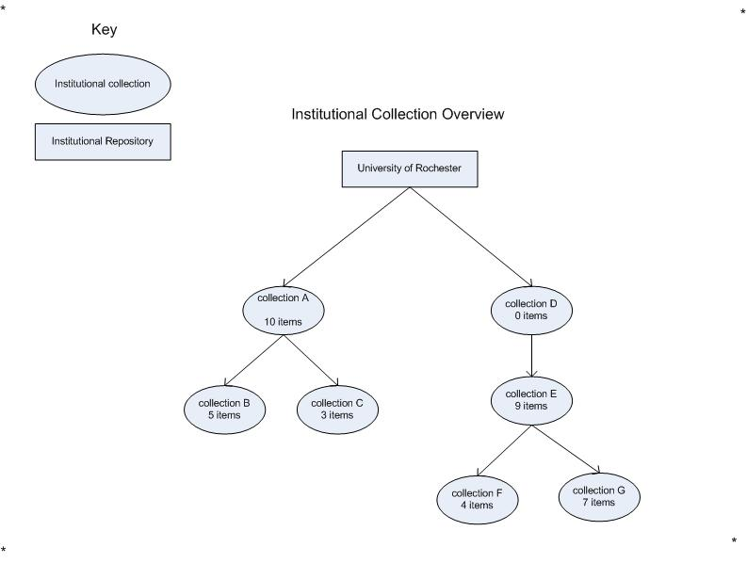
The above shows the institutional repository called “University of Rochester” with seven institutional collections. Collections will be in a tree format. Collections A and D are referred to as “top level” collections. Collections B and C are sub-collections (children) of collection A. Collection E is a sub collection of Collection D and collections F and G are sub-collections of Collection E. Collections E, F and G can all be referred to as children of Collection D. The above will be used to help with conveying how statistics information will be counted.

Collection A has 10 direct items
Collection B has 5 direct items
Collection C has 3 direct items
Collection D has 0 direct items
Collection E has 9 direct items
Collection F has 4 direct items
Collection G has 7 direct items

  - Counting Items

FR-1 There will be a count for all items within the repository.

The system will display the count of items in two different ways for collection trees.
FR-2 One count will be only for the items directly added to the collection so the following counts would be true:
Collection A has 10 direct items
Collection B has 5 direct items
Collection C has 3 direct items
Collection D has 0 direct items
Collection E has 9 direct items
Collection F has 4 direct items
Collection G has 7 direct items

FR – 3 The system will also display counts for all items including items within children collections – so the following is true:
Collection A = A (10) + B (5) + C (3) or 18 items
Collection B = B (5) items (no children)
Collection C = C (3) items (no children)
Collection D = D (0) + E (9) + F (4) + G (7) or 20 items
Collection E = E (9) + F (4) + G (7) or 20 items
Collection F = F (4) items (no children)
Collection G = G (7) items (no children)

FR-4 If an item exists more than once within a collection tree, that item will only be counted once.

  - Counting File Downloads

FR-6 File downloads will be counted on an IP-address per day count.

This means if file X is downloaded 5 times by IP-address Z on date D there will be a way to retrieve the fact that IP-address Z downloaded file X 5 times on date D.

FR-7: File downloads will act the same as item counts – there will be two ways to count them:

- Including and excluding download counts of files in items of child collections
- If the same file is referenced twice within a collection tree the counts for that download file will only be counted once.

IP-addresses will be stored in its full form and also split out into its 4 different octet values stored as a decimal number for range calculations.

  - Ignoring and normalizing un-wanted file download counts

FR-8: There will be a way to ignore unwanted counts by ip-address. This could be set up by creating an IP-address ignore table.

FR-9: There will be a way to ignore unwanted counts by ip-address ranges

FR-10: There will be a way to add ignored counts back into the system.

FR-11: There will be a way to view downloaded counts for ip-addresses

  - Counting collections

FR-12: There will be a way to count the number of collections in the repository.

