IR Plus Personal Publishing Functional Requirements Specification

Updated By | Updated Date | Version
Nathan Sarr  Sharmila Ranaganathan | 1/1/2007 | 1.0
Nathan Sarr | 1/1/2008 | 1.1

Publication areas General Description:

Note: This covers general publications. This does not cover ETD submissions. This will have a separate set of requirements due to its special cases. See publishing ETD Requirements and Use cases.
Publication (Definition): A publication is considered a set of metadata plus an optional set of zero or more of files.

The primary function of this area will be to allow users to have a workspace to manage and create publications they wish to publish and store in the system. Collections will be the conceptual containers of publications (just like folders are the organizational mechanism for files).
There are two areas where publications will live.
- Personal Collections – This is much like a personal folder and it is an area for someone to organize their publications. Users will have full control over this area.

- Institutional Collections – These are collections maintained and controlled by the University. Once a publication is submitted and accepted into one of these collections the user will have no control over withdrawing/deleting/editing publications in these locations except in some unique circumstances [see publishing use cases].

Publications not placed in an institutional collection will be referred to as “pending publications” (or they are in the pending state). Publications accepted into an institutional collection will be referred to as a “published publication” (or they are in the published state). Publications submitted to an Institutional collection but not moved directly into an institutional collection will be in the “reviewing” state. Publications can also be “withdrawn” formerly known as “tomb stoned”. This is a published publication that the author has requested be removed from the institutional collection or collections and this request has been approved and carried out by an administrator of the institutional collection or collections within which this publication existed.

The following metadata (figure 1.1) can be associated with a publication:
(Table Heading Key)
Name = name of the field
Description = description of the field
Rep = repeatable according to the IR Plus System
Mand = Mandatory according to IR Plus System.
Dublin Core Identifier = identifier used as Dublin core field [N/A indicates not part of the Dublin core standard]

Publication Metadata (Figure 1.1)
Name | Description | Rep | Mand | Dublin Core identifier
Title | The title or name used to identify the publication | Yes | Yes | dc.title
Author/Contributors | All people who have made some type of contribution to a publication. This can include the author, a thesis advisor, illustrator, etc. | Yes | Yes | dc.creator
Series/Report number | The series the publication belongs to and it’s report number. A publication can belong to more than one series. | Yes | No | dc.relation.ispartofseries
Identifiers | A unique numeric or alphanumeric code used for identifying the publication for example an ISBN, ISSN, handle etc. | Yes | No | dc.identifier
Language | The language the publication was written in. | Yes | Yes | dc.language
Subject Key Words | Subject words used to describe the publication. | Yes | No | dc.subject
Abstract | The abstract of the publication | Yes | No | dc.description.abstract
Sponsors | One or more people or groups who sponsored the development or creation of the publication. | Yes | No | dc.description.sponsorship
Description | Short description of the publication. | No | No | dc.description
Links | URLs that link to information that relates to the publication. | Yes | No | N/A
Citation | For book includes author, title, publisher and year of publication while a journal citation includes author, article title and periodical title, date, volume and page numbers. | No | No | dc.identifier.citation
Repository License | The license agreed to by the user that gives the institution the right to manage the publication [This is only for published items] | No | Yes | N/A
Publisher | The publisher of the publication if it has been previously published | No [DC allows repeatable] | No | dc.publisher
Date Published | used if the publication has been previously published by a publisher | No | No | N/A
Date of Deposit | Date the publication was added to the IR Plus system. This is managed internally and not added by the user | No | Yes | N/A
Date First Made Available to Public | The first time the publication was shown or presented to the public. For example the publication was presented to the public at a conference. | No | No | N/A
Release Date | Date this publication can be made available to the public through the IR Plus system. This will be used to prevent publications from being made public in the IR Plus system until a specified date. | No | Yes | N/A
Version | The version of the publication in the IR Plus System | Yes | Yes | N/A
Submitter | User who submitted the publication | No | Yes | N/A
Reviewer | User who reviewed and approved the publication if a review is required before submission. | No | Yes – if no review submitter name used | N/A
Content Type | The type of content contained within the publication | Yes | Yes | dc.type
Extent Type | Pagination and other information | Yes | No | dc.format.extent

Understanding the general flow of publishing:

Below is a picture of a user who has uploaded two documents with several versions of each document:
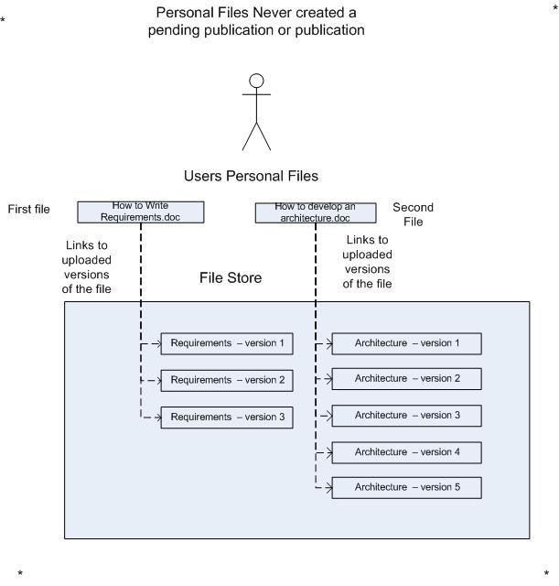
Once the user is happy with their content they will be able to publish their documents into the system. The following is a picture of the user selecting the most recent versions of their personal and creating a pending publication. The pending publication is accepted into the software engineering collection making it a published publication and setting it as version one:
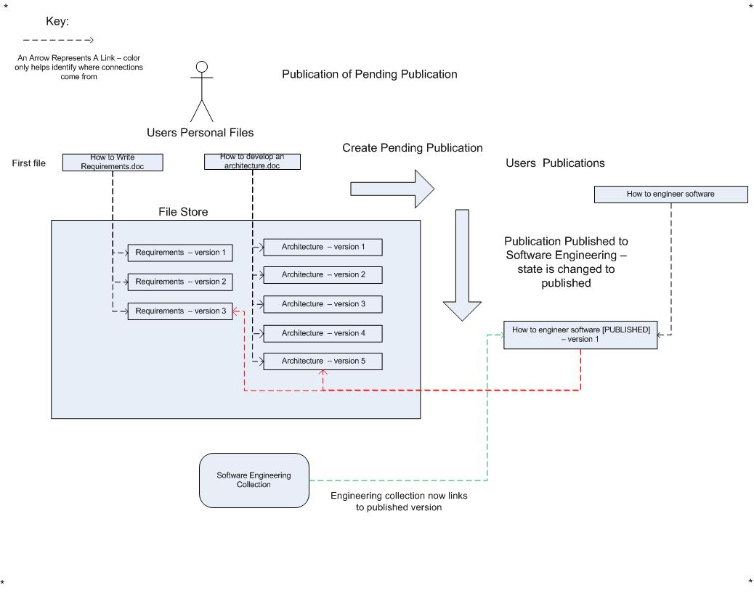

If at some point the publication needs to be updated with new files, the following displays the new relations ship:
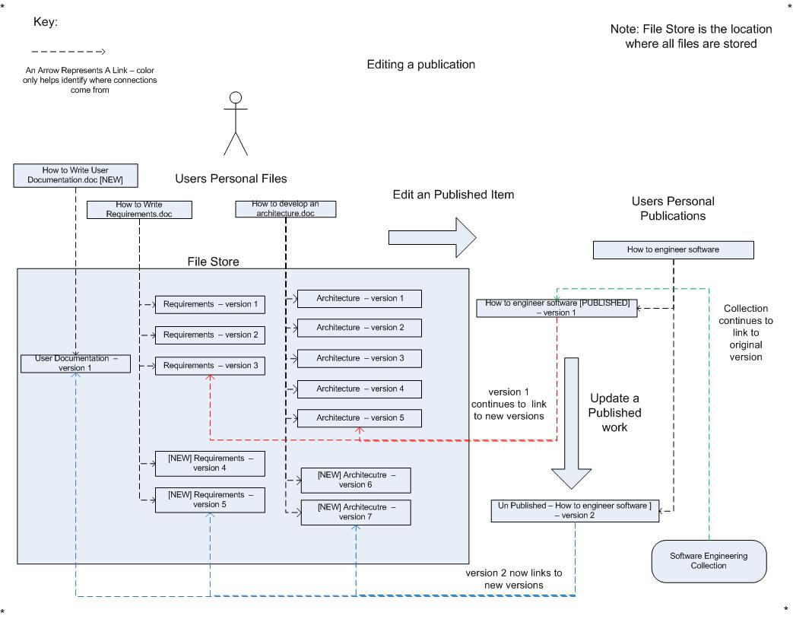
Notice that the new version is not directly added to the software engineering collection. The new version must be explicitly published by the user as a new version. The user can choose to never publish this new version as well as publish this new version to other institutional collections without updating the version (Version 1) in the software engineering collection.

Functional Requirements:

FR-1: The user will have a root personal collection location in the format: /My Publications/. This will be called the root collection. Publications will be allowed to be created in the root location. Personal Collections will be allowed to be added to the root location.

FR-2: The user who submits the publication will be considered the owner of the publication even if they ARE NOT the Author/primary creator.
FR-3: The following represents the abilities on pending publications

Permission Name
 | Owner
Read | X
Remove File | X
Add File | X
Edit Metadata | X
Change File View Permissions | X

FR-4: The following represents the abilities on pending publications being reviewed

Permission Name
 | Owner | Reviewer
Read |  | X
Remove File
Add File
Edit Metadata |  | X
Change File View Permissions
Delete

The above shows that the owner of the pending publications will not be able to edit the pending publication while it is under review.

FR-5: The following represents the permissions that can be assigned to the files within the publication. This is needed to protect original modifiable copies of files that must be preserved but should not be available to the general public.

Permission Name
Name | Description
Publicly Viewable | All users can view this file
Select User Viewable | Only selected registered users can view the file – collection administrators and administrators will always be able to see this file. Users will only be able to mark this as private – administrators will determine viewership.

FR-6: The user will be able to create an unlimited number of personal collections and sub-collections. However for system performance it will be assumed that users will not create folder structures much deeper than [TBD] levels.

FR-7: Publications WILL be allowed to have the same name within a personal collection and institutional collection. Publications will be compared by their internal system identifier.

FR-8: Deleting a publication from a personal collection will be allowed at any point in time. This will remove the publication from the personal collection but it will NOT remove it from any locations where the publication has been published to [Published publication]. These following two areas have been identified as indicating a published Publication:
Researcher Page
Institutional Collection

FR-9: If a pending publication has been deleted and the file in the pending publication does not exist on the researcher page, in the user’s personal files and folders, or another publication, that file is permanently removed from the system.

FR-10: Once a pending publication has been submitted and accepted into an institutional collection, any changes to that publication will result in a new version of that publication being created. The originally published version will remain unchanged in the published areas. If the user wishes to update a published publication the user will be required to request the new version replace the existing publication with the following options:
- Leave the previously published version viewable
- Withdraw the previously published version

FR-11: If the publication contains one or more images in the format [.jpg, .tiff, .png, .gif] the user will be allowed to select the primary image. This image will be thumb nailed and displayed next to the item as a representation of the item.

FR-12: Users will be able to search for personal collections. The search will be a full text across the following information:

- Personal Collection Name

- Personal Collection Description

The search will be case insensitive and operate on like a user entered the search followed by a [*] Meaning a search for a folder named Test will include Test, Testing, Tested …

FR-13: Users will be able to search for publications in their personal collections. The following information will be searched:

- All Collection metadata [See collection metadata table figure 1.1]

FR-14: Publications can be published into one or more collections.

(* Note for more on withdrawing a publication see IR Plus Repository and Institutional Collection Administration Functional Requirements Specification)

FR-16: Publications can be placed into institutional collections in one of two ways:
- The user has “direct submit” privileges and they are allowed to place a publication directly into the specified collection

- The user has “review submit” privileges which mean the submitted publication must first be reviewed and approved by a “reviewer” for entry into the institutional collection.

[See Institutional Collection Administration Functional Requirements and Use Cases about privileges for assigning submit privileges to users]

FR-17: Personal collections will not be able to be moved into their own child Personal collections.

FR-18: Institutional collections will not be able to be moved into their own child Institutional collections

FR-19 NAME AUTHORITY GOES HERE

Personal Collection Management Use Cases
Id | User | Use Case Name | Priority
900 (A-C) |  | (A)Create/(B)Re-Name/(C)Delete Personal Collections (s) | High
901 |  | Move a personal collection and all contents within it | High
902 |  | Search for a personal collection – SEE Functional Requirement FR-12 | High

User Publication Management Use Cases
Id | User | Use Case Name | Priority
1000 |  | Create a new publication | High
1001 |  | Edit an unpublished publication | High
1002 |  | Edit a published publication in Personal Collection | High
1003 |  | Edit a Published publication – not in Personal Collection – because user has removed it from personal collection | High
1004 |  | Delete a publication in personal collections (Published/Unpublished) | High
1005 |  | Request to have a published publication withdrawn | High
1006 |  | Review of a publication to be submitted to an institutional collection (Accepted no modification/ Accepted modification / Rejected) | High
1007 |  | Request to have pending publication metadata be completed by Metadata expert | Low
1008 |  | Metadata of published publication updated by Metadata expert [Librarian] | High

Use Cases:

Id: | 900-A
Name: | Create a new personal collection
Primary Actor: | Internal User
Scope: | IR Plus
Level: | User Goal
Stakeholders and Interests: | Organize publications
Precondition: | User has permission to create personal collection in the system
Minimal Guarantee: | Personal collection is created or user notified why the personal collection cannot be created
Success Guarantee: | Personal collection is created in the system  - The collection has a name  - The collection has a created date
Main Success Scenario: | - User selects location to create the personal collection  - User selects new personal collection option  - User enters the name of the personal collection  - A description will be optional  - User selects confirm option  - Personal collection is created in the specified location
Extensions: | - [step-4]Personal collection with name already exists in specified location  - User is notified the personal collection name already exists.  - The personal collection is not created

Id: | 900-B
Name: | Delete a personal collection
Primary Actor: | Internal User
Scope: | IR Plus
Level: | User Goal
Stakeholders and Interests: | Organize/Clean up view of publications
Precondition: | User has permission to create publications in the system
Minimal Guarantee: | Personal collection is deleted
Success Guarantee: | [See Minimal Guarantee]
Main Success Scenario: | - User selects the personal collection to delete  - User selects delete personal collection option  - User asked to confirm delete  - Personal collection and all its contents are deleted from the specified location [Sub-Collections and publications]  - [Note] See publication use case 1004 for description of how publications are deleted from system.
Extensions: | - [Step-3] user cancels delete  - Personal collection is not deleted

Id: | 900-C
Name: | Re-name a personal collection
Primary Actor: | Internal User
Scope: | IR Plus
Level: | User Goal
Stakeholders and Interests: | Organize publications
Precondition: | User has permission to create publications in the system
Minimal Guarantee: | Personal collection is renamed or user is notified why the personal collection cannot be created
Success Guarantee: | Personal collection is renamed
Main Success Scenario: | - User selects the personal collection to rename  - User selects edit personal collection option  - User enters new name of the personal collection  - User selects confirm option  - Personal collection is renamed
Extensions: | - [Step-4]Personal collection with name already exists in specified location  - User is notified the name already exists.  - The personal collection is not renamed  - User given option to choose new name

Id: | 901
Name: | Move a personal collection
Primary Actor: | Internal User
Scope: | IR Plus
Level: | User Goal
Stakeholders and Interests: | Organize publications
Precondition: | User has permission to create publications in the system
Minimal Guarantee: | Personal collection is moved or user is notified why the personal collection cannot be moved
Success Guarantee: | Personal collection is moved
Main Success Scenario: | - User selects the personal collection to move  - User selects move option  - User selects location to move the personal collection to  - User confirms move  - Personal collection and all contents within the personal collection are moved to the selected location
Extensions: | - [Step 4]Personal collection with name already exists in specified location  - User is notified the personal collection name already exists in the specified location.  - The personal collection is not moved

Id: | 902
Name: | Search personal collections
Primary Actor: | Internal User
Scope: | IR Plus
Level: | User Goal
Stakeholders and Interests: | Find personal collections
Precondition: | User has permission to create personal collection in the system
Minimal Guarantee: | Personal collections are searched
Success Guarantee: | Personal collections are searched
Main Success Scenario: | - User enters search criteria  - User selects search option  - All personal collections matching the search criteria are returned  - User will have the option to select the identified matches  - User will be brought to a view displaying the personal collection
Extensions:

Id: | 1000
Name: | Create a publication
Primary Actor: | Internal User
Scope: | IR Plus
Level: | User Goal
Stakeholders and Interests: | Create a publication to be published into the system
Precondition: | User has ability to publish a publication
Minimal Guarantee: | Publication is created or the user is notified why the publication cannot be created [ or not given option ]
Success Guarantee: | Publication is created
Main Success Scenario: | - User selects create publication option  - Optionally allowed to pre-select files that are part of the publication  - Selecting a folder will select all files within the folder and subfolder  - User prompted to enter the name of the publication and personal collection in which to place the publication  - User allowed to add more files to the publication  - User enters metadata for the publication  - User selects institutional collections to submit the publication to  - User accepts repository license agreement  - Publication published to selected collections
Extensions: | - [Step-1] user is not owner of the file but instead the file is shared by a different user who is the owner  - User is notified that only files that they are the owner of can be published [this is due to delete rules]  - [Steps 3, 4, 5, 6,] User given option to save and finish later  - [Step-5] User does not have submit privileges to the collection  - User notified that they do not have submit privileges to the institutional collection  - Publication is not sent to institutional collection  - [Step-6] User does not accept license agreement  - The publication is not submitted to any institutional collections  - [Step-7] User only has “Submit Review” [See FR-16] for certain institutional collections  - Publication for those collections are placed in review state  - If rejected user is notified that publication was rejected for the institutional collection and reason for the rejection  - If accepted user is notified the publication was accepted into the institutional collection

Id: | 1001
Name: | Edit an pending publication
Primary Actor: | Internal User
Scope: | IR Plus
Level: | User Goal
Stakeholders and Interests: | User has not yet published the publication and must be able to update a publication in the system [ This means they previously selected the save and finish later option – see use case 1000]
Precondition: | User has ability to publish a publication
Minimal Guarantee: | Publication is updated
Success Guarantee: | [Same as minimal Guarantee]
Main Success Scenario: | - User selects publication to edit  - [See steps 2-7 of create publication use case 1000]
Extensions:

Id: | 1002
Name: | Edit a publication (Published) - from personal collections
Primary Actor: | Internal User
Scope: | IR Plus
Level: | User Goal
Stakeholders and Interests: | Be able to update a publication in the system
Precondition: | User has ability to publish a publication
Minimal Guarantee: | Publication is updated and a new version is created
Success Guarantee: | [See Minimal Guarantee]
Main Success Scenario: | - User selects publication to edit  - User selects edit publication option  - User notified this publication has been published and a new version will be created.  - A NEW VERSION of the publication is created  - User edits publication  - User selects update published version option  - User shown collections where the published version exists and the current version in each collection.  - User selects collections to update with new version  - User selects confirm option  - User made to accept repository license agreement  - Collections updated with new version of publication
Extensions: | - [Step-10] Accept but User does not have direct submit privileges  - Submission goes under review  - [Step-10] User does not accept repository license agreement  - Submission not sent to review or added to institutional collection

Id: | 1003
Name: | Edit a publication (Published) - from collection page – not in Personal Collection – user has deleted it from personal collection
Primary Actor: | Internal User
Scope: | IR Plus
Level: | User Goal
Stakeholders and Interests: | Be able to update a publication in the system
Precondition: | User has ability to publish a publication – user owner of publication
Minimal Guarantee: | Publication is updated and a new version is created
Success Guarantee: | [See Minimal Guarantee]
Main Success Scenario: | - User finds publication to edit in a collection  - User selects update publication option  - Publication along with its version tree is copied into their personal publications.  - [See steps 4-11 of edit publication use case (1002 – in Personal Collection)]
Extensions:

Id: | 1004
Name: | Delete a publication in a personal collection
Primary Actor: | Internal User
Scope: | IR Plus
Level: | User Goal
Stakeholders and Interests: | Be able to clean up personal publishing area
Precondition: | Publication exists in personal publishing area
Minimal Guarantee: | Publication is deleted from personal publication area
Success Guarantee: | [See Minimal Guarantee]
Main Success Scenario: | - User selects publication to delete  - User selects delete publication option  - User asked to confirm – if publication has been published they are notified this will not be removed from collections this publication has been added to  - Publication removed from personal publishing area
Extensions:

Id: | 1005
Name: | Request to have a published publication withdrawn
Primary Actor: | Internal User
Scope: | IR Plus
Level: | User Goal
Stakeholders and Interests: | Be able to suppress material authors/administrators feel are inappropriate or do not want publicly available
Precondition: | Publication exists in institutional collection
Minimal Guarantee: | Publication is withdrawn from public view or user notified why the publication will not be withdrawn
Success Guarantee: | [See Minimal Guarantee]
Main Success Scenario: | - User sends email to administrator  - User notified by email response from administrator  - See administration use cases
Extensions:

Id: | 1006
Name: | Review of a publication to be submitted to an institutional collection
Primary Actor: | Internal User
Scope: | IR Plus
Level: | Reviewer
Stakeholders and Interests: | Allow administrators to control information that is allowed into an institutional collection
Precondition: | User has submitted a publication to be reviewed
Minimal Guarantee: | Publication is accepted or reviewer sends user notification of rejection
Success Guarantee: | Publication is accepted
Main Success Scenario: | - Reviewer selects publication to review  - Reviewer allowed to edit metadata [The reviewer is NOT allowed to add/remove files]  - Reviewer accepts publication  - Publication added to institutional collection  - User notified of acceptance [email/note in system?]
Extensions: | - [Step-3] reviewer rejects publication  - Reviewer enters rejection reason  - User notified of rejection

Id: | 1007
Name: | Request to have pending publication metadata be completed by Metadata expert
Primary Actor: | Internal User
Scope: | IR Plus
Level: | User
Stakeholders and Interests: | Users do not want to fill in the metadata or would rather someone else handle this
Precondition: | User has submitted a pending publication to have metadata reviewed
Minimal Guarantee: | Metadata is updated
Success Guarantee: | [See Minimal Guarantee]
Main Success Scenario: | - User selects publication to have metadata reviewed  - User selects metadata expert to review/enter metadata  - User selects confirm option  - Publication is sent to metadata expert  - Publication updated by metadata expert  - Publication sent back to user
Extensions:

Id: | 1008
Name: | Metadata of published publication updated by Metadata expert [Librarian]
Primary Actor: | Librarian
Scope: | IR Plus
Level: | Internal Librarian User
Stakeholders and Interests: | Librarian wants to maintain metadata integrity within the system
Precondition: | Publication exists in an Institutional Collection
Minimal Guarantee: | Metadata is updated
Success Guarantee: | [See Minimal Guarantee]
Main Success Scenario: | - Librarian selects publication in institutional collection to edit metadata  - Librarian selects edit metadata option  - Librarian edits metadata  - Librarian selects save option  - Metadata saved
Extensions: | - [Step-4] Librarian cancels edits  - No changes made

