***12th Annual Conference --- Rochester NY Chesterton Society***

***presents:*** A fresh look at GK Chesterton's **"The Ethics of Elfland"**

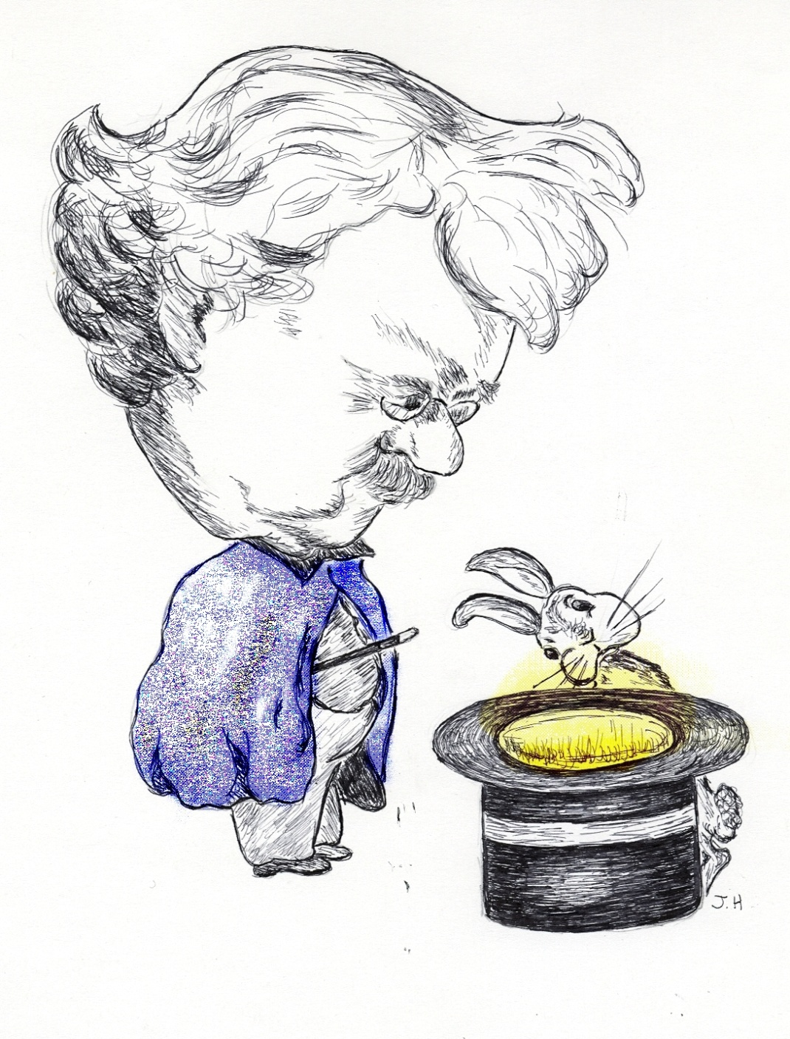**More than Magic**

with speakers **Dale Ahlquist,** American Chesterton Society **• Joseph Pearce,** Author **•   
Kevin O'Brien,** Theatre of the Word, Incorporated **• James Warren,** Author and ... well...Magician!

**St. John Fisher College**

Coleman Chapel, Murphy Hall

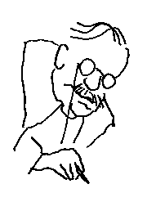**Sat. Sept. 26, 2015  
9 am to 3:30 pm**

**Donation**: $10.  **Free to students.** Lunch available at nominal cost.

*Funded by the Basilian Fathers of St. John Fisher College.   
With support from members of the Rochester NY Chesterton Society and from the St. Irenaeus Ministries.*

*For questions, email* rochesterton@hotmail.com *© 2015 Rochester NY Chesterton Society*