the Rochester NY Chesterton SocietY presents
The 18th Annual fr. leo hetzler conference

Faith of Our Fathers

Tumultuous History of the Church in England

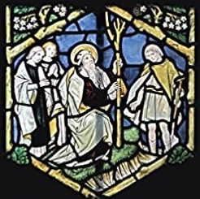
Joseph Pearce, Author
Dale Ahlquist, Society of GK Chesterton
Dr. RJ Stansbury, Roberts Wesleyan University
Ted Janiszewski, St. Irenaeus Ministries

Saturday, November 12th, 2022
9 am – 3:30 pm

St. John Fisher College, Rochester NY

Donation: $20. Free to students. Lunch available at nominal cost.

Funded by the Basilian Fathers of St. John Fisher College.
With support from members of the Rochester NY Chesterton Society and from the St. Irenaeus Ministries.
For questions, email rochesterton@hotmail.com

