13th Annual Conference --- Rochester NY Chesterton Society
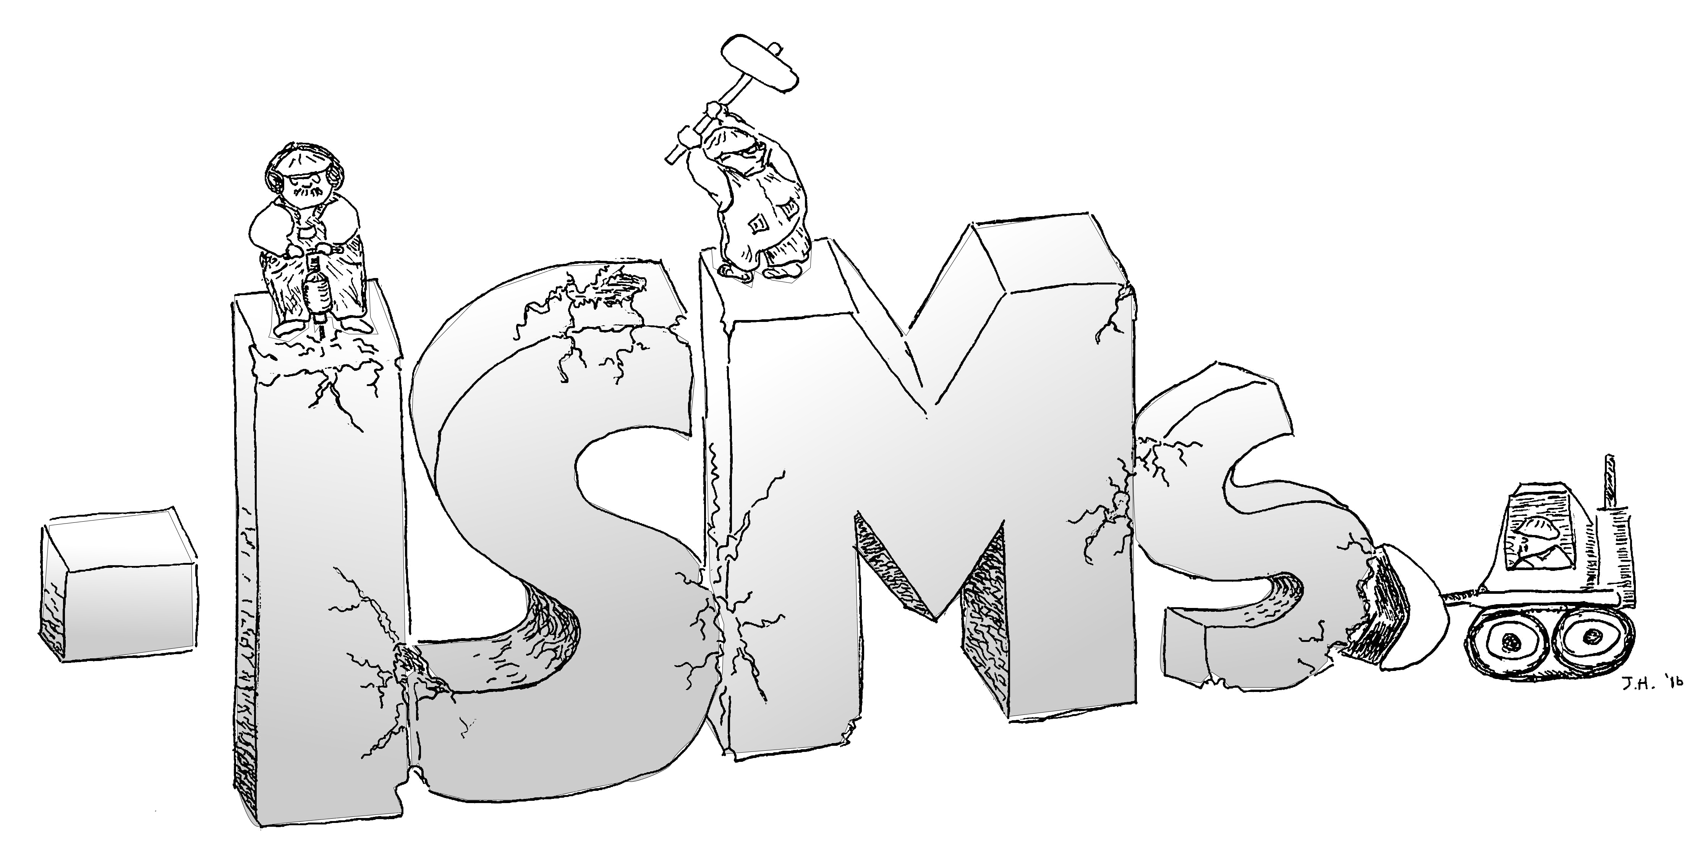
Relativism Materialism Scientism Sensationalism Freudianism , Puritanism, Nihilism Spiritualism
Marxism Atheism Modernism logical positivism
Arianism Minimifidianism Racism Progressivism
Deism Existentialism Satanism
Rationalism Communism
Sexism Clericalism
Socialism Anti-clericalism
Intellect- Nominalism
ualism Capitalism

Hedonism
Causalism Determinism Dualism
Fatalism Egoism Ignorantism Primitivism
Pyrrhonism Solfidianism Psychism Pantheism
...a Chestertonian look at what surrounds us...

with speakers Dale Ahlquist, American Chesterton Society • Joseph Pearce, Author •
Dr. Tom Martin University of Nebraska • Dr. RJ Stansbury, Roberts Wesleyan University

St. John Fisher College
Coleman Chapel, Murphy Hall
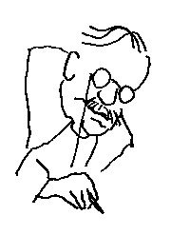
Sat. Sept. 24, 2016
9 am to 3:30 pm
Donation: $10. Free to students. Lunch available at nominal cost.
Funded by the Basilian Fathers of St. John Fisher College.
With support from members of the Rochester NY Chesterton Society and from the St. Irenaeus Ministries.
For questions, email rochesterton@hotmail.com © 2016 Rochester NY Chesterton Society

