Rochester NY Chesterton Society
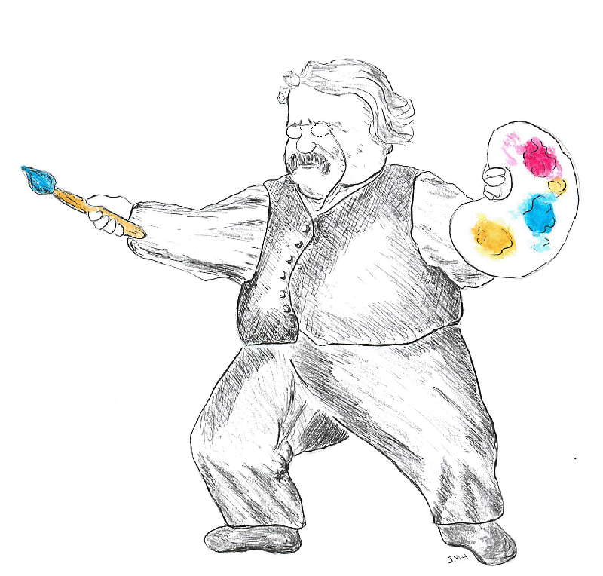
8th Annual Conference

Transforming
the Culture

“Art is the signature of man.”
-- GK Chesterton

Joseph Pearce, Author • Kevin O’Brien, Theater of the Word, Inc.
Dale Ahlquist, Am. Chesterton Society • Dr. Tom Martin, Philosophy, U. Nebraska

Saturday, October 1st, 2011
9 am – 3:30 pm

St. John Fisher College, Coleman Chapel, Murphy Hall

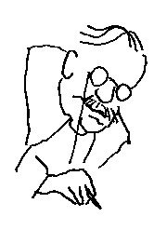
Donation: $10. Free to students. Lunch available at nominal cost.

Funded by the Basilian Fathers of St. John Fisher College.
With support from members of the Rochester NY Chesterton Society and from the St. Irenaeus Center.
For questions, email rochesterton@hotmail.com

© 2011 Rochester NY Chesterton Society

