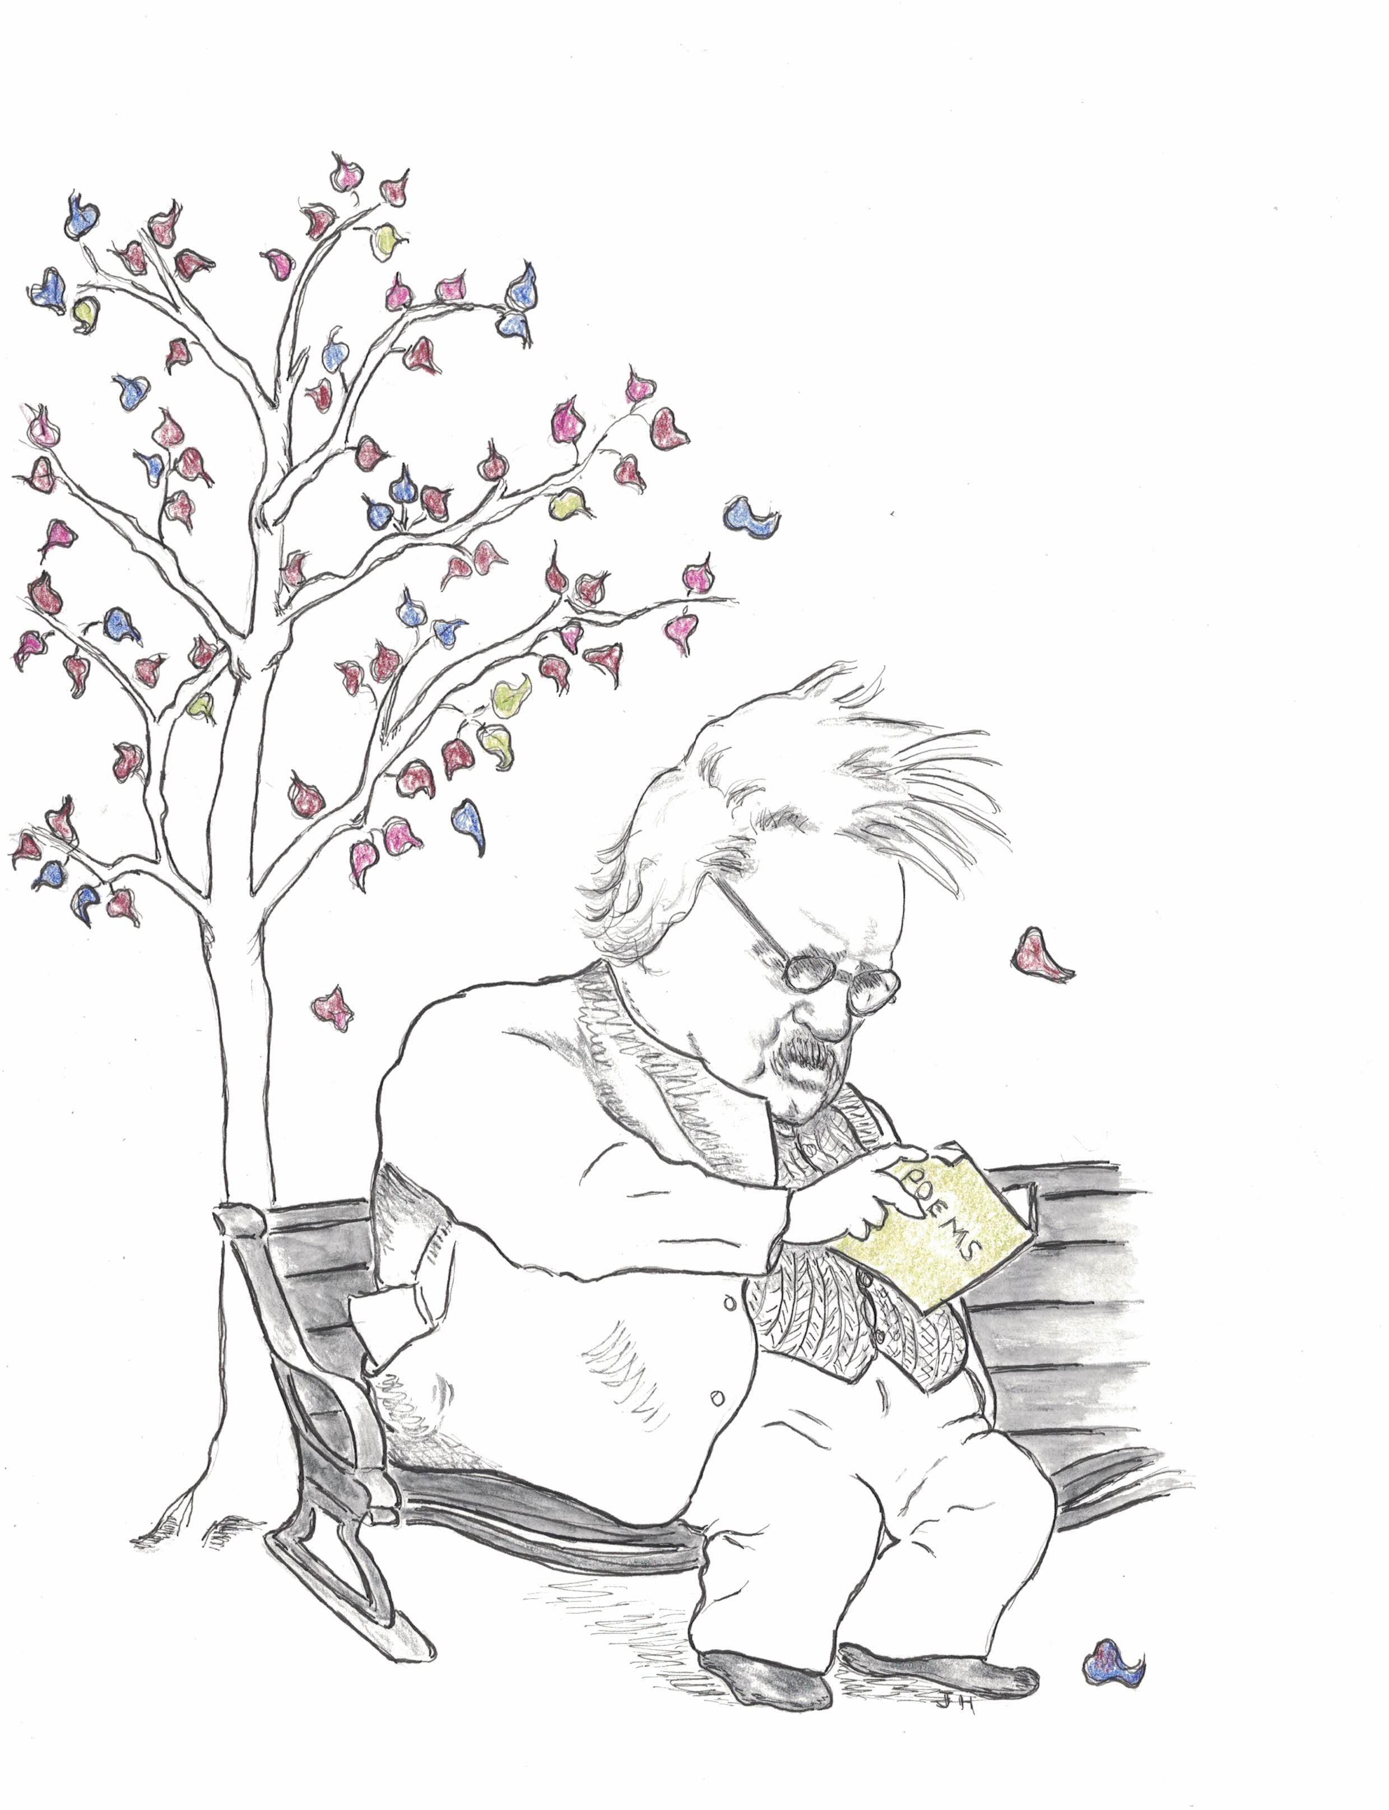
the Rochester NY Chesterton SocietY presents
The fr. leo hetzler conference

POETRY

fruit of Christian joy

Joseph Pearce, Author
Dale Ahlquist, Society of GK Chesterton
Jonathan Thorndike, Belmont University
Ted Janiszewski, St. Irenaeus Ministries

Saturday, September 25th, 2021
9 am – 3:30 pm

St. John the Evangelist Church, 553 Humboldt St. Rochester NY

Donation: $20. Free to students. Lunch available at nominal cost.

Funded by the Basilian Fathers of St. John Fisher College.
With support from members of the Rochester NY Chesterton Society and from the St. Irenaeus Ministries.
For questions, email rochesterton@hotmail.com
© 2021 Rochester NY Chesterton Society

