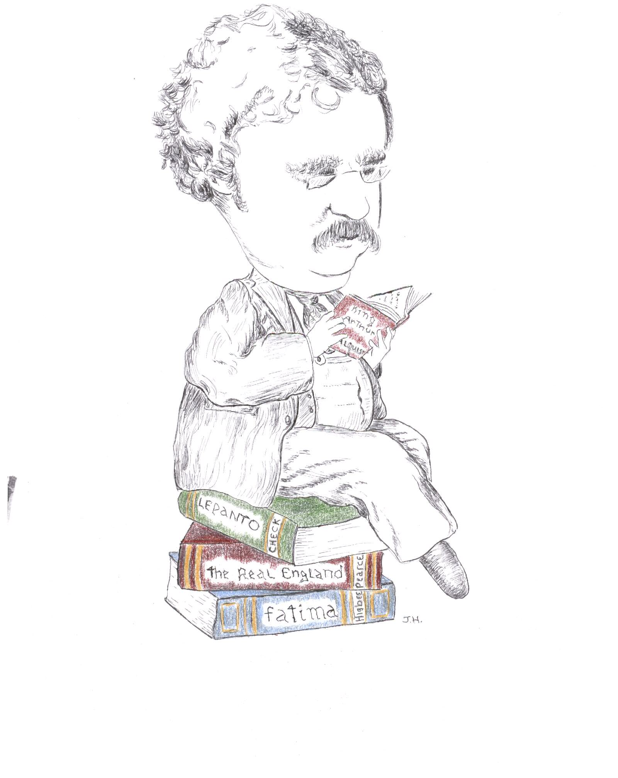
Rochester NY Chesterton Society
9th Annual Conference

HISTORY
MATTERS

…a look at
some of the history
we don’t know

“History is stuffed with miracles.”
GK Chesterton, New York Herald, 2-12-21

SPEAKERS: Joseph Pearce, Author • Chris Check, Catholic Answers
Dale Ahlquist, American Chesterton Society • David Higbee, St. Irenaeus Ministries

Saturday, September 29th, 2012
9 am – 3:30 pm

St. John Fisher College, Coleman Chapel, Murphy Hall

Donation: $10. Free to students. Lunch available at nominal cost.

Funded by the Basilian Fathers of St. John Fisher College.
With support from members of the Rochester NY Chesterton Society and from the St. Irenaeus Center.
For questions, email rochesterton@hotmail.com
© 2012 Rochester NY Chesterton Society

