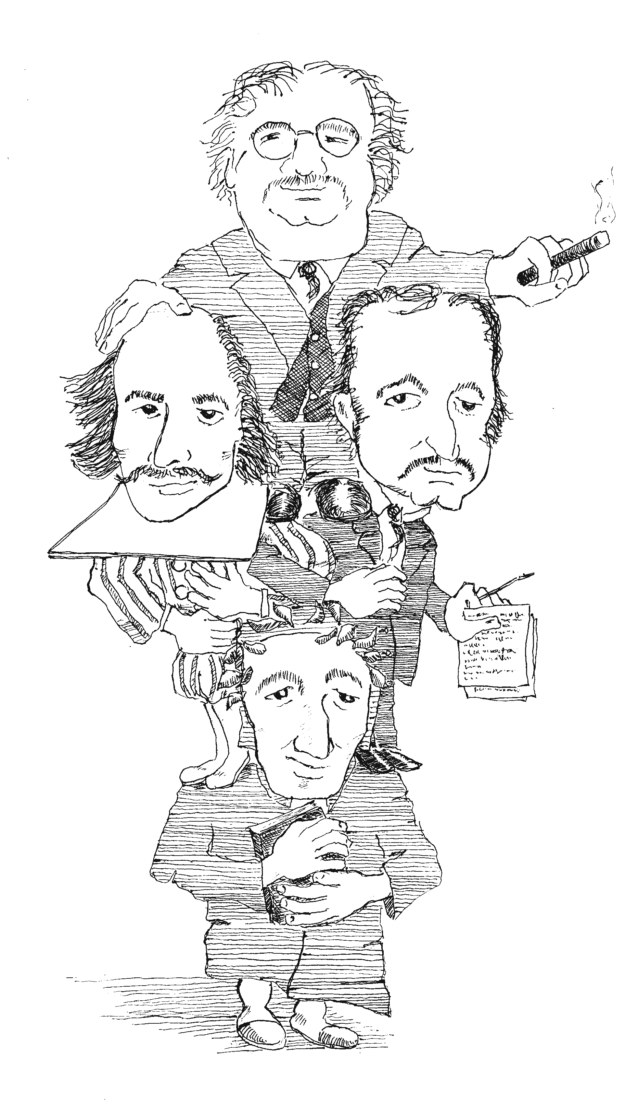
14th Annual Conference
Rochester NY Chesterton Society

On the Shoulders of GIANTS

Dale Ahlquist on
GK Chesterton

Kevin O'Brien
as
Charles
Dickens

Joseph Pearce
on
Wm.
Shakespeare

Dante Alighieri
Dante andante?
Book sale till 3 PM
to benefit:
St. John Bosco Schools
& Chesterton Academy

St. John Fisher College
Murphy Hall

Sat. Sept. 30, 2017
9 am to 3:30 pm
Donation: $15. Free to students. Lunch available at nominal cost.
Funded by the Basilian Fathers of St. John Fisher College.
With support from members of the Rochester NY Chesterton Society and from the St. Irenaeus Ministries.
For questions, email rochesterton@hotmail.com © 2017 Rochester NY Chesterton Society

