Bachelor’s thesis

Degree programme

2019-2020

Perla Rocío Ramírez Sanabria

Implementing Security in IoT Gateway in Legacy Devices for Telemedicine Applications.c

– A comparison between Lightweight IPsec and CoAP



BACHELOR’S / MASTER’S THESIS | ABSTRACT

TURKU UNIVERSITY OF APPLIED SCIENCES

Degree programme

Completion year of the thesis | number of pages, number of pages in appendices

Author(s)

TITLE OF THESIS

­ subtitle of the report (if used)

Write the summary here, maximum 2000 characters. You can find Abstract instructions from Messi.

KEYWORDS:

Insert 3–7 keywords here using the keyword practice of your field. You can use the web catalogue in http:/finto.fi/en/.

OPINNÄYTETYÖ (AMK / YAMK) | TIIVISTELMÄ

TURUN AMMATTIKORKEAKOULU

Koulutus

Opinnäytetyön valmistumisajankohta | xx sivua, xx liitesivua

Tekijä(t)

OPINNÄYTETYÖN NIMI

­ mahdollinen alaotsikko

Kirjoita tiivistelmä tähän, merkkimäärä on enintään 2000 merkkiä. Ohjeita tiivistelmän kirjoittamiseen löytyy Messin opinnäytetyön ohjeista.

ASIASANAT:

Kirjoita 3–7 opinnäytetyösi sisältöä kuvaavaa asiasanaa tähän. Käytä sopivien asiasanojen etsimiseen sivustoa http:/finto.fi/fi/. Jos sivustolta ei löydy työsi sisältöä vastaavia asiasanoja, esitä asiasanoina työsi keskeisiä termejä.

content

List of Abbreviations (OR) Symbols 6

1 Introduction 6

2 Heading 7

2.1 Heading 2 7

2.2 Heading 2 7

3 Heading 8

4 closing chapter 9

references 10

appendices

Appendix 1. Heading of appendix

Appendix 2. How to use equations, figures, pictures and tables

figures

Figure 1. Example of a figure (Source). 3

equations

Equation 1. Example of an equation (Source). 4

pictures

Picture 1. Section break. 1

Picture 2. Clicking the cursor to the right place to remove the section break. 2

Picture 3. Fn and Backspace keys. 2

Picture 4. Selecting Format Page Numbers. 3

Picture 5. Page Number Format window. 3

Picture 6. Adding the name for the picture. 1

Picture 7. Adding the new type of Label. 2

tables

Table 1. Example of a table. 3

List of Abbreviations (OR) Symbols

Write a list of symbols or abbreviations here in alphabetical order. Use the Abbreviations or symbols text style when you write the list.

If you do not use a list of abbreviations or symbols, remove this page. Remove only the text on the page, not the section break below the text! You are able to see the section break by pressing the button  from *Home* tab.

Abbreviation Explanation of abbreviation (Source)

# Introduction

Start writing the body text from here using the Normal text style. Please read the template instructions in Messi before using this thesis template. The instructions explain how to use text styles in the template. In Word’s 2007–2016 versions, you can find text styles by pressing Alt + Command + Shift + S buttons together.

# Heading

Start writing the body text here using the Normal text style.

## Heading 2

Use the 1 Heading style in level 1 headings (with one number), the 1.1 Heading style in level 2 headings (with two numbers) and the 1.1.1 Heading style in level 3 headings (three numbers). You can use the automatic Table of Contents only if you have used the heading styles in your headings.

## Heading 2

There cannot be only one subchapter under the main chapter. If you consider using subchapters necessary, there should be at least two of them under the main chapter.

Unnumbered heading

Numbers are used only in the first three levels of headings. Use the text style Unnumbered heading for other headings.

# Heading

Start writing the body text here using the Normal text style.

# closing chapter

Start writing the body text here using the Normal text style.

Use such heading for the final chapter that it states the most essential contents of the chapter. If it is not possible to use a content-based heading, the heading of the final chapter can be e.g. ”CONCLUSION”. Instructions for writing the final chapter are available in Messi.

references

Add references used by using the Source material text style.

Heading of appendix

On this page, attach an enclosed document as its own entity. Instructions for attaching different kinds of enclosures (e.g. docx and pdf) are available in the thesis instructions in Messi.

If you do not include any appendices in your work, remove this page by following the instructions below.

Since this instruction will be removed during the process, you can first print this instruction or copy it to a new blank Word document, if necessary.

**How to remove an appendix page**

1. First, remove the section 3 header: Move the cursor to the page from where you want the appendix to be removed. Double click on the header area to activate it.
2. Word will open *Header & Footer Tools*. Select the command *Link to previous* by pressing  button and answer Yes. The section 3 header is now the same as in section 2.
3. If you want to remove several appendix pages, remove all the headers of appendices in the same way (as described in points 1 and 2). When you are done close Header and Footer (press X on the upper right corner with *Close Header & Foote*r written underneath it).
4. Next you need to remove the section break before the appendix page. You are able to see the section break by pressing the button  from *Home* tab. The section break will appear at the end of the previous page (before the appendix page). It is marked with a double-line (see Picture 1).



Picture 1. Section break.

1. To remove the section break click the cursor between the  and the section break (see Picture 2). Then press keys **Fn** + **Backspace** and the section break will be deleted (see Picture 3).



Picture 2. Clicking the cursor to the right place to remove the section break.

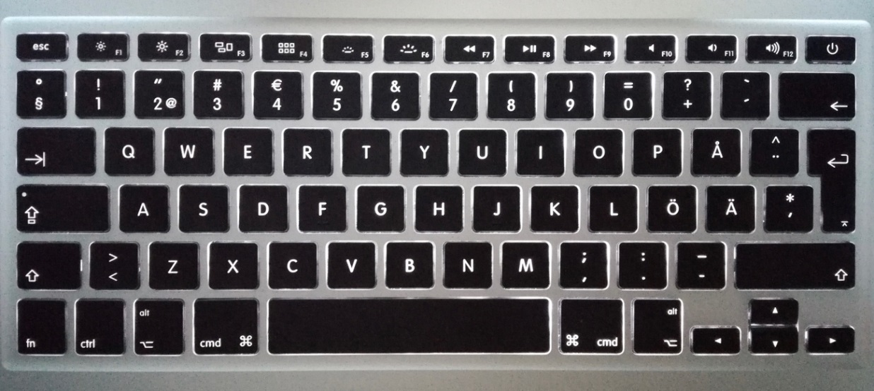

Picture 3. Fn and Backspace keys.

1. Finally remove all the text from the appendix page.
2. If you want to remove several appendix pages, remove all the section breaks before them and all the content on the appendix pages as described in points 4–6.

**If you remove all appendix pages according to the instructions above, see points 8–9, because removing all of them mixes up the page numbering!**

1. When you remove all the section breaks before the appendix pages and all the content in them, the page number on the introduction page becomes number 1. It should be the same as the page number seen on the lower left corner of the document when you are on the introduction page.

To correct the page numbering you must double click the page number on the introduction page, so that Word opens *Header & Footer Tools*. From the upper left corner of the tools select *Page number* > *Format Page Numbers* (see Picture 4).

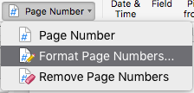

Picture 4. Selecting Format Page Numbers.

1. Word opens a window called *Page Number Format*. Choose the option *Continue from previous section* and click OK (see Picture 5). After this the page numbering should start correctly from the introduction page and from the right number.

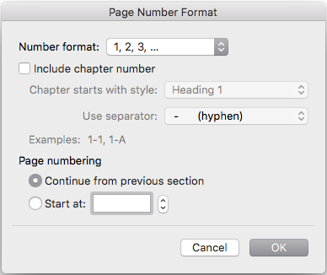

Picture 5. Page Number Format window.

How to use equations, figures, pictures and tables

Equations, figures, pictures and tables must always be referred to in the main text. Equations, figures, pictures and tables are numbered in Arabic numbers. The name of an equation, figure or picture is placed under the item. The title of a table is placed above the table. Equation, figure, picture and table names end with a full stop. If a equation, figure, picture or table is not prepared by the author himself, insert the source of reference. The items themselves (equations, figures, pictures and tables) are separated from the text with a blank line.

The thesis template includes a caption text style for names of equations, figures, pictures and for titles of tables. When you mark a header text with the style in question, you will receive automatically generated lists of equations, figures, pictures and tables on the table of contents page.

Instructions:

After adding an equation, figure or picture move the cursor to an empty row under the item. Select *Insert Caption* in the *References* tab. Select Equation, Figure or Picture in the *Label* menu. Write ”.” after the sequence number. Then write the explanation text for the equation, figure or picture and end the text with a dot. Press OK.

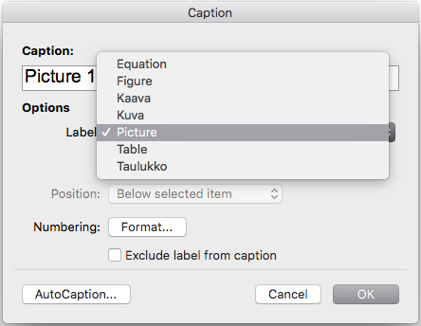

Picture 6. Adding the name for the picture.

Equations, figures, pictures and tables are automatically formatted as *Caption* style and they will automatically appear in the table of equations, figures, pictures or tables on the table of contents page after the table of contents lists are updated.

**Note!** Some label types may be missing inform the *Label* menu (see Picture 7). Most likely the missing label type is Figure. In this case, use the following instructions.

How to add a new type of label to the Label menu

Move the cursor to the empty line below the item (for example figure). Select *Insert Caption* in *References* tab. The programme automatically suggest that you insert the label for Picture but you must press the *New Label* button (see Picture 7). Write the **type** of the new label (for example figure) in the opened window and accept it with OK. Now the programme suggests that you insert the label for this type of item. Now the new type of label is listed in the *Label* menu for futher use.

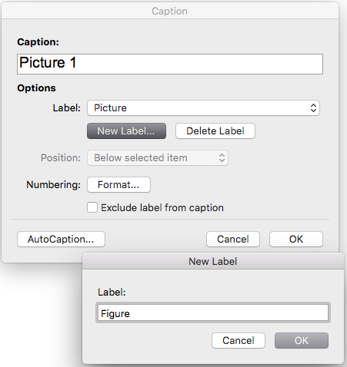

Picture 7. Adding the new type of Label.

If equations, figures, pictures or tables are large, it may be necessary to place the preceding text on a different page, and add an empty space at the bottom of the page.

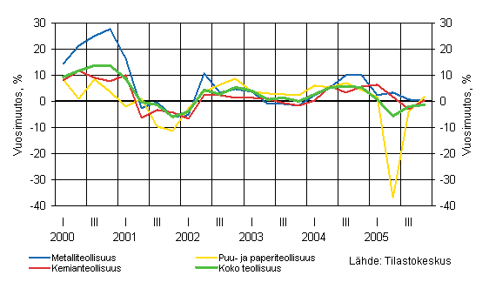

Figure 1. Example of a figure (Source).

Adding the title of a table

The title of a table is placed above the table. After adding a table, move the cursor above the table on an empty row. Select *Insert Caption* in the *References* tab. Select Table in the *Label* menu. Write ”.” after the sequence number. Then write the explanation text for the table and end the explanation with a dot. Press OK.

Tables that continue to the next page must always be placed in appendices. If the table continues to the next page, you must write (continue) on the lower right corner. You must write the word Table and its sequence number and the word (continue) to the next page. For example, Table 3 (continue).

Table 1. Example of a table.

|  |  |  |
| --- | --- | --- |
| Heading | Heading | Heading |
| A | 13% | 27% |
| B | 46% | 59% |

(continue)

Table 1 (continue).

|  |  |  |
| --- | --- | --- |
| Heading | Heading | Heading |
| C | 10% | 10% |
| D | 31% | 4% |
| In total | 100% | 100% |

Word’s 2007–2016 versions have different table styles. The *Table Tools* tab appears when the table is activated. By using Word table styles the tables become vivid. Table styles should be used with caution, so that the result is stylish.

Please do not place more than one equation, figure, picture or table in a row. You should put at least one text paragraph between them to clarify the content.

$$x=\frac{-b±\sqrt{b^{2}-4ac}}{2a}$$

Equation 1. Example of an equation (Source).

An equation, a figure, picture or table must not start or end a section. The right place for it is near the section where it is referred to.