ForgeCode Agent — Executive Design Review
Project folder: /Users/ericlara/Documents/OpenSourceCodingAgentLab
This DOCX was generated from the independent architecture, product/scope, and QA subagent outputs. No application code was written before these design documents.

Design Summary
ForgeCode Agent is an original open-source CLI/TUI coding agent designed around clean domain boundaries, deterministic agent loops, auditable tool use, human approval gates, git/worktree isolation, and strict QA-first development.

MVP Scope
Init, plan, run, review, apply, doctor, and resume commands; provider abstraction; safe file/search/patch/shell/git tools; fake provider test harness; golden transcript tests; documented subagent team workflow.

Clean-Code Architecture
Hexagonal ports/adapters, command pattern for tools, state machine controller, strategy pattern for providers/context policies, repository pattern for run persistence, and policy objects for approvals/security.

QA Strategy
TDD is mandatory. The initial quality system centers on fake providers/tools, deterministic golden transcripts, sandbox and git tests, context compaction tests, and security abuse tests.

Diagrams

Domain / Context Diagram
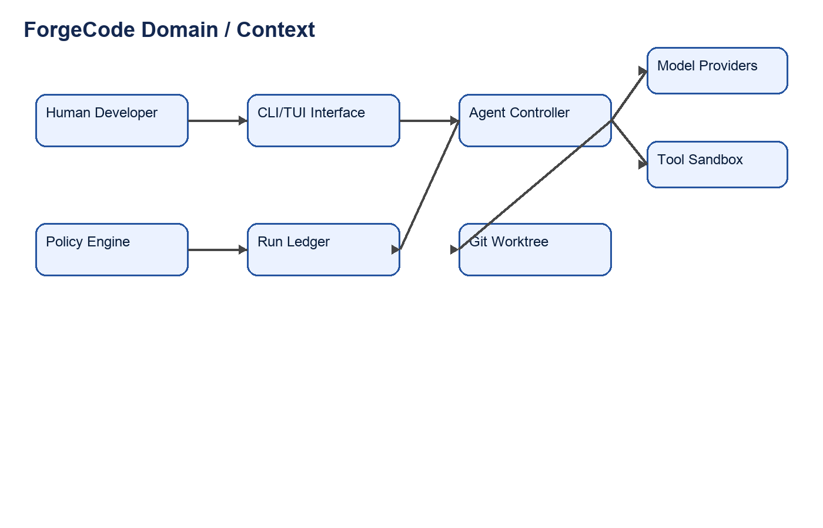

Agent Loop Flow Diagram
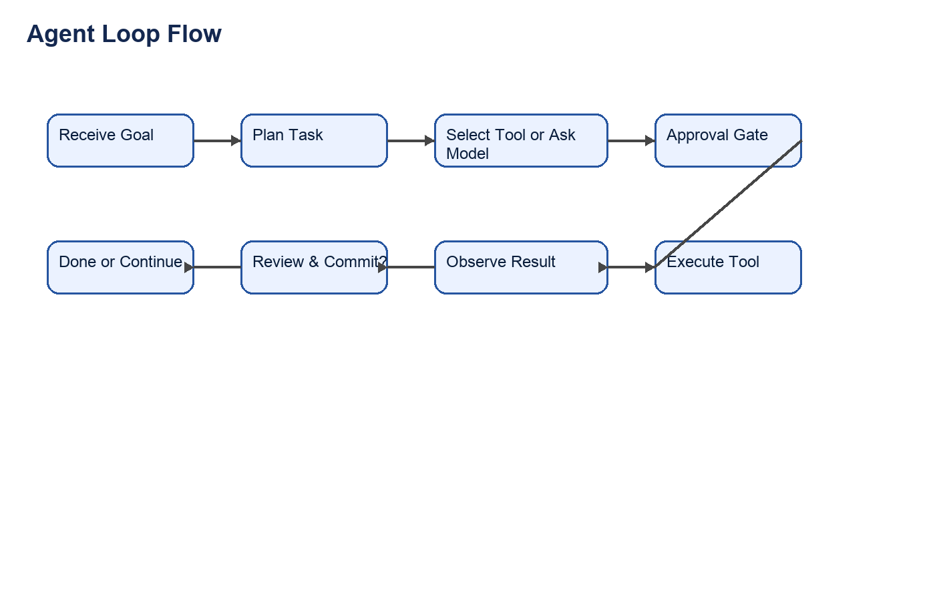

Typical Task Sequence
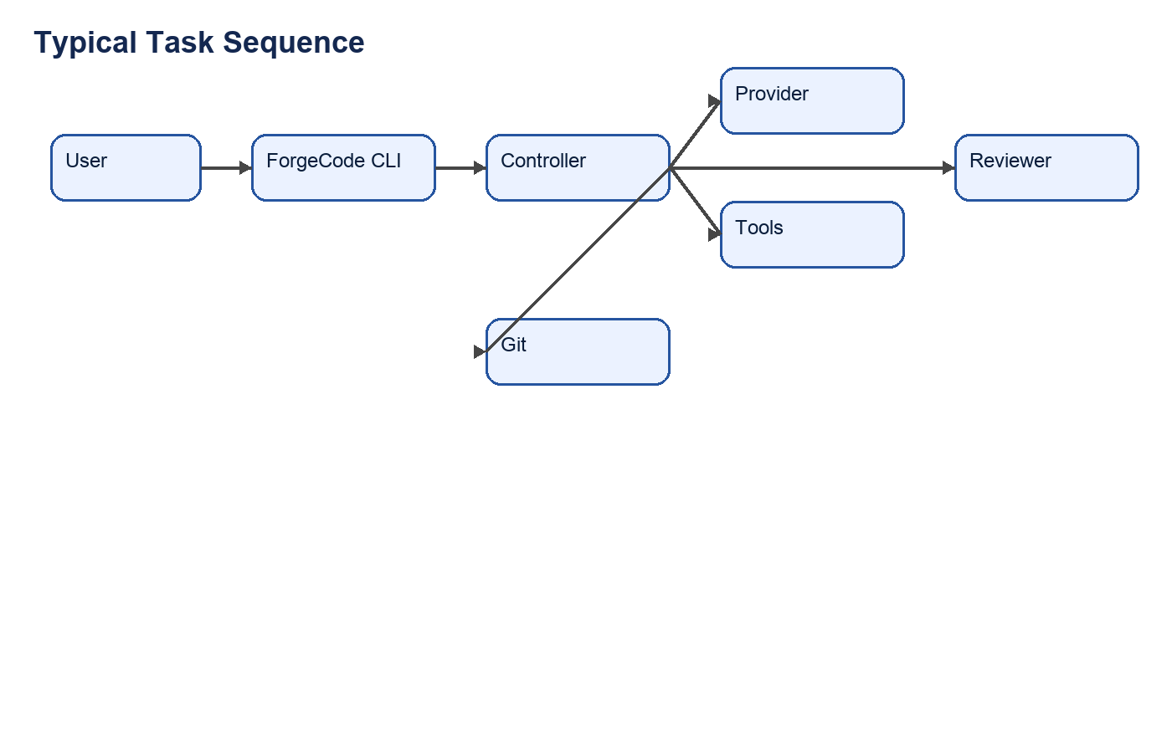

Human Review Gates
- Approve product direction before broad feature expansion.
- Approve provider secrets/configuration.
- Approve push, publish, destructive commands, and external delivery.
- Approve license before public release.

Source Documents
- docs/architecture/architecture-research.md
- docs/product/feature-scope.md
- docs/qa/qa-test-strategy.md
- docs/qa/initial-test-suite-design.md
- docs/diagrams/*.mmd

Appendix: Mermaid Sources

forgecode-agent-flow.mmd
flowchart TD
A([User task received]) --> B[Intake\nrequest + repo + git status]
B --> C{Task requires code changes?}
C -- No --> D[Build read-only context]
D --> E[Answer / explain / review]
E --> Z([Complete])
C -- Yes --> F[Build context\nfiles + symbols + tests + memory]
F --> G[Plan\ntargets + tools + risks + verification]
G --> H{Approval required?}
H -- Yes --> I[Show plan/action scope]
I --> J{User approves?}
J -- No --> K[Revise plan or stop]
K --> Z
H -- No --> L[Execute next action]
J -- Yes --> L
L --> M{Action type}
M -- Read/Search --> N[Context tool]
M -- Patch --> O[Patch proposal]
M -- Shell/Test --> P[Sandbox command]
M -- Delegate --> Q[Subagent task packet]
N --> R[Update trace + context]
O --> S{Patch safe to apply?}
S -- No --> T[Re-read/rebase or request approval]
T --> R
S -- Yes --> U[Apply patch + git checkpoint]
U --> R
P --> V[Capture output + diagnostics]
V --> R
Q --> W[Collect structured findings / patch proposal]
W --> R
R --> X{Plan complete?}
X -- No --> L
X -- Yes --> Y[Verify\ntests + lint + diff review]
Y --> AA{Verification passed?}
AA -- Yes --> AB[Summarize changes\nverification + risks]
AB --> Z
AA -- No --> AC{Budget remains?}
AC -- Yes --> AD[Repair loop\nclassify failure + update plan]
AD --> L
AC -- No --> AE[Stop with failure report\nlogs + next actions]
AE --> Z

forgecode-domain-context.mmd
flowchart LR
User[Developer / Maintainer]
Repo[(Local Git Repository)]
Config[(User + Repo Config)]
Memory[(Project and Session Memory)]
Providers[Model Providers\nHosted or Local]
Plugins[Plugins\nTools / Context / Subagents]
Shell[Local Shell / Sandbox]
Git[Git / Worktrees]
CI[Optional CI / Remote Checks]
subgraph ForgeCode[ForgeCode Agent]
CLI[CLI]
TUI[Optional TUI]
App[Session Controller\nApprovals + Use Cases]
Runtime[Agent Runtime\nLoop + Coordinator]
Context[Context Service\nRepo Map + Retrieval]
Policy[Policy Engine\nPermissions + Risk]
Patch[Patch Manager\nDiffs + Apply + Revert]
Sandbox[Sandbox Executor\nCommands + Logs]
Obs[Observability\nEvents + JSONL Traces]
Registry[Plugin Registry]
end
User --> CLI
User --> TUI
CLI --> App
TUI --> App
App --> Runtime
App --> Policy
Runtime --> Context
Runtime --> Patch
Runtime --> Sandbox
Runtime --> Registry
Runtime --> Obs
Context --> Repo
Context --> Memory
Context --> Config
Runtime --> Providers
Registry --> Plugins
Policy --> Sandbox
Policy --> Patch
Patch --> Repo
Patch --> Git
Sandbox --> Shell
Sandbox --> Repo
Sandbox --> CI
Obs --> Memory
Git --> Repo

forgecode-sequence.mmd
sequenceDiagram
autonumber
actor U as User
participant UI as CLI/TUI
participant App as Session Controller
participant PE as Policy Engine
participant AR as Agent Runtime
participant CS as Context Service
participant MP as Model Provider
participant SA as Subagent Coordinator
participant PM as Patch Manager
participant SB as Sandbox Executor
participant GT as Git/Worktree Manager
participant LOG as Event Log
U->>UI: Request coding task
UI->>App: Start/resume session
App->>GT: Read branch, HEAD, dirty status
GT-->>App: Repository state
App->>PE: Evaluate mode and permissions
PE-->>App: Approval requirements
App->>AR: Run task with policy and repo state
AR->>CS: Build relevant context
CS-->>AR: Files, symbols, tests, memories
AR->>MP: Ask for plan with grounded context
MP-->>AR: Structured plan
AR->>LOG: Record plan event
alt Plan or action needs approval
AR-->>App: Approval request with scope/risk
App-->>UI: Display approval prompt
U->>UI: Approve / deny / revise
UI->>App: Decision
App->>PE: Record decision
end
opt Parallel bounded delegation
AR->>SA: Dispatch Scout/Verifier/Reviewer packets
SA->>CS: Read/search allowed context
SA->>MP: Specialized reasoning calls
SA-->>AR: Findings and patch proposals
AR->>LOG: Record subagent results
end
AR->>PM: Create minimal patch proposal
PM->>GT: Check file freshness and checkpoint
GT-->>PM: Safe to apply or conflict
PM-->>AR: Diff preview
alt Patch permitted
AR->>PM: Apply patch
PM->>GT: Update working tree/checkpoint metadata
PM-->>AR: Applied diff
else Conflict or denied
PM-->>AR: Rebase required or stop reason
end
AR->>SB: Run verification command under sandbox policy
SB->>PE: Check command/network/write permission
PE-->>SB: Allow / require approval / deny
SB-->>AR: Exit code, output, diagnostics
AR->>LOG: Record command result
alt Verification failed and budget remains
AR->>MP: Diagnose failure and repair plan
MP-->>AR: Repair action
AR->>PM: Apply repair patch
AR->>SB: Re-run targeted verification
end
AR-->>App: Final result summary, diff, verification status
App-->>UI: Render final response
UI-->>U: Changes, tests, risks, next steps

