App Dev Project Report

1. Student Details
Name: Ryan Thomas Rony
Roll Number: 23F2004010
Email: 23F2004010@ds.study.iitm.ac.in
About Me: I am a Course Instructor at IIT Madras BS Degree program with a deep interest in web application development and data-driven technologies. I enjoy building meaningful applications that combine learning, analytics, and user experience.

2. Project Details

Project Title: Placement Portal

Problem Statement:
To design and build a web-based application that allows Admin (Institute), Company, and students to interact with the system based on their roles. Allowing companies to post drives and students to apply for it

Approach:
The application was developed using the Flask framework with a modular backend structure. The system implements role-based access control for Admin, Company, and Student users.
Students can browse placement drives and apply if they meet eligibility requirements such as CGPA and subject grades. Companies can create placement drives, manage applications, and track student progress through multiple recruitment rounds. The Admin role manages user accounts, approvals, and blacklisting

3. AI/LLM Declaration
I used ChatGPT (GPT-5) to assist in writing SQLAlchemy model definitions, creating API documentation samples, and improving variable naming consistency.
The extent of AI/LLM usage is around 10–15%, limited to code suggestions and documentation formatting.
All final implementation logic, debugging, and integration were done manually.

4. Technologies and Frameworks Used
Technology / Library | Purpose
Flask | Core backend web framework
SQLAlchemy | Object Relational Mapper for SQLite database
Jinja2 | Template engine for rendering dynamic HTML pages
Bootstrap | Frontend styling and responsive design
Flask-Login | User authentication and session management
Werkzeug | Password Hashing and Security

5. Database Schema / ER Diagram
Tables:
1. User
Stores profile information for all users of the system including students, companies, and administrators.
Attributes include:
- id – Unique identifier for each user (Primary Key)
- username – Unique username for login
- name – Full name of the user
- email – Email address used for authentication
- password – Encrypted password for login
- role – Defines the user type (Admin, Company, or Student)
- is_blacklisted – Indicates whether the user account is blocked by the admin
- CGPA – Academic CGPA of the student (applicable only for student users)
- website – Company website link (applicable only for company users)
2. PlacementDrive
Stores information about placement drives created by companies.
Attributes include:
- id – Unique identifier for each placement drive (Primary Key)
- company_id – References the company that created the placement drive (Foreign Key → User)
- job_title – Title of the job role being offered
- job_description – Description of the job role and responsibilities
- job_salary – Salary offered for the job
- cgpa_reqd – Minimum CGPA required for eligibility
- status – Status of the placement drive (open/closed)
3. StudentApplication
Stores records of student applications to placement drives and tracks their recruitment progress.
Attributes include:
- id – Unique identifier for each application (Primary Key)
- student_id – References the student who applied for the drive (Foreign Key → User)
- placement_drive_id – References the placement drive being applied to (Foreign Key → PlacementDrive)
- allowedtoapply – Indicates whether the student meets eligibility requirements
- hired – Indicates whether the student was successfully hired

Relationships:
One-to-Many → User (Company) → PlacementDrive
A company user can create multiple placement drives, while each placement drive belongs to a single company.
One-to-Many → User (Student) → StudentApplication
A student can submit multiple applications to different placement drives.
One-to-Many → PlacementDrive → StudentApplication
A placement drive can receive multiple student applications, while each application belongs to only one placement drive.

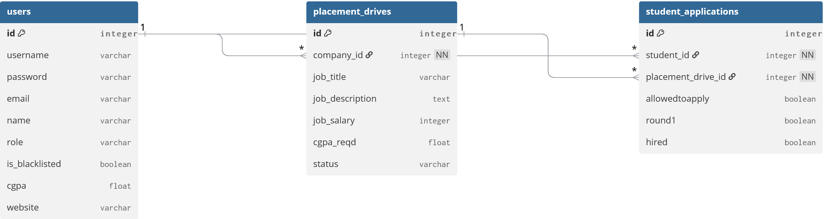

6. API Resource Endpoints
Endpoint | Method | Description
/api/login | POST | Authenticate user and generate session
/api/users | GET | Retrieve a list of all users
/api/users | POST | Register a new user
/api/users/{userId} | GET | Get details of a specific user
/api/users/{userId} | PUT | Update a user's profile
/api/users/{userId} | DELETE | Delete a user from the system
/api/drives | GET | Retrieve all placement drives
/api/drives | POST | Create a newly posted placement drive
/api/drives/{driveId} | GET | Get details of a specific placement drive
/api/drives/{driveId} | PUT | Update placement drive details
/api/drives/{driveId} | DELETE | Delete a placement drive
/api/applications | GET | Retrieve all student applications
/api/applications | POST | Submit a new application for a drive
/api/applications/{applicationId} | GET | Get details of an application
/api/applications/{applicationId} | PUT | Update application recruitment status (Rounds, hired)
/api/applications/{applicationId} | DELETE | Withdraw or delete an application

YAML API Definition File:
Included separately in the submission ZIP as api.yaml.

7. Architecture and Features (optional)

Architecture Overview:
- app.py – main Flask application entry point
- /models – database models using SQLAlchemy
- /routes – Flask Blueprints for user and activity routes
- /templates – Jinja2 HTML templates
- /static – CSS, JS, and chart visualization files

8. Video Presentation
Drive Link:
https://drive.google.com/file/d/your-video-link-here
(Accessible to all with “View” permission.)

