World Builder

User Manual

Written by Peter de Vocht
April 14, 2002
Version 1.01

Table of Contents

Introduction 3
Loading Landscapes 4
Creating Landscapes 4
World Builder Window 5
Map Settings Window 7
Selected Object Window 9
Top View Window 12
Bot Management Window 12
Saving your data 13

Introduction
The world builder is a tool designed to create new worlds and scenarios to be used with War Games Inc. The world builder needs a reasonably high spec machine to operator, higher so than the game itself. The builder does not use optimizations used by the game and needs more memory (128MB or more) and an OpenGL accelerated 32MB video card are recommended.

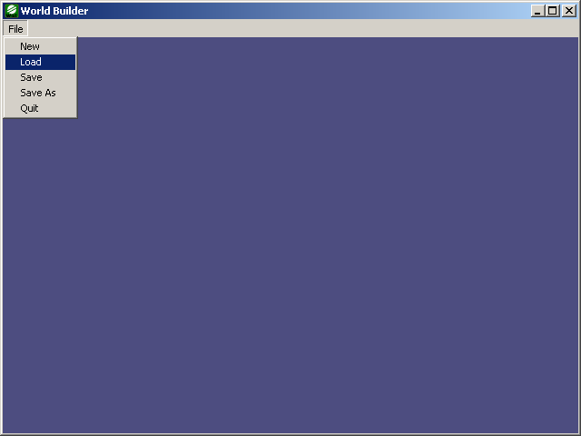

The initial view of the world builder is that of a blue window with a menu. To start the editor, either load an existing .def world definition file (which can be found in the data\stories directory of the War Games Inc system), or create a new .def file.

Loading Landscapes
You can load .def files form the data\stories directory to edit. Select load from the file menu of the “World Editor Window”.

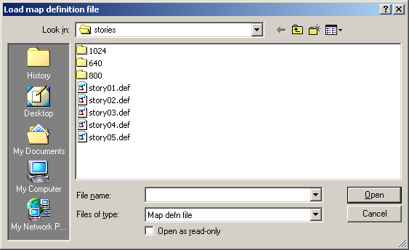

Creating Landscapes
Landscapes are created from 24 bit grey-scaled bitmaps. These are the only files that can be used as a height-map for a landscape. At present the bitmap files MUST be exactly 128x128 pixels in size. The builder creates a polygon mesh from this bitmap and the data required to traverse the landscape.

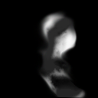

The above image is the 24 bit grey-scale map of story 1 of War Games Inc. Such images can be created with pain programs such as Photoshop, or landscape creation programs such as Terragen (http://www.planetside.co.uk/terragen/).

Select “New” from the file-menu. This will bring up a dialog-box that enables you to select a bitmap. Remember – this bitmap has to be gray-scaled, 24 bit, and 128x128 pixels in size.

A series of windows will appear as soon as you’ve opened a valid bitmap. Your screen will look something like the screenshot shown below.

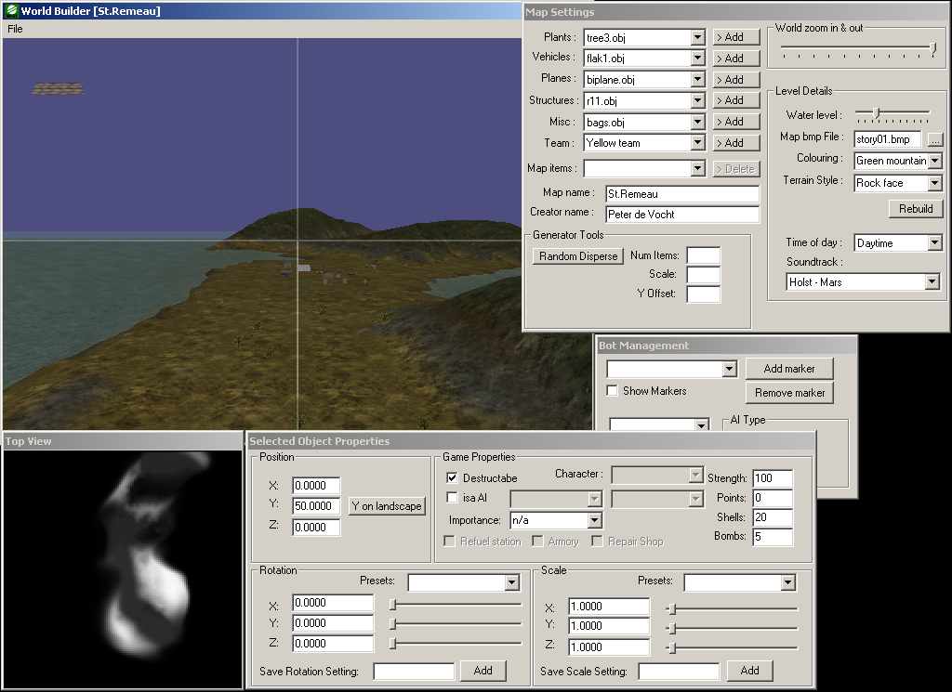
We will take a look at each of the individual windows and their functions.

World Builder Window
The main window shown in the picture, below, is the exploration window. It gives you a WYSIWYG view of the game scenario. You can “plant” buildings, vehicles, and player starting positions.

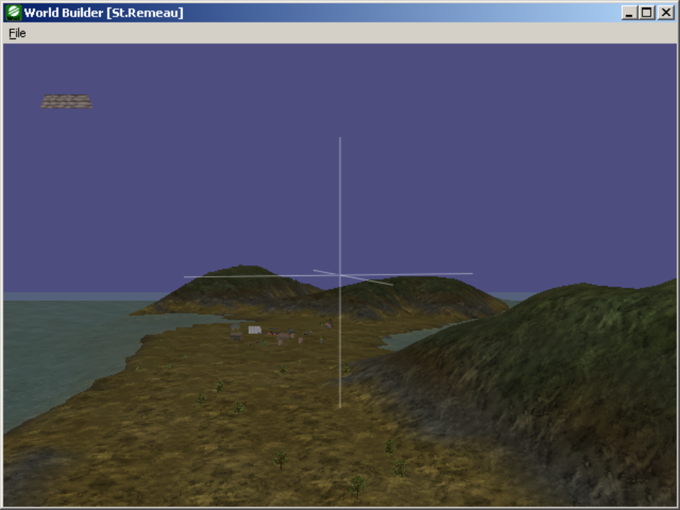

You can move around the generated landscape using the cursor keys while this window is active. The icon shown in the top-left corner shows a series of sandbags. This is the currently selected object for dropping onto the landscape. This object can be changed using the map settings window. The editor’s cursor is shown as an axis show in the center of this diagram. This cursor is the focus of the editor.

Using the cursor keys moves this cursor. Left clicking the mouse inside this window and moving the mouse side-ways, rotates the view with the cursor as its center. Moving the mouse forwards and backwards with the left mouse down zooms the view relative to the cursor.

Key Function
Cursor left move cursor to the left
Cursor right move cursor to the right
Cursor up move cursor forward
Cursor down move cursor backwards
A move cursor up (skywards)
Z move cursor down (downwards)
ESC unselect selected object and return to cursor mode

Any of these keys pressed while the control key is down doubles the movement speed.

The mouse left and right buttons are used for moving the camera and selecting objects. Holding down the left mouse button and moving the mouse left or right moves the camera in a circle around the selected object or the selection axis. Moving the mouse up or down while holding down the left button zooms the camera in or out from the selected object or selection axis.

The right button is used for selecting objects on the landscape. It’s the easiest way of selecting an object, but it can be tricky when there are other objects around.

Map Settings Window
This window is the world builder’s main control window. It has a series of objects you can drop on the landscape categorized as plants, vehicles, planes, structures, misc, and team.

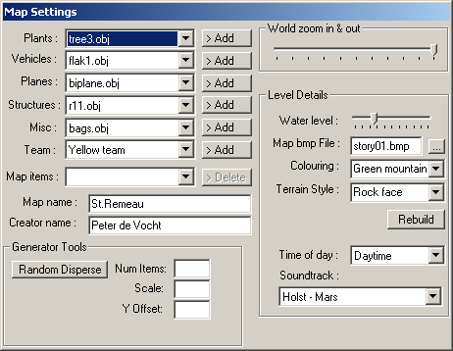
Objects are added at the center of the location of the edit cursor. Simply select an object from the category you require, and click the “> Add” button to the right of the drop down box.

Once you select an item from one of the drop down boxes you will be shown a preview of the object in the top left corner of the “World Builder Window”.

Team
There can be up to four teams in a game. These are red team, green team, blue team, and yellow team. The “flags” are the start positions of individual team members. You can have up to 16 players per team. Having more than one team marker is only relevant for multi-player games.

The first marker of the red team is the start position of a player in single-player type games. If there are no red markers, this switches to the first marker of the green team, then blue team, then yellow team. Without any markers, a scenario can not be used by the game engine.

Map items
“Map items” is a list of items already on the map. Selecting an item from this drop down list selects the object and sets the camera to point at this object. At this stage you can move the selected item with the cursor keys and the A and Z keys as described in the “World Builder Window” section.

Map name
Map name is the descriptive name of this particular scenario. This text will show up in the multi-player drop down selection box of the game.

Creator name
Creator name is your name, give your map ownership and show other people who created the map.

World zoom in/out
The area shown in the “World Builder Window” is limited, in order to view more, you can zoom in and out using this slider bar.

Water level
All levels are surrounded by water. Water level specifies the height of the water. Experiment by moving this slider up/down and click the “rebuild” button to view the effect.

Map bmp file
The bitmap used for creating the height-map mesh that is this scenario. You selected this bitmap when you created a new scenario. You can change the bitmap by clicking on the “…” button to the right of this edit field, or by typing a new name into the edit field. Click the “rebuild” button to process your changes.

Colouring
You can select from a variety of colour schemes for colouring the landscape. Select a colour-scheme from the drop down box, and click the “rebuild” button to process your selected colour.

Terrain style
The bump-map used to give the terrain its characteristic (e.g. rocky, sandy, etc.) Select your preferred bump-map, and click the “rebuild” button to process your changes.

Time of day
Also know as the weather button. You can select the in-game “weather”, which at present consists of “day”, “night”, and “fog”. The effects of these changes are not visible in the World Builder, only in the game.

Soundtrack
You can choose to have in-game music or not, as you download extra expansion packs you will get more soundtracks available to you.

Generator tools
The generator tools section is tool for rapidly populating an area of the map with a single object. The currently selected object (shown in the left top corner of the “World Builder Window”) will be copied “Num Items” times at a scale specified by “Scale”, and floating above the landscape by factor “Y Offset”. Click the “Random disperse” button to start the process.

By default, such objects will be placed randomly across the whole map. Using the top view window and your mouse, however, you can limit the placement extend to a rectangular area. Move your mouse to the top view window, and drag a rectangle holding down your left mouse button.

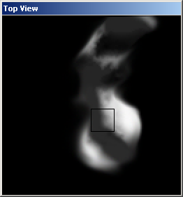

The result should look something like the image shown above.

Selected Object Window
The selected object window is central to the properties of individual items added to the map. Most fields in this window will be greyed out if you haven’t selected an object on the map.

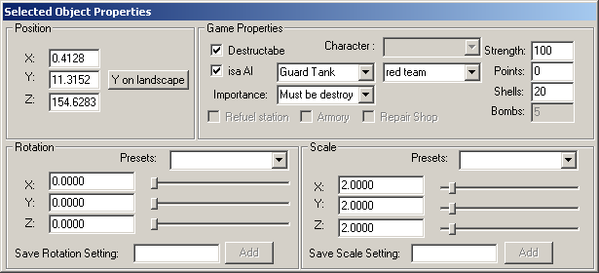

You have to add an object to the map before you can select it. The most obvious settings are the position, rotation and scale of the object. Position shows the actually Cartesian coordinates of the object in the world. Rotation shows the rotation around the object’s center in degrees. Scale reflects the size of the object in its 3 dimensions. Initially all objects in the game system are scaled between –1 and 1 with (0,0,0) as their relative internal origin.

Game Properties
Game properties reflect how the selected object interacts with the game play. This is what makes the game interesting and playable. Each object can have an individual role in the game. This is called “importance” and is reflected through the importance dialog box. An object can have 3 levels of importance in the present version of the world builder, these are: n/a (no importance – can be destroyed or not – doesn’t matter), must be destroyed (the object must be destroyed before you can accomplish your mission), and must not be destroyed (if the object is destroyed your mission will have failed).

Destructible
An object is by default marked as destructible. If you don’t want an object to be affected by weapons fire, uncheck the destructible box.

isa AI
This check box is only applicable for vehicles. Vehicles can set to be controlled by the computer in game. The following AI types apply to the following vehicle types.

Guard tank, attack tank, patrol tank tanks (Churchill, tiger, etc,)
Bomber plane, fighter plane planes (biplane, tri-plane, etc.)
Flak flak units (flak1, flak2, etc.)
Artillery artillery units (gun1, gun2, etc.)
MG42 manned machine guns

After you nominate a vehicle as an AI, you must tell the computer what team the AI is on (AI’s can be on the same team as a player, they won’t attack players on the same teams, and AI’s can fight each other if they’re on different teams).

Character
The flag objects (team markers) can be given special properties with the character drop down box. These properties pertain to the weapons a character is equipped with. The categories are:

Category | Machine gun | Bazooka | Explosives
Soldier | √ | x | √
Engineer | x | √ | √
Saboteur | x | √ | √
Special forces | √ | √ | √

Importance
The importance of any object can be one of three possible states:

n/a not applicable (not relevant)
must be destroyed The object must be destroyed before a mission can be considered complete
must not be destroyed The object must at no case be destroyed, if it is, the game will be over.

Strength
The initial percentage strength of an object (represented as a number between 1 and 100). By default, all objects have strength of 100%.

Points
This field is not used at present.

Shells
The number of shells an object carries. For tanks, artillery and flak units, this is the ammo they carry for their main gun. For planes, the number of unguided missiles on board, and for characters the amount of ammo for the bazooka.

Bombs
The number of bombs an object carries. For planes, this is the bomb payload of a plane, and for characters, this is the amount of dynamite a person carries.

Resource replenishment
Certain objects (structures only) can be set as resource replenishers. If a vehicle, or character approaches a resource replenisher structure, it gets an automatic top-up of the relevant resource. Replenish able resources are:

Refuel station
Replenish fuel (tanks, artillery, and planes, use fuel)

Armory
Replenish ammunition (anything that has or is a weapon is re-armed)

Repair shop
Replenish strength.

Top View Window
The top view window shows the height-map of the world as seen from above, white areas indicate higher locations, black areas show lower locations.

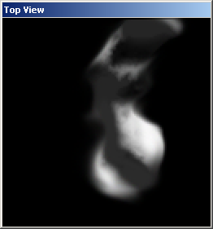

You can select rectangular areas by clicking and dragging with your mouse in this window. After you finish dragging the window will show a rectangle. This rectangle limits the area of the “random disperse” function discussed above.

Bot Management Window
The bot (aka. AI) management window enables the user to set-up paths for AI. Bots don’t need paths, but paths can help bots navigate tricky locations, drive across bridges and find their ways through villages. Once you have placed a marker, you can’t move it. You can’t place markers while an object is selected. Press the ESC button to deselect the current object and return to cursor mode.

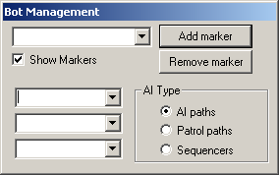

AI Type
AI type determines what kind of marker you add to the map. There are three types at present. These are:

AI paths
Applies to attack and guard AI tanks only. Setup paths for AI tank units.

Patrol paths
Applies to patrol tank AIs only. These are special paths that must be circular (i.e. the first marker connect to the first marker to be a valid path. Patrol tanks go round and round the path until someone comes close enough to attack.

Sequencers
Sequencers are location markers. An optional part of the game play is to set locations that MUST be visited before a game mission can be accomplished, these are determined by the sequence location markers. Such markers are shown on the game map as large white markers, and are only shown one at a time. Once the first sequence locator has been visited (via proximity), the next marker is shown, until there are no more markers left.

Show markers
Markers are shown as black bars on the landscape, connected to each other with coloured lines.

NB. Planes and all other AIs do not use markers.

Saving your data
The most important thing is how to make a new map appear as a new level in the War Games Inc. engine. Any .def file will be immediately visible to a multi-player game. In order to play a multi-player map both players must have the data of the .def file before starting a game.

You can also opt to create a single player level. The .def file and the .bmp height-map must be stored in the data\stories folder. To create a new single player level you must create a new story text file. These story files must be numbered consecutively (story01.txt, 02, 03, … 10, …, 99). You can add your new level by taking the next available number after the existing ones.

The content of this text file looks as follows:

title=The story begins
screen=story1.jpg,story2.jpg
map=story01.def

Title is the text that shows up in the game’s single player level pull-down box. Screen is a comma-separated list of JPEG files (must be 1024x1024 in size each) containing the story of the level. These JPEGS must be in the data\stories directory too, but duplicated twice under 3 different directories.

Each story will be automatically prefixed with either eng_ or ger_ in their filenames determining the language used (English or German). The directories define the resolutions of the maps. Perhaps its is best you take a look at the examples provided by the War Games Inc. game.

data\stories\640 contains jpegs sized 1024x1024 with the mission text sized at 640x480
data\stories\800 contains jpegs sized 1024x1024 with the mission text sized at 800x600
data\stories\1024 contains jpegs sized 1024x1024 with the mission text sized at 1024x768 and higher

