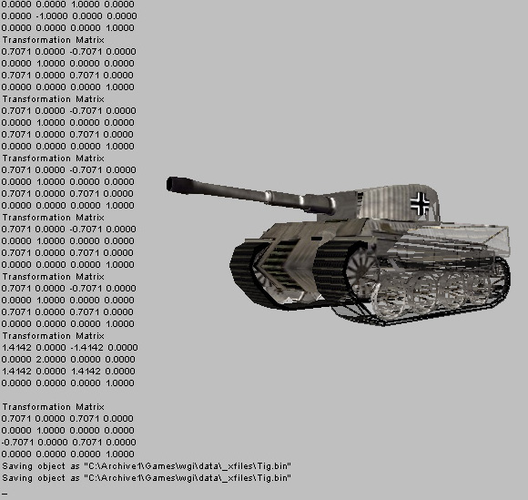  Win32 asset converter screen-shot | 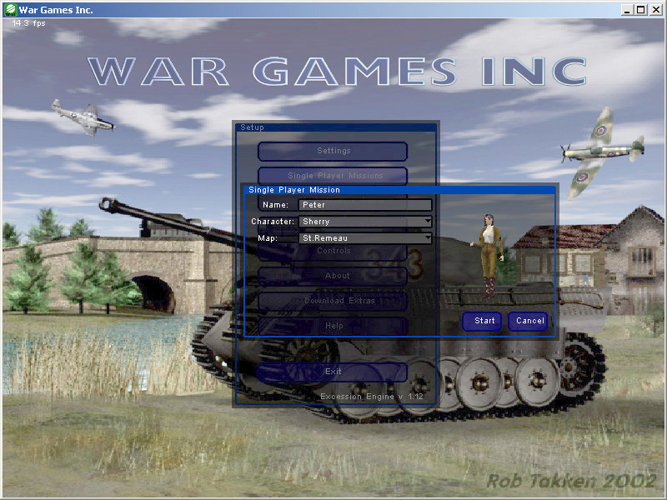  War Games Inc. title screen and interface
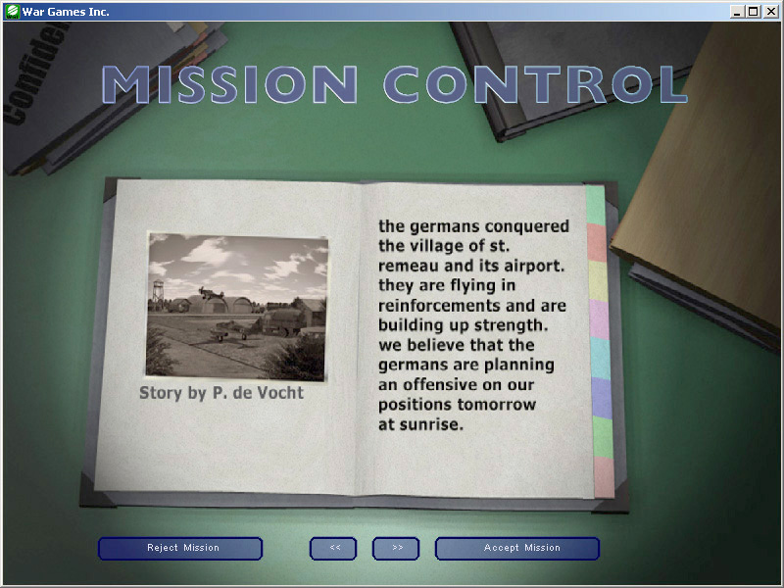  War Games Inc. in-game story board | 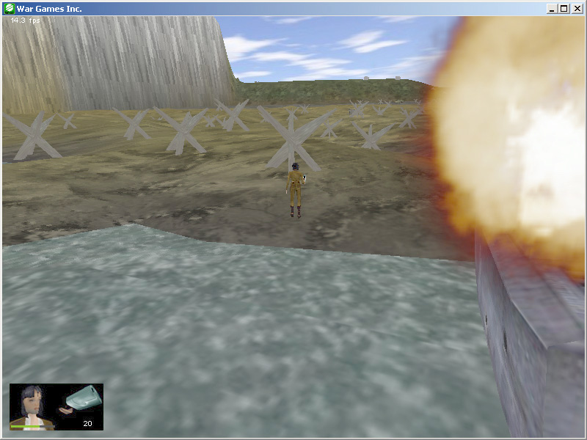  War Games Inc. in-game screenshot

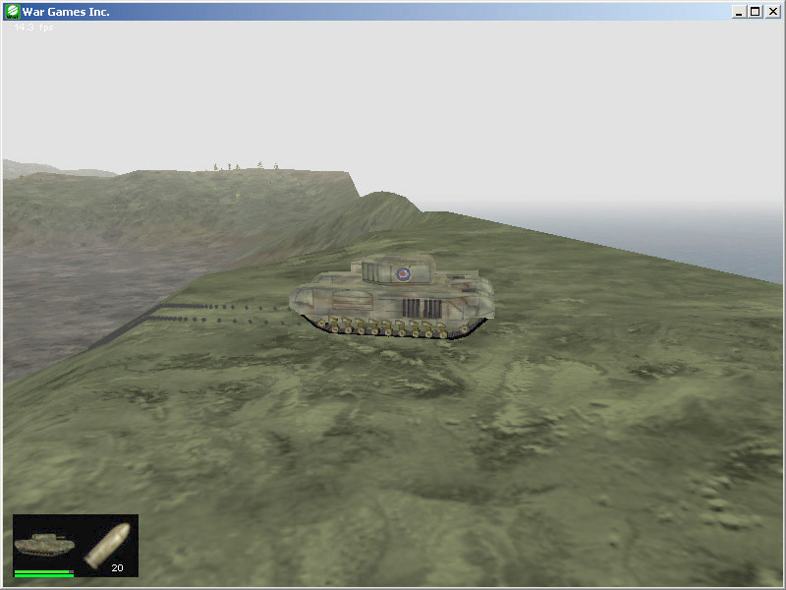  War Games Inc. in-game screenshot | 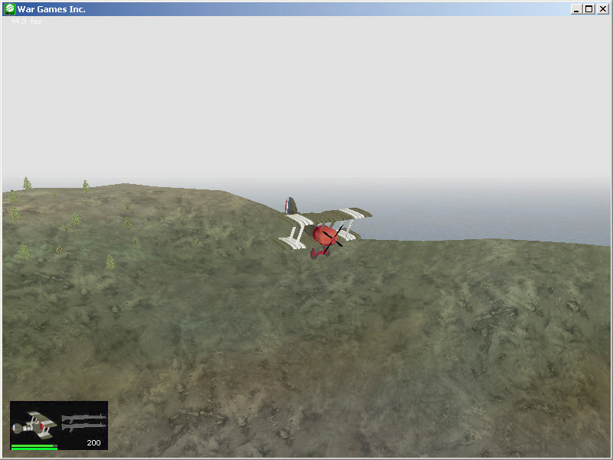  War Games Inc. in-game screenshot

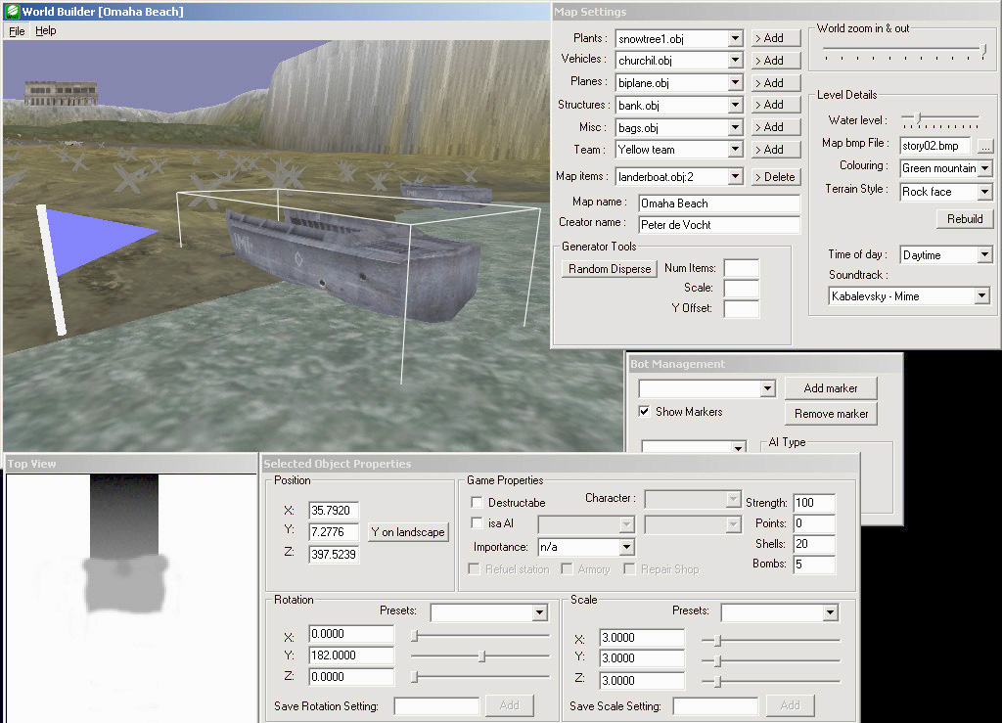
World Builder (level editor and terrain editor) screen-shot

