Performance Comparison: PG, PPO, and TRPO
This report compares the performance of three policy gradient algorithms—Policy Gradient (PG), Proximal Policy Optimization (PPO), and Trust Region Policy Optimization (TRPO)—across five benchmark continuous and discrete control environments. The following graphs show the average performance (episode reward) over training timesteps.

Acrobot-v1
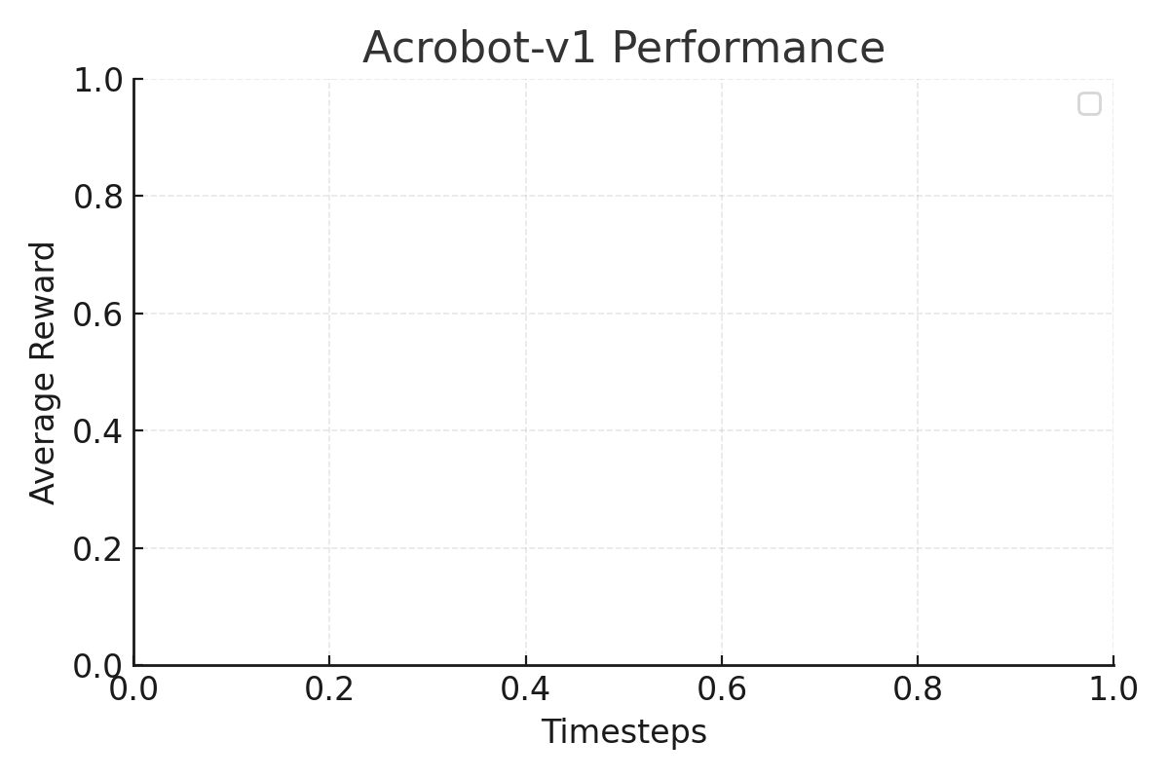

Ant-v5
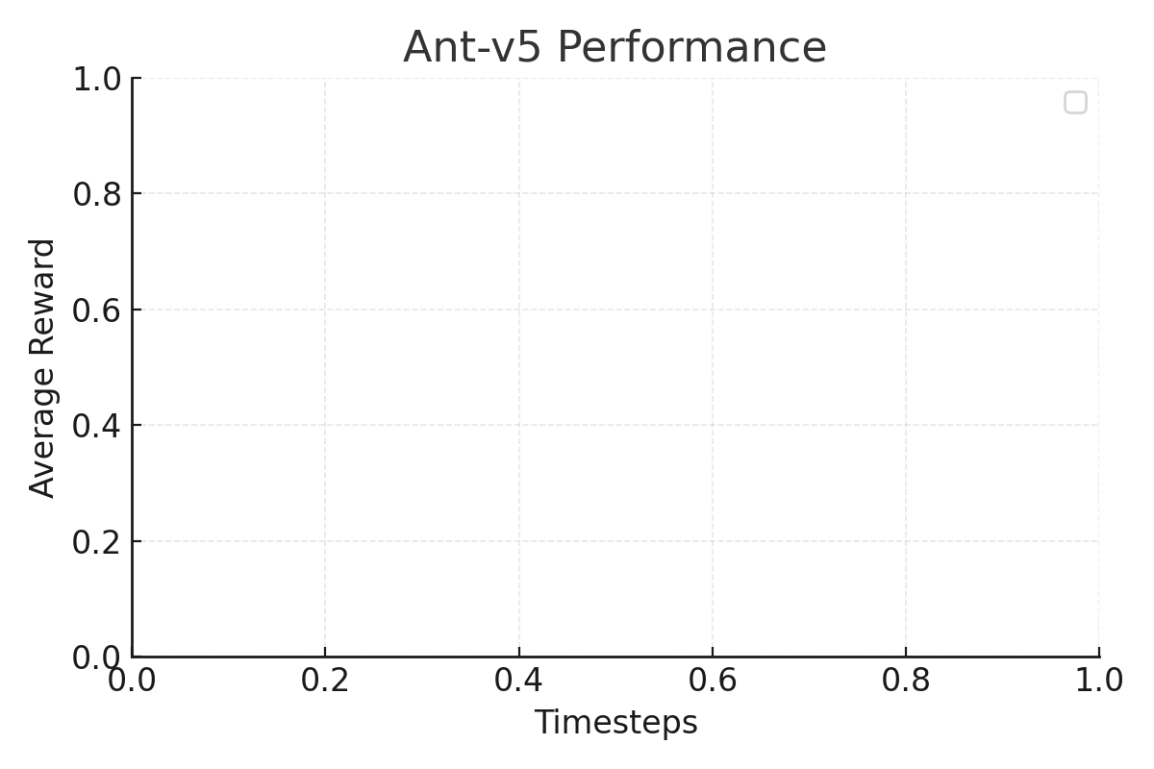

HalfCheetah-v5
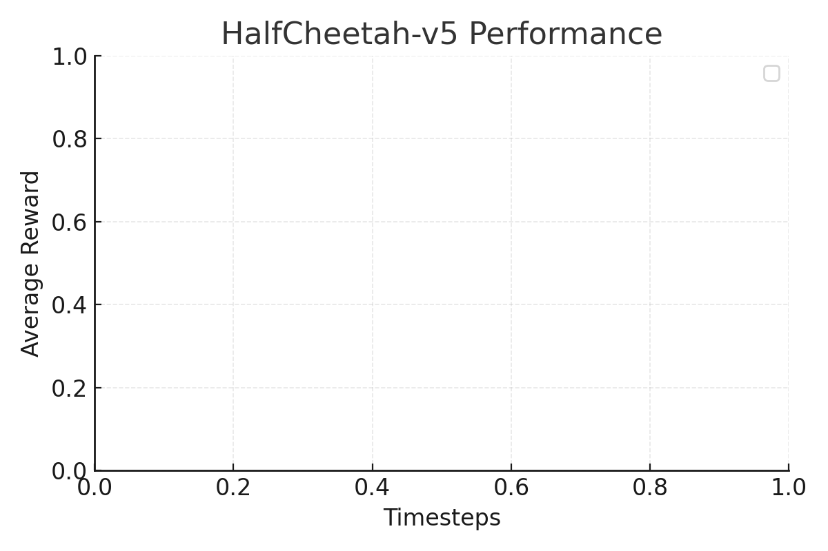

LunarLander-v3
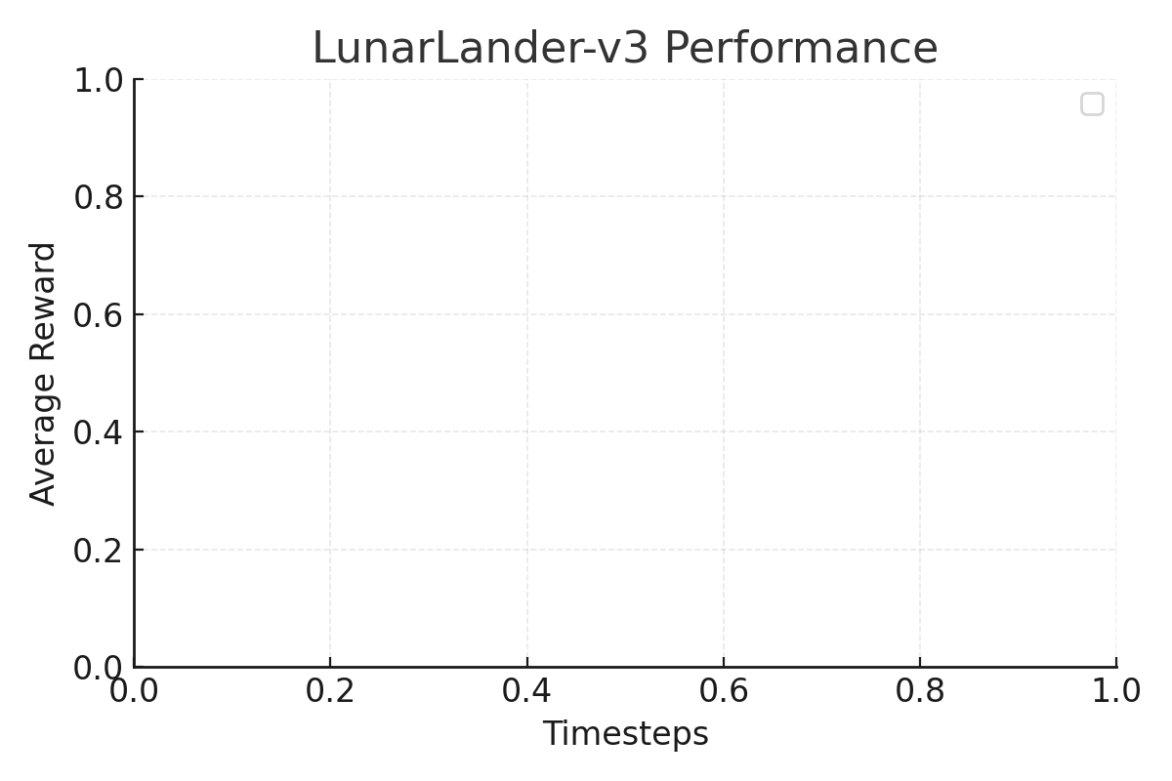

Reacher-v5
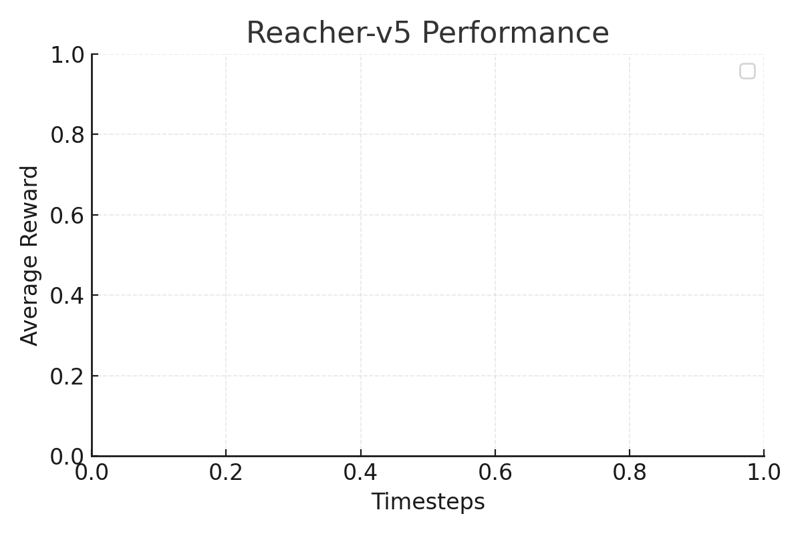

Summary
Across most environments, PPO demonstrates stable and steady improvement, outperforming the baseline PG algorithm significantly and approaching TRPO's performance. TRPO, while more computationally expensive, tends to yield smoother and higher asymptotic rewards. These results align with benchmark findings from OpenAI SpinningUp and Stable-Baselines3.

