25 September – Untouchable
Dir: Eric Toledano & Olivier Nakache France 2011 112mins Cert: 15A
Starring: François Cluzet, Omar Sy, Anne Le Ny, Audrey Fleurot, Clotilde Mollet, Alba Gaïa Bellugi, Cyril Mendy, Christian Ameri
Language:French


France’s most talked-about performance and film this year comes in the shape of this comedy that’s become the country’s second-biggest box-office hit of all time with its portrait of friendship across the racial and economic divide. Paralyzed from the neck down after an accident, gloomy millionaire Philippe (François Cluzet, Tell No One) finds little in life worth living for, until the arrival of his new assistant, Driss (Omar Sy), a Senegalese rowdy from the downtrodden banlieues. A slapstick, gleefully incorrect throwback to ’80s culture-clash comedies like Trading Places, only played out across contemporary France’s ever-palpable racial and class tensions, Untouchable hit a nerve with French audiences, critics hailing it as a cultural milestone and Liberation asking, “Is this the new Amélie?” - Jason Sanders / San Francisco International Film Festival 2012

9 October – A hijacking
Dir:Tobias Lindholm Denmark 2012 103 mins Cert: 15A
Starring: Pilou Asbæk, Søren Malling, Abdihakin Asgar
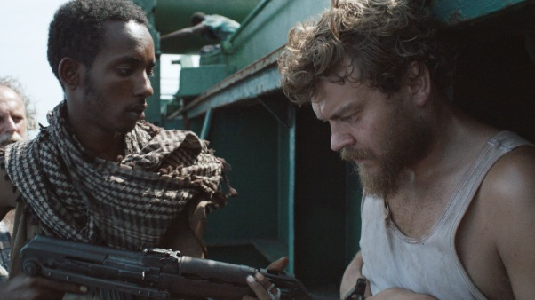
Language: Danish
Tobias Lindholm’s multiple award-winning feature takes a distinctive approach to the story of a cargo ship hijacked by Somali pirates. The drama alternates between the stressed crew on the Rozen and the shipping-company boardroom back home. Søren Malling, best known for his roles in Danish TV series Borgen (which Lindholm also wrote) and The Killing, plays the stern CEO. He sees himself as an ace mediator, and decides to take charge, interfering with the experienced professional (played by a real-life hostage negotiator). Meanwhile, back at sea, the captive crew live in stifling conditions. The mild-mannered chef (Pilou Asbæk) is one of the few who keeps his head. - Sydney Film Festival 2013

23 October– Mud

Dir: Jeff Nichols USA 2012 130mins Cert: 12A
Starring: Starring: Matthew McConaughey, Tye Sheridan, Jacob Lofland, Sam Shepard
Language: English
Ellis and Neckbone are best friends approaching the twilight of their youth. While exploring, they stumble upon the hiding place of charismatic outlaw Mud (played with controlled charm by a well-cast Matthew McConaughey), who takes a quick liking to the boys and recruits them to his cause: the search for true love and a clean getaway.

Illustrating a vibrant imagination, sumptuous attention to detail, and a remarkable gift for extracting magnetic performances from a talented ensemble, Nichols hurtles us into the middle of a lush adventure, ensnaring the excitement every youngster feels when trouble lurks everywhere and anything is possible. Steeped in the vanishing myth of the Deep South, a place that Nichols dearly loves, Mud’s handcrafted vision shines through in each richly textured frame and proves a tall tale for the ages. - Sundance Film Festival 2012
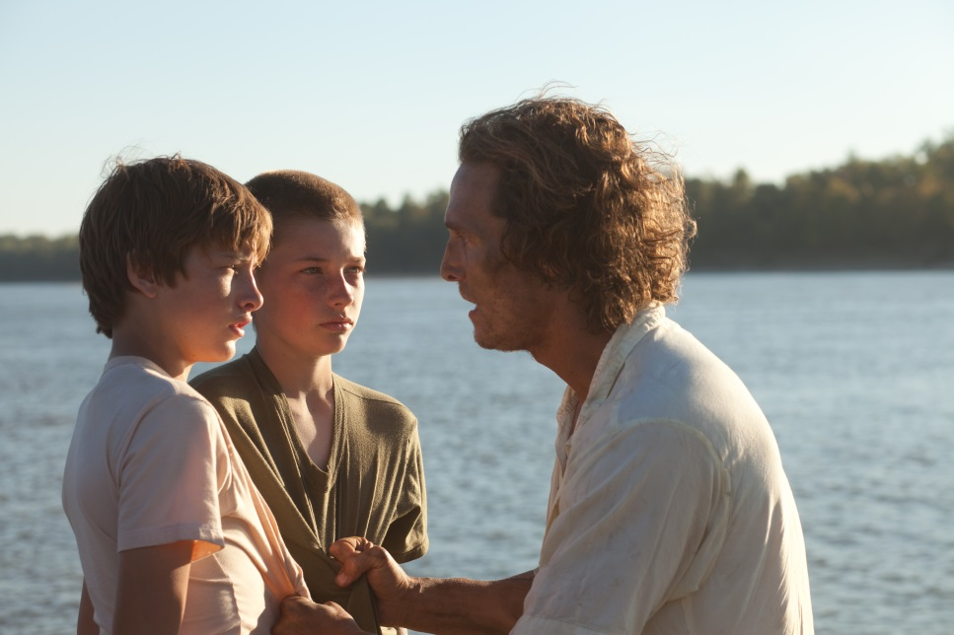
6 November – Lore
Dir: Cate Shortland Germany 2012 109 mins Cert: 15A
Starring: Saskia Rosendahl, Kai Malina, Ursina Lardi, Nele Trebs
Language: German

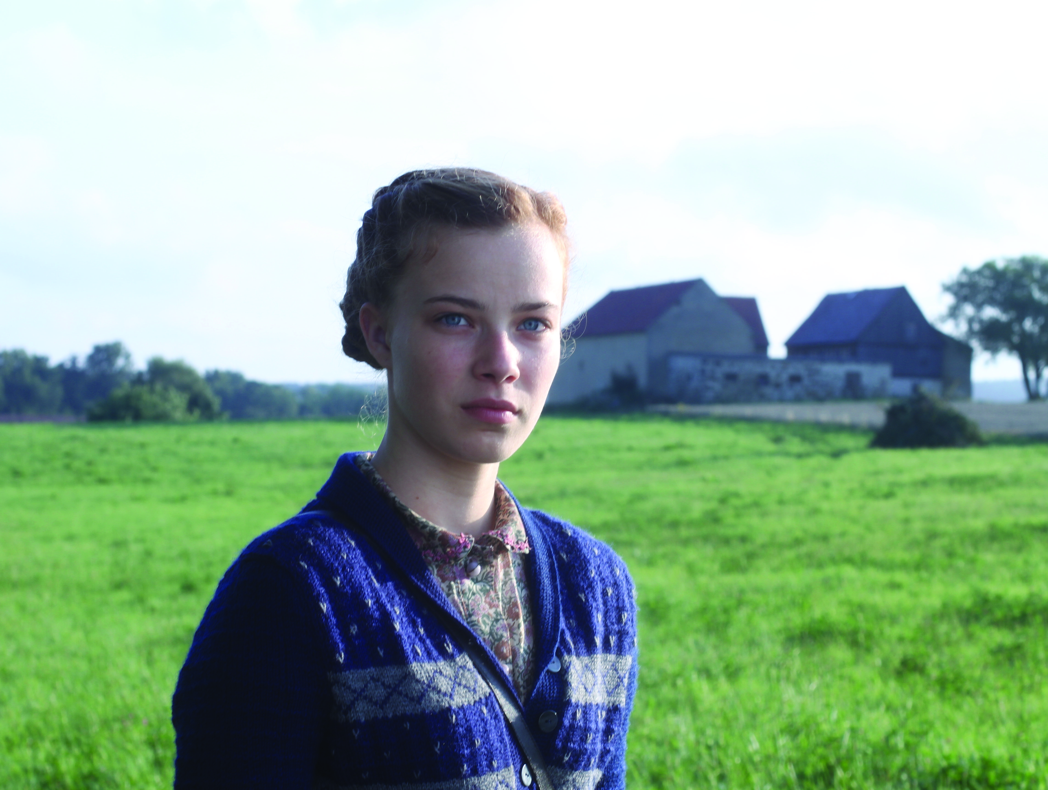
Cate Shortland (Somersault) offers a unique perspective on the nature of collusion with this story of a young German girl who, at the end of WWII, leads her siblings through a devastated and defeated nation. Shortland’s attention to detail and the beauty of the imagery she creates in her account of a national psyche brainwashed to believe in their own supremacy, only to confront the horror that resulted, is filled with brilliance and surprise in equal measure. - Dingle Film Festival 2012

20 November – Love Is All You Need
Dir: Susanne Bier 2012 Denmark 116 mins Cert: 15A
Starring: Trine Dyrholm, Pierce Brosnan, Molly Blixt Egelind, Sebastien Jensen, Paprika Steen, Kim Bodnia, Christiane Schaumburg-Muller, Micky Skeel Hansen
Language: Danish

In a standard romantic comedy, the manner in which Philip (Pierce Brosnan), a widower/workaholic fruit-and-vegetable mogul, and Ida (Trine Dyrholm), a cancer survivor now weathering her husband’s infidelity, first cross paths—trading insults after a fender-bender at the airport—might be construed as a "meet cute." However, Oscar-winning director Susanne Bier (In a Better World) is aspiring to something far more sophisticated here. As these strangers jet off to sunny

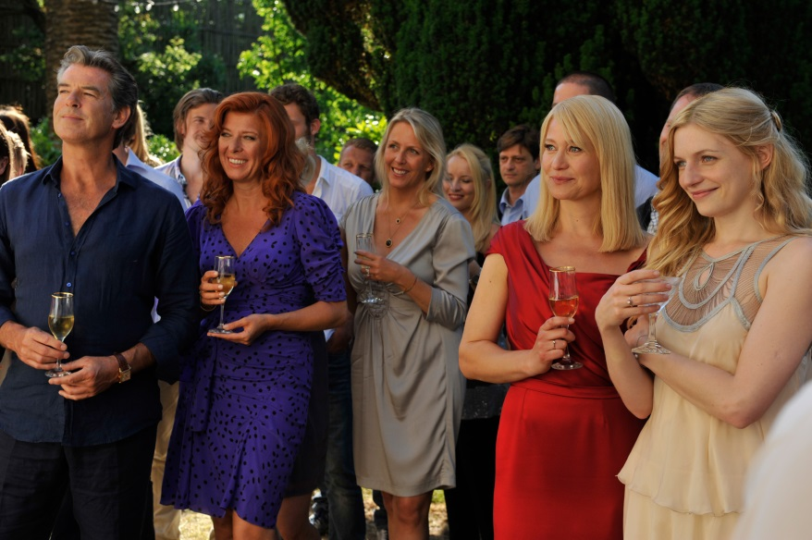
Sorrento for the wedding of his son and her daughter, they tumble into a charming drama containing all of Bier’s exemplary character dynamics and meticulous plot construction. - Vancouver International Film Festival 2012

4 December - I Wish
Dir: Hirokazu Kore-Eda Japan 2012 128 mins Cert: CLUB
Starring: Koki Maeda, Ohshirô Maeda, Nene Ohtsuka, Jô Odagiri
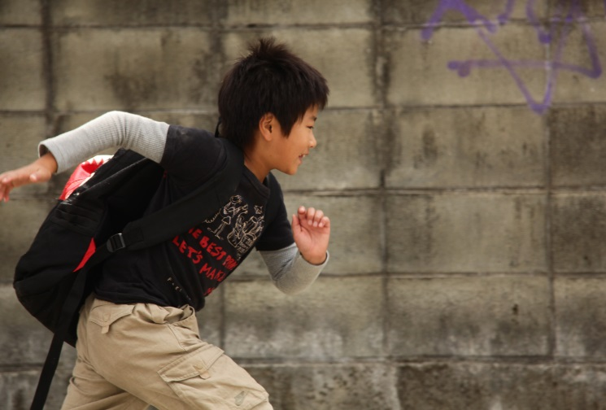
Language: Japanese

Koichi lives with his mother and grandparents in Kagoshima, in the southern part of Kyushu island. His brother Ryunosuke lives with their father in the northern Kyushu town of Hakata. Separated by their parent’s divorce, Koichi desperately yearns to be reunited with his brother. Hearing that a new bullet train line will soon link the two cities, he starts to believe that the miracle will happen the moment the new bullet trains pass one another at top speed. - San Sebastian International Film Festival 2012

