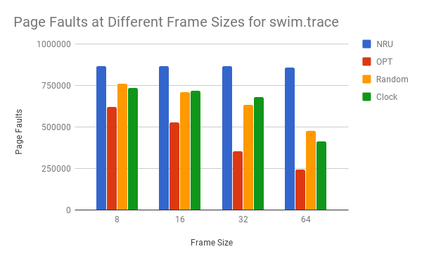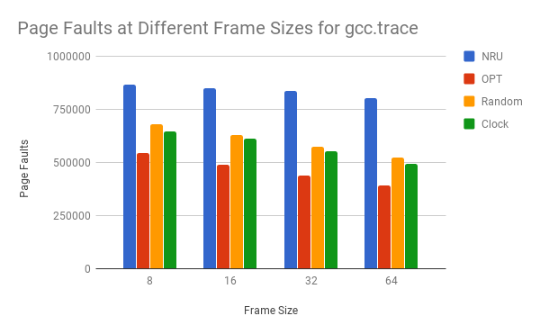 In an actual operating system I would implement the clock algorithm at the highest frame size possible. While OPT did perform best it is impossible to implement because you can never know when an address will get used again or when it will not. Clock was second best at every number of frames for gcc.trace and either second or third for everything in swim.trace. As would be expected for every algorithm the performance increases as the number of frames increases.