 | DEPARTAMENTO DE ENGENHARIA INFORMÁTICA  www.dei.estg.ipleiria.pt

Aplicações para a internet
Engenharia Informática

HTML 5 / CSS 3 Review

Objectives:
- Recall HTML5 and CSS3
- Install Homestead (server environment that will be used in this course)

Note the following:
- Before starting the exercise please read the presentation "AINET Review HTML5 CSS3";
- Every page MUST comply to the HTML5 standard and it must be properly validated as such;

- Go to the official Homestead web page (https://laravel.com/docs/5.4/homestead) and follow the instructions to install the Homestead box. As soon as the box starts to install jump to exercise 2.

Some additional notes:
- On Windows machines install Git for Windows before installing the box. Go to https://git-for-windows.github.io, download the binary and follow the installer's instructions;
- If you have a laptop without virtualization extensions you must install a 32-bit version by cloning the following repository: https://github.com/rmff/laravel-homestead-32bit;
- If you are using OS X with Parallels (instead of Virtualbox) you can install homestead by cloning the following repository: https://github.com/laravel/settler;
- In case of trouble follow the video instructions placed on Moodle.

- Create a web page "markup.html" identical to the one presented on Figure 1. Copy the following text before applying the HTML markup.
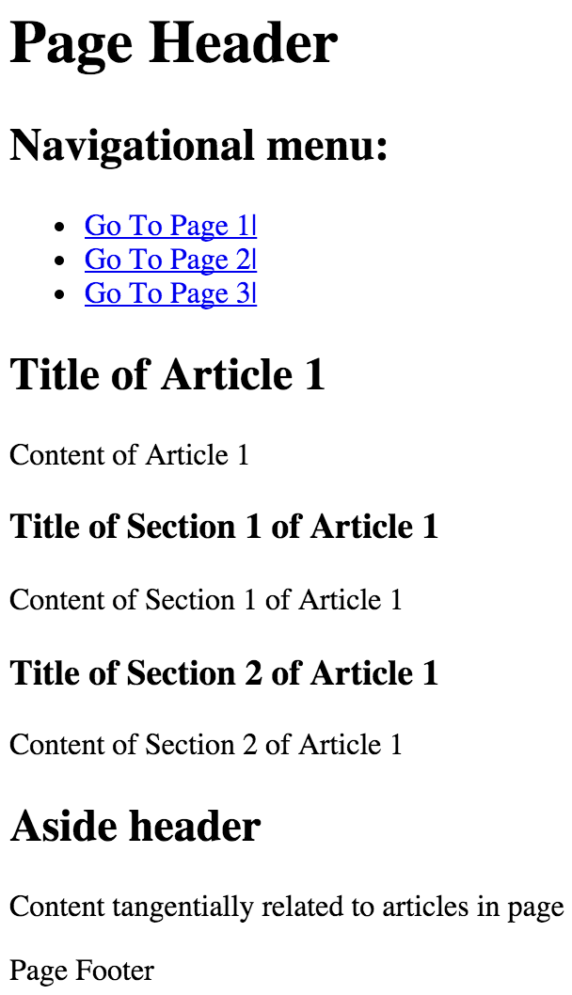Figure 1: markup.html
Page Header
Navigational menu:
Go To Page1 |
Go To Page2 |
Go To Page3 |
Title of Article 1
Content of Article 1
Title of Section 1 of Article 1
Content of Section 1 of Article 1
Title of Section 2 of Article 1
Content of Section 2 of Article 1
Aside header
Content tangentially related to articles in page
Page Footer

Some rules:
- Make sure you use proper semantics such as header, section, article, aside and footer;
- The navigation links are: http://www.w3.org/TR/html5/ (Go To Page 1), http://validator.w3.org/ (Go To Page 2), https://developer.mozilla.org/en-US/docs/Web/HTML (Go To Page 3);
- Use the validator.w3.org validation service to validate the web page.

- Based on the previous exercise, create the web page "layout.html" that must match the one presented on Figure 2. To solve the exercise you need to change the following CSS properties: border, border-radius, padding, margin-top, background-color, width, float, box-sizing and clear. Place the CSS rules on a separated file.
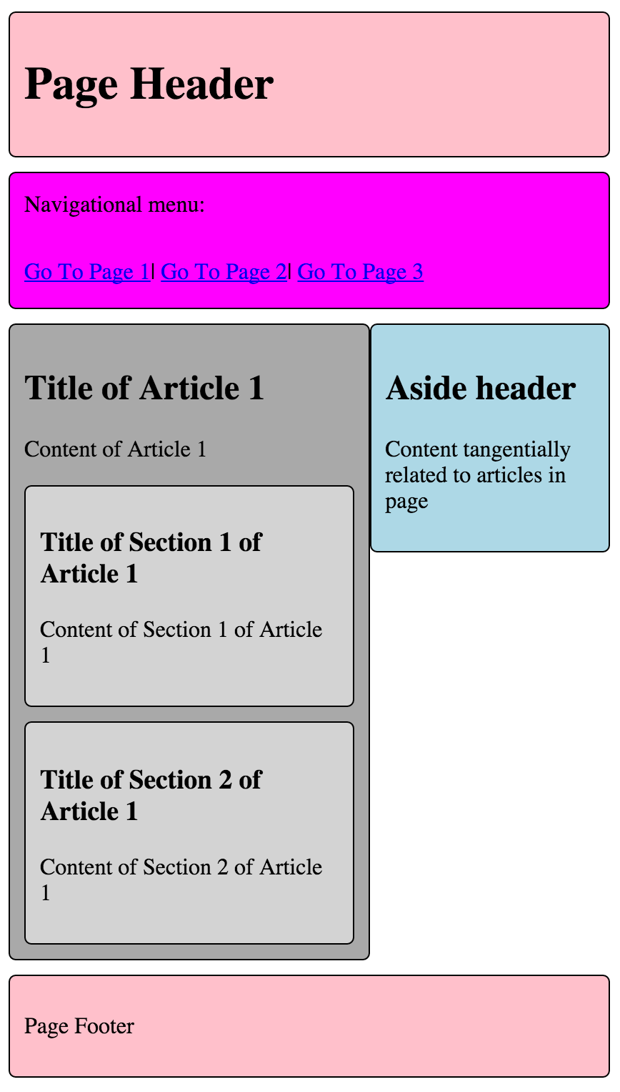Figure 2: layout.html

When writing the stylesheet follow these guidelines:
- vertical distance between boxes: 10px
- padding inside each box: 10px
- border radius for each box: 5px
- colors used: pink, magenta, darkgray, lightgray, lightblue
- two-column split: 60/40

Note: validate both the HTML and CSS files.
- After finishing the installation of the Homestead box, test it with these instructions:
- On you computer, create a folder where you will place all your course materials (e.g. C:\Ainet)

- Inside that folder, create another one to place the first worksheet (e.g. C:\Ainet\ws1).

- To create a virtual host for your first worksheet, edit the Homestead.yaml file and:
- add the following lines to the folders section (don't use tabs):
- map: c:/Ainet/ws1
to: /home/vagrant/ws1
- add the following lines to the sites section (don't use tabs):
- map: ws1.ainet
to: /home/vagrant/ws1

- Edit your hosts file and add the following line at the end:
192.168.10.10 ws1.ainet

Windows tip: create a shortcut with the following target:

"notepad c:\windows\system32\drivers\etc\hosts"

Add make sure that the shortcut is only executed as an administrator.

- Place the "markup.html" and "layout.html" files inside the folder c:\Ainet\ws1

- Open your browser (e.g. Chrome or Firefox recommended), and type:
http://ws1.ainet/markup.html

- You should see your "markup.html" file being served by Homestead. Now, replace "markup.html" with "layout.html" and check if the page is rendered correctly;

- Now that your Homestead box is working, inside the folder C:\Ainet\ws1 create a web page called "test.php". Edit the file and write:
<?php
phpinfo();

- Open your browser and type:
http://ws1.ainet/test.php

- The browser should render a page similar to the following one:

