Afr-Egy-Shabti-2016-2

# 

# Order details

## Sales order

Sold by [amafamily12](http://myworld.ebay.com/amafamily12) ( [63](http://feedback.ebay.com/ws/eBayISAPI.dll?ViewFeedback&userid=amafamily12) )

### Delivery package 1 of 1

Estimated delivery Monday, Feb 29, 2016 - Monday, Mar 7, 2016

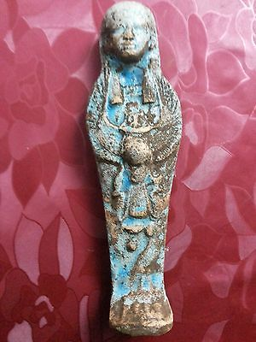

#### [Ancient Egyptian blue Ushabti](http://www.ebay.com/itm/161969717566)

|  |  |
| --- | --- |
| Item price | $40.00 |
| Quantity | 1 |
| Item number | 161969717566 |
| Shipping service | Standard Shipping |

