Afr-Egy-Pharoah-Alabaster

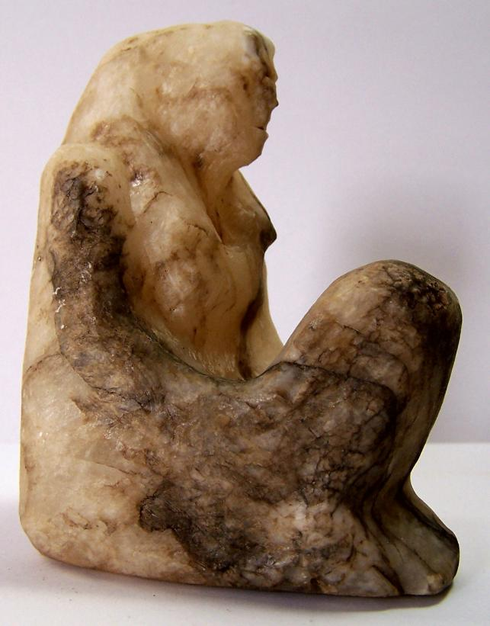

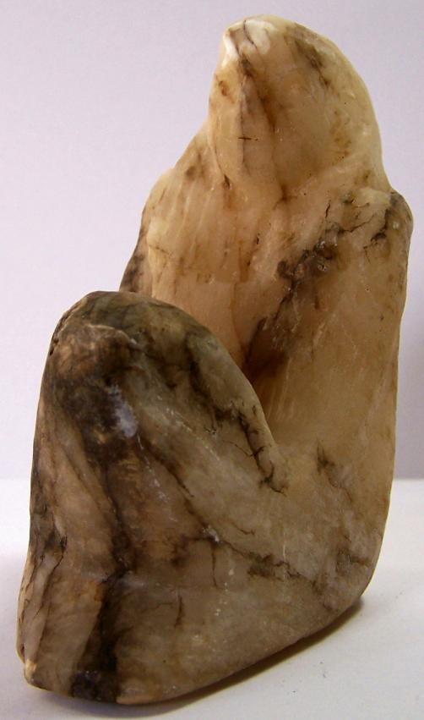

| Shipping details |
| --- |
| **Ralph J Coffman Jr**  149 Atlantic Ave  Swampscott MA 01907-2427  United States |

## Order details

|  |  |  |  |
| --- | --- | --- | --- |
| **Item title** | **Available actions** | **Shipping & handling (estimated delivery*)** | **Price** |

[Printer version](http://payments.ebay.com/ws/eBayISAPI.dll?ViewPaymentStatus&transid=0&userloginid=802-867&orderid=128344462018&printerversion=true&itemid=360544087120)

|  |  |  |
| --- | --- | --- |
| Seller: | [**Member id** antiquewd](http://myworld.ebay.com/antiquewd) ( [**Feedback Score Of** 1527](http://feedback.ebay.com/ws/eBayISAPI.dll?ViewFeedback&userid=antiquewd)) | [Contact seller](http://contact.ebay.com/ws/eBayISAPI.dll?ShowCoreAskSellerQuestion&frm=3998&iid=0&redirect=0&requested=antiquewd) |

|  |  |  |  |  |
| --- | --- | --- | --- | --- |
| **Order # 128344462018**  Paid on Dec-23-12 via PayPal | | | | |
|  |  | |  | | --- | |  | | |  |  | | --- | --- | | [Contact seller](http://contact.ebay.com/ws/eBayISAPI.dll?ShowCoreAskSellerQuestion&frm=3998&iid=360544087120&redirect=0&requested=antiquewd) |  | | |  |  |

|  |  |  |  |  |  |  |  |
| --- | --- | --- | --- | --- | --- | --- | --- |
| [**Item Title:** Near Eastern style clay statue figure**- opens in a new window or tab**](http://cgi.ebay.com/ws/eBayISAPI.dll?ViewItem&item=360544087120)  **Item Id:**360544087120 - Price: US $20.50  Quantity:1  Having a problem with this purchase? [We can help](javascript:;) | |  | | --- | |  | | |  |  | | --- | --- | | [Leave feedback](http://feedback.ebay.com/ws/eBayISAPI.dll?LeaveFeedbackShow&useridfrom=802-867&useridto=antiquewd&item=360544087120&transactid=0) |  | | | Standard Shipping : **US $29.00**  USPS First Class Package®  Estimated delivery: December 27 - December 31 | US $20.50 |
| [**Item Title:**Near Eastern stone style rolling stamp**- opens in a new window or tab**](http://cgi.ebay.com/ws/eBayISAPI.dll?ViewItem&item=370718327574)  **Item Id:**370718327574 - Price: US $26.00  Quantity:1  Having a problem with this purchase? [We can help](javascript:;) | |  | | --- | |  | | |  |  | | --- | --- | | [Leave feedback](http://feedback.ebay.com/ws/eBayISAPI.dll?LeaveFeedbackShow&useridfrom=802-867&useridto=antiquewd&item=370718327574&transactid=0) |  | | | Shipped with item above | US $26.00 |

|  |  |  |  |  |  |  |  |
| --- | --- | --- | --- | --- | --- | --- | --- |
| [**Item Title:**Egyptian stone style statue figure**- opens in a new window or tab**](http://cgi.ebay.com/ws/eBayISAPI.dll?ViewItem&item=370718335516)  **Item Id:**370718335516 - Price: US $76.00  Quantity:1  Having a problem with this purchase? [We can help](javascript:;) | |  | | --- | |  | | |  |  | | --- | --- | | [Leave feedback](http://feedback.ebay.com/ws/eBayISAPI.dll?LeaveFeedbackShow&useridfrom=802-867&useridto=antiquewd&item=370718335516&transactid=0) |  | | | Shipped with item above | US $76.00 |