Afr-Egy-Ushabtis

Authentic Ancient Egyptian Baby Horus

 & Antique Shabti Figurines

The White Egyptian Baby Horus (top, center) is 100% authentic ancient Egyptian

from the Collection of the Late Michael Verney-Elliott

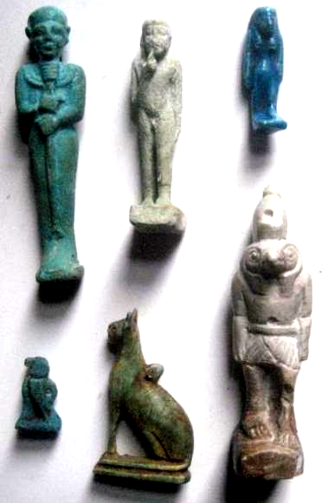

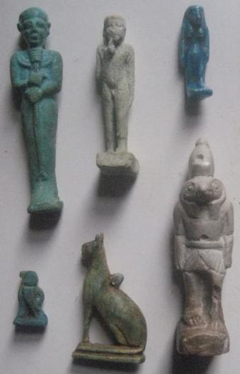

|  |  |
| --- | --- |
| Order details |  |
|  |  |
| Payment details |  |
|  |  |

|  |
| --- |
| Shipping details |
| **Ralph J Coffman Jr**  149 Atlantic Ave  Swampscott MA 01907-2427  United States |

## Order details

|  |  |  |  |
| --- | --- | --- | --- |
| **Item title** | **Available actions** | **Shipping & handling (estimated delivery*)** | **Price** |

[Printer version](http://payments.ebay.com/ws/eBayISAPI.dll?ViewPaymentStatus&transid=0&userloginid=802-867&printerversion=true&itemid=390515814566)

|  |  |  |
| --- | --- | --- |
| Seller: | [**Member id** russelliott](http://myworld.ebay.com/russelliott) ( [**Feedback Score Of** 4486](http://feedback.ebay.com/ws/eBayISAPI.dll?ViewFeedback&userid=russelliott)) | [Contact seller](http://contact.ebay.com/ws/eBayISAPI.dll?ShowCoreAskSellerQuestion&frm=3998&iid=390515814566&redirect=0&requested=russelliott) |

|  |  |  |  |  |
| --- | --- | --- | --- | --- |
| Your Dec-23-12 payment is being processed through PayPal | | | | |
|  |  |  |  |  |

|  |  |  |  |  |  |  |  |  |
| --- | --- | --- | --- | --- | --- | --- | --- | --- |
|  | [**Item Title:**Authentic Ancient Egyptian Baby Horus & Shabti Figurines**- opens in a new window or tab**](http://cgi.ebay.com/ws/eBayISAPI.dll?ViewItem&item=390515814566)  **Item Id:**390515814566 - Price: GBP 207.55  Quantity:1  Having a problem with this purchase? [We can help](javascript:;) | |  | | --- | |  | | |  |  | | --- | --- | | [View PayPal transaction**- opens in a new window or tab**](http://payments.ebay.com/ws/eBayISAPI.dll?IntermediateResolutionInfo&qs=transid%3D0%26buyerorseller%3D0%26sspagename%3DBuyTransCS%26itemid%3D390515814566&transid=0&pn=UnifiedCheckoutSummaryRedirect2PP&itemid=390515814566) |  | | | Standard Int'l Postage : **GBP 9.99**  Estimated delivery: Varies* You can [contact the seller](http://contact.ebay.com/ws/eBayISAPI.dll?ShowCoreAskSellerQuestion&frm=3998&iid=390515814566&SSpagename=PageAskSellerQuestion_VI&redirect=0&requested=russelliott) for more information. | GBP 207.55 |



|  |  |  |  |  |
| --- | --- | --- | --- | --- |
|  | | |  | |
|  |  | |  |  |  |  |  |  |  |  |  |  |  |  |  |  |  |  |  |  | | --- | --- | --- | --- | --- | --- | --- | --- | --- | --- | --- | --- | --- | --- | --- | --- | --- | --- | | |  | | --- | | |  |  |  |  |  |  |  |  |  |  |  |  |  |  |  | | --- | --- | --- | --- | --- | --- | --- | --- | --- | --- | --- | --- | --- | --- | --- | | |  |  | | --- | --- | | Subtotal: | GBP 207.55 | |  | | | Shipping & handling: | GBP 9.99 | |  | | |  | | |  | | | Total: | GBP 217.54 | | | | | |  |