Dis-AFR-Sahara-Neolithic-Venus

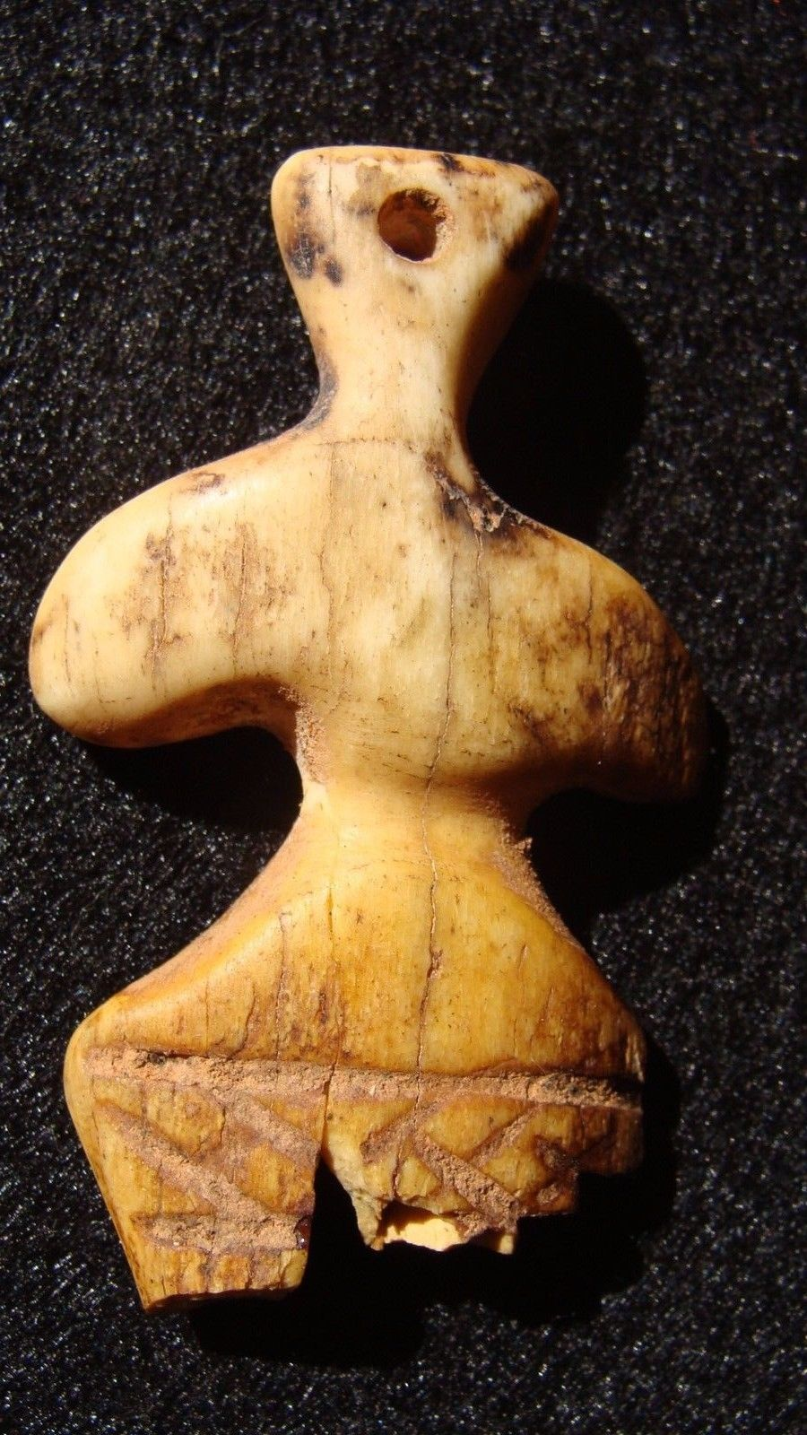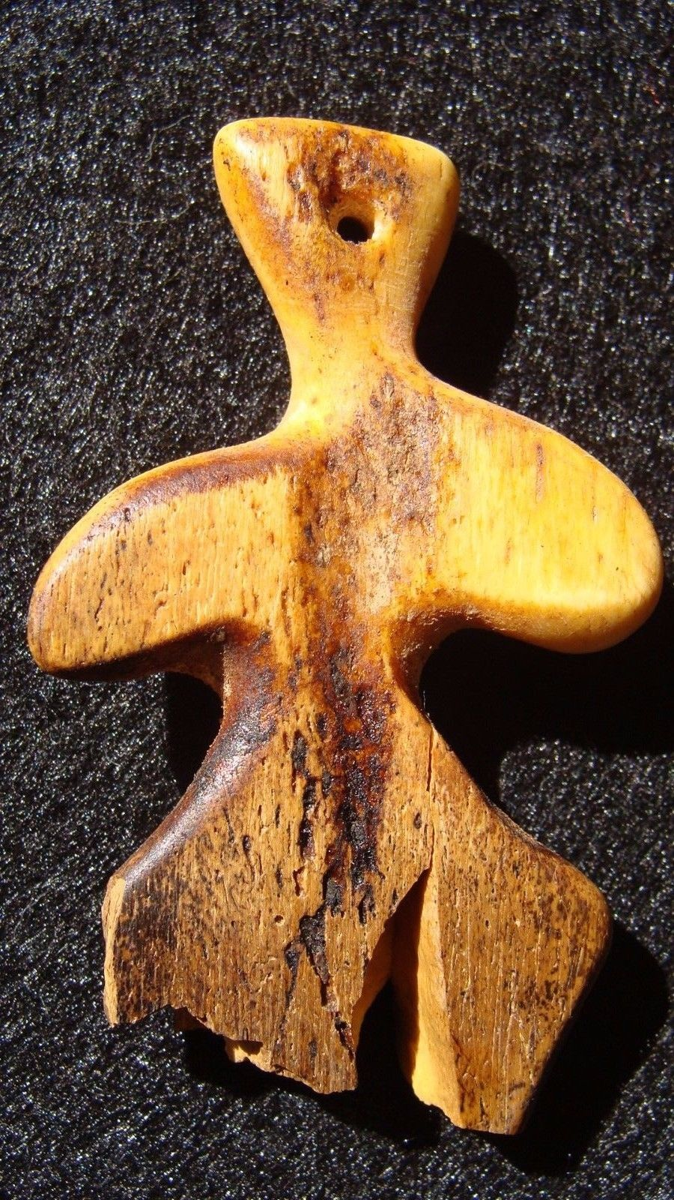

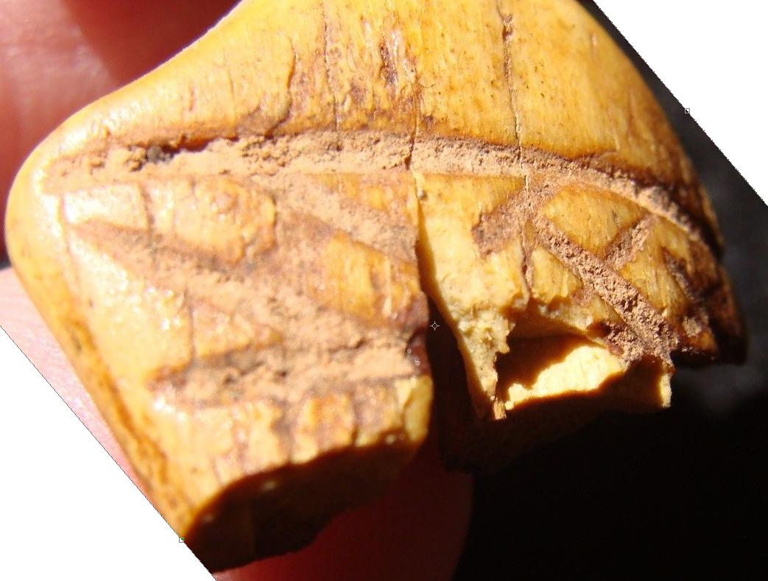

Formal Label:

Accession Number:

Date or Time Horizon:

Geographical Area:

Cultural Affiliation:

Media:

Dimensions:

Weight:

Provenance: