Afr-Aterian-Dates

Aterian may be termed a Middle Paleolithic or Late Pleistocene flake-oriented technocomplex with a huge geographic area extending across North Africa and is defined by tanged lithics with similarities to Mousterian use of Le­vallois technique and some formal tools, resembling Upper Paleolithic technology, and, hence, is similarities to the Mousterian tradition, particularly for the presence of Le­vallois technique and a marked evolution of some formal tools, which re­semble elements of Upper Paleolithic technology, and, hence, is generally believed to have developed from of the Middle Paleolithic-Middle Stone Age (MP-MSA) ‘‘Mousterian’’ (e.g., Hahn 1984; Wengler 1997). The phenomenon of tanged lithic artifacts can be found in MP-MSA contexts on the Arabian Peninsula (McClure 1994). With regard to the central Sahara, the Aterian technocomplex is key for relationship to the Mousterian and to the dispersion of Homo sapiens from the Nile Valley, to the eastern Sa­hara, and to the Maghreb in the MP-MSA /Upper Paleolithic transition. The following Aterian dates suggest this **west to east flow of Aterian culture**:

103±3 ka (mean OSL) La Grotte des Contrebandiers on the Atlantic coast of Morocco with Moroccan Mousterian 116 3± ka with a hiatus of up to 13 ±3 ka. -Rabat-Moroco Barton-l-2009-OSL-dating-Dar-es-Soltan-I

47,000 ± 3200: Haua Fteah, a karstic cave in Cyrenaica, Libya,

Taforalt >40,000 (or Grotte des Pigeons), a cave located in the northern Oujda region of Morocco,

>39,900: Wadi Saoura, in southwestern Algeria,

>35,000 Bir el Ater, in far eastern Algeria the type site of the MP-MSA Aterian,

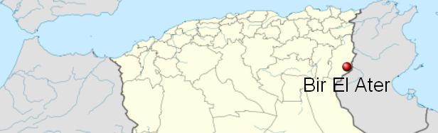

>30,000 Dar es Soltan the type site of the last 'glacial' period known as the Soltanian (Choubert, 1953; Choubert et al., 1956) a low calcarenite cliff on the Atlantic coast of Morocco near Rabat (33°58′44″N, 6°53′51″W)

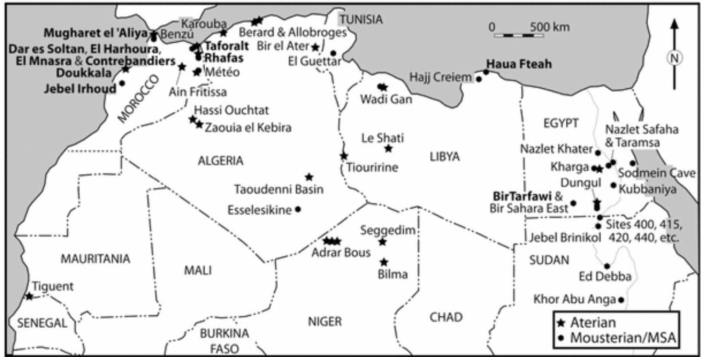.

From

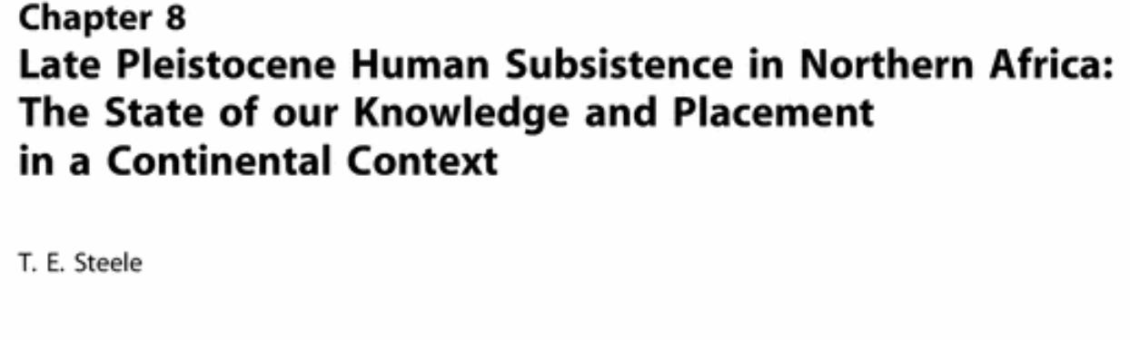

# Modern Origins 2012

|  |  |
| --- | --- |
| **Editors** | Jean-Jacques Hublin • Shannon P. McPherron |

T. E. Steele

Radiocarbon Dates of Aterian Sites in North Africa

Sites Age BP Lab. No. Reference

.

|  |  |  |  |
| --- | --- | --- | --- |
| Grotte des Contrebandiers | 103±3 ka OOOSL(OSL) |  |  |
| Grotte des Contrebandiers | 24,500 ± 600 | Gif-2582 | Delibrias *et al.* (1982) |
| Grotte des Contrebandiers | 23,700 ± 1000 | Gif-2585 | Delibrias *et al.* (1982) |
| Dar es Soltan | >27,000 | UCLA-678B | Ruhlmann (1951) |
| Dar es Soltan | >30,000 | UCLA-878A | Roche (1956) |
| Taforalt (layer 18) | >32,370 +2470/-1890 | Gif-2276 | Debenath (1992) |
| Taforalt (layer 19) | >34,550 +3200/-2280 | Gif-2277 | Debenath (1992) |
| Taforalt (base layer 19) | >40,000 | G if-2588 | Debenath (1992) |
| Taforalt (top layer 19) | >40,000 | Gif-2589 | Debenath (1992) |
| Taforalt (layer 23) | >40,000 | Gif-2279 | Debenath (1992) |
| Bir el Ater | >35,000 | MC-657 | Close (1980) |
| Wadi Saoura | >39,900 | 1-1787 | Chavaillon (1964) |
| Haua Fteah | 47,000 ± 3200 | GrN-2023 | McBurney (1967) |

McClure, H. A. (1994). A new Arabian stone tool assemblage and

notes on the Aterian industry of North Africa. Arabian Archaeology

and Epigraphy, 5, 1–16.

• 

## • [Single-grain OSL dating at La Grotte des Contrebandiers (‘Smugglers’ Cave’), Morocco: improved age constraints for the Middle Paleolithic levels](http://www.sciencedirect.com.libproxy.mit.edu/science/article/pii/S0305440311003128)

Original Research Article

• *Journal of Archaeological Science*, *Volume 38, Issue 12*, *December 2011*, *Pages 3631-3643*

• Z. Jacobs, M.C. Meyer, R.G. Roberts, V. Aldeias, H. Dibble, M.A. El Hajraoui