DIS-Afr-Kongo-N’kisi

*N’kisi* (plural, *miN’kisi*), a container or object in which medicines (*bilongo*) have been incorporated into or applied to in order to make it potent, is intimately associated with Kongo kingdom origins ca. 1100 AD/CE and the BaKongo (sing., Kongo) people as a whole (in modern western Zaire).

Around 1100 AD/CE Ntinu Lukeni or Weni (son of a local king) in the Bantu Kongo-speaking Vungu (Bungu) Kingdom on the north bank of the Nzadi River, invaded the south bank of the river where three groups of aboriginal, pygmy inhabitants were found: BaMbaka-mbaka, Mbwidi-Mibodila and BaFula Mengo. These pygmies were characterized by the BaKong as having hydrocephaly (large heads), which metaphorically and symbolically referred to the pygmy’s profound knowledge of the riches of the forests in which they lived and the medicines they derived from local plants.

This hydrocephalic symbolism was visualized by the adjacent Kuba who live in the Lower Kasai Riverregion of central incorporated into the Bwoom masks with additional symbolic paraphernalia suggesting their ancient origins.

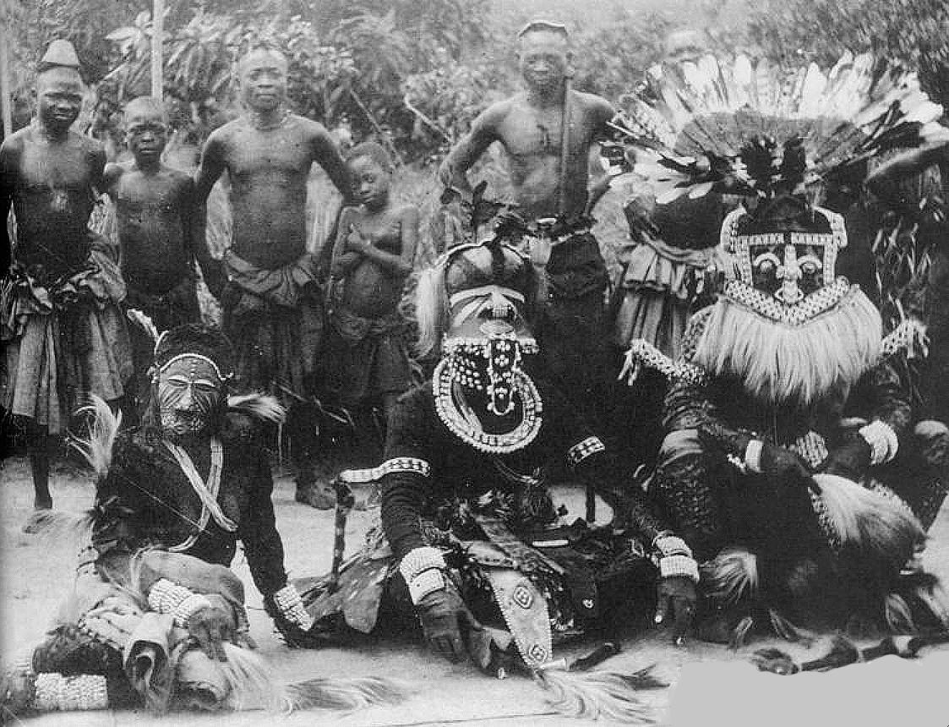

Fig. 1. Kuba masqueraders, Nesheng, southern Kasai River, 1909. **Bwoom** mask, front, center, of hydrocephalic (large-headed) aboriginal pygmy symbolizing local knowledge of the forest and its riches. Front-center, right: **Mwaash aMbooy**, representing Woot, the founding ancestor of the Kuba. Front–center left: **Ngady Mwaash aMbooy**, the incestuous sister-wife of Woot.

In order to incorporate this knowledge into BaKongo culture, Ntinu Lukeni married the daughter of a local pygmy spiritual leader, Manikabunga, established the town of Mpemba Kasi (near the modern village of Matadi in the Kwilu valley), where the original Kongo Kingdom rulers would be buried, and possibly initiated the tradition of using pygmy medicines (*bilongo*) in conjunction with miN’kisi which may have had their origins with Manikabunga.

In order to economically establish the Kongo Kingdom, Ntinu Lukeni began to charge tolls for passage of traders along the Nzadi River. In order to culturally establish a BaKongo hegemony he required indigenous peoples along the banks of the Nzadi River to speak Kongo, a Bantu language and required his men to marry the daughters of indigenous non-Bantu chiefs.

Then Motinobene

M*in’kisi* which can take many forms only have an animate being when *bilongo* energize them. *Bilongo* are often in the form of sachets tied to the statuettes and contain ingredients with metaphoric symbolism that is intended to evoke a desired action.

In addition, the client must also meld ontologically with the *n’kisi,* and this may be accomplished through the application of color symbolism in the form of pigments (white and red) that metonymically establish a connection between the client, the powerful dead and the *n’kisi* sculpture (MacGaffey 1986: 139-141). Kaolin or white clay (*mpemba*) literally means “land of the dead” or “cemetery.” Kaolin is found in streambeds and corresponds to the belief that “the dead live in or under the water and are white in color” (Van Wing 1941). Another important pigment is red ochre (*nsadi*) “also associated with the dead’ and implies “transition” (Van Wing 1941).

In actual practice, a priest (*nganga* or *nganga’a n’kisi)* acts on behalf of the individual client to prepare the *n’kisi* *bilongo*. Then the client identifies the potency of the elements of the *bilongo* in her/his being through the agency of the *nganga* and is cautioned to avoid their powers, while at the same time through the physical application of red and white pigments to her/his body establishes a direct connection with the powerful dead. Disjunction with the metaphoric elements and conjunction with the metonymic elements encompass the completeness of the *n’kisi* rite (MacGaffey 1986: 141).

References:

MacGaffey, Wyatt. 1986. *Religion and society in central Africa: the Bakongo of Lower Zaire*. Chicago: University of Chicago Press.

Van Wing, Joseph Hubert Leopold. 1941. *Études Bakongo*. II. *Religion et magie*. Institut royal colonial belge. Section des sciences morales et politiques. Mémoires, collection in-8°, t. IX, fasc. 1. Brussels: Desclée de Brouwer.