DIS-AM,C-Taino-Amulets-2016-1-11

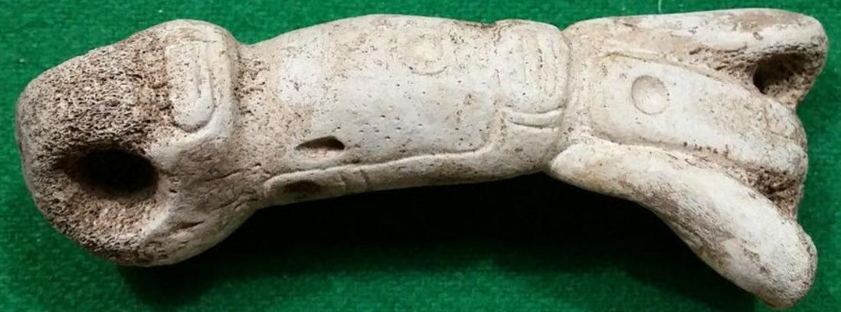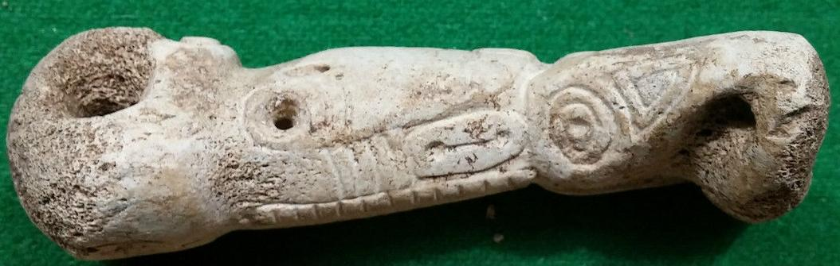 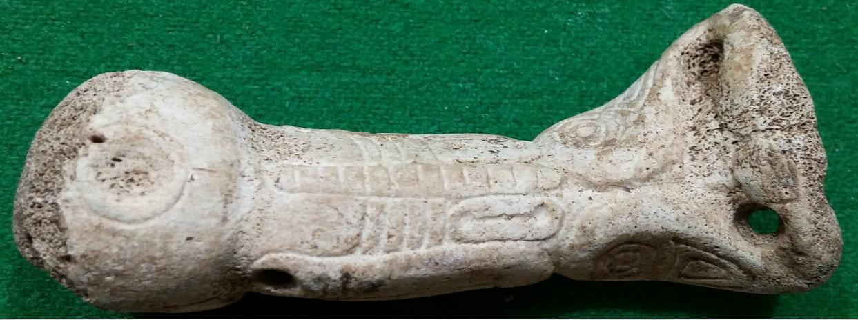 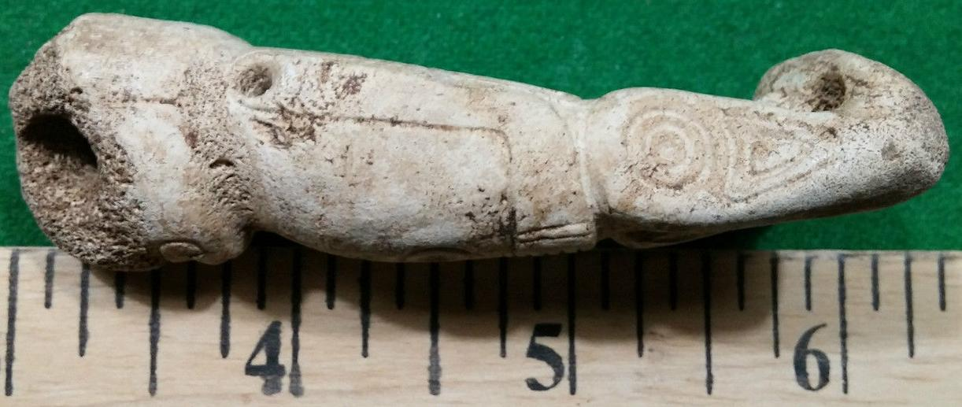

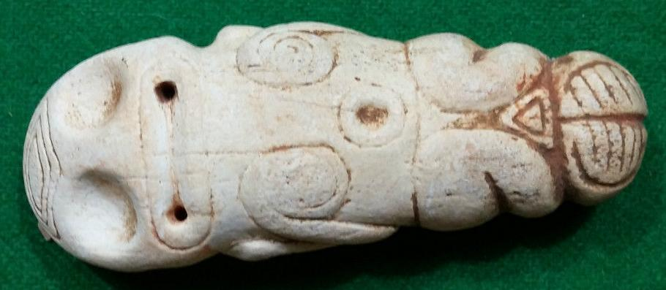

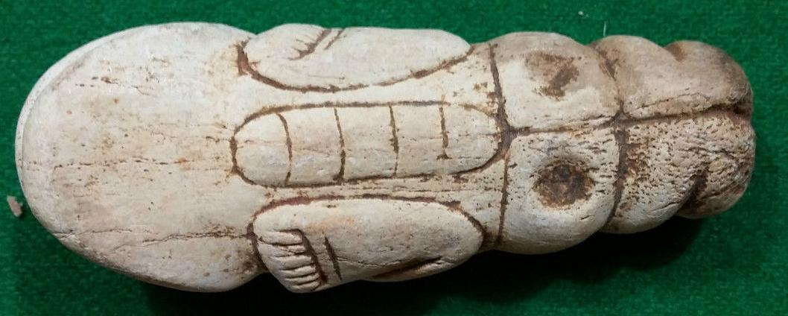

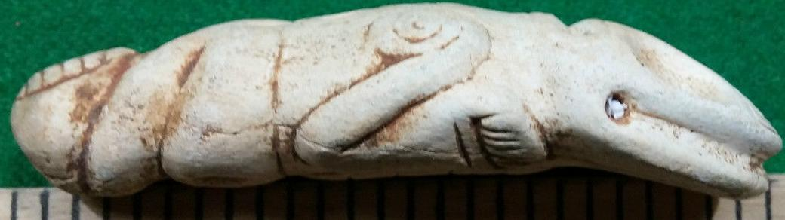

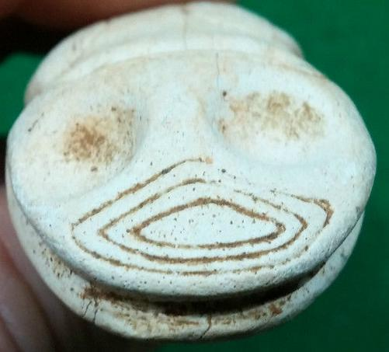

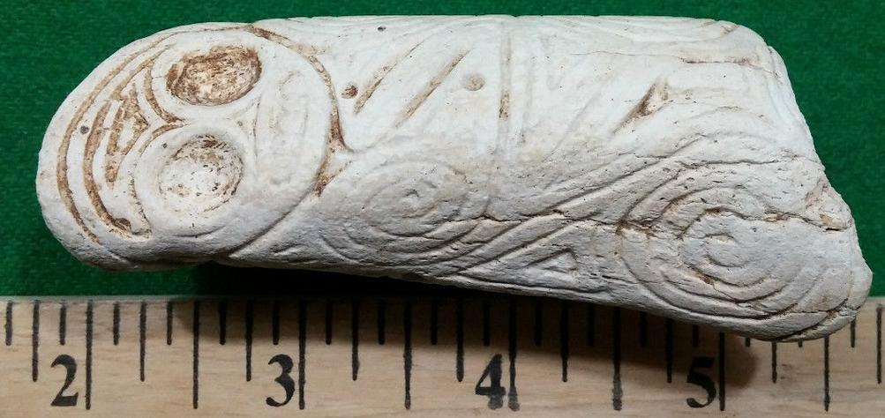 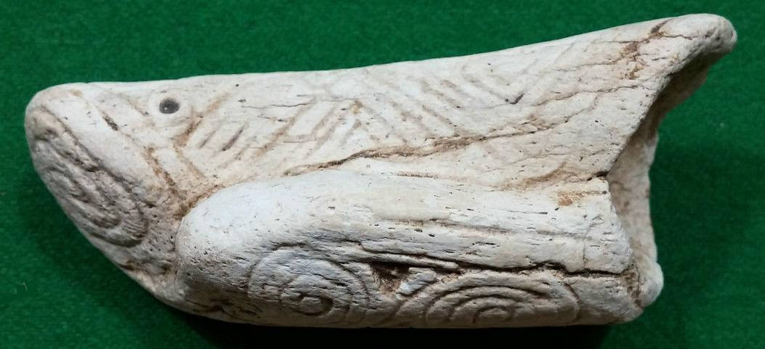

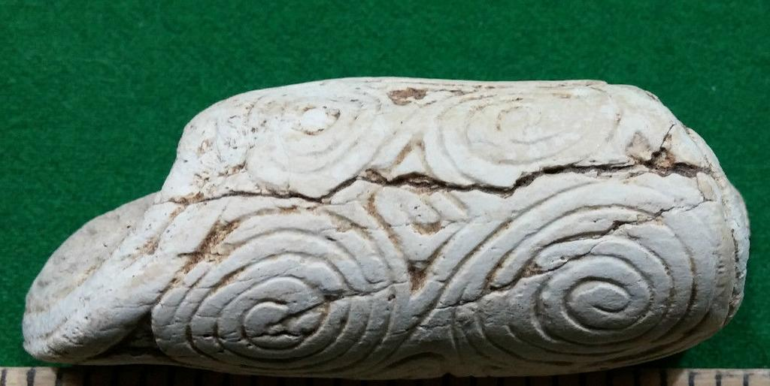

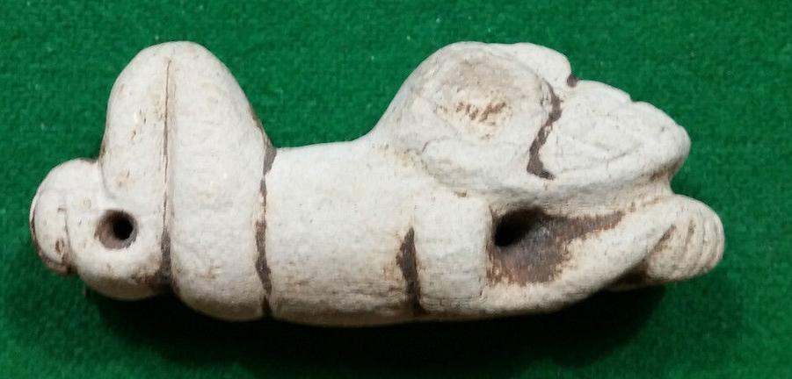

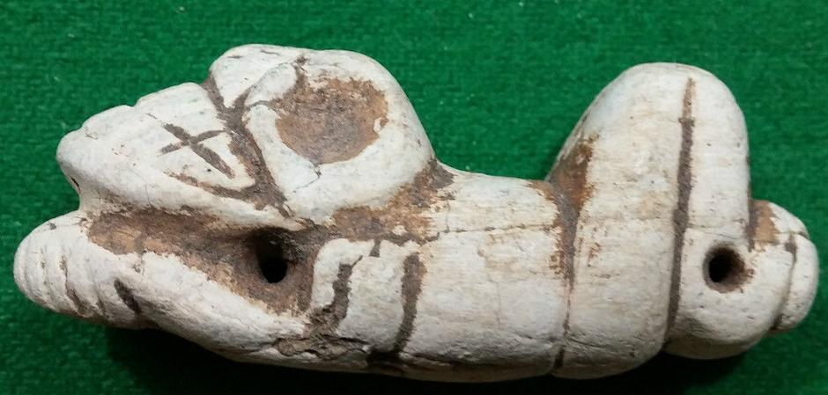

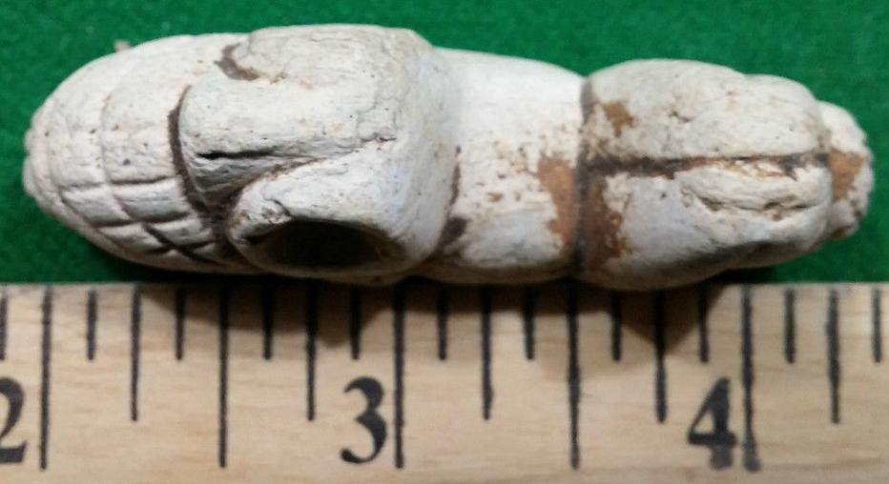 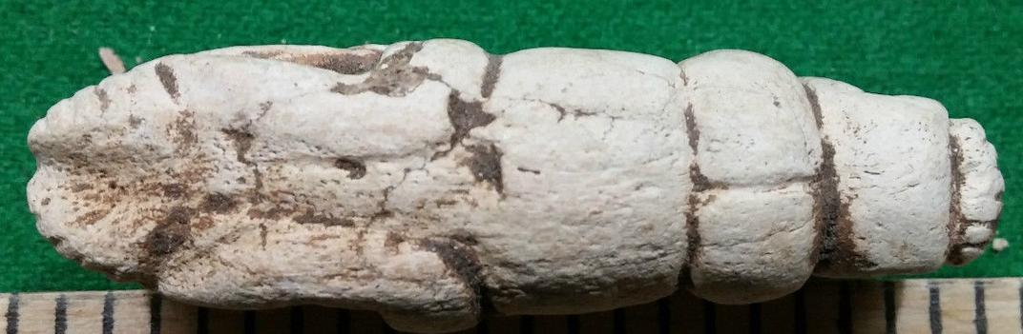

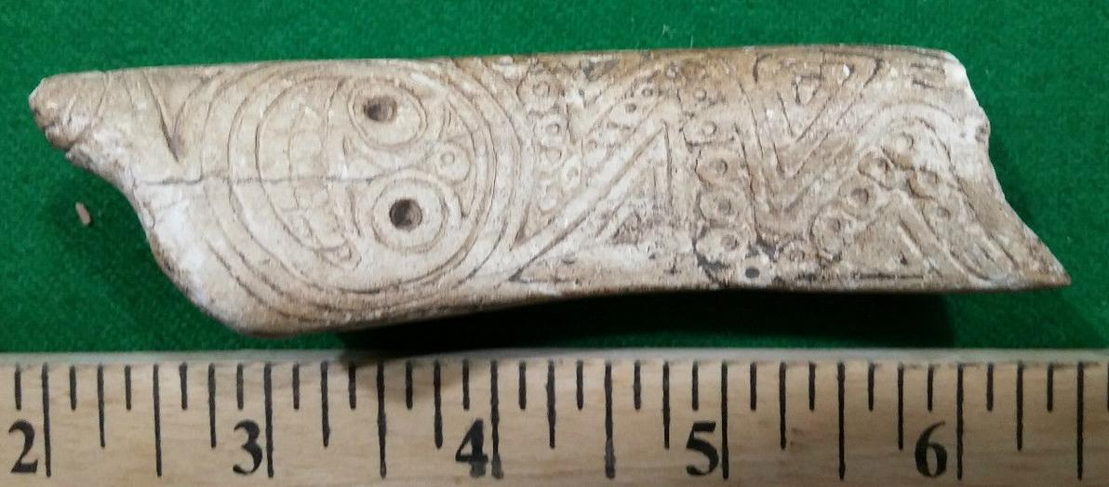

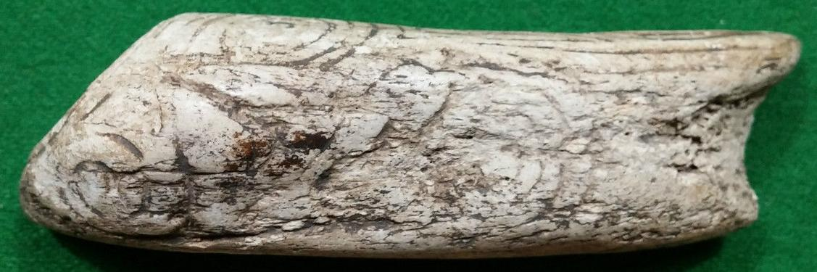

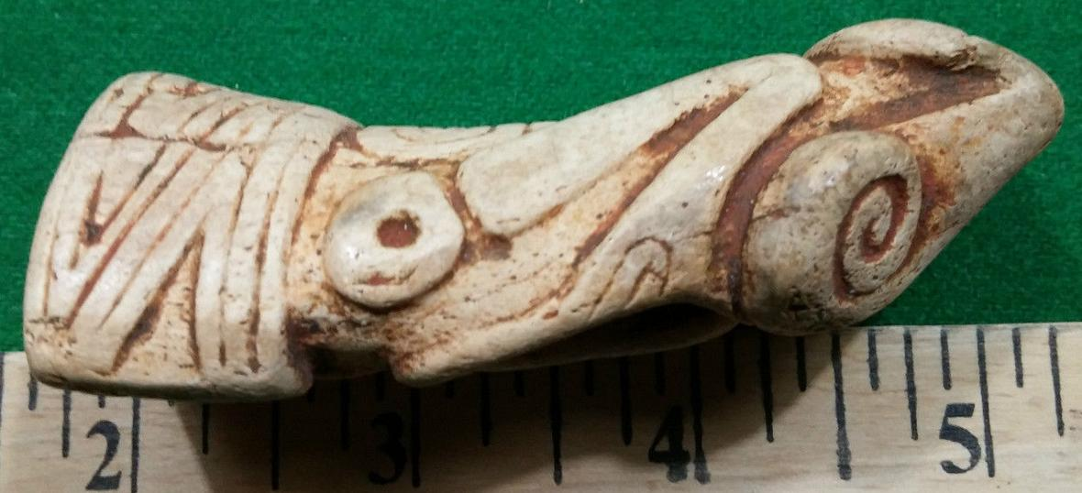 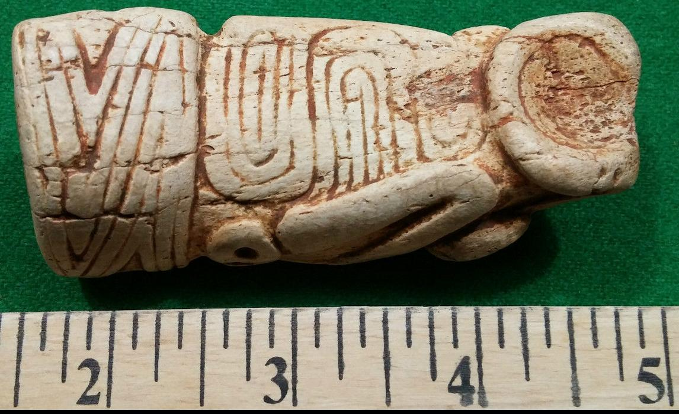 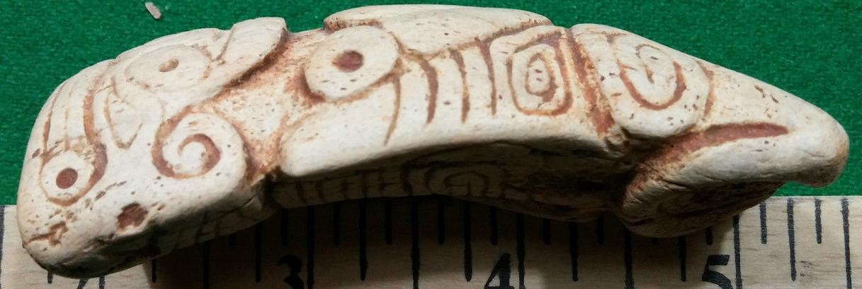

# Order details

## Sales order

Sold by [user1billion](http://myworld.ebay.com/user1billion) ( [784](http://feedback.ebay.com/ws/eBayISAPI.dll?ViewFeedback&userid=user1billion) )

### Delivery package 1 of 1

Estimated delivery Wednesday, Jan 20, 2016 - Tuesday, Jan 26, 2016

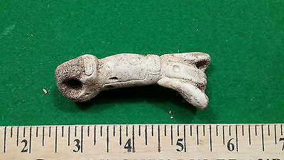

#### [Taino carved pendent Very Old - Pre Columbian](http://www.ebay.com/itm/161937417835)

|  |  |
| --- | --- |
| Item price | $99.00 |
| Quantity | 1 |
| Item number | 161937417835 |
| Shipping service | Canada Post Xpresspost - International |

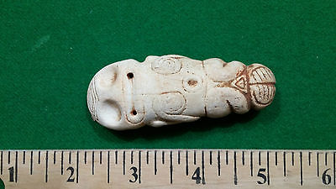

#### [Taino carved pendent / Talisman Very Old - Pre Columbian](http://www.ebay.com/itm/161937438892)

|  |  |
| --- | --- |
| Item price | $129.00 |
| Quantity | 1 |
| Item number | 161937438892 |
| Shipping service | Canada Post Xpresspost - International |

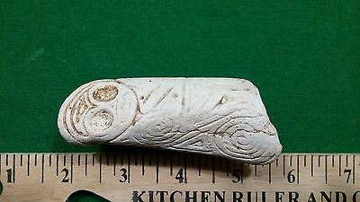

#### [Taino carved pendent or Talisman Very Old - Pre Columbian](http://www.ebay.com/itm/161937444555)

|  |  |
| --- | --- |
| Item price | $99.00 |
| Quantity | 1 |
| Item number | 161937444555 |
| Shipping service | Canada Post Xpresspost - International |

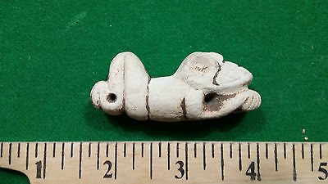

#### [Taino well carved pendent Very Old - Pre Columbian](http://www.ebay.com/itm/272095099304)

|  |  |
| --- | --- |
| Item price | $99.00 |
| Quantity | 1 |
| Item number | 272095099304 |
| Shipping service | Canada Post Xpresspost - International |

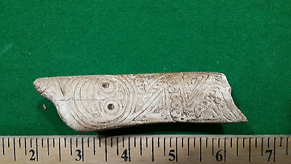

#### [Taino carved pendent / Talisman Very Old - Pre Columbian](http://www.ebay.com/itm/272095116474)

|  |  |
| --- | --- |
| Item price | $99.00 |
| Quantity | 1 |
| Item number | 272095116474 |
| Shipping service | Canada Post Xpresspost - Internati |

## Shipping address

Ralph J Coffman Jr

149 Atlantic Ave

Swampscott MA 01907-2427

United States

## Order total

|  |  |
| --- | --- |
| Subtotal | $724.00 |
| Shipping | $154.90 |

**Total**

$878.90