DIS-MEX-Jalisco-

### Pre Hispanic period**[**[**edit**](https://en.wikipedia.org/w/index.php?title=Jalisco&action=edit&section=7)**]**

Nomadic peoples moving south arrived to the Jalisco area around 15,000 years ago.[[36]](https://en.wikipedia.org/wiki/Jalisco" \l "cite_note-aborigengob-36)[[37]](https://en.wikipedia.org/wiki/Jalisco" \l "cite_note-atraccul-37) Some of oldest evidence of human occupation is found around Zacoalco and Chapala lakes, which used to be connected. This evidence includes human and animal bones and tools made of bone and stone.[[36]](https://en.wikipedia.org/wiki/Jalisco" \l "cite_note-aborigengob-36) Other signs of human habitation **include**[**petroglyphs**](https://en.wikipedia.org/wiki/Petroglyph)**and cave paintings found at**

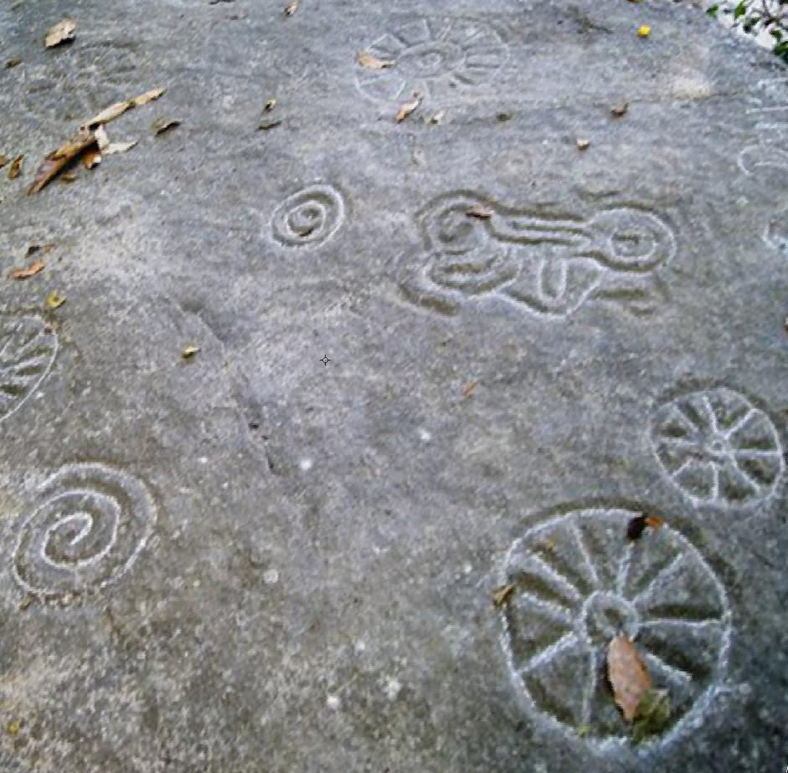 **Cabo Corrientes,** 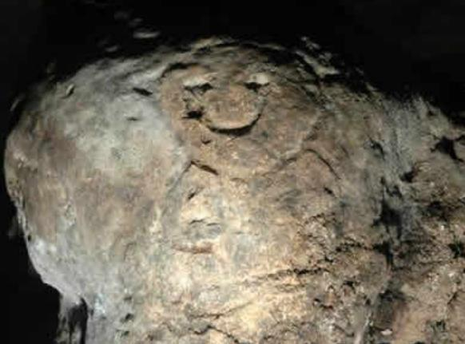

**San Gabriel,**

**Jesús María, La Huerta, Puerto Vallarta, Mixtlán, Villa Purificación, Casimiro Castillo, Zapotlán el Grande and Pihuamo.[[38]](https://en.wikipedia.org/wiki/Jalisco" \l "cite_note-enchis-38)**

Agriculture began in the same region as well around 7,000 years ago, giving rise to the first permanent settlements in western Mexico.[[36]](https://en.wikipedia.org/wiki/Jalisco" \l "cite_note-aborigengob-36) Ceramics began to be produced about 3,500 years ago for both utilitarian and ceremonial purposes. The oldest pieces of Jalisco area pottery are called El Opeño, after an area near [Zamora, Michoacán](https://en.wikipedia.org/wiki/Zamora,_Michoacán) and [Capacha](https://en.wikipedia.org/wiki/Capacha) after an area in [Colima](https://en.wikipedia.org/wiki/Colima). The appearance of these styles indicates a certain specialization of labor, with distinct settled cultures established by 1000 BCE.[[36]](https://en.wikipedia.org/wiki/Jalisco" \l "cite_note-aborigengob-36) The earliest settled cultures were centered on the site of Chupícuaro, Guanajuato, which has a large zone of influence from [Durango](https://en.wikipedia.org/wiki/Durango) east, crossing through modern Jalisco’s north. Sites related to these cultures have been found in Bolaños, Totoate, the Bolaños River Canyon and Totatiche as well as other locations in the Los Altos Region.[[36]](https://en.wikipedia.org/wiki/Jalisco" \l "cite_note-aborigengob-36) Cultures dating to the early part of the Christian era are distinguished by the use of [shaft tombs](https://en.wikipedia.org/wiki/Western_Mexico_shaft_tomb_tradition), with major examples found in Acatlán de Juárez, El Arenal and Casimiro Castillo. The use of this type of tomb is unkno wn anywhere else in Mexico.[[36]](https://en.wikipedia.org/wiki/Jalisco" \l "cite_note-aborigengob-36)[[38]](https://en.wikipedia.org/wiki/Jalisco" \l "cite_note-enchis-38) In the 7th century, [Toltec](https://en.wikipedia.org/wiki/Toltec) and [Teotihuacan](https://en.wikipedia.org/wiki/Teotihuacan) influence is evident in the area, with a dominion called Xalisco established by the Toltecs in 618.[[27]](https://en.wikipedia.org/wiki/Jalisco" \l "cite_note-houston-27)[[39]](https://en.wikipedia.org/wiki/Jalisco" \l "cite_note-cronologiagob-39) The dominion was established through the military domination of the weaker local groups. During this time, ceramics were improved and the working of gold, silver and copper appeared. More recent archeology of the area has produced evidence of larger cities, large scale irrigation and a kind of script used by various cultures of the area.[[38]](https://en.wikipedia.org/wiki/Jalisco" \l "cite_note-enchis-38)

The Toltec influence had a strong influence over religious development with deities formalizing into gods recognized by the later Aztec civilization such as [Tlaloc](https://en.wikipedia.org/wiki/Tlaloc), [Mictlantecuhtli](https://en.wikipedia.org/wiki/Mictlantecuhtli) and [Quetzalcoatl](https://en.wikipedia.org/wiki/Quetzalcoatl).[[36]](https://en.wikipedia.org/wiki/Jalisco" \l "cite_note-aborigengob-36) A number of cities were built during this time, including Ixtepete, which show many features of [Mesoamerican](https://en.wikipedia.org/wiki/Mesoamerica) architecture such as the building of pyramid bases, temples and [Mesoamerican ball courts](https://en.wikipedia.org/wiki/Mesoamerican_ball_court). However, these are sparse because there were very few communities of the size needed to support them. Stones used for building were often cut in angles and with relief such as those found in Tamazula and [El Chanal](https://en.wikipedia.org/wiki/El_Chanal), Colima. Ixtepete from the tenth century has talud/tablero construction showing Teotihuacan influence.[[36]](https://en.wikipedia.org/wiki/Jalisco" \l "cite_note-aborigengob-36) By 1112, the tribes dominated by the Toltecs rebelled and brought an end to the domination; however, the area would be conquered again in 1129, this time by the [Chichimecas](https://en.wikipedia.org/wiki/Chichimeca).[[39]](https://en.wikipedia.org/wiki/Jalisco" \l "cite_note-cronologiagob-39)

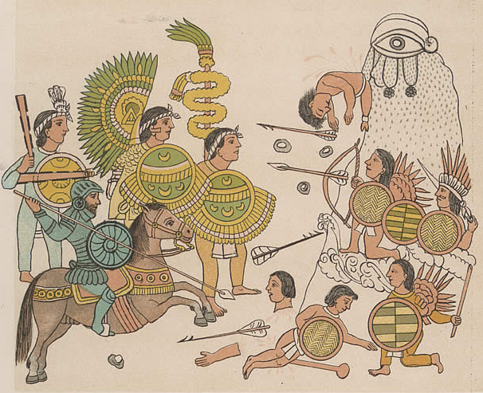

Cristóbal de Olid leads Spanish soldiers with [Tlaxcalan](https://en.wikipedia.org/wiki/Tlaxcala_(Nahua_state)) allies in the conquests of Jalisco, 1522. From [Lienzo de Tlaxcala](https://en.wikipedia.org/wiki/Lienzo_de_Tlaxcala) written by and under the supervision of [Diego Muñoz Camargo](https://en.wikipedia.org/wiki/Diego_Muñoz_Camargo) in the years leading up to 1585 highlights the religious, cultural, and military history of the [Tlaxcaltec](https://en.wikipedia.org/wiki/Tlaxcaltec) people, in particular focusing on the post-[conquest](https://en.wikipedia.org/wiki/Spanish_conquest_of_Mexico) aspects.

The *History of Tlaxcala* is divided into three sections:

* *"Relaciones Geográficas"* or *"Descripción de la ciudad y provincia de Tlaxcala"*, a Spanish text written by Camargo between 1581 and 1584 in response to [Philip II of Spain](https://en.wikipedia.org/wiki/Philip_II_of_Spain)'s *Relaciones Geográfica* questionnaire.
* The "Tlaxcala Calendar", a largely pictorial section, with both Spanish and [Nahuatl](https://en.wikipedia.org/wiki/Nahuatl) captions.
* The "Tlaxcala Codex" a largely pictorial section, with both Spanish and Nahuatl captions.

The *History of Tlaxcala* is held at the [University of Glasgow](https://en.wikipedia.org/wiki/University_of_Glasgow).

Over its history, the Jalisco area has been occupied by a variety of ethnicities including the Bapames, Caxcans, Cocas, Cuachilchils, Huichols, Cuyutecos, Otomis, Nahuas, Tecuejes, Tepehuans, Tecos, Purépecha, Pinomes, Tzaultecas and Xilotlantzingas. Some writers have also mentioned groups such as the Pinos, Otontlatolis, Amultecas, Coras, Xiximes, Tecuares, Tecoxines and Tecualmes.[[38]](https://en.wikipedia.org/wiki/Jalisco" \l "cite_note-enchis-38) When the Spanish arrived the main ethnic groups were the Cazcanes, who inhabitd the northern regions near Teocalteche and the Lagos de Morenos and the Huichols, who also inhabited the northwest near Huejúcar and Colotlán. Other groups included the [Guachichil](https://en.wikipedia.org/wiki/Guachichil) in the Los Altos area, the Nahuatl speaking Cuyutecos in the west, the Tecuexes and Cocas near what is now Guadalajara and the Guamares in the east near the [Guanajuato](https://en.wikipedia.org/wiki/Guanajuato) border.[[27]](https://en.wikipedia.org/wiki/Jalisco" \l "cite_note-houston-27)

Shortly after the [conquest of the Aztecs](https://en.wikipedia.org/wiki/Spanish_conquest_of_the_Aztec_Empire) in 1521, the Spanish pushed west.[[39]](https://en.wikipedia.org/wiki/Jalisco" \l "cite_note-cronologiagob-39) They overpowered the Purépecha in Michoacán, converting their capital of [Tzintzuntzan](https://en.wikipedia.org/wiki/Tzintzuntzan_(Mesoamerican_site)) as a base to move further west. One reason for the push towards the Pacific was to build ships and shipping facilities in order to initiate trade with Asia. Another draw was to find more mineral wealth as the Purépecha had already developed copper working along with silver and gold.[[40]](https://en.wikipedia.org/wiki/Jalisco" \l "cite_note-conquistagob-40)

In 1522, [Cristóbal de Olid](https://en.wikipedia.org/wiki/Cristóbal_de_Olid) was sent by [Hernán Cortés](https://en.wikipedia.org/wiki/Hernán_Cortés) northwest from Mexico City into Jalisco.[[27]](https://en.wikipedia.org/wiki/Jalisco" \l "cite_note-houston-27) Other incursions were undertaken by Alonso de Avalos and Juan Alvarez Chico in 1521, [Gonzalo de Sandoval](https://en.wikipedia.org/wiki/Gonzalo_de_Sandoval) in 1522 and Francisco Cortés de San Buenaventura in 1524.[[38]](https://en.wikipedia.org/wiki/Jalisco" \l "cite_note-enchis-38) The first area explored now belongs to the south of Jalisco down into what it now the state of Colima.[[40]](https://en.wikipedia.org/wiki/Jalisco" \l "cite_note-conquistagob-40) In 1529, the president of the First Audencia in New Spain, [Nuño de Guzmán](https://en.wikipedia.org/wiki/Nuño_de_Guzmán) came west from Mexico City with a force of 300 Spanish and 6,000 Indian allies, traveling through Michoacán, Guanajuato, Jalisco and Sinaloa. At the end of 1531, Guzmán founded the Villa del Espíritu Santo de la Mayor Españas as the capital of the newly conquered western lands. The name was changed shortly thereafter to Santiago Galicia de Compostela.[[38]](https://en.wikipedia.org/wiki/Jalisco" \l "cite_note-enchis-38) In 1531, Guzmán ordered his chief lieutenant, Juan de Oñate to found the Villa of Guadalajara, named after Guzmán’s hometown in Spain. It was initially founded in what is now [Nochistlán](https://en.wikipedia.org/wiki/Nochistlán) in [Zacatecas](https://en.wikipedia.org/wiki/Zacatecas). Construction began in 1532, but the small settlement came under repeated attacks from the Cazcanes until it was abandoned in 1533. The town of Guadalajara would move four times in total before coming to its modern site in 1542.[[27]](https://en.wikipedia.org/wiki/Jalisco" \l "cite_note-houston-27)

Most of Jalisco was conquered by Nuño de Guzmán, who then sent expeditions from there into Zacatecas and Aguascalientes in 1530.[[39]](https://en.wikipedia.org/wiki/Jalisco" \l "cite_note-cronologiagob-39) The first [encomiendas](https://en.wikipedia.org/wiki/Encomienda) were granted to the Spanish conquistadors in Nueva Galicia by Nuño de Guzmán and later by Antonio de Mendoza.[[40]](https://en.wikipedia.org/wiki/Jalisco" \l "cite_note-conquistagob-40)[[41]](https://en.wikipedia.org/wiki/Jalisco" \l "cite_note-colonizacion-41) Nuño de Guzmán founded five Spanish settlements, San Miguel, Chiametla, Compostela, Purificación and Guadalajara to form the first administrative structure of the area. However, most of these settlements were too small to support the grand plans of many Spanish in America and attracted few settlers. By the end of the early colonial period, all of these settlements either disappeared or were moved to other locations.[[40]](https://en.wikipedia.org/wiki/Jalisco" \l "cite_note-conquistagob-40) Guzmán was named the first governor of the region and Franciscans established monasteries in Tetlán and Ajijic.[[39]](https://en.wikipedia.org/wiki/Jalisco" \l "cite_note-cronologiagob-39)

Guzmán was brutal to the local indigenous populations, sending many to slavery in the Caribbean and committing genocide in areas. This would eventually lead to his imprisonment in 1536 by viceroy [Antonio de Mendoza](https://en.wikipedia.org/wiki/Antonio_de_Mendoza).[[27]](https://en.wikipedia.org/wiki/Jalisco" \l "cite_note-houston-27) However, not only Guzmán was to blame for subsequent indigenous hostility. The Spanish in Guadalajara and other locations began to take indigenous peoples as slaves in 1543.[[39]](https://en.wikipedia.org/wiki/Jalisco" \l "cite_note-cronologiagob-39) These Spanish in the area were looking to enrich themselves as fast as possible, following the success of the same of those who arrived first to the Mexico City area. This led to abuses of the native populations, widespread corruption and confrontations between the Spanish and the indigenous and among the Spanish themselves.[[41]](https://en.wikipedia.org/wiki/Jalisco" \l "cite_note-colonizacion-41) Overwork and disease reduced the native population by about ninety percent between 1550 and 1650.[[41]](https://en.wikipedia.org/wiki/Jalisco" \l "cite_note-colonizacion-41)

1. Rosa María Espiritu Miguel (December 3, 2009).[*"Cultura aborigen en Jalisco" [Aboriginal culture in Jalisco]*](http://www.jalisco.gob.mx/wps/portal/!ut/p/c5/04_SB8K8xLLM9MSSzPy8xBz9CP0os3gzb2djr1AXEwMDF383A0_3MEdXxwBDD0dLc6B8pFm8T4iPh7FXkJGBv4mPsYGRm7-Po0uQqwEQENAdDrIPv36QvAEO4GiAV7-Jjzl--TBDfT-P_NxU_YLcCINMT11HAH03lqQ!/dl3/d3/L2dJQSEvUUt3QS9ZQnZ3LzZfNk )(in Spanish). Mexico: State of Jalisco*. RetrievedSeptember 9, 2011*.
2. ^ [Jump up to:](https://en.wikipedia.org/wiki/Jalisco" \l "cite_ref-atraccul_37-0)***a*** ***[b](https://en.wikipedia.org/wiki/Jalisco" \l "cite_ref-atraccul_37-1)*** ***[c](https://en.wikipedia.org/wiki/Jalisco" \l "cite_ref-atraccul_37-2)*** ***[d](https://en.wikipedia.org/wiki/Jalisco" \l "cite_ref-atraccul_37-3)*** ***[e](https://en.wikipedia.org/wiki/Jalisco" \l "cite_ref-atraccul_37-4)*** ***[f](https://en.wikipedia.org/wiki/Jalisco" \l "cite_ref-atraccul_37-5)*** ***[g](https://en.wikipedia.org/wiki/Jalisco" \l "cite_ref-atraccul_37-6)*** ***[h](https://en.wikipedia.org/wiki/Jalisco" \l "cite_ref-atraccul_37-7)*** ***[i](https://en.wikipedia.org/wiki/Jalisco" \l "cite_ref-atraccul_37-8)*** ***[j](https://en.wikipedia.org/wiki/Jalisco" \l "cite_ref-atraccul_37-9)*** [*"Atractivos Culturales y Turísticos" [Cultural and Tourist Attractions]*](http://www.e-local.gob.mx/work/templates/enciclo/jalisco/).Enciclopedia de los Municipios de México Jalisco(in Spanish). Mexico: Instituto Nacional para el Federalismo y el Desarrollo Municipal and Government of Jalisco. 2005*. RetrievedSeptember 9, 2011*.
3. ^ [Jump up to:](https://en.wikipedia.org/wiki/Jalisco" \l "cite_ref-enchis_38-0)***a*** ***[b](https://en.wikipedia.org/wiki/Jalisco" \l "cite_ref-enchis_38-1)*** ***[c](https://en.wikipedia.org/wiki/Jalisco" \l "cite_ref-enchis_38-2)*** ***[d](https://en.wikipedia.org/wiki/Jalisco" \l "cite_ref-enchis_38-3)*** ***[e](https://en.wikipedia.org/wiki/Jalisco" \l "cite_ref-enchis_38-4)*** ***[f](https://en.wikipedia.org/wiki/Jalisco" \l "cite_ref-enchis_38-5)*** ***[g](https://en.wikipedia.org/wiki/Jalisco" \l "cite_ref-enchis_38-6)*** ***[h](https://en.wikipedia.org/wiki/Jalisco" \l "cite_ref-enchis_38-7)*** ***[i](https://en.wikipedia.org/wiki/Jalisco" \l "cite_ref-enchis_38-8)*** ***[j](https://en.wikipedia.org/wiki/Jalisco" \l "cite_ref-enchis_38-9)*** ***[k](https://en.wikipedia.org/wiki/Jalisco" \l "cite_ref-enchis_38-10)*** ***[l](https://en.wikipedia.org/wiki/Jalisco" \l "cite_ref-enchis_38-11)*** ***[m](https://en.wikipedia.org/wiki/Jalisco" \l "cite_ref-enchis_38-12)*** ***[n](https://en.wikipedia.org/wiki/Jalisco" \l "cite_ref-enchis_38-13)*** ***[o](https://en.wikipedia.org/wiki/Jalisco" \l "cite_ref-enchis_38-14)*** ***[p](https://en.wikipedia.org/wiki/Jalisco" \l "cite_ref-enchis_38-15)*** ***[q](https://en.wikipedia.org/wiki/Jalisco" \l "cite_ref-enchis_38-16)*** ***[r](https://en.wikipedia.org/wiki/Jalisco" \l "cite_ref-enchis_38-17)*** ***[s](https://en.wikipedia.org/wiki/Jalisco" \l "cite_ref-enchis_38-18)*** ***[t](https://en.wikipedia.org/wiki/Jalisco" \l "cite_ref-enchis_38-19)*** ***[u](https://en.wikipedia.org/wiki/Jalisco" \l "cite_ref-enchis_38-20)*** ***[v](https://en.wikipedia.org/wiki/Jalisco" \l "cite_ref-enchis_38-21)*** ***[w](https://en.wikipedia.org/wiki/Jalisco" \l "cite_ref-enchis_38-22)*** ***[x](https://en.wikipedia.org/wiki/Jalisco" \l "cite_ref-enchis_38-23)*** ***[y](https://en.wikipedia.org/wiki/Jalisco" \l "cite_ref-enchis_38-24)*** ***[z](https://en.wikipedia.org/wiki/Jalisco" \l "cite_ref-enchis_38-25)*** ***[aa](https://en.wikipedia.org/wiki/Jalisco" \l "cite_ref-enchis_38-26)*** ***[ab](https://en.wikipedia.org/wiki/Jalisco" \l "cite_ref-enchis_38-27)*** ***[ac](https://en.wikipedia.org/wiki/Jalisco" \l "cite_ref-enchis_38-28)*** [*"Historia" [History]*](http://www.e-local.gob.mx/work/templates/enciclo/jalisco/).Enciclopedia de los Municipios de México Jalisco(in Spanish). Mexico: Instituto Nacional para el Federalismo y el Desarrollo Municipal and Government of Jalisco. 2005*. RetrievedSeptember 9, 2011*.
4. ^ [Jump up to:](https://en.wikipedia.org/wiki/Jalisco" \l "cite_ref-cronologiagob_39-0)***a*** ***[b](https://en.wikipedia.org/wiki/Jalisco" \l "cite_ref-cronologiagob_39-1)*** ***[c](https://en.wikipedia.org/wiki/Jalisco" \l "cite_ref-cronologiagob_39-2)*** ***[d](https://en.wikipedia.org/wiki/Jalisco" \l "cite_ref-cronologiagob_39-3)*** ***[e](https://en.wikipedia.org/wiki/Jalisco" \l "cite_ref-cronologiagob_39-4)*** ***[f](https://en.wikipedia.org/wiki/Jalisco" \l "cite_ref-cronologiagob_39-5)*** ***[g](https://en.wikipedia.org/wiki/Jalisco" \l "cite_ref-cronologiagob_39-6)*** ***[h](https://en.wikipedia.org/wiki/Jalisco" \l "cite_ref-cronologiagob_39-7)*** ***[i](https://en.wikipedia.org/wiki/Jalisco" \l "cite_ref-cronologiagob_39-8)*** ***[j](https://en.wikipedia.org/wiki/Jalisco" \l "cite_ref-cronologiagob_39-9)*** ***[k](https://en.wikipedia.org/wiki/Jalisco" \l "cite_ref-cronologiagob_39-10)*** ***[l](https://en.wikipedia.org/wiki/Jalisco" \l "cite_ref-cronologiagob_39-11)*** ***[m](https://en.wikipedia.org/wiki/Jalisco" \l "cite_ref-cronologiagob_39-12)*** ***[n](https://en.wikipedia.org/wiki/Jalisco" \l "cite_ref-cronologiagob_39-13)*** ***[o](https://en.wikipedia.org/wiki/Jalisco" \l "cite_ref-cronologiagob_39-14)*** ***[p](https://en.wikipedia.org/wiki/Jalisco" \l "cite_ref-cronologiagob_39-15)*** ***[q](https://en.wikipedia.org/wiki/Jalisco" \l "cite_ref-cronologiagob_39-16)*** ***[r](https://en.wikipedia.org/wiki/Jalisco" \l "cite_ref-cronologiagob_39-17)*** ***[s](https://en.wikipedia.org/wiki/Jalisco" \l "cite_ref-cronologiagob_39-18)*** ***[t](https://en.wikipedia.org/wiki/Jalisco" \l "cite_ref-cronologiagob_39-19)*** ***[u](https://en.wikipedia.org/wiki/Jalisco" \l "cite_ref-cronologiagob_39-20)*** ***[v](https://en.wikipedia.org/wiki/Jalisco" \l "cite_ref-cronologiagob_39-21)*** ***[w](https://en.wikipedia.org/wiki/Jalisco" \l "cite_ref-cronologiagob_39-22)*** Rosa María Espiritu Miguel (December 3, 2009).[*"Cronología" [Chronology]*](http://www.jalisco.gob.mx/wps/portal/!ut/p/c5/04_SB8K8xLLM9MSSzPy8xBz9CP0os3gzb2djr1AXEwMDF383A0_3MEdXxwBDD0dLc6B8pFm8T4iPh7FXkJGBv4mPsYGRm7-Po0uQqwEQENAdDrIPv36QvAEO4GiAV7-Jjzl--TBDfT-P_NxU_YLcCINMT11HAH03lqQ!/dl3/d3/L2dJQSEvUUt3QS9ZQnZ3LzZfNk )(in Spanish). Mexico: State of Jalisco*. Retrieved September 9,2011*.
5. ^ [Jump up to:](https://en.wikipedia.org/wiki/Jalisco" \l "cite_ref-conquistagob_40-0)***a*** ***[b](https://en.wikipedia.org/wiki/Jalisco" \l "cite_ref-conquistagob_40-1)*** ***[c](https://en.wikipedia.org/wiki/Jalisco" \l "cite_ref-conquistagob_40-2)*** ***[d](https://en.wikipedia.org/wiki/Jalisco" \l "cite_ref-conquistagob_40-3)*** ***[e](https://en.wikipedia.org/wiki/Jalisco" \l "cite_ref-conquistagob_40-4)*** ***[f](https://en.wikipedia.org/wiki/Jalisco" \l "cite_ref-conquistagob_40-5)*** ***[g](https://en.wikipedia.org/wiki/Jalisco" \l "cite_ref-conquistagob_40-6)*** Rosa María Espiritu Miguel (December 3, 2009).[*"Conquista" [Conquest]*](http://www.jalisco.gob.mx/wps/portal/!ut/p/c5/04_SB8K8xLLM9MSSzPy8xBz9CP0os3gzb2djr1AXEwMDF383A0_3MEdXxwBDD0dLc6B8pFm8T4iPh7FXkJGBv4mPsYGRm7-Po0uQqwEQENAdDrIPv36QvAEO4GiAV7-Jjzl--TBDfT-P_NxU_YLcCINMT11HAH03lqQ!/dl3/d3/L2dJQSEvUUt3QS9ZQnZ3LzZfNk )(in Spanish). Mexico: State of Jalisco*. Retrieved September 9, 2011*.
6. ^ [Jump up to:](https://en.wikipedia.org/wiki/Jalisco" \l "cite_ref-colonizacion_41-0)***a*** ***[b](https://en.wikipedia.org/wiki/Jalisco" \l "cite_ref-colonizacion_41-1)*** ***[c](https://en.wikipedia.org/wiki/Jalisco" \l "cite_ref-colonizacion_41-2)*** ***[d](https://en.wikipedia.org/wiki/Jalisco" \l "cite_ref-colonizacion_41-3)*** ***[e](https://en.wikipedia.org/wiki/Jalisco" \l "cite_ref-colonizacion_41-4)*** ***[f](https://en.wikipedia.org/wiki/Jalisco" \l "cite_ref-colonizacion_41-5)*** ***[g](https://en.wikipedia.org/wiki/Jalisco" \l "cite_ref-colonizacion_41-6)*** Rosa María Espiritu Miguel (December 3, 2009).[*"Colonizacion" [Colonization]*](http://www.jalisco.gob.mx/wps/portal/!ut/p/c5/04_SB8K8xLLM9MSSzPy8xBz9CP0os3gzb2djr1AXEwMDF383A0_3MEdXxwBDD0dLc6B8pFm8T4iPh7FXkJGBv4mPsYGRm7-Po0uQqwEQENAdDrIPv36QvAEO4GiAV7-Jjzl--TBDfT-P_NxU_YLcCINMT11HAH03lqQ!/dl3/d3/L2dJQSEvUUt3QS9ZQnZ3LzZfNk )(in Spanish). Mexico: State of Jalisco*. Retrieved September 9, 2011*.

## *January 2003*

# Historia de

|  |
| --- |
|  |

# Tlaxcala

## Mexico: 1585 Sp Coll MS Hunter 242 (U.3.15)

|  |
| --- |
| The choice for the first book of the month of 2003 is Diego Muñoz Camargo's Historia de Tlaxcala. This is a Sixteenth Century manuscript originating in post-Spanish conquest Mexico and deals with the social, political, military, religious and cultural history of the Province of Tlaxcala. This manuscript has been chosen not only because it is beautiful, unique and historically important but also because it is currently being exhibited in London at the [Royal Academy's Aztecs exhibition](http://www.aztecs.org.uk/?lid=508). This exhibition is the most comprehensive survey of Aztec culture ever mounted, bringing together some 350 outstanding works highlighting the splendours, variety and sophistication of the Aztec civilisation. |

|  |  |
| --- | --- |
| **Folio 249r   Christopher Columbus symbolically offers the "New World" to Charles V** | The *Historia* is a very unusual manuscript in that it can be separated into three different sections; one textual and two pictorial written in Spanish and native Náhuatl. The three different sections have names in their own right; the textual section is known as the *Relaciones Geográficas* or *Descripción de la ciudad y provincia de Tlaxcala* while the two pictorial sections are known as the *Tlaxcala Calendar* and*Tlaxcala Codex*. Although the subjects and issues covered in all three sections are linked, it is unclear whether they were all produced at the same time, though it is known that they were not produced by the same author. Written on European paper using pen and china-ink, the manuscript survives bound in its original vellum with gilded and goffered edges.  The textual section is the easiest part to date, originally having been written between 1581 and 1584 by the Tlaxcaltecan historian, Diego Muñoz Camargo. The text is an extended version of the questionnaire, the *Relaciones Geográfica,*issued at the order of Philip II of Spain and sent to every town and province of New Spain. It covered topics such as population demographics, political jurisdictions, languages spoken, physical terrain and native vegetation to name but a few. The information gathered would provide a massive database on what the Spanish Empire comprised of and the possibilities achievable for the Crown with the resources at its disposal. |

|  |  |
| --- | --- |
| The task of commissioning a response to the questionnaire in the Province of Tlaxcala fell to the *alcade* *mayor*, the Alonso de Nava. He thought Diego Muñoz Camargo, an educated *mestizo* (half-Indian, half-Spanish) the most appropriate person to prepare a report. Camargo was the son (probably illegitimate) of a Spanish conquistador and an indigenous Indian woman. He spent a good period of his youth in Mexico City where he became fluent in Spanish and the local Indian language, Náhuatl, through teaching Indians who had been brought back from Florida. Camargo became acquainted with Tlaxcala through properties his father owned in the town, later settling and marrying a Tlaxcaltecan noblewoman, Leonor Vázquez. He was well enough respected and had a good enough grounding in native Tlaxcaltecan history and language that few would have been more qualified for thetask ofwriting the *Relaciones Geográfica*.  Both the textual *Descripción de la ciudad y provincia de Tlaxcala*and the supplementary pictorial*Tlaxcala Codex* deal with the history of the province of Tlaxcala from the beginning of the conquest of the region by the Spanish. At the time of Hernan Cortés' arrival (1519), the Mexican plateau was predominantly populated by Náhuatl-speaking Indians whose close-knit political organisation, the Aztec empire, had been developing for around 150 years. The one great exception to this Sixteenth Century superpower was the province of Tlaxcala. Sitting to the east of Tenochtitlán (Mexico City), the Tlaxcaltecas had defended a territory of some size and held the Aztecs, or Mexicas as they are often known, at bay while the Aztec Empire began to engulf them. On their arrival, the Spanish were welcomed with open arms by the Tlaxcaltecas who became their main indigenous ally in the war to conquer the Aztec Empire. | **Folio 239v   The erection of the first cross in New Spain by the twelve friars from the order of St. Francis** |

|  |  |  |  |
| --- | --- | --- | --- |
| **Folio 239r   A human sacrifice ceremony observed by Spaniards.  They are denounced for holding the pagan offering of a decapitated quail** | |  | | --- | | The *Tlaxcala Codex*can be considered a supplementary section of Camargo's *Descripción*, as they both deal with the same topics; the joint history of the Tlaxcaltecas and the Spanish in their wars against the Aztecs and the evangelical battle for Christianity. The *Codex*comprises of 157 images drawn in pen and china-ink and then captioned above in Náhuatl (although many of the Náhuatl captions have subsequently been lost through cropping). Each image and caption has then been glossed underneath in Spanish by a different hand. These drawings are almost certainly not the work of Camargo since certain errors exist in the drawings and captions that suggest a less-well-informed person carried out the work. It has been suggested that the *Codex* might in fact be an independent work, copied in whole, or part from an existing work. Some eighty of the drawings appear to be nearly identical to those found on the *Lienzo de Tlaxcala*, a mid Sixteenth Century Mexican manuscript which may have acted as a form of template for the *Codex*. | | **Detail from folio 239r   Caption in Náhuatl describes how people are killed in the "house of the devil".  Many original captions were lost through cropping when the manuscript was bound** | |

|  |  |  |
| --- | --- | --- |
| **Folio 245v   A map of the monastery of Tlaxcala including the church, bell tower, orchard and 73 steps to the church patio** | The text and accompanying *Codex*drawings deal with many different events and nuances of Sixteenth Century Tlaxcaltecan life. The city of Tlaxcala is described, with all of its main streets and buildings; the *Casas Reales*of the four leaders of Tlaxcala along with the churches and monasteries established are all detailed. The allied campaign that the Tlaxcaltecas and Spanish waged against the Aztecs is documented in full. The battle of Cholula and its subsequent destruction, the death of the Aztec King, Motecuhzoma II, the *noche triste*, where the Spanish were driven from Tenochtitlán, the battle of Otumba and the final battle for Mexico are all described. |  |

|  |
| --- |
| **Folio 316r   The battle of Nochtlan**  The evangelical battle to convert the Indians from their traditional gods to the Christian faith is also documented. From the arrival of the first twelve Franciscan friars, the erection of the first cross, the first baptisms, to the meting out of swift justice to those converts slipping back into "idolatrous" ways. In order to evangelise the Indians, the Spanish seemed determined to show the power of their god over the polytheist native religion. This not only involved preaching of the gospel but also the destruction of indigenous places of worship and the burning of many ancient written religious and cultural histories. Camargo is very critical of these destructive acts; as a historian he would have recognised the irreparable damage being done in the Spanish drive to convert the Indians to Christianity. He recognised the importance of preserving whatever history the Indians still had and spent much time in his text describing the traditional beliefs of the Indians. He describes the belief in the existence of four worlds before the current one and traditional ideas on genesis. This recognition in the importance of traditional culture and history is probably why the third pictorial section of the *Historia*; the*Tlaxcala Calendar*is included. |

|  |  |
| --- | --- |
| **Folio 242r Franciscan friars burning traditional books and clothes.  The images in the fire represent the destruction of the old gods whose masks correspond to the twenty signs of the *tonalamatl***  **Folio 241v   Punishment and "justice" for a convert to Christianity who has "slid back" into idolatry ways.  According to the Náhuatl caption he is to be hanged the very next day** |  |

|  |  |
| --- | --- |
|  | **Recto of insert between folio 177 and 178**  The *Calendar*comprises two separate astronomical diagrams describing the traditional Mexican calendrical system. These diagrams take the form of two calendar wheels that are found between folios 177 and 178 of the manuscript. The first, designed by Francisco de las Navas, a Franciscan monk correlates the twenty signs of the*tonalamatl*, at the centre, with the 52 years of the *xiuhmolpilli*, at the circumference, showing how the four  special signs combine with thirteen special numbers to produce 52 year names. These are further correlated with the Christian calendar, from 1 Reed (1519) when Cortés arrived to 13 Rabbit (1570). The second calendar wheel was designed by an Indian governor of Tlaxcala, Antonio de Guevara. It shows, 18 months of the Mexican year and the five days without feasts of the 365 day year; the sign for each feast, an explanation of the sign and the name and the correlation with the months of the Christian calendar. A note explains how each month is divided into a 20-day period named after the moon, *meztli*, which is depicted in the centre of the wheel. Among the many calendar wheels included in histories of the Spanish colonial period, these two wheels have the acknowledged distinction of being the earliest.  Although Camargo is very critical of the acts of cultural and historical destruction perpetrated by the Spanish, the overall tone of the *Historia*is far more ambivalent. The shared history of the Tlaxcaltecas and Spanish and the unique relationship they maintain is suggested quite deliberately throughout. The *Historia*was compiled as a gift for Philip II and these references were almost certainly an attempt to curry favour with the Crown and establish privileges for the Tlaxcaltecas. Camargo was interpreter for a Tlaxcaltecan delegation of Indians including Antonio de Guevara who travelled to Spain in 1584. It was in Madrid, the next year, that the copying and binding of the*Historia* was finally completed. The purpose of this visit was to secure additional privileges for the Tlaxcaltecan court; the adulatory nature of the *Historia*may have assisted the delegation, for the same year Royal cedulas were issued granting a series of new exemptions and immunities to Tlaxcala.  However, the benefits - irregardless of the manuscript's significance in their being granted - were short-lived. Subsequent years saw the Spanish authorities pursue a rigorous programme imposing stronger Crown control over New World territories in order to ensure maximum profit: this included the reversal of Tlaxcala's exemptions. As Eleanor Wake notes, very quickly, "Tlaxcala became but another source of tributary income". |
|  |

|  |
| --- |
| **Verso of insert between folio 177 and 178**  The *Historia de Tlaxcala* appears to have remained in the Biblioteca Real, housed in El Escorial near Madrid at least until the early Seventeenth Century after which its fate becomes obscure until purchased by Dr. William Hunter for his museum established in 1768. Upon his death, Hunter bequeathed his collection; the *Historia*included, to Glasgow University. The manuscript remained largely unknown to scholars for some considerable time and did not appear on the census of Mesoamerican manuscripts of 1975. René Acuña published the first facsimile edition of the manuscript under the title *Descripción de la ciudad y provincia de Tlaxcala, Mexico* in 1981 and the *Historia* has since gained deserved and widespread recognition as one of the most historically important early Mesoamerican documents extant. |

|  |
| --- |
| Other items of interest Visit the [Royal Academy's Aztecs exhibition](http://www.aztecs.org.uk/?lid=508) website.  The exhibition runs from 16 November 2002 until 11 April 2003  Although the original is restricted, the facsimile edition of [MS Hunter 242 (U.3.15)](http://special.lib.gla.ac.uk/manuscripts/search/detaild.cfm?DID=33116),  *Descripción de la ciudad y provincia de Tlaxcala de las Indias y del mar océano para el buen gobierno y ennoblecimiento dellas.*By Diego Muñoz Camargo, ed. by René Acuña. 1981. UNAM : Mexico can be consulted at [Sp Coll RF 76](http://eleanor.lib.gla.ac.uk/record=b1160328)  **The following books have been very helpful in compiling this article:**  Acuña, René, 1984. *Relaciones Geográficas del Siglo XVI: Tlaxcala.*UNAM : Mexico.  [Sp Coll Hunterian Add. 210](http://eleanor.lib.gla.ac.uk/record=b1258904)  Berger, Una, 1988. *Mexican painted manuscripts in the United Kingdom.*[British Museum Occasional Paper 91] British Museum : London. [Sp Coll Hunterian Add. f74](http://eleanor.lib.gla.ac.uk/record=b1886308)  Brotherston, Gordon, 1995. *Painted books from Mexico; codices in UK collections and the world they represent.*British Museum :  London. [Sp Coll Hunterian Add. 271](http://eleanor.lib.gla.ac.uk/record=b1761314)  Gibson, Charles, 1950. The identity of Diego Munoz Camargo. *The Hispanic American Historical Review*30:2:195-208 (available from [JSTOR](http://uk.jstor.org/))  Gibson, Charles, 1967. *Tlaxcala in the Sixteenth Century.*Stanford University Press : Stanford, Ca.. Main Library [History UA854 GIB](http://eleanor.lib.gla.ac.uk/record=b1291144)  Morner, Magnus and Gibson, Charles, 1962. Diego Munoz Camargo and the Segregation Policy of the Spanish Crown. T*he Hispanic American Historical Review*42:4:558-568 (available from [JSTOR](http://uk.jstor.org/))  *The State of Tlaxcala,*1994. Government of the State of Tlaxcala : Mexico. [Sp Coll Hunterian Add, q77](http://eleanor.lib.gla.ac.uk/record=b2047611)  Wake, Eleanor, 2002. Codex Tlaxcala: new insights an new questions. *Estudios de Cultura Náhuatl*33: 91-140 (available from: [http://www.ejournal.unam.mx](http://www.ejournal.unam.mx/)) |